CIS430 Web and E-Business Design and Development - **Assignment 1**

|  |  |
| --- | --- |
| First Name | Noah |
| Last Name | St Mark |
| Student ID# | 041636260 |

STUDENT COMMENTARY: I hope you don’t mind! I challenged myself to create a nice webpage. I completed all the requirements.

Table of Contents

Creating a Home Page for Cycle Out Cancer 1

Problem: 1

Instructions: Perform the following tasks: 1

How to submit your Assignment 4

# Creating a Home Page for Cycle Out Cancer

## Problem:

You are part of a philanthropic group of motorcyclists, Cycle Out Cancer, who participate in community events and parades to distribute cancer awareness information. Create the webpage shown in Figure 3–71 that marks up the content on the organization’s home page.

## Instructions: Perform the following tasks:

1. Open the **cycle03.html** in your HTML editor and then modify the comment at the top of the page to include your name and today’s date. Make sure the <title>…</title> tags contain the text **Cycle Out Cancer Home Page.**

2. Change the <p>…</p> tags that mark up “Cycle Out Cancer” in the **header** section to <h1>…</h1> tags.

3. Change the <p>…</p> tags that mark up “We Ride So Others May Live” in the **header** section to <h2>…</h2> tags.

4. Delete the <!-- add photo--> comment in the **header** section and add an **img** tag with the following attributes and values:

**src="cycle.jpg"**

**alt="Woman saluting riders"**

**width="385"**

**height="578"**

5. Modify the content in the nav section to create links to each of the future pages of the website with the href attribute values as follows:

**<a href="about.html">About Us</a>**

**<a href="events.html">Events</a>**

**<a href="faq.html">Cancer FAQs</a>**

**<a href="contact.html">Contact Us</a>**

6. Modify the list of links in the **nav** section to be indented list items using <li>…</li> tags within an unordered list created with <ul>…</ul> tags. The two nonbreaking space codes **&nbsp**; should be positioned after the closing </a> tag but before the closing </li> tag for each item.

7. In the <div id="main"> section, mark up the following headings with <h3>…</h3> tags:

Rides and Activities

Blood and Organ Donation

Survivor Stories

7 Steps Every Cancer Patient Should Take

Key Terminology

8. Below the “Rides and Activities” heading in the <div id="main"> section, mark up the ­first line (“Rides and activities are…”) with <p>…</p> tags. Mark up the list of four hospitals as an unordered list.

9. Below the “Blood and Organ Donation” heading in the <div id="main"> section, use the fi­rst URL as the **href** attribute value to create a link with the text **Information on donating blood from the American Red Cross**.

Use the second URL as the **href** attribute value to create a link with the text **Information on donating organs from WebMD**.

10. Below the “Survivor Stories” heading in the <div id="main"> section, mark up the four testimonials using <p>…</p> tags. (Hint: Each paragraph ends with the name of a person.)

11. Below the “7 Steps Every Cancer Patient Should Take” heading in the <div id="main"> section, delete numbers 1 through 7, and then mark up and indent the seven steps as list items using <li>…</li> tags within an ordered list created with <ol>…</ol> tags.

12. Below the “Key Terminology” heading in the <div id="main"> section, mark up the entire section as a description list using <dl>…</dl> tags. Mark up each term as a de­finition term with <dt>…</dt> tags and each defi­nition with <dd>…</dd> tags

13. Validate your code and fi­x any errors.

14. Check the spelling of the text.

15. Save and open the page within a browser as shown in Figure 3–71.

16. Submit your assignment.

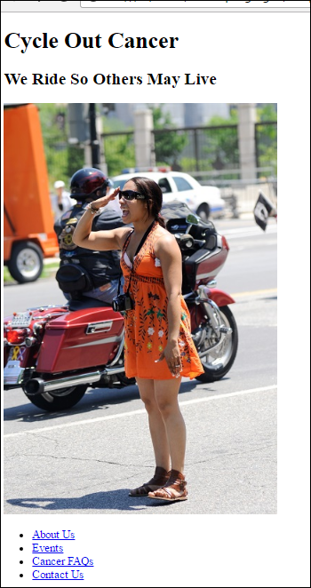

**Figure 3–71 – part 1.**

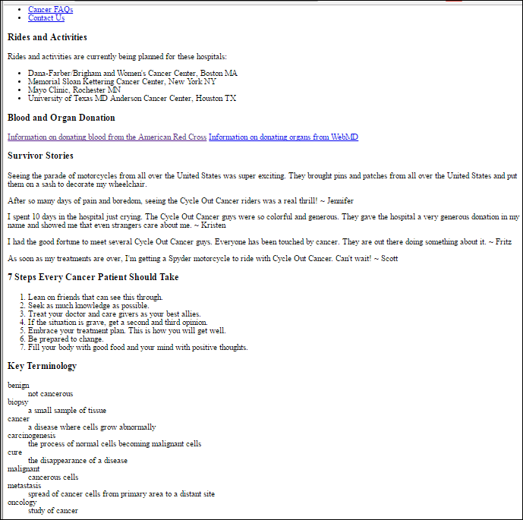

**Figure 3–71 – part 2.**

# How to submit your Assignment

1. After editing all the files and creating the required page(s), compress the final folder (containing all the files) and submit it as a single compressed file (Zip or Rar files).
2. Rename the compressed file as following.

*YourLastName* – *YourFirstName* – *StudentIdNumber*.zip

Example:

Smith – John – 234566435.zip

1. Upload the file and submit it (only using Blackboard)

**The end.**