# Marginal efficiency of investment

The marginal efficiency of investment is that [rate of discount](https://en.wikipedia.org/wiki/Discounting) which would equate the price of a [fixed](https://en.wikipedia.org/wiki/Fixed_asset) investment [asset](https://en.wikipedia.org/wiki/Asset) with its [present discounted value of expected income](https://en.wikipedia.org/wiki/Discounted_cash_flow). We must consider the performance of our investment, so we need to introduce the marginal efficiency to our model.

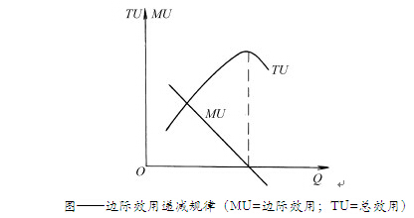

MU= marginal utility, TU=total utility, AU=average utility.

As a simple example, we will face a law of diminishing marginal utility if we invest a small amounts. On the other hand, we must think over the law of increasing marginal utility within an excessive investment. We consider the investment needs to be an appropriate amount. This is because the MU will returns to negative with increasing of Q (quantity). These variables can be expressed as follows:

$$TU=\int_{0}^{Q}{MU}$$

$$AU=TU/Q$$

So we must give a reasonable distribution for our investment, We cannot make a unbalance distribution occurs to MU low to a certain extent. Or we will have a failed scheme for our distribution.