What you learn

1. Git stash
2. Switch branch

Imagine real case. You work as a team for a project. (Assume that you host this project)

(Looloo retail_forecast case)

Day1. You have setup code in main branch. Let’s assume that there are only 1 files in main branch

D1 : src/base_preprocess.py at main branch

Day2. You need to add lookback feature and training code. So, you have created a new branch which is “branch7” and adding many files in branch7

D2 : src/add_lookback.py, src/training.py at branch7 (new files)

src/base_preprocess.py at branch7 (same as D1 in main branch)

Script / … at branch7 (new files)

config / … at branch7 (new files)

Day3 you made some change in src/base_preprocess.py.

D3 : src/add_lookback.pysrc/training.py at branch7 (new files)

src/base_preprocess.py at branch7 (change made from main)

Script / … at branch7 (new files)

config / … at branch7 (new files)

Day4 You want to get back to main branch to recheck your code.

You have 2 choices

1. Git add, git commit before checkout main (recommended)
2. Git stash (for more detail : https://www.atlassian.com/git/tutorials/saving-changes/git-stash)

D1 at main

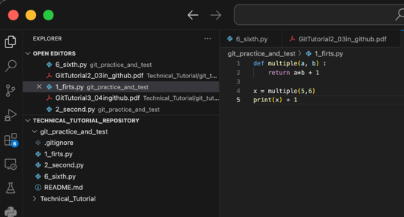

D2,3 at branch7

* Change 1_firts.py
* New file (branch7_file.py)

D4

1. Git add and commit at branch7
2. Git checkout main
3. You would see that

* 1_firts.py code จะเหมือนกับตอนแรกที่ branch main เลย # there is a change in this file ใน branch 7 ไม่ตามมาด้วย

(ถึงเปิดไฟล์นั้นอยู่พอ checkout ส่วนที่เพิ่มมามันก็จะหายไปเลย re-render ให้เหมือน main ตอนแรก)

* ไม่มี branch7_file.py ตามมาด้วย ** อย่าเผลอไปกด save ล่ะ เวลามันขึ้นสีแดงๆขีด
* กลับไป checkout branch7 ก็จะเจอของที่แก้ไว้

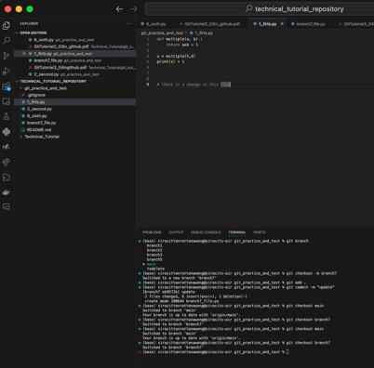

What you learn

1. git reset (revert commit)

Imagine real case. You work as a team for a project. (Assume that you host this project)

(Looloo retail_forecast case)

Day1. You have set up code in main branch. Let’s assume that there are only 1 file in main. Then new branch “branch7”

Also git push -u origin branch7 to remote repo

D1 : src/base_preprocess.py at main branch

Day2. You need to add lookback feature and training code

D2 : src/add_lookback.pysrc/training.py at branch7 (new files)

src/base_preprocess.py at branch7 (same as D1 in main branch)

Script / … at branch7 (new files)

config / … at branch7 (new files)

Day3 You accidentally push all code to the branch7 remote repo (In fact, you should push only src/add_lookback.py)

D3 : src/add_lookback.py at branch7 (in remote branch7)

src/base_preprocess.py, src/training.py at branch7 (in remote branch7)

Script / … at branch7 (in remote branch7)

config / … at branch7 (in remote branch7)

Day4 You want to revert remote repository of branch7 to the previous version and then push only src/add_lookback.py again

(No change in local, only remote)

D1 at main

D2,3 at branch7

* push file_should_be_push.py
* push file_should_not_be_push.py

D4 at branch7 (No change in local, only remote)

1. git log and find day1 commit (press q to exit)
2. git reset –soft __________ (commit code)
3. git reset
4. git add file you want to add
5. git commit
6. git push –force (same as git push origin branch7 –force) (it will push to the checkout branch)

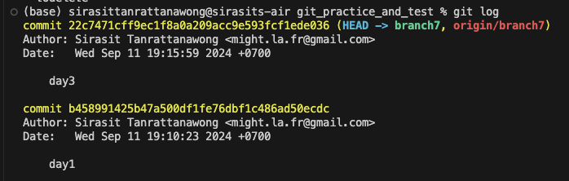

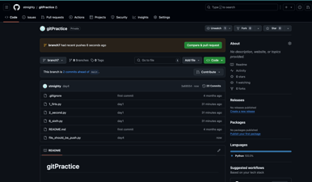

Note read git reset --hard if you also want to change local file not only remote