Name | Drug Class | Structure | logP  (ALOGPS 2.1) | Net charge  @pH 7.4 | Mol. Weight  (g/mol) | TPSA  (Å²)
Acriflavine | Toxic dye | 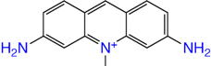 | -1.67 | +1 | 224.28 | 55.9
Ethidium | Toxic dye | 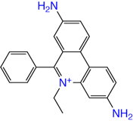 | 0.83 | +1 | 314.4 | 55.9
Norfloxacin | Fluoroquinolone antibiotic | 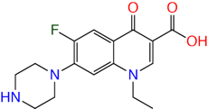 | -0.47 | 0 | 319.33 | 72.9
Ofloxacin | Fluoroquinolone antibiotic | 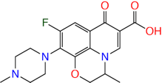 | -0.02 | 0 | 361.4 | 73.3
Pentamidine | Antifungal | 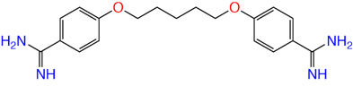 | 1.32 | +2 | 340.4 | 118
Pipemidic acid | Quinolone antibiotic | 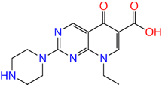 | -1.52 | 0 | 303.32 | 98.7
Puromycin | Aminonucleoside antibiotic | 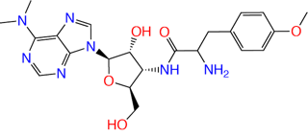 | -0.10 | +1 | 471.5 | 161
Tetraphenyl-phosphonium | Polyaromatic phosphonium | 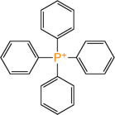 | 6.63 | +1 | 339.4 | 0

