The Description of the Algorithm Evaluated in the VisDrone2019 Challenge

|  |  |
| --- | --- |
| SungTae Moon  KARI  169-84 Gwahak-ro, Yuseong-gu, Deajeon, Korea  stmoon@kari.re.kr | Dongoo Lee  KARI  169-84 Gwahak-ro, Yuseong-gu, Deajeon, Korea  ldg810@kari.re.kr |
| Yongwoo Kim  KARI  169-84 Gwahak-ro ,Yuseong-gu, Deajeon, Korea  ywkim85@kari.re.kr | SungHyun Moon  KAIST  291 Daehak-ro, Yuseong-gu, Daejeon, Korea  mosuhy@gmail.com |

# Full name and abbreviated name of the algorithm

*DroneEye based on M2Det*

# Task in the VisDrone2018 Challenge

*TASK2 – Object Detection in Videos*

# Description of the algorithm

*The DroneEye was implemented based on M2Det network[1]. However, the VisDrone’s objects are small and the number of object is too large, compared to other datasets. Our proposed system focuses the detection of small object with general size object. To check the small objects, the image is split into 4 pieces without image reduction. The each split image is processed by M2Det and merged again using NMS. For the suitable detection to drone images, the way for image augmentation is fine-tuned.*

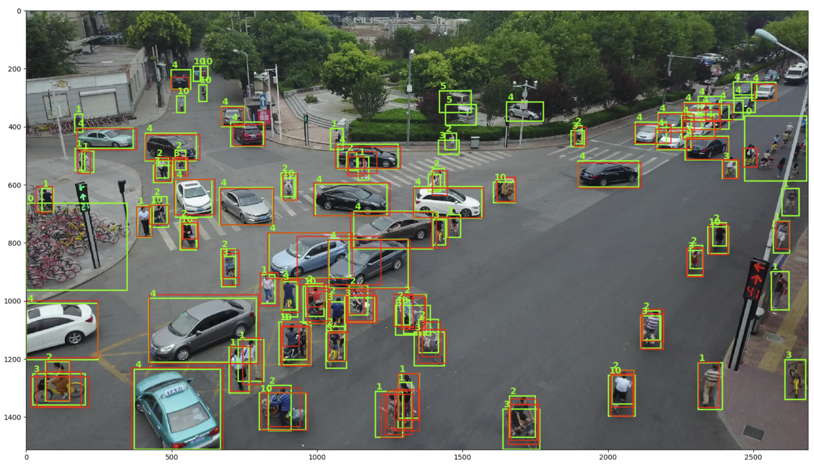 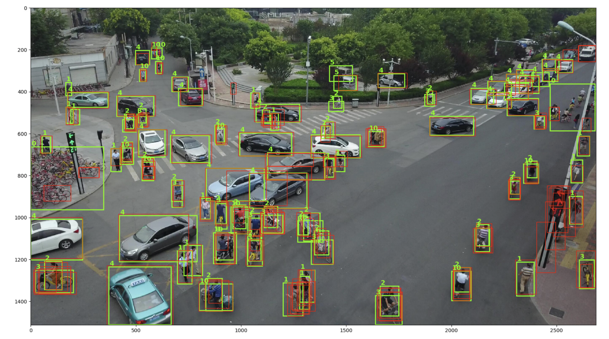

*(a) M2Det (b) DroneEye(ours)*

|  |  |  |  |  |  |  |  |
| --- | --- | --- | --- | --- | --- | --- | --- |
|  | bicycle(%) | car(%) | motor(%) | Pedestrian(%) | People(%) | Van(%) | Sum(%) |
| M2Det | 8.83 | 63.49 | 22.67 | 29.45 | 33.63 | 4.38 | 27.07 |
| DroneEye(ours) | 26.48 | 50.55 | 28.09 | 30.07 | 43.15 | 19.91 | 33.04 |

# Experimental environment

The DroneEye is developed with PyTorch, When Input size is 512x512, we conduct experiments on a machine with 4 NVIDIA Titan X GPUs, CUDA 10.1. To train the system, VisDrone 2019 dataset is used.

# References

[1] Qijie Zhao, Tao Sheng, Yongtao Wang, Zhi Tang, Ying Chen, Ling Cai, Haibin Ling, M2Det: A Single-Shot Object Detector based on Multi-Level Feature Pyramid Network. arXiv preprint, abs/1811.04533, 2018.