Program Structures & Algorithms
Spring 2022
Assignment No. 4
Name: SAITARUN MOVVA
(NUID): 002922800
Task

- task is to implement a parallel sorting algorithm such that each partition of the array is sorted in parallel. You will consider two different schemes for deciding whether to sort in parallel.
- A cutoff (defaults to, say, 1000) which you will update according to the first argument in the command line when running. It's your job to experiment and come up with a good value for this cutoff. If there are fewer elements to sort than the cutoff, then you should use the system sort instead.
- Recursion depth or the number of available threads. Using this determination, you might decide on an ideal number (t) of separate threads (stick to powers of 2) and arrange for that number of partitions to be parallelized (by preventing recursion after the depth of lg t is reached).
An appropriate combination of these.
- There is a Main class and the ParSort class in the sort.par package of the INFO6205 repository. The Main class can be used as is but the ParSort class needs to be implemented where you see "TODO..." [it turns out that these TODOs are already implemented].
- Unless you have a good reason not to, you should just go along with the Java8-style future implementations provided for you in the class repository.
- You must prepare a report that shows the results of your experiments and draws a conclusion (or more) about the efficacy of this method of parallelizing sort. Your experiments should involve sorting arrays of sufficient size for the parallel sort to make a difference. You should run with many different array sizes (they must be sufficiently large to make parallel sorting worthwhile, obviously) and different cutoff schemes.

Relationship Conclusion
I experimented by changing the cut-off values for different sizes of array and also changing the number of threads by the power of two. I have seen that the runtime for cutoff value gets lowest at the range of 25 to 30 percent of the array size. Using more than 4 threads does not result in a much lower lower runtime comparatively as shown in the screen shots and data graphs. So after this experiment, I would say that 4 threads are the optimal number of threads and that lowest runtime is normally achieved when the cutoff value is in the range of 25 to 30 percent of the array size.
Relation : number of threads = 2^ depth.
Maximum depth possible = log(array size/cutoff size);

Evidence to the Conclusion

Output Screenshot
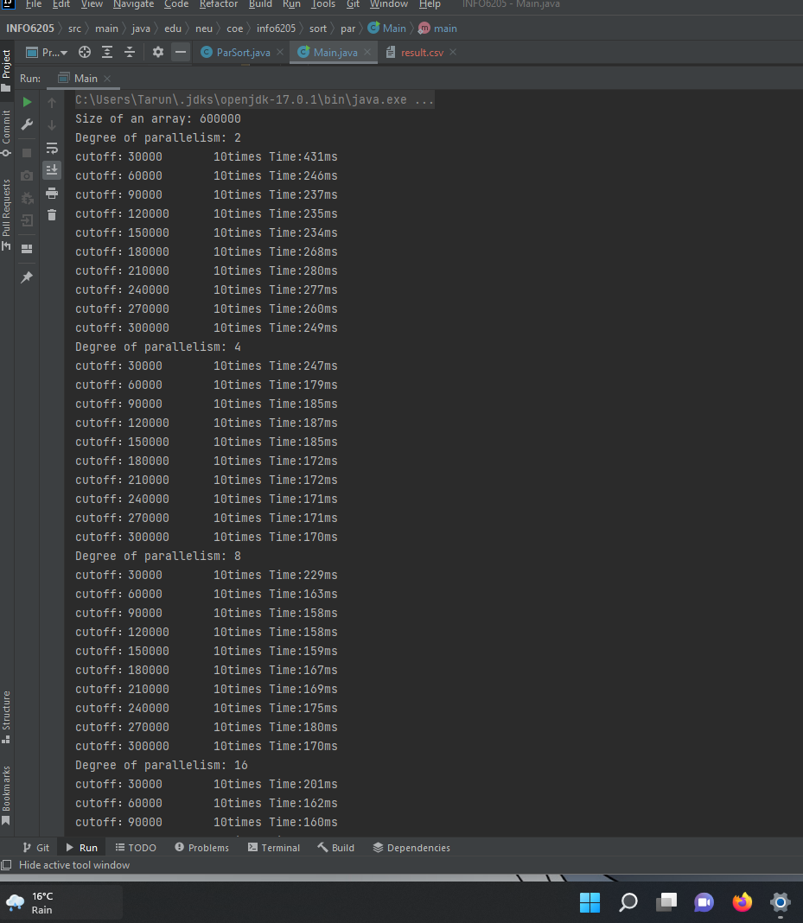
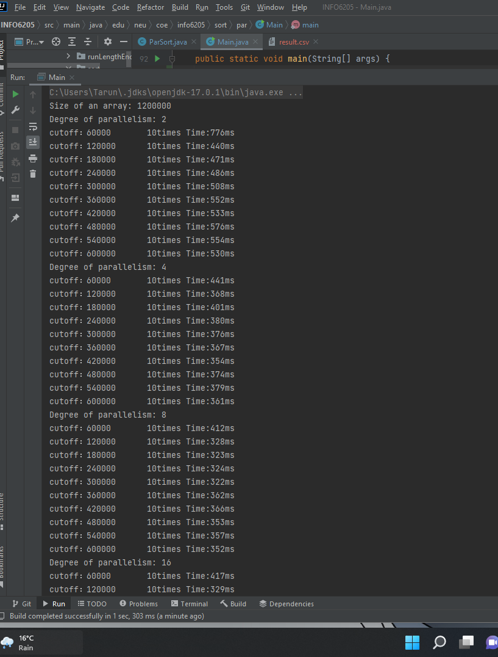
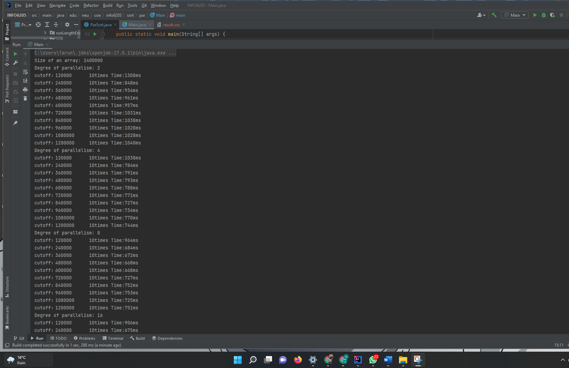
Output
Size of an array: 600000
Degree of parallelism: 2
cutoff：30000 10times Time:431ms
cutoff：60000 10times Time:246ms
cutoff：90000 10times Time:237ms
cutoff：120000 10times Time:235ms
cutoff：150000 10times Time:234ms
cutoff：180000 10times Time:268ms
cutoff：210000 10times Time:280ms
cutoff：240000 10times Time:277ms
cutoff：270000 10times Time:260ms
cutoff：300000 10times Time:249ms
Degree of parallelism: 4
cutoff：30000 10times Time:247ms
cutoff：60000 10times Time:179ms
cutoff：90000 10times Time:185ms
cutoff：120000 10times Time:187ms
cutoff：150000 10times Time:185ms
cutoff：180000 10times Time:172ms
cutoff：210000 10times Time:172ms
cutoff：240000 10times Time:171ms
cutoff：270000 10times Time:171ms
cutoff：300000 10times Time:170ms
Degree of parallelism: 8
cutoff：30000 10times Time:229ms
cutoff：60000 10times Time:163ms
cutoff：90000 10times Time:158ms
cutoff：120000 10times Time:158ms
cutoff：150000 10times Time:159ms
cutoff：180000 10times Time:167ms
cutoff：210000 10times Time:169ms
cutoff：240000 10times Time:175ms
cutoff：270000 10times Time:180ms
cutoff：300000 10times Time:170ms
Degree of parallelism: 16
cutoff：30000 10times Time:201ms
cutoff：60000 10times Time:162ms
cutoff：90000 10times Time:160ms
cutoff：120000 10times Time:159ms
cutoff：150000 10times Time:162ms
cutoff：180000 10times Time:179ms
cutoff：210000 10times Time:174ms
cutoff：240000 10times Time:170ms
cutoff：270000 10times Time:170ms
cutoff：300000 10times Time:172ms
Degree of parallelism: 32
cutoff：30000 10times Time:162ms
cutoff：60000 10times Time:158ms
cutoff：90000 10times Time:157ms
cutoff：120000 10times Time:160ms
cutoff：150000 10times Time:157ms
cutoff：180000 10times Time:169ms
cutoff：210000 10times Time:170ms
cutoff：240000 10times Time:173ms
cutoff：270000 10times Time:173ms
cutoff：300000 10times Time:175ms
Degree of parallelism: 64
cutoff：30000 10times Time:156ms
cutoff：60000 10times Time:162ms
cutoff：90000 10times Time:161ms
cutoff：120000 10times Time:157ms
cutoff：150000 10times Time:158ms
cutoff：180000 10times Time:170ms
cutoff：210000 10times Time:174ms
cutoff：240000 10times Time:175ms
cutoff：270000 10times Time:170ms
cutoff：300000 10times Time:169ms
Size of an array: 1200000
Degree of parallelism: 2
cutoff：60000 10times Time:776ms
cutoff：120000 10times Time:440ms
cutoff：180000 10times Time:471ms
cutoff：240000 10times Time:486ms
cutoff：300000 10times Time:508ms
cutoff：360000 10times Time:552ms
cutoff：420000 10times Time:533ms
cutoff：480000 10times Time:576ms
cutoff：540000 10times Time:554ms
cutoff：600000 10times Time:530ms
Degree of parallelism: 4
cutoff：60000 10times Time:441ms
cutoff：120000 10times Time:368ms
cutoff：180000 10times Time:401ms
cutoff：240000 10times Time:380ms
cutoff：300000 10times Time:376ms
cutoff：360000 10times Time:367ms
cutoff：420000 10times Time:354ms
cutoff：480000 10times Time:374ms
cutoff：540000 10times Time:379ms
cutoff：600000 10times Time:361ms
Degree of parallelism: 8
cutoff：60000 10times Time:412ms
cutoff：120000 10times Time:328ms
cutoff：180000 10times Time:323ms
cutoff：240000 10times Time:324ms
cutoff：300000 10times Time:322ms
cutoff：360000 10times Time:362ms
cutoff：420000 10times Time:366ms
cutoff：480000 10times Time:353ms
cutoff：540000 10times Time:357ms
cutoff：600000 10times Time:352ms
Degree of parallelism: 16
cutoff：60000 10times Time:417ms
cutoff：120000 10times Time:329ms
cutoff：180000 10times Time:325ms
cutoff：240000 10times Time:326ms
cutoff：300000 10times Time:326ms
cutoff：360000 10times Time:368ms
cutoff：420000 10times Time:361ms
cutoff：480000 10times Time:364ms
cutoff：540000 10times Time:369ms
cutoff：600000 10times Time:360ms
Degree of parallelism: 32
cutoff：60000 10times Time:328ms
cutoff：120000 10times Time:323ms
cutoff：180000 10times Time:326ms
cutoff：240000 10times Time:321ms
cutoff：300000 10times Time:325ms
cutoff：360000 10times Time:353ms
cutoff：420000 10times Time:365ms
cutoff：480000 10times Time:353ms
cutoff：540000 10times Time:360ms
cutoff：600000 10times Time:375ms
Degree of parallelism: 64
cutoff：60000 10times Time:318ms
cutoff：120000 10times Time:327ms
cutoff：180000 10times Time:324ms
cutoff：240000 10times Time:322ms
cutoff：300000 10times Time:325ms
cutoff：360000 10times Time:361ms
cutoff：420000 10times Time:361ms
cutoff：480000 10times Time:348ms
cutoff：540000 10times Time:356ms
cutoff：600000 10times Time:358ms
Size of an array: 2400000
Degree of parallelism: 2
cutoff：120000 10times Time:1308ms
cutoff：240000 10times Time:848ms
cutoff：360000 10times Time:934ms
cutoff：480000 10times Time:961ms
cutoff：600000 10times Time:957ms
cutoff：720000 10times Time:1031ms
cutoff：840000 10times Time:1038ms
cutoff：960000 10times Time:1028ms
cutoff：1080000 10times Time:1028ms
cutoff：1200000 10times Time:1040ms
Degree of parallelism: 4
cutoff：120000 10times Time:1038ms
cutoff：240000 10times Time:784ms
cutoff：360000 10times Time:791ms
cutoff：480000 10times Time:793ms
cutoff：600000 10times Time:788ms
cutoff：720000 10times Time:771ms
cutoff：840000 10times Time:727ms
cutoff：960000 10times Time:734ms
cutoff：1080000 10times Time:770ms
cutoff：1200000 10times Time:744ms
Degree of parallelism: 8
cutoff：120000 10times Time:964ms
cutoff：240000 10times Time:684ms
cutoff：360000 10times Time:672ms
cutoff：480000 10times Time:668ms
cutoff：600000 10times Time:668ms
cutoff：720000 10times Time:727ms
cutoff：840000 10times Time:752ms
cutoff：960000 10times Time:753ms
cutoff：1080000 10times Time:725ms
cutoff：1200000 10times Time:751ms
Degree of parallelism: 16
cutoff：120000 10times Time:906ms
cutoff：240000 10times Time:675ms
cutoff：360000 10times Time:673ms
cutoff：480000 10times Time:673ms
cutoff：600000 10times Time:667ms
cutoff：720000 10times Time:719ms
cutoff：840000 10times Time:738ms
cutoff：960000 10times Time:719ms
cutoff：1080000 10times Time:746ms
cutoff：1200000 10times Time:728ms
Degree of parallelism: 32
cutoff：120000 10times Time:682ms
cutoff：240000 10times Time:663ms
cutoff：360000 10times Time:681ms
cutoff：480000 10times Time:668ms
cutoff：600000 10times Time:670ms
cutoff：720000 10times Time:736ms
cutoff：840000 10times Time:749ms
cutoff：960000 10times Time:733ms
cutoff：1080000 10times Time:738ms
cutoff：1200000 10times Time:724ms
Degree of parallelism: 64
cutoff：120000 10times Time:656ms
cutoff：240000 10times Time:669ms
cutoff：360000 10times Time:676ms
cutoff：480000 10times Time:671ms
cutoff：600000 10times Time:667ms
cutoff：720000 10times Time:760ms
cutoff：840000 10times Time:725ms
cutoff：960000 10times Time:731ms
cutoff：1080000 10times Time:730ms
cutoff：1200000 10times Time:749ms

