Baggage screening application

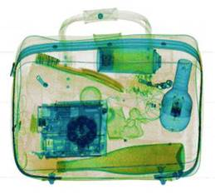
The TSA, law enforcement, and private security companies have invested huge amounts of money to create systems that check baggage for unapproved items, such as weapons, liquids, explosives, etc. A fee on every commercial ticket is used to fund this, and it adds significant delays and hassles to air travel.

TSA officials have to create training and certification procedures to be sure that employees are good at the task of the illegal objects in scanned luggage. They must do this accurately. But the type of errors matter. If one out of 1000 bags has an illegal item, calling all bags OK will give a screener a 99.99% accuracy rate but it also leads to a 100% miss rate. The TSA, and whoever designs its training, cares about baggage screening times as well. Here, time is money. If screening a bag takes too long, they will need to hire more screeners.

Your task (groups of around 3 people)
You and your team have been hired by TSA to determine criteria for certifying and training screeners. I have provided a 'sample screening task' in which you can practice the task, obtain hit rate/false alarm rates, use time constraints, etc. You need to make recommendations about measuring a screener's performance to make sure they are 'good enough', using signal detection theory and speed-accuracy trade-offs to help justify your recommendations.

Your recommendations should be evidence-based using data you collect on your own team. This should include a speed-accuracy trade-off function relating decision time to different measures of accuracy you might care about (false alarms, d-prime or A; which may be more likely to be measureable), and assessing signal detection bias. Your report should contain:

1. Introduction and goals
2. Brief discussion of how signal detection theory and speed-accuracy is important for baggage screening.
3. Recommendation for time to be given, based on a speed-accuracy analysis.
4. Recommendation for accuracy, sensitivity, and bias measures that should be achieved by trainees on a training corpus, with example data describing how you determined this.

Note: new stimuli can be added to the testing system by saving images in the stimuli\ folder. Files starting with an 'x' will be recorded as indicating the xrayed baggage contains an illegal object.

