Usability Testing for Interface Design

Knowledge of the Hick-Hyman law and Fitts's Law together provide some useful guidance for being able to design interfaces for use in computer applications. Human factors researchers have used their knowledge of these phenomena (as well as other principles) to both provide guidance for design, and to evaluate interfaces through laboratory user testing.

Some of the principles to consider:
- More buttons take longer to select from (Hick's law)
- Infrequently-used options may not impair as much (Hick-Hyman law)
- Larger buttons will be easier to target
- Closer buttons will be easier to target

There are other factors that will also matter, including factors related to visual search, ease of finding targets, visual similarity and confusability, high-level organization to permit easy, consistent placement of buttons, etc.

In today's practical exercise, you will design an interface buttons that might be used in an interface or app. It is typical that the amount of screen you can devote to these buttons is relatively small, so you cannot just always make the buttons larger in order to make them easier to use. I have provided o tool that lets you create a layout of buttons, and a companion program that will repeatedly test how long it takes you to mouseclick on each target. Consequently:
- Brainstorm an application might require 10-20 buttons to operate.
- Produce a paper mock-up of the application with several alternate button layouts.
- Implement the layout via the computer application.
- Test each layout with all members of your group to produce reliable estimates of the timing of each target.
- Turn in a recommendation report on the proposed layouts.

Button layouts

- Try to constrain your use of space to roughly the same area in different layouts.
- You should design at least two layouts that use roughly the same amount of space.
- You might have two different people make two designs.
- Consider spreading buttons left/right
- Consider using fullscreen mode and having a button on the edge for easier targetting.
- Use a different label for each target.
- Similarly-labeled targets will be harder to decide between.
- There are relatively small effects of button size, so make sure you try some large differences.

Implementation
The designer (designUI.pbl) will let you add, move, edit, and delete buttons, as well as saving the layout and loading/changing to other layout files. The layout files are saved with a .dsn extension, but they are just .csv files that you can edit in a text editor or excel if you want more control or to additional buttons quickly.

These controls are all in the center of the screen. You should avoid placing buttons in the center area, as this will represent the 'work' area of your application. During evaluation, on each trial, the mouse will start somewhere in this area.

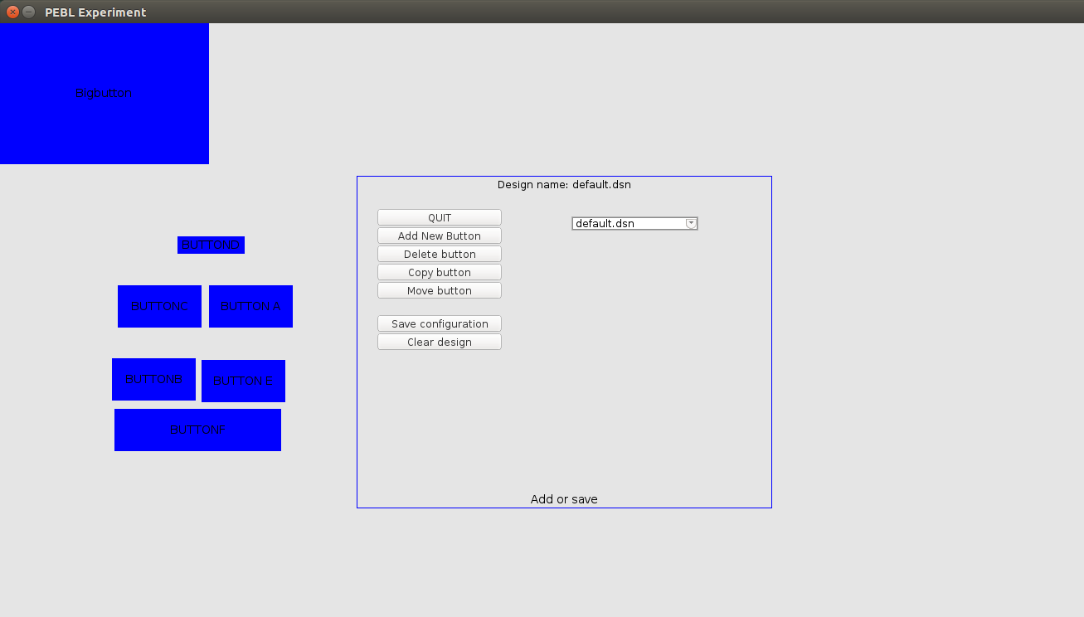

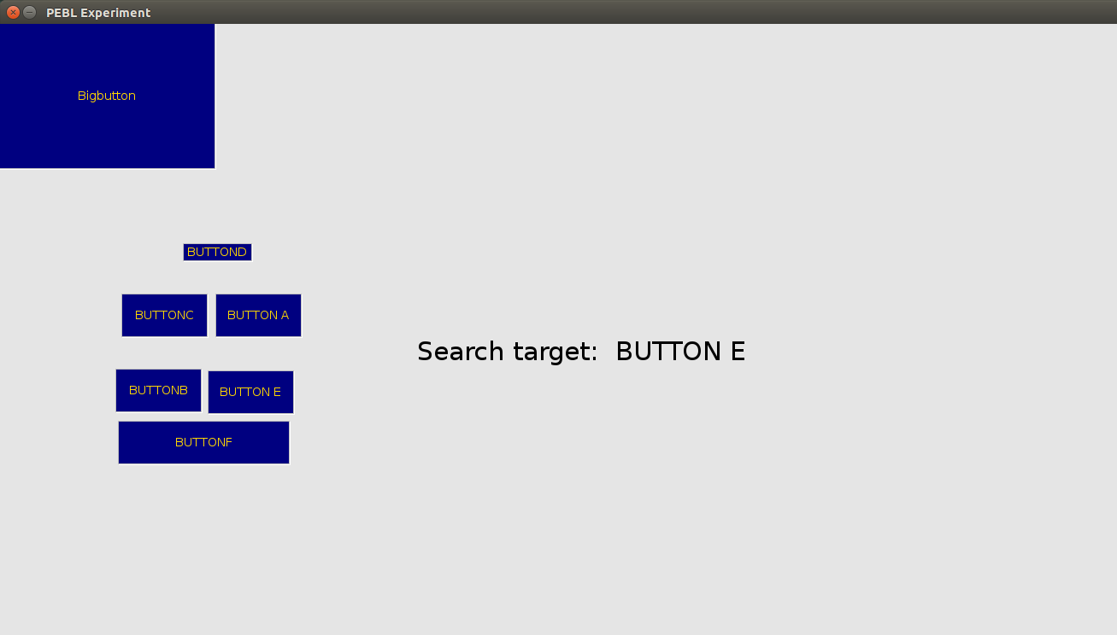
Testing
Once you start the testUI.pbl application, it will search for any .dsn files in the same directory and ask you to select one. Yuo also specify how many trials of each button you want to test. A layout that looks like the one you designed will be shown. At the center, it will tell you which button to click, and this will repeat until the test is complete.

- The testing application will give a cue for each target an equal number of times.
- On each trial, the mouse cursor will start out in the middle area of the screen and a cue word will be shown. You will be given 5 seconds to find the button with that word on it. If you don't find it by then, a new trial will begin.
- You should do at least 5 trials per button.

Evaluation

A .csv file named after the design file is saved in the data\ folder, and multiple participants will be added to the file. Each row will provide a score for a each button. The columns are:
1. Timestamp of test
2. Name of button
3. Size of button (square root of area)
4. width of button
5. height of button
6. x coordinate
7. y coordinate
8. Number of ttrials
9. Median RT
10. Mean RT

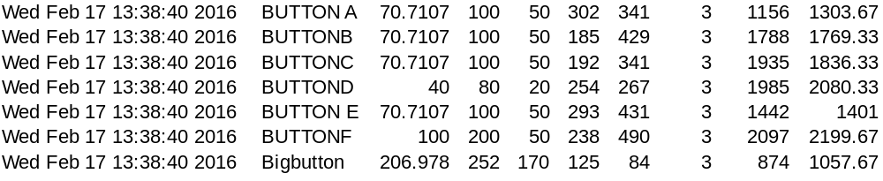

If you have multiple subjects, you will need to aggregate common rows together to come up with grand-mean for each button. Notice that although the overall mean RT might be an OK measure of how 'good' the interface is, it might be more important to make the more frequently-used buttons the fastest, at the cost of less-frequent buttons.

Report
Provide a screenshot of each alternative design, along with an analysis of which buttons were easiest and which were most difficult. Describe the basic rationale or reasoning for the alternatives, and if the difference between was an attempt to test some particular hypothesis. When describing the results for different buttons, provide a rationale for why different buttons were faster; consider the layout as well as size of buttons when doing this.

