Visualization of PEBL movetotarget task
Shane T. Mueller shanem@mtu.edu
25 March, 2024
Note: This analysis script runs in RStudio, and requires the prepdat and ggplot2 libraries.
library(prepdat)
library(ggplot2)
dat <- file_merge(folder_path = "data",
has_header=T,
raw_file_name="movetotarget-summary",
raw_file_extension="csv")
## Found 2 files
## 2 files were merged and saved into dataset.txt
## file_merge() finished!
dat$rate <- dat$rt/dat$dist
dat.test <- dat[dat$trial>0,]
##find log-median rate of movement per subject/trial
dat.bysub <- aggregate(dat.test$rate,
list(trial=dat.test$trial,
subnum=dat.test$subnum),
function(x){log(median(x))})
dat.bysub$hr <-aggregate(dat.test$hit,
list(trial=dat.test$trial,
subnum=dat.test$subnum),
mean)$x
This figure shows log-median movement rate (time/distance) for each trial–which involves 30 move-to-targets. This removes the first ‘practice’ trial, and so the progression shows learning over the timeframe of the session. In the figure, each participant is shown as a separate connected series.
ggplot(dat.bysub,aes(x=trial,y=x))+
geom_point()+
geom_line(aes(group=subnum)) +
geom_smooth(method='loess') +
scale_x_continuous(breaks=1:10)+
xlab("Trial") + ylab("Log-median movement rate")
## `geom_smooth()` using formula = 'y ~ x'
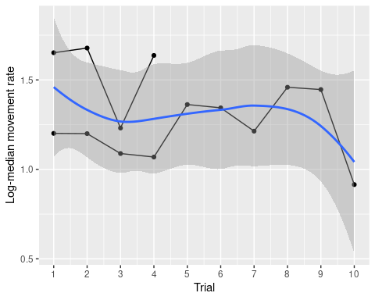
ggplot(dat.bysub,aes(x=trial,y=hr))+
geom_point()+
geom_line(aes(group=subnum)) +
geom_smooth(method='loess') +
scale_x_continuous(breaks=1:10)+
xlab("Trial") + ylab("Hit rate")
## `geom_smooth()` using formula = 'y ~ x'
