Data Collection Lab on Signal Detection Theory
PSY 3860

Background

Many psychological tasks can be understood in terms of Signal Detection Theory. In this laboratory activity, we will collect data on yourself using a visual categorization task in which you try to decide whether a stimulus is 'high' or 'low': does it have relatively more or less '*' symbols in a field.

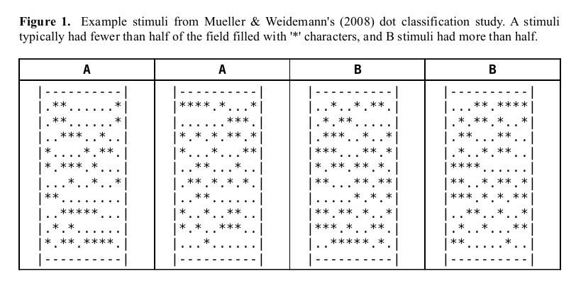

Like many detection and classification tasks, you can't always be correct, even if you were able to count the number of *s in the field. We will run a number of short experiments using this task to measure sensitivity and bias, how these measures can change. You will write a laboratory report on this study and submit it by the next class.

1. Basic task and base rate. You will need to install the software system PEBL (http://pebl.sf.net) on your computer if it is not on the computer yet. After you run it the first time, it will create a directory in Documents\pebl-exp.0.14\ that will store experiments and allow you run experimental tests. You should have received or downloaded .zip file that will unzip to a folder SDT, containing the file SDT.pbl. Save this in Documents\pebl-exp.0.14. When you run PEBL, the SDT.pbl file will appear in the window on the left of the screen, as well as an spreadsheet file.
- Run the test on yourself. When asked, choose 'A-B Response' and '50:50' base rate. Try to be as accurate as possible. At the end, the test will tell you a hit rate and false alarm rate. Compute d' and log(beta) using the worksheet.
- Conduct the test twice more, using both the 3:1 and the 1:3 A/B conditions. Again, try to be as accurate as possible. For each one, record hit rate and false alarm rate. Compute SDT statistics for the three conditions, and create an ROC curve using the spreadsheet.
- Discuss how and why changing the base rate influenced sensitivity and bias in this demonstration.

2. Flexible bias. Instead of trying to induce bias changes by changing the base rate, we will try to do it through instructions. Use the data from the original round, and now conduct two additional rounds where you use the 50:50 base rate conditions. In one of the rounds, only give the “A” response when you are very sure. In the other round, only give the “B” response when you are very sure. Like part 1, compute SDT statistics, and create on ROC curve.
- Discuss how and why changing the instructions impacted sensitivity and bias.

3. Confidence Procedure. Instead of running three separate rounds to create an ROC curve, an alternative is to collect confidence ratings. Run the 'confidence rating' procedure, using the 1:3 base rate. At the end of the procedure, you will see the counts of each confidence rating for each stimulus type. You can enter these values into the ROC excel worksheet (the lower calculations) to create a 'confidence-ROC' function. Do this again using the 3:1 base rate condition.
- Examine whether the sensitivy scores and ROC function produced is similar to those obtained in parts 1 and 2.

4. Changing sensitivity. Using the 'edit' button, we can change the number of *s in either A or B. A has on average 46 stars, and B has on average 54 stars. If we make the B mean higher (60), or the A mean lower (40), this should increase the sensitivity—but does it? Change A or B or both to increase the sensitivity, and run the study one last time using the confidence rating procedure.
- Discuss how the ROC function and sensitivity scores obtained are impacted by this change.

Use the following report template as a guideline for your report.
Lab Report

Student Name:____________________________

Introduction
The goal of the study was to determine how the speed and accuracy of responses would change in response to differences in base rate. In addition, we examined how response bias would be impacted. We hypothesized:
1. That more common stimuli would lead to faster responses

Method
Participants. Data from two participants was included in this report
Procedure. Detailed description of procedure here, including basic paradigm, instructions, diagram/screenshot, number of trials, main independent variables/conditions, and dependent measures.

Results
- Describe main results in terms of dependent and independent variables
- Include table or figure of results
- Discuss each hypothesis stated in the introduction.

