Assignment1 of Session - 7 Data Visualizations

Vishwanath

October 17, 2017

#Question - 1. Explore the relationship between the following  
# 1(i)  
x<- c(1:100) # define vector x  
y<- c(x^2) # Set value of y  
# plot the relationship graph  
plot(x,y, main = "a plot of x agaist x^2", xlab="X---->", ylab = "x^2---->")

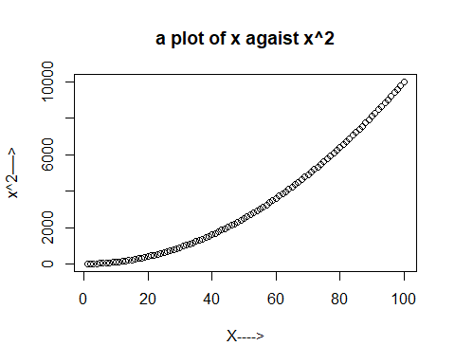

# 1(ii)  
x<- c(1:100) # define vector x  
y<- c(x^3) # Set value of y  
# plot the relationship graph  
plot(x,y, main = "a plot of x agaist x^3", xlab = 'Value of X', ylab = 'Cube of x')

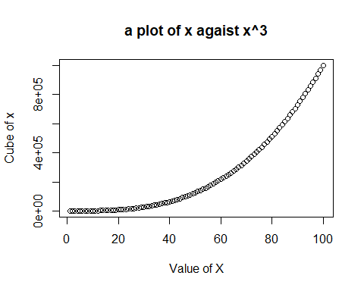

# 1(iii): x + y = 101  
x<- c(1:100) # define vector x  
y=101-x;y # Set value of y

## [1] 100 99 98 97 96 95 94 93 92 91 90 89 88 87 86 85 84  
## [18] 83 82 81 80 79 78 77 76 75 74 73 72 71 70 69 68 67  
## [35] 66 65 64 63 62 61 60 59 58 57 56 55 54 53 52 51 50  
## [52] 49 48 47 46 45 44 43 42 41 40 39 38 37 36 35 34 33  
## [69] 32 31 30 29 28 27 26 25 24 23 22 21 20 19 18 17 16  
## [86] 15 14 13 12 11 10 9 8 7 6 5 4 3 2 1

# plot the relationship graph  
plot(x,y)

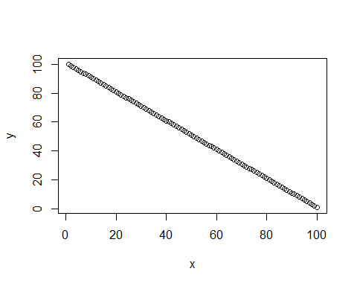

# 1(iii): xy = 500  
x<- c(1:100) # define vector x  
y=500/x;y # Set value of y

## [1] 500.000000 250.000000 166.666667 125.000000 100.000000 83.333333  
## [7] 71.428571 62.500000 55.555556 50.000000 45.454545 41.666667  
## [13] 38.461538 35.714286 33.333333 31.250000 29.411765 27.777778  
## [19] 26.315789 25.000000 23.809524 22.727273 21.739130 20.833333  
## [25] 20.000000 19.230769 18.518519 17.857143 17.241379 16.666667  
## [31] 16.129032 15.625000 15.151515 14.705882 14.285714 13.888889  
## [37] 13.513514 13.157895 12.820513 12.500000 12.195122 11.904762  
## [43] 11.627907 11.363636 11.111111 10.869565 10.638298 10.416667  
## [49] 10.204082 10.000000 9.803922 9.615385 9.433962 9.259259  
## [55] 9.090909 8.928571 8.771930 8.620690 8.474576 8.333333  
## [61] 8.196721 8.064516 7.936508 7.812500 7.692308 7.575758  
## [67] 7.462687 7.352941 7.246377 7.142857 7.042254 6.944444  
## [73] 6.849315 6.756757 6.666667 6.578947 6.493506 6.410256  
## [79] 6.329114 6.250000 6.172840 6.097561 6.024096 5.952381  
## [85] 5.882353 5.813953 5.747126 5.681818 5.617978 5.555556  
## [91] 5.494505 5.434783 5.376344 5.319149 5.263158 5.208333  
## [97] 5.154639 5.102041 5.050505 5.000000

# plot the relationship graph  
plot(x,y)

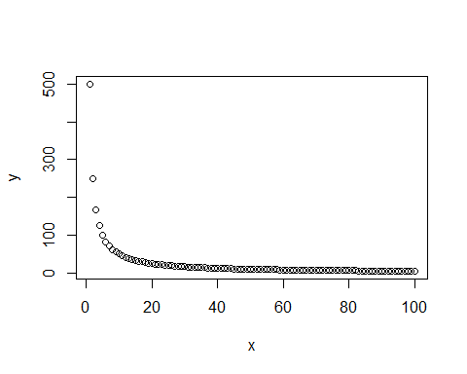

# Question2.   
# Define cars vector  
cars<- c(1,3,6,4,9)  
# Graph the cars vector with all defaults plot(cars)  
plot(cars)

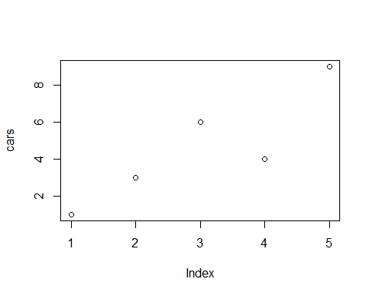

# Graph cars using blue points overlayed by a line  
plot(cars, type = 'o', col='blue')  
  
# Create a title with a red, bold/italic font  
title(main="Autos", col.main="red", font.main=4)

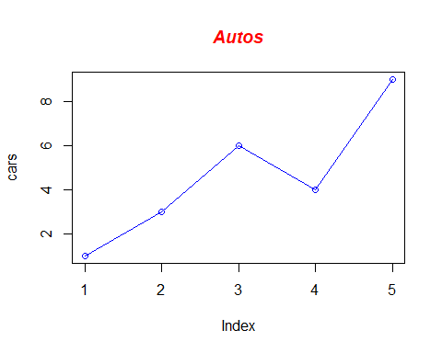

# Define 2 vectors  
cars <- c(1, 3, 6, 4, 9)  
trucks <- c(2, 5, 4, 5, 12)  
  
# Graph cars using a y axis that ranges from 0 to 12  
plot(cars, type="o", col="blue", ylim=c(0,12))  
  
# Graph trucks with red dashed line and square points  
lines(trucks, type="o", pch=22, lty=2, col="red")  
  
# Create a title with a red, bold/italic font  
title(main="Autos", col.main="red", font.main=4)

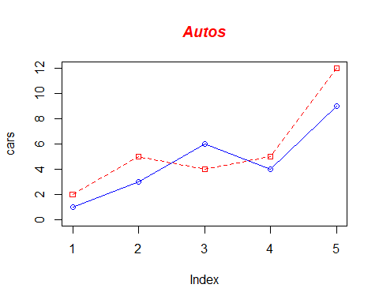

## R Markdown

This is an R Markdown document. Markdown is a simple formatting syntax for authoring HTML, PDF, and MS Word documents. For more details on using R Markdown see <http://rmarkdown.rstudio.com>.

When you click the **Knit** button a document will be generated that includes both content as well as the output of any embedded R code chunks within the document. You can embed an R code chunk like this:

summary(cars)

## Min. 1st Qu. Median Mean 3rd Qu. Max.   
## 1.0 3.0 4.0 4.6 6.0 9.0

## Including Plots

You can also embed plots, for example:



Note that the echo = FALSE parameter was added to the code chunk to prevent printing of the R code that generated the plot.