Samuel Nunn

June 6, 2020

Foundations of Programming: Python

Assignment 08

<https://github.com/stnunn/ITFnd100-Mod08>

Working with Classes and Objects in Python

# Introduction and Assumptions

In this assignment, we use Classes and Objects to manage a list of Products and Prices. We utilize some code from previous lessons, with modifications, to accomplish our goals.

# Instructions

1. Start a new PyCharm project called “Assignment08” within the C:\_PythonClass\ directory. Create a Header section with your information, and create a section for importing Modules, as seen in Figure 1.

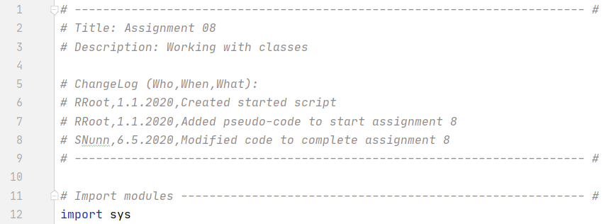

Figure 1. Script Title, Header Section, and Import Modules

1. In the “Data” section, declare your variables and constants. Also, create the Product class. Initialize it using __init__(). Use __str__() and __repr__() to display plain text instead of memory addresses, as seen in Figure 2.

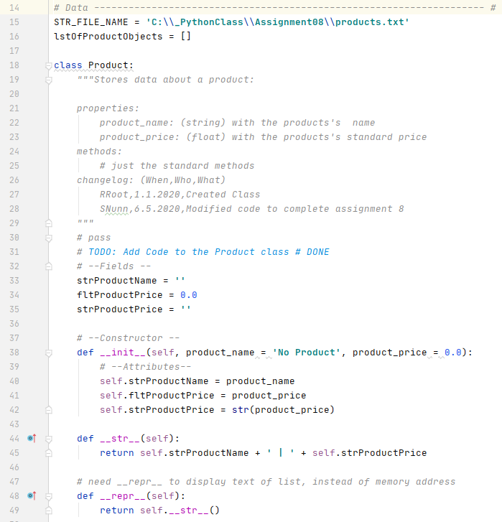

Figure 2. – Data. Declare variables and constants. Setup the Product class.

1. In the “Processing” section, create a “class” called “FileProcessor”. Then, indent and create all the “FileProcessor” class functions, as seen in Figure 3 and Figure 4. 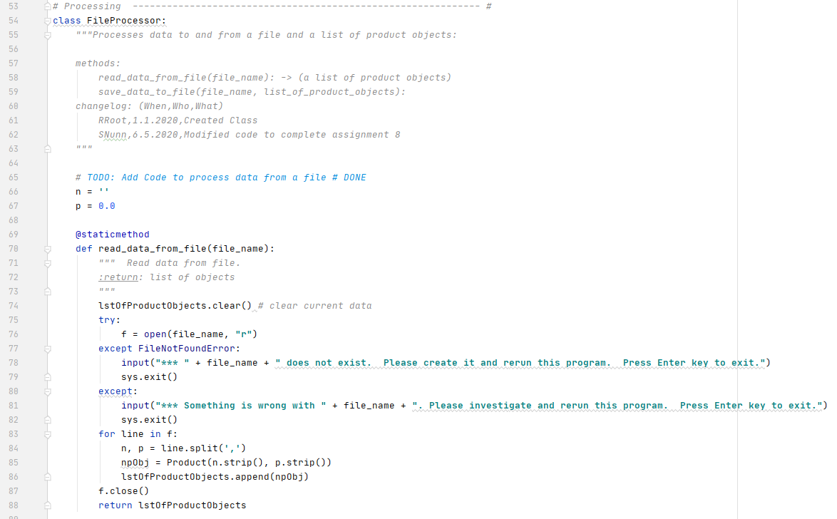

Figure 3. Process the Data

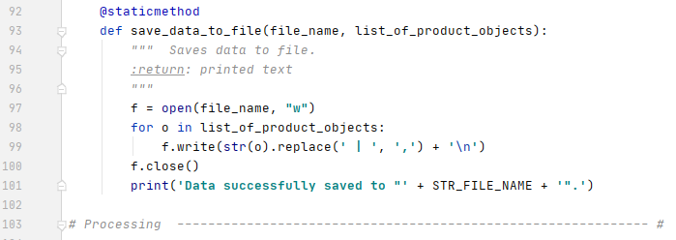

Figure 4. Process the Data

1. In the Presentation (Input/Output) section, create a new class called IO. Create functions as seen in Figure 5, Figure 6, and Figure 7.

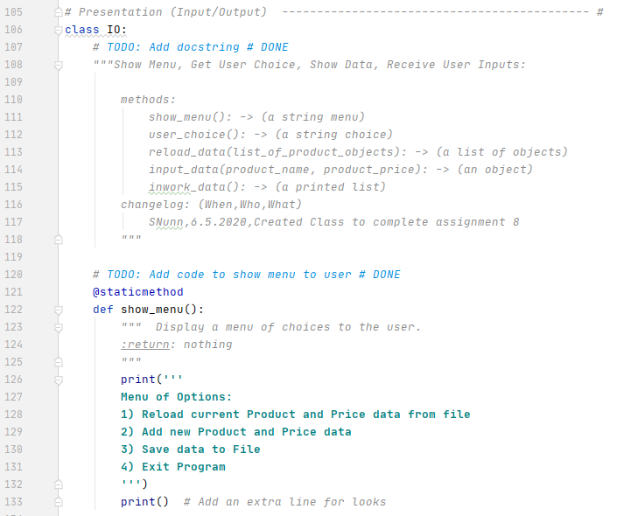

Figure 5 - IO Class

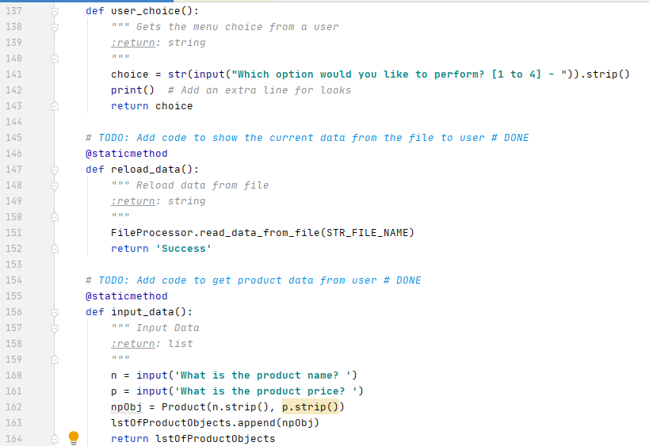

Figure 6. IO Class

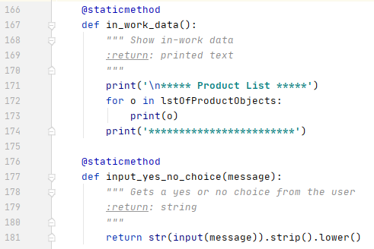

Figure 7. IO Class

1. In the Main Body of the Script, first use the FileProcessor.read_data_from_file() function to load all the data from the file. We enter a “While loop”, where we use IO functions to show the in-work data and the menu. Then, based on user choice, we call the appropriate IO or FileProcessor functions. This makes our Main Body much more readable, and allows us to reuse our functions, as seen in Figure 8.

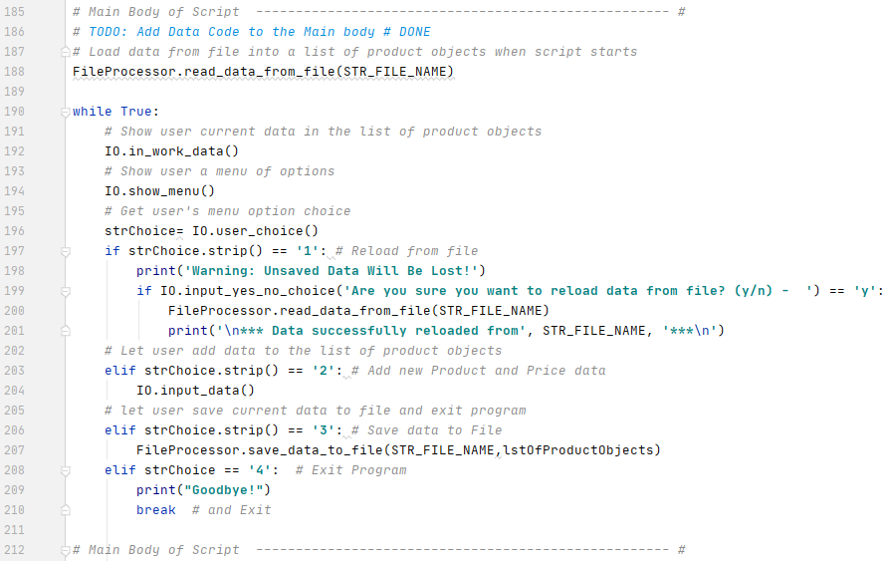

Figure 8. Main Body

1. Run the program in the command prompt, as seen in Figures 9 – 12, below.

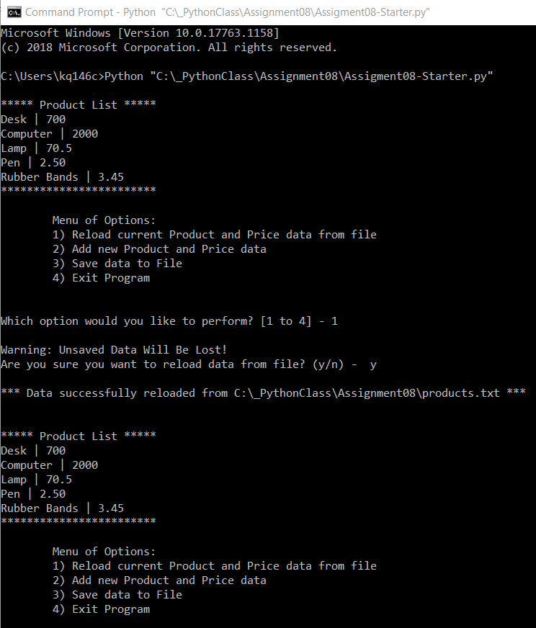

Figure 9 – List is Loaded and Displayed on Program Start. Option 1 Selected.

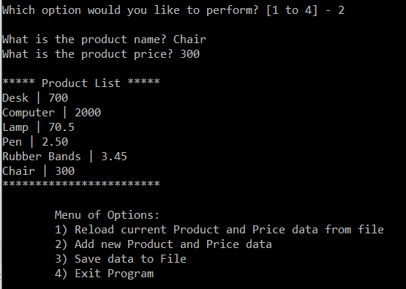

Figure 10 - Option 2

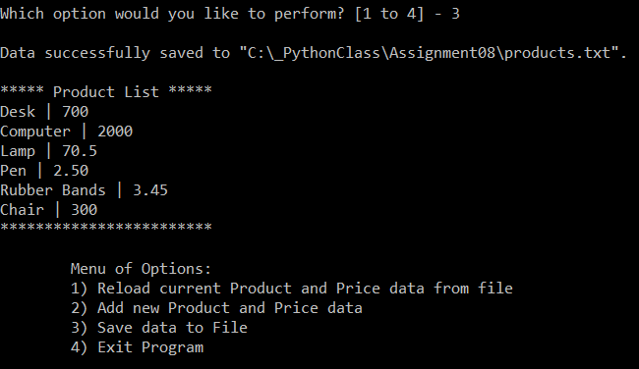

Figure 11 - Option 3

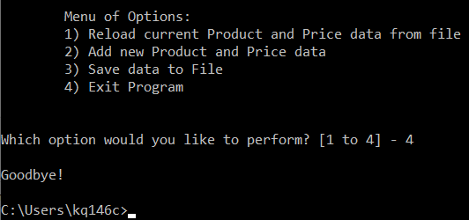

Figure 12 – Option 4

1. Open the .txt file to see the Products and Prices which have been saved, as seen in Figure 13.

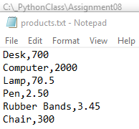

Figure 13. Open Products.txt to see the saved output

# Summary

In this assignment, we learned how to use Classes and Objects to manage a list of Products and Prices. We utilized some code from previous lessons, with modifications, to accomplish our goals. Objects can make working with large data sets much more organized.