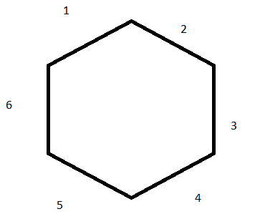­

A2{12, 13, 14, 15, 16, 23, 24, 25, 26, 34, 35, 36, 45, 46, 56} - 15

A3{123, 124, 125, 126, 134, 135, 136, 145, 146, 156, 234, 235, 236, 245, 246, 256, 345, 346, 356, 456} - 20

A4{1234, 1235, 1236, 1345, 1346, 1356, 1456, 2345, 2346, 2456, 3456} - 11

A5{12345, 13456, 12456, 12356, 12346, 23456} - 6

A6{123456} – 1

Bonus {Joker (Anti-B­­­arrier)}

: 53 + 1

Barrier, Goal (Water), Start (Plant), Empty