File: Doc_Sensi_for_StochSD.doc 190807

Sensi – A sensitivity analyser for StochSD models
Leif Gustafsson & Erik Gustafsson. Copyright 2017.

1. Introduction

Sensi is a program for calculating the sensitivity of an objective function (e.g. V) with respect to a parameter (e.g. P) in an StochSD simulation model. A sensitivity analysis may use different kinds of parameters like Start values of levels, Proportional constants, Time constants or Time points for an action.

In the model building process it is important to know how much a parameter affects another quantity (here called an objective function). This is accomplished by making a basic simulation using the appropriate value of a parameter, and recording the outcome of the object function. Then the parameter value is incremented and a new simulation is done producing a new value of the objective function. The ratio between the change in the objective function and the change in the parameter value is the sensitivity of the objective function with respect to the parameter. This can be expressed in absolute or relative terms:

Absolute Sensitivity = ΔV/ΔP.

Relative Sensitivity = ΔV/V / ΔP/P.

The former expression answers the question: “How much will the objective function, V, increase if the parameter value, P, is increased by say one unit.?”

The latter expression deals with relative measures (like percentage) and answers the question: “How many per cents will then the objective function increase if the parameter increases with, say one percent?”

The purpose of Sensi is to be a simple, robust, and easy-to-use sensitivity analyser for StochSD models.

With Sensi you specify all parameters and all objective functions to be investigated. The results are presented in a matrix where each selected parameters effect upon each selected objective function is presented in absolute or relative terms.

2. The user’s interface of Sensi

By clicking the Sensi button in the Tools menu the Sensi form (see Figure 1) is shown to the left of the Modelling Window.

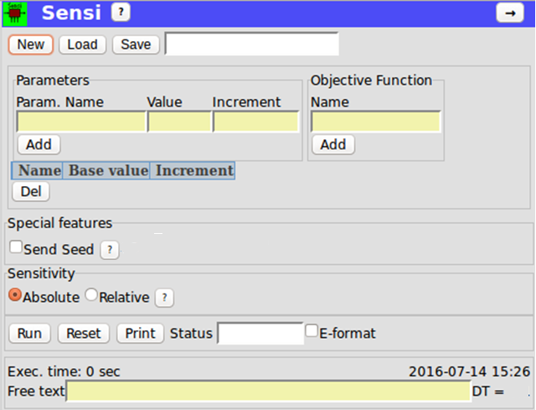
Figure 1. The Sensi form.

To use Sensi you have to:
- Open your StochSD model. It will be run from Sensi as specified according to step size, integration method, start and stop times.
2. Specify the name, value, and increment of each Parameter to be studied and Add it.
3. Specify and Add the names of the Objective Functions to be studied.
4. Press the Run button.

The results will be shown in a grid with Parameters (row-wise) and Objective Functions (column-wise) as shown in Figure 3.

With the radio-button 'Absolute Sensitivity' (ΔV/ΔP) and 'Relative Sensitivity’ (ΔV/V: ΔP/P) you may at any time switch between Absolute and Relative Sensitivity without additional simulations required.

By checking “E-format” the results are given in the form: X.XX±EXXX instead of maximal information within nine positions.

NOTE: You may only write in yellow fields.
NOTE: StochSD allows several quantities with the same name. Avoid this in your model!

Additional features and comments

● Help button [?] gives you short information of how to use Sensi.

● Parameters are specified by name, starting value and increment. The parameter may be handled by the [Add] or [Delete] buttons. Be careful to spell the names correctly. Note that Delete operates on checked rows (a “” in the first column).

● Status (‘RUNNING or ‘DONE’) shows the status of the process.

● Run button starts the sensitivity analysis.

● Print button prints the Sensi form as shown.

● Exec time shows the total execution time from you pressed the Run button until results are presented.

3. Sensitivity analyses on deterministic and stochastic models
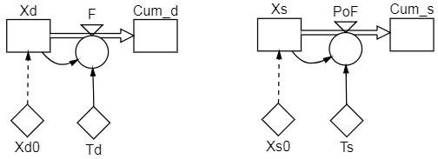
Here follows a demonstration of Sensi for analysis of a deterministic and of a stochastic model, respectively. Both models describe a radioactive decay process where the numbers of decayed atoms is counted (accumulated). In both cases we want to study the sensitivity of the parameters X0 (initial value) and T (decay time constant) upon X and Cum. The simulations ran from zero to 20 time units with a time step of 0.1. See Figure 2.

Figure 2. A deterministic (d) and a stochastic (s) model to be sensitivity analysed.

3.1. Sensitivity analysis of the deterministic model

The parameters X0d and Td and the Objective Function Xd and Cum_d were added to the result grid, and the Run button was pressed giving the results shown in Figure 3.
Figure 3. The results of a sensitivity analysis of a deterministic model.
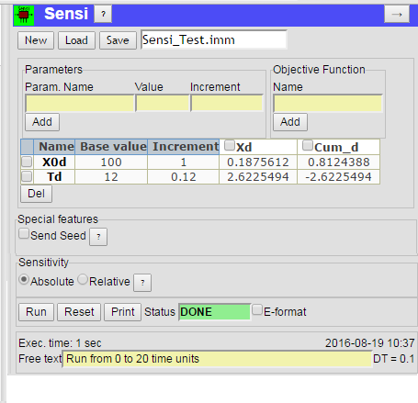

As seen, increasing the initial number of atoms X0d from 100 to 101 atoms resulted in the increase of the number of undecayed atoms by 0.188 atoms and by 0.812 decayed atoms at the end of the run. An increase of the time constant Td from 12 to 12.12 time units increased the number of undecayed atoms by 2.62 and reduced the number of decayed atoms by the same number.

3.1. Sensitivity analysis of the stochastic model

For a stochastic model the outcome is random. To reduce the randomness, it is important to use the same seed for the base run (here X0s =1000 and Ts=12 time units) and for the two incremented runs (X0s=1010, Ts=12) and (X0s=1000, Ts=12.12). (Increment here chosen to 1% of the value of the parameters.)

For this we use the Send Seed device. Checking SendSeed opens a small window where you can specify a Seed-of-Seeds. This provides the same Actual Seed to the stochastic model for the multiple simulations that are performed when you press the Run button. Next time you press the Run button, a new Actual Seed is used.

In the stochastic case you must do the sensitivity analysis a large number of times since the results are stochastic. (In the future it is desirable to include a an option to performs the sensitivity analysis a large number of times in order to obtain e.g. an average of the stochastic sensitivity.) In Figure 4 the results of a stochastic sensitivity analysis is shown.

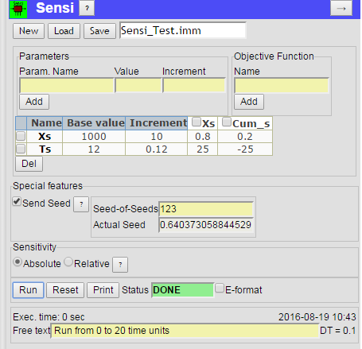
Figure 4. The results of a stochastic sensitivity analysis.

4. Reference

- Gunawan R, Cao Y, Petzold L, Doyle FJ. Sensitivity analysis of discrete stochastic systems. Biophys J.,2005 Apr, 88(4): 2530-2540.

5. Responsibility

The user is fully responsible for the use of this product. The producer and the supplier of this code take no responsibility for the use or functioning of Sensi.

