

StochSD User’s Manual

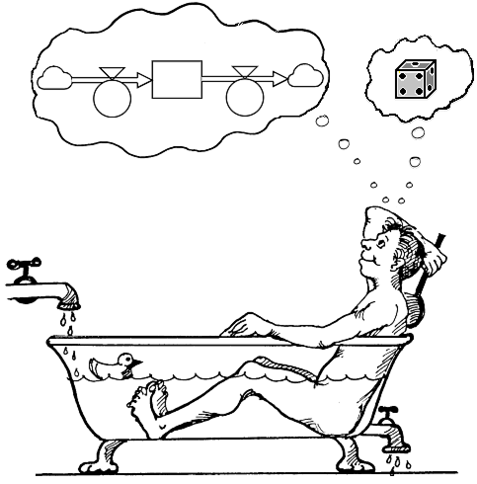

Part I. Deterministic modelling and simulation in StochSD

Part II. Stochastic modelling and simulation with StochSD

© Leif Gustafsson, Erik Gustafsson and Magnus Gustafsson, Uppsala University, Uppsala, Sweden.

File: StochSD_User’s_Manual_2019.doc 190823.

Home Page: https://stochsd.sourceforge.io/homepage/

Contents

1. Introduction 5

Part I. Deterministic modelling in StochSD 7

2. The building blocks of a model 8

3. Starting up StochSD 11
3.1 Menus 11
3.2 Buttons 14
3.3 Time display, Time Unit and Inspection field 15

4. Model building 16
4.1 Building blocks at the model window 16
4.2 Styling buttons 17
4.3 Naming and defining relations or values of the building blocks 18

5. Equations 20

6. Specifications of the simulation 21

7. Simulation 23

8. Results presentation 24
8.1 The Number Box 24
8.2 The Table 25
8.3 The Time Plot 25
8.4 The Compare Simulations Plot 26
8.5 The XY-Plot 26

9. Examples 28

10. Functions 31
10.1 General Functions 33
10.2 Historical Functions 35
10.3 Mathematical Functions 37
10.4 Programming Functions 37
10.5 Random Number Functions 38
10.6 Statistical Distributions 40
10.7 Time Functions 40
10.8 Converter (Table look-up function) 41

11. Macros 44

12. Practical tips 46

13. References to deterministic modelling 47

Part II. Stochastic modelling in StochSD 49

14. Stochastic modelling 50
14.1 A historic note and the motivation for StochSD 50
14.2 What is stochasticity? 50
14.3 Five types of uncertainty 51
14.4 Uncertainties in a model 52
14.5 What can happen if you ignore stochasticity? 56
14.6 A warning example – Comparing the results from a deterministic
and a stochastic SIR model 57
14.7 Making a stochastic model reproducible 57

15. A stochastic StochSD model 59

16. Tools in StochSD 60
16.1 The Optim tool 60
16.2 The Sensi tool 60
16.3 The StatRes tool 61
16.4 The ParmVar tool 61
16.5 Hiding the tool 61

17. References to stochastic modelling 62

Appendix A. Installation of StochSD 63
A.1 StochSD Desktop 63
A.2 StochSD Web 63

Appendix B. About Licence and Responsibility 64
B.1 About License 64
B.2 Responsibility 64
1. Introduction

StochSD (Stochastic System Dynamics) is an open-source tool for stochastic (and deterministic) simulation based on the System Dynamics approach.

System dynamics (SD) is a pedagogic approach to modelling the behaviour of complex systems over time based on stocks and flows. The pedagogic advantages are several: First, the model is created in a click-and-play way where you choose between a few building blocks and some presentation forms for charts and tables.
Second, SD’s graphic approach to a stock-and-flow model gives an intuitive understanding of integration over time. Third, in the graphical presentation the model structure displays the feedback loops explaining the models behaviour in terms of growth (from positive loops) and stabilising factors (from negative loops).
Fourth, the SD models are very easy to program; you focus on one symbol at a time and fill in its relation to those symbols pointing at it. Fifth, the model and its results is easy to understand and communicate, also to persons less experienced in mathematics or programming. These advantages come without sacrificing any utilities in other Continuous System Simulation languages.

The unique feature in StochSD is that it also supports stochastic modelling. It has necessary random functions. Furthermore, a stochastic model requires many simulation runs and a statistical analysis over these runs. In StochSD a special tool is included for specifying the number of runs, provide controllable seeds (if desired), collect data of selected quantities, make statistical results over the runs, and present the results in different ways.

StochSD is based on Insight Maker version 5 from which we have taken the open System Dynamics part: simulation engine, function library, error detection facility, macro facility etc., and replaced the non-open parts with other packages and our own code and design.

That StochSD is open-source means that you get it and use it for free. It also gives you the right to modify the StochSD source code under open-source licence, see Appendix B. StochSD is written in JavaScript.

StochSD is developed to build, simulate and analyse deterministic and stochastic modelling and simulation according to the System Dynamics approach. StochSD is also supplemented with tools for sensitivity analysis, optimisation, statistical analysis and parameter estimation.

Part I of this manual focuses on how you build and simulate deterministic models in StochSD, while Part II focuses on stochastic modelling, simulation and statistical analysis from multiple simulation runs.

StochSD can be used to study time continuous progress in a great number of areas, for example biology, economics, ecology, physics or technology. A model is constructed by placing and connecting predefined graphical symbols at suitable places on the screen. StochSD then transforms the graphical model into an executable code.

StochSD is available in two versions: StochSD Desktop and StochSD Web. Both versions of StochSD work on Windows, Mac OS X and GNU/Linux.

The Desktop version is downloaded from StochSD’s homepage and runs as a normal program (using NW.js which stands for Node-Webkit.JavaScript), while the web version requires a web-browser such as Google Chrome or Mozilla Firefox to load StochSD and run your models. StochSD does not support Internet Explorer.

For installation of StochSD Desktop or running of StochSD Web, see Appendix A.

StochSD Home Page: https://.sourceforge.io/homepage.

StochSD was developed by Leif Gustafsson, Erik Gustafsson and Magnus Gustafsson, Uppsala University, Uppsala, Sweden.
Mail: leif.gunnar.gustafsson@gmail.com
Part I. Deterministic modelling in StochSD
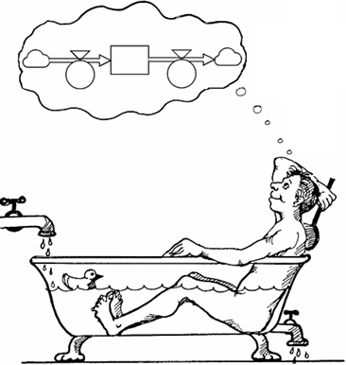
Purpose: To build dynamic compartment models and simulate their behaviours.

Worldview: The world consists of two kinds of fundamental elements: Stocks and Flows.

Deterministic modelling teaches the student to the fundamentals of model building and simulation in Systems Dynamics. It is also an ideal starting point for understanding the relation between the structure and the behaviour of a real system or a model. Furthermore, deterministic modelling can be used to study systems where we completely understand the physical laws so that there is no uncertainty.

However, most systems under study contain uncertainties of different kinds due to limited knowledge. How such uncertainties are included in a dynamic model is treated in Part II.
2. The building blocks of a model

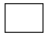
Stock is a container for something, e.g. water, people, cars, or money. (Synonyms: State variable, Compartment, Level). A new Stock should be assigned a start value and a proper name after double-clicking the symbol.

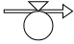
Flow is the active element that generates changes. A flow is always a rate - something per time unit. It may be water per second, Immigrants per year, Deaths per month, Cars produced per week, etc. Flows fill up or drain Stocks. (Synonyms: Transition, Rate). The new Flow should be defined and assigned a proper name after double-clicking the symbol. Note that the arrow shows the positive direction of a flow. If the flow rate is negative, it flows at the direction opposite to the arrow.

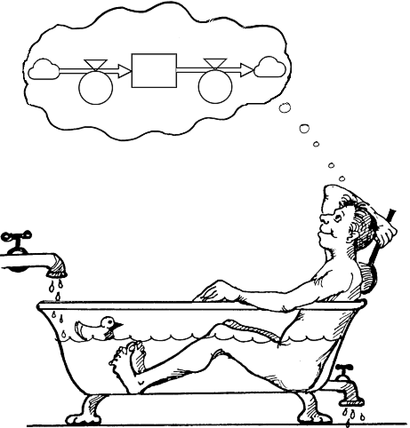
The dynamic behaviour of a model is created by flows accumulated in and/or drained from Stocks! Flows into Stocks make the world go around!

A bathtub analogy is often used as a metaphor. The Stock is a bathtub where e.g. water is added by an Inflow and drained by an Outflow.

A Stock can only be changed by physical flows (of water, money, rabbits, etc.), but a flow rate can change because of influence from other elements. This influence (transmitted through an information link) is represented by a single arrow and may not be confused with a physical flow. Figure 2.1. The bathtub analogy.
Information link: Influence from one element to another. (Synonymous: Link, Information, Signal.) A link has no name.

For practical reasons, we add three more graphical symbols.


Auxiliary contains a calculation based on functions and the values of other elements linked to it. (Synonym: Auxiliary). The auxiliary can be defined and assigned a proper name after double-clicking the symbol.


Parameter is a special case of an auxiliary that may not have any incoming link. (A Parameter can have a constant value, a time function or a random function. Of pedagogical reasons, it is good to distinguish between a Parameter (who’s value is externally defined) and an Auxiliary (that is deduced from other model elements). Parameters are defined and named after double-clicking the symbol.

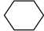
Converter is a table look-up function where you can describe the relation between two elements like X and Y in tabular form. See Section 10.2.6.

Important note: One of the most common and severe errors in model building is the confusion of time units used. There must be one and only one time unit consistently used throughout the model. Therefore, in StochSD you can’t start the modelling before you have specified what time unit you will use for the model! The time unit can e.g. be second, minute, hour, day, week, month, year, century, etc. For a generic model you can specify it as e.g. t.u. (for time unit).

A short preview of modelling in StochSD

To give the reader a short preview of the building blocks and their use in StochSD modelling, we have to take a wider view including a specific System Under Study and influences from its Environment to be described as a Model. First, we have to dismiss the common view that a Model is a description of the System Under Study. Of course, the model is a huge simplification, but it also covers more than the System Under Study.

Any System Under Study that we want to describe, understand or predict its behaviour is a selected piece of the reality or universe. The system borders divide the universe into two parts: The System Under Study and its Environment. However, what is included in the System Under Study is not only about space and time period to study, it is above all about a chosen level of details. (If you decide to model a population you may include say, age and sex, but not the individuals and their organs, tissues, cells, molecules, atoms, etc.).

How cautious and clever you were when defining the System Under Study, you will see that you still have to consider the impact from the environment onto the Model. In StochSD we handle such impacts by parameters () that may be constants, time function or random functions in any combination.

To make it concrete, assume that you want to study an infectious disease in a population with a so-called SIR model that has the three stages S (Susceptibles), I (Infectious) and R (Recovered). When a Susceptible meets an Infectious there is a risk of infecting the Susceptible. The Infectious will recover after on average T time units, but a fraction of the them will die. In Figure 2.2, the System Under Study is described in the kernel of the model. However, there are a number of issues outside the System boundaries that you have to concider. The risk for a Susceptible to be infected per time unit, c, depends on the structure of the society, the behaviour of the individuals, etc. Since we have no ambition or possibility to describe all such factors, we may e.g. settle with a description of its average value placed in the parameter c. The same is valid for the sojourn time T in the Infectious stage which may be a complex function of treatment and medication.

We may also want to concider that the weather (Precipitation and Temperature) will influence the infectious rate, and the Temperature will also affect the mortality rate of the Infectious.

In Figure 2.2, we have described the epidemic system with a structure of Stocks, Flows and an Auxiliary and with equations that describes the relation between the elements in the kernel of the model. Outside the kernal we have placed all parameters to show that they are aggregated information from environmental behaviours that affect the System Under Study.

In the outer frame of the model in Figure 2.2, you find the Specifications necessary to run the model. These are hidden in most graphic modelling languages, but they are still a part of the model.
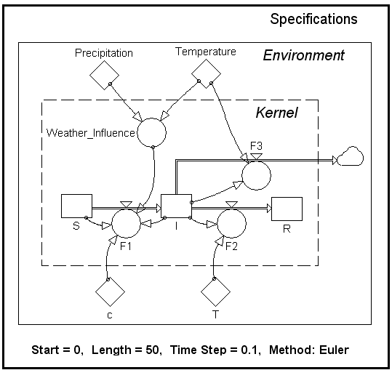

Actual or
assumed reality

Environment
to the system
System
Under Study

Figure 2.2. An executable simulation model consists of more than a description of the System under study. The model must contain: 1) The kernel that describes the model of the System Under Study, 2) The parameters describing influence from the environment, and in- and outflows through the boarders of the system 3) Specifications of Start time, Length of simulation, Time Step and updating method.

In practical modelling, the parameters (quantifying the influences from the environment) are usually placed where it is appropriate. But the concept of external parameters will still be obvious by the symbol: . (Therefore, StochSD has prevented input links to parameters, and refers such calculations to Auxiliaries).

3. Starting up StochSD

StochSD is available in two versions: StochSD Desktop and StochSD Web. For installation and use, see Appendix A. This manual applies for both versions.

When you open StochSD, the StochSD screen is shown. On the upper part of the screen you see the main menus and some buttons, and below is the model window (which is empty at start), where you build your model in a click-and draw manner.
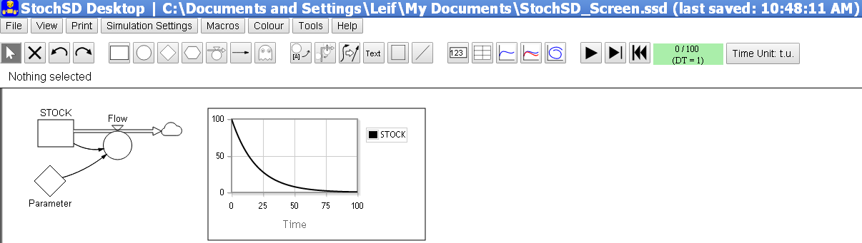
Figure 3.1. The StochSD Tool panel consists of a Title bar, Menus and Buttons located above the Modelling window. The modelling window is shown with a few building blocks and a Time Plot.

The Title bar shows the file name (with its path) and the time for last saving.

The Menus consist of pull-down and pop-up menus and a row of Buttons for construction, result presentation and running the model. To the right of this row is a field for Start Time, Current Time and Time Step, And the a field for the Time Unit that must be specified before the model building can start.

Finally, to the left under the buttons, there is an Inspection field where you can se the definitions of the marked primitives.

3.1 Menus

In the menus you find: File, View, Print, Simulation Settings, Macros, Colour, Tools and Help.

The File menu
The file handling in StochSD is handled from the File menu in a similar way to most programs, e.g. Microsoft Word.

In StochSD, a model constitutes a file. You can create a new model, save the model and open it again.

When run locally, you can choose the folder to save the model in.
When StochSD runs on a server the files are always stored in the Downloads folder.

The File menu contains the usual facilities:
- New
- Open
- Save
- Save As …
- Recent Files

To create a new model you click the New option button in the File menu.

A model can be opened by clicking the Open option in the File menu (or directly: Ctrl-O).

By pressing the Save as … option in the File menu, you open a form for saving your model. Her you can give the file a proper name. In the Desktop version of StochSD you can also browse to a dictionary of your choice, while in the Web version the model is always stored in the Download library.

When the model has a name and location, you can use Save option in the File menu (or directly use; Ctrl-S).

Up to five Recent Files are directly accessible. (Only for StochSD Desktop version.)

The View menu
With the View menu you can customise the size of StochSD on your screen.
- Zoom in (Ctrl +)
- Zoom out (Ctrl -)
- Reset zoom (Ctrl 0)

The Print menu
Printing the model diagram or its underlying equations is performed from the Print menu. This menu contains:
- Print Diagram (Ctrl-P)
- Print Equations

The model diagram can be printed on paper with the Print button or Ctrl-P.
The equations can be listed and then printed on paper.

Simulation Settings menu
Before you execute the model, you should open the Simulation Settings menu to specify what time period to study and the size of the Time Step (Often denoted DT). The Time Step sets the time between recalculations of the model. Finally, Method stands for the updating algorithm (“integration”) where you can choose between Euler and Runge-Kutta fourth order (RK4). Euler is faster and the default, while RK4 is more accurate for a given DT. For stochastic models the advantage of RK4 is lost; it will only make the simulation time longer.
- Start Time
- Length
- Time Step
- Method (Euler or RK4)

Macros menu
Enables the introduction of macros to StochSD, see Section 11.

Here you can define your own functions. However, in stochastic modelling, it is often important to make the stochastic simulation reproducible. This can be accomplished by locking the seed to the random number generators. In the macro form, this can simply be done by selecting a seed and clicing a button. See Section 11.

Colour menu
After marking one or several elements, you can open the Colour menu and select one out of 12 colours.

Note that you can couple the colour of an element and the colour of its plot in a diagram. (An option in each diagram.)

Tools menu
In the Tools menu, you find tools for Optimisation, Sensitivity analysis, Statistical calculations and presentation and Parameter estimation. Pressing a tool option will make the tool appear in a window on the right-hand side of the screen. With the Hide option you can close the tool. The Tools menu has the following options:
- Optim
- Sensi
- StatRes
- ParmVar
- Hide

The tools will be treated in Part II, Section 16.

Help menu
The Help menu contains:
- About StochSD
- User’s manual
- Optim manual
- Sensi manual
- StatRes manual
- ParmVar manual
- Debug log
- Restart and clear model
- Restart and keep model

‘About StochSD’ very briefly describes StochSD. The ‘User’s manual’ you are now reading is also available here. You can also find more detailed manuals about the tools for Optimisation (Optim), Sensitivity analysis (Sensi), Statistical calculations and presentation (StatRes) and Parameter estimation (ParmVar). The ‘Debug log’ is only valuable for a developer of the software. Finally, if StochSD is malfunctioning, you can restart it with or without the current model loaded.

3.2. Buttons

The buttons from left to right are:

Manipulation buttons
These buttons are for recapturing the ‘unloaded mouse’, deleting a block, or undoing or redoing an operation.
- Mouse
- Delete
- Undo
- Redo

Up to 10 undo steps are remembered and can be redone with the Undo and Redo buttons.

Building block buttons (Primitives, Elements)
Here are the building blocks of a StochSD model.
- Stock
- Auxiliary
- Parameter
- Converter (for a table look-up function)
- Flow
- Link
- Ghost

More about the Building blocks in Section 4.

Styling buttons
The styling buttons provides blocks for styling the model by moving the names of the building blocks, moving the valve symbol of the flow and for inserting frames, texts and lines.
- Move label around the element
- Move valve symbol
- Straighten a link
- Text
- Frame
- Line

The label can be moved to a position North, West, South or East of its element.
or
).
(
The valve symbol can be flipped to
In a broken flow, the valve symbol can be placed at the different segments.

An ugly link can be straightened by marking it and pressing the Straightening button.

Result buttons
These blocks provide Number boxes, Tables, Time Plots , Compare (Simulations) Plot and XY-Plots, for presenting results. The Compare Plot enables plots from two or more simulations in the same diagram.
- Number box
- Table
- Time Plot
- Compare (Simulations) Plot
- XY-Plot (Plots Y versus X)

Execution buttons
The execution buttons controls the simulation.
- Run/Halt
- Step
- Stop

3.3. Time display, Time Unit and Inspection field

Time display
To the right of the Execution buttons you find a display, which at run time shows:
Start Time / Current time & (Time Step used).
You can also see a green progress bar expand over the grey field during execution.

Time display
To the right of the Time display there is a field for the Time Unit that must be specified before the model building can start. It is crucial to be consistent and choose one and only one time unit across the model.

The time unit can e.g. be second, minute, hour, day, week, month, year, century, etc. For a generic model you can specify it as e.g. t.u. (short for ‘time unit’).

The Time Unit must contain at least one of the characters A-Z or a-z, and it must not incude ( ) ( ) ‘ or “.

Inspection fields
Finally, to the left under the buttons, there is an Inspection field where you can se the definitions of the marked primitives. For example, if ‘Flow’ is defined as ‘parameter⋅STOCK’ this will show up as: [Flow] = [Parameter]* [STOCK] when the Flow symbol is marked.
4. Model building

4.1 Building blocks at the model window

The main elements for building a model are: Stock, Auxiliary, Parameter, Converter, Flow, Link and Ghost.


Figure 4.1. The buttons for StochSD building blocks: Stock, Auxiliary, Parameter, Converter, Flow, Link and Ghost.

The six first mentioned elements are described in Chapter 2. With the Ghost button you can duplicate any of the first five elements to be displayed twice.

The building blocks are attached to the Model window and connected to each other in a click-and-draw manner. Before a primitive (Stock, Flow, Auxiliary, Parameter or Converter) is defined by a value or formula, you will see a question mark ‘?’ in it.

Stock: It is usually practical to start by placing and naming the Stocks – which are the elements you usually (but not always) are most interested in. Then draw and name the Flows into, out from or between Stocks. Thereafter, place and name Auxiliaries, Parameters and Connectors. Finally, place the Links to connect elements.

To place a Stock, Auxiliary, Parameter or Converter, click on its button, place the mouse cursor at an appropriate place in the Modelling window and drop it by clicking again.

To create a Flow, click on the Flow button, place the mouse cursor, press the left mouse button to anchor the starting point, hold the button down and draw the mouse in horizontal or vertical direction until it reaches its destination where you release the mouse button.

A Flow has a start and an end point that may connect to a Stock or it will start and/or end with a cloud symbol to show that the flow content comes from or goes to somewhere outside the defined model. If the start or end point is over a Stock, it will be connected to this Stock and the cloud disappears.

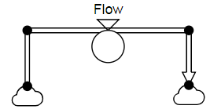
A Flow can also be broken in x and y directions. This is obtained by clicking the Right mouse button during the drawing operation. The flow may afterwards be adjusted by clicking the Flow and using the handles (at start, end and points where the Flow is broken). Then anchor points will show up when the flow is marked. With these anchor points you can adjust the flow. You may also move the name around and flip or move the valve symbol as described in “Styling buttons” below.
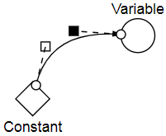
A Link is used to connect two elements. It means that one element affects the other. The Link is obtained by clicking its button. Then place the mouse cursor over a Stock, Auxiliary, Parameter or Converter and draw it to another of these building blocks – but not to the Parameter (you may not have incoming links to a Parameter). A Link can be bent into a nice Beziér curve. When you click on a link two anchor points and two handles will be visible. Then you can grip the handle and bend the link.

To create a Ghost of a Stock, Auxiliary, Parameter or Converter, first click on the actual building block in the Model window, then click on the Ghost button and finally click on an appropriate place in the Model window. The Ghost is then graphically represented as a copy of the original element with a ghost symbol inserted.

The Ghost means that the same Stock, Auxiliary, Parameter or Converter may be represented at two or more places in the model. A Ghost cannot have any flows or incoming links - but it can have outgoing links! This is to prevent the logics of the model be spread out.

Using Ghosts can eliminate connecting links to cross over the model that makes the model look ugly and unstructured. You may also use Ghosts to assemble information from or Stocks from different parts of a model into an ‘instrument panel of Ghosts and Number boxes (see Chapter 8).

The elements on the screen can afterwards be adjusted by drawing them to new positions.

The names of the symbols: Stock, Auxiliary, Parameter, Converter and Flow are always starting with ‘[‘ and ending with ‘]’. For example [Stock1], [Flow2], [Parameter1]. However, If you write the name without brackets, StochSD will include them. More about naming in Section 4.3.

The default names should be renamed to be descriptive, e.g. [Rabbits], [Births per month], [Fertility]. A Link has no label and the Ghost gets the same name as the symbol it ghosts. All names can be rotated around its symbol with the ‘Rotate name’ button (the first of the Styling buttons), see Section 4.2.

4.2 Styling buttons

Finally, there are six Styling buttons for moving the name label around a building block, for moving the valve symbol of a flow, for straighten a curved link, and for including texts, frames and lines into the model.


Figure 4.2. The Styling buttons: Move label, Move valve, Straighten link, Text, Frame and Line.

The name label of one or several marked elements can be relocated to North, West, South and East of the symbol.

The ‘valve symbol’ of a marked flow can be flipped upside-down and in a ‘broken’ flow also be relocated to different segments of the flow.

The third button straightens a marked link. This can sometimes be more convenient than adjusting Anchor points or Handles.

Text frames, Empty frames and Straight lines are created by clicking respective button, placing it and drawing its to a proper extension in the Model window. The size of these blocks can also be adjusted afterwards.

4.3 Naming and defining relations or values of the building blocks

In StochSD a name of a building block always includes brackets, e.g. [Stock1], [WaterFlow], [c]. However, if you write the name without brackets, StochSD will include them. The name may contain almost all alpha-numeric characters. The only restriction is that you may not use brackets, parenthesis or quotation marks ( [, ], (, ), ’ or “ ) within a name string. However, in the graphic model and in tables and diagrams, the brackets are removed of aesthetic reasons.

When a building block is placed, it is time to give it an appropriate name and to define its value or relation to other building blocks affecting it in a formula.

Double-clicking a building block opens its Dialog box (form) where you can specify the building blocks name and define its formula. Figure 4.3 shows the Dialog box for a flow named [Flow] that is affected by [STOCK] and [Parameter].

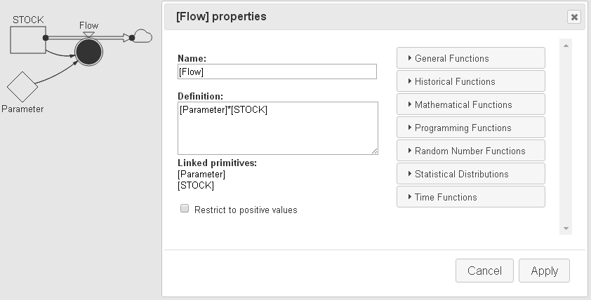

Figure 4.3. To the left a small model and to the right a Dialog box of [Flow] with: 1) Name field where the name can be changed, 2) Definition field where the value or function is specified. 3) Linked primitives: show the building blocks that must be included in the Definition field. 4) Library functions which also could be used in the Definition field.
5) Check box for Restriction to positive values. 6) Cancel or Apply buttons.

For the Stock, Auxiliary, Parameter and Flow building blocks the Dialog boxes are similar. (A Ghost has the same (not just a copy) dialog box as the building block it ghosts.)

The Dialog box contains a Name field where the name (e.g. [Stock3], or [Auxiliary5]) can be changed to a suitable name in upper or lower case characters. If you skip the brackets (‘[‘ and ‘]’) in the Name field, StochSD will automatically insert them.

Below is the Definition field of the building block where you define a formula or a value. Here, linked building blocks and library functions can be used together with numbers and the arithmetic operators + - * / ^ and ( ).

Further below, Linked primitives (building blocks) to be used in the Definition are listed. They enter the Definition field when you click them. It is best to enter the primitives from here with a click, because then you don’t miss the brackets. Without the brackets, StochSD don’t understand the definition.

For Stock and Flow building blocks a check box ‘Restrict to positive values’ is found at the bottom-left. (This should very seldom be used.)

To the right you find, Library of functions subdivided into groups named: General Functions, Historical Functions, Mathematical Functions, Programming Functions, Random Number Functions, Statistical Distributions and Time Functions. Clicking on such a group button will give you a list of functions in the chosen category. These functions will be treated in Section 10.

StochSD knows how to calculate the value of a Stock from inflows to and outflows from a Stock from the graphical structure without further specification. Therefore, a Stock only requires the initial value at ‘TimeZero’ (i.e. the time when the simulation starts) to be entered into the definition field. Usually, the initial value for a stock is a number. But it is also possible to initiate the Stock to the value of an auxiliary or Parameter linked to the Stock. The initial value may also be a random number.

The Converter is a table look-up function where you specify the pairs: x₁,y₁; x₂,y₂, …, x_{n},y_{n} of values. It has its own Dialog box. See Section 10.2.6.

A Link has no dialog box. It just links one building block to another.

Leave the dialog box by clicking the Apply button to realise your specifications or by clicking the Cancel button to leave the dialog box without new specifications.

If there is a mismatch between the list of Linked primitives and the [Bracketed primitives] in the formula (say that only [X] is used or that you have written c*[X] or you have written [c]*[X]*[Y], where [Y] is not linked in Figure 4.3), then you get a Modelling Error message when you click the Apply button. If the definition is grammatically correct the question mark ‘?’in the symbol of the primitive will disappear.

5. Equations

When you defined all relations and values related to the building blocks, StochSD automatically generates the equations that mathematically describe the model. When all primitives are defined in a grammatically correct way – no ?-mark in any building-block symbol – you are ready to run the simulation model.

The equations (or more correctly ‘algorithm in assignment statements’) are used exactly as you defined them with one exception. A Stock is only directly defined by the initial value you chose, but also indirectly by the in- and outflows you graphically attached to it. If you modelled [Stock] with one inflow [F1] and one outflow [F2], then [Stock] will be updated by: [Stock] := [Stock] + DT*[F1] - DT*[F2], for each time step. This algorithm is called the Euler method. You can also choose a more advanced method called RK4, see the Simulation Settings menu in Section 3.1 and Section 6.

The model equations can be viewed by opening the Print menu and choose Print Equations. You will then see the Equation List. (From here you may also print the equations.)

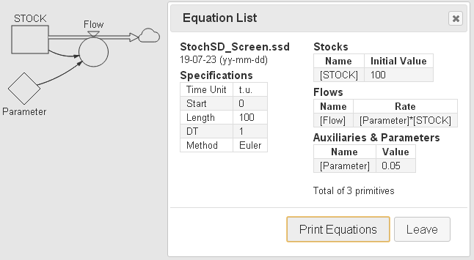

Figure 5.1. The Equation List for the small model shown to the left.

6. Specification of the simulation

Before you execute the model, you should specify what time period to study and how frequently recalculations of the model should be performed.

The specification of the time handling is done in the Simulation Settings menu. Here you specify Start¸ Length, and TimeStep for the simulation. If you don’t want the default Euler method for the updating of stocks, you can change to RK4 in this menu.

The integration (updating of the model over time) is performed by Euler’s algorithm. This algorithm updates a Stock X over time according to:
X(next) = X(now) + Inflows(during now to next) – Outflows(during now to next). Mathematically this is expressed as: X(T+DT) = X(T) + DT*InFlow – DT*OutFlow.
Now

Next
T

T+DT
DT

Start

End

Length
time

Figure 6.1. The time-handling relating Start, Length and TimeStep (DT).

For a ‘well-behaved’ deterministic model there are more efficient algorithms than Euler’s e.g. a Runge-Kutta 4:th order (RK4). While Euler’s method only estimate the change (derivatives) at the beginning of a time step (i.e. at time t), while the RK4 method estimates the derivatives at t, t+½DT and t+DT. This works well on deterministic models because the derivatives are usually smooth. However, stochastic models change randomly at each time step why we don’t have smooth derivatives, and RK4 would just prolong the execution time.

Choosing a proper time step
A short time-step always increases the accuracy of the calculations but it also increases the number of recalculations of the model and thus also the execution time. You should, therefore, try to find a compromise where the time-step (DT) is sufficiently short to give good accuracy - but not shorter than this.

Theoretically, the step-size should be considerably shorter than the shortest time-parameter in the model. Mathematically, there exists of course a relation between step-size and accuracy (given the integration algorithm) for every model. But this is complicated to calculate. Therefore, finding an appropriate step-size is a practical task that should be done for every new model before starting the experiments.

A practical way to find an appropriate step-size is the following:
Choose a step-size and perform a simulation. Then increase or decrease the time step (by a factor of e.g. two or ten) and investigate if it has any important effect on the simulation results. If the results changes significantly, then continue to decrease the time step. (You may also consider a more efficient integration algorithm, e.g. RK4.) If the time step is unnecessarily short, increase it.

For this purpose you may use the Compare Simulations Plot described in Section 8, where this is exemplified.

For stochastic models it is more complicated, because the outcomes to be compared will vary randomly. One way is to use a deterministic version of that model to find a proper time step (using the Euler method), and then use half that time step for the stochastic model.

Another model is to make say 100 replications for each time step and compare the average results for different time steps.

7. Simulation

A simulation of the model is performed by pressing the Run/Halt button. It is also possible to test the model behaviour with the Step button. You may also reset the calculations with the Reset button.

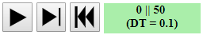

Figure 7.1. The execution buttons: Run/Halt, Step and Reset. (To the right of the buttons the Start Time || Actual simulation time or End Time (after the run) and (Time Step) are displayed.

Pressing the Run button ( ►) starts the simulation and enables specified Simulation Results in Number boxes, Tables, Time Plot, Compare Simulations Plot or XY-plot, see Chapter 8.

With ( ►|) you can run a single time step at a time. Finally, (|◄) will rest to model to Time Zero.

The calculations behind the scene of a simulation
What happens during a simulation is that StochSD, time-step by time-step, recalculates the equation system. The working procedure used is the following (DT is the simulation time-step used and EndTime is the StartTime + Simulation Length):

Time = StartTime
The Stocks are initiated
GoTo 6
Time = Time+DT
The Stocks are recalculated
The Auxiliaries, Parameters &
Converters are recalculated
The Flows are recalculated
The results for this time-step are stored
If Time < EndTime then GoTo 4

Figure 7.2. The calculations performed behind the scene. The calculations of the Stocks are updated according to Euler’s integration method.

8. Results presentation

To present the results of a simulation run you can use Number Boxes, Tables, Time Plots, Compare Simulations Plots and XY-Plots.

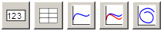
Figure 8.1. Result presentation buttons for Number box, Table, Time Plot, Compare Simulations Plot and XY-Plot.

8.1 The Number Box

The Number Box is particularly useful to show the values of Parameters, Auxiliaries and Stocks. This means that you in the Forrester diagram can directly see the value of a parameter, the initial value of a Stock before the simulation or its final value after the run. See Figure 8.2.

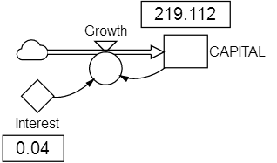

Figure 8.2. Use of Number Boxes. Here capital growth of 100 Euro at 4% interest after 20 years is shown. (DT=1 to create annual interest in the way the bank will calculate it.)

To use the Number Box, you must first mark the element you want to watch. Then click and place the Number Box.

A Table, Time Plot, Compare Simulations Plot or XY-plot is obtained by clicking respective result button. Then you place the cursor on a proper place on the screen and click-and-draw the item to a proper size. Tables and plots can also afterwards be drawn to a proper size by using the handles.

By double-clicking the Table, Time Plot, Compare Simulations Plot or XY-Plot, you can choose the values of the elements to be displayed over the simulation run. You can also choose to only display what happens during a selected period of the simulation run and how often the results should be tabulated or plotted. The plots are automatically scaled after a simulation, but you can select your own scaling.

8.2 The Table

For Tables you can also choose to show only a part of the data and select the time between the rows.

From the Table Properties form, you can also export your values as Comma-separated values (CSV) or Tab-separated values (TSV) for use or analysis in e.g. a spreadsheet.
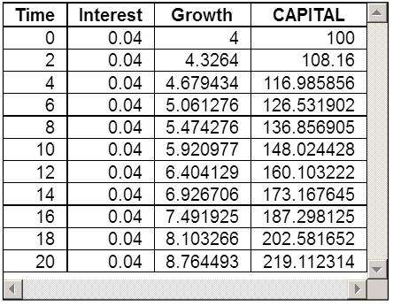
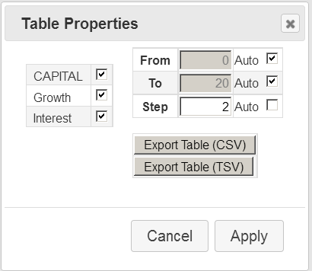

Figure 8.3. The Table Property form and a Table presenting the results of Interest, CAPITAL and Growth of 100 Euro at 4% interest (from the model in Figure 8.2). Here we have chosen to show each second year.

8.3 The Time Plot

In the Time Plot Properties form you mark what quantities to present and whether to relate them to the left axis or to the right one. We can also add a Title and Labels for the axes. Further, we can let StochSD to use different colours, or let the curves have the same colours as their primitives. Having the same colour of the element and its line in a plot reduces the risk of misunderstanding. In a Time Plot, a Stock will be drawn with a solid line, a Flow with a dashed line and other types of elements with a dotted line.
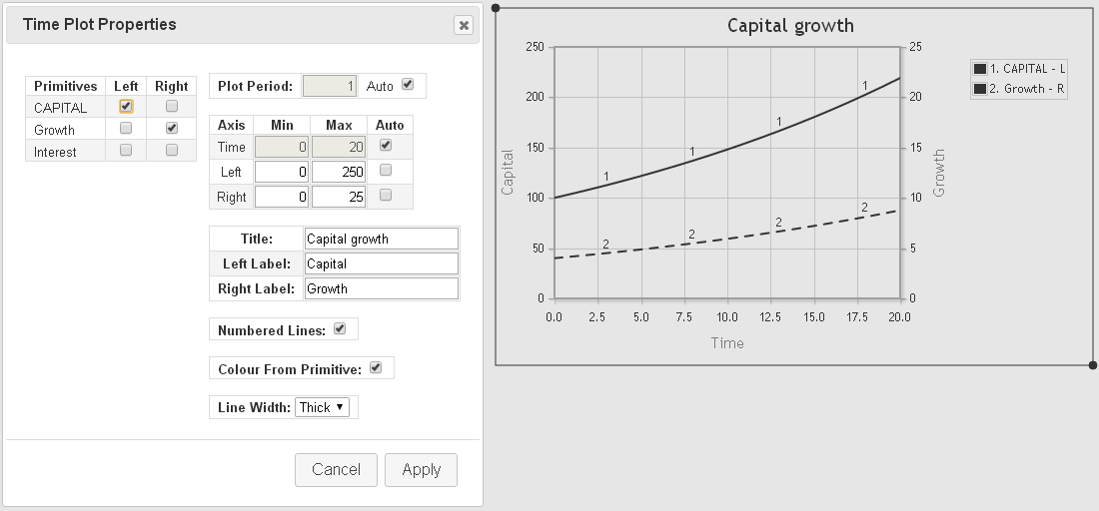
Finally we can use Numbered Lines, Colours from primitives and Thick or Thin curves.

Figure 8.4. The Time Plot Properties form and a Time Plot presenting the results of CAPITAL and Growth (from the model in Figure 8.2). Here we have related CAPITAL to the left y-axis and Growth to the right one. We have also added a Title and Labels for the axes. Finally we have chosen Thick curves.

8.4 The Compare Simulations Plot

The Compare Simulations Plot (or jus Compare Plot) can present curves from different simulations in the same plot. This is especially helpful in two cases. First, you can use it to find a proper time step (DT) and, second, you can use it for sensitivity analysis to directly se the effect on an important quantity when changing a parameter.

In Figure 8.5, we show the behaviours of a logistic model (dX/dt = a⋅X -b⋅X²; X(0)=2, a=1, b=0.02) for 5 simulations with different values of DT.
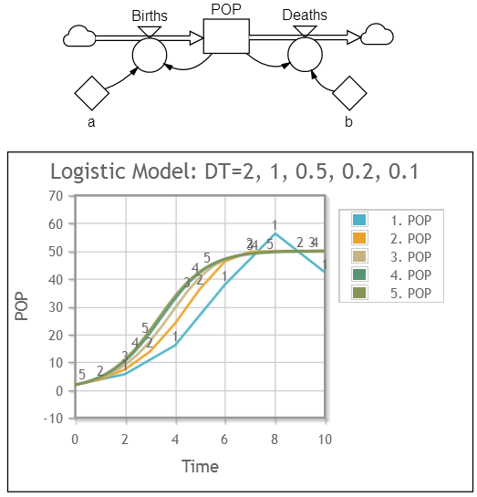
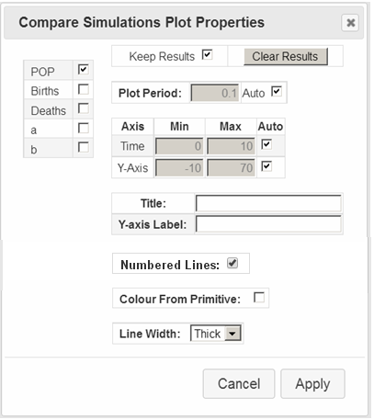

Figure 8.5. The Compare Simulations Plot presenting the logistic growth of a population. This device can help you to find a proper time step, DT. Here you see that DT=2, 1 & 0.5 give a bad accuracy. DT=0.2 & 0.1 are rather similar. So choose a time step ≤ 0.1 (depending on the accuracy required).

The Compare Simulations Plot Properties form is similar to that of the Time Plot, but has only one y-axis. However, two facilities are added: a Keep Results checkbox and a Clear Results button.

A Stock will be drawn with a solid line, a Flow with a dashed line and other types of elements with a dotted line.

Finally we can use Thick or Thin curves.

8.5 The XY-Plot

A XY-Plot shows one quantity (y-axis) varying against another quantity other than Time (on the x-axis). In an XY-Plot each point in time is shown with the coordinates (x,y), which makes a curve when times progresses – but the time is implicit and not shown.

In a XY-plot you can choose between Line, Markers or both. The colour is black.

A Volterra model describes the prey-predation relation between species. In Figure 8.6 the behaviour of a simple Volterra model of Rabbits and Foxes is shown in an XY-Plot.

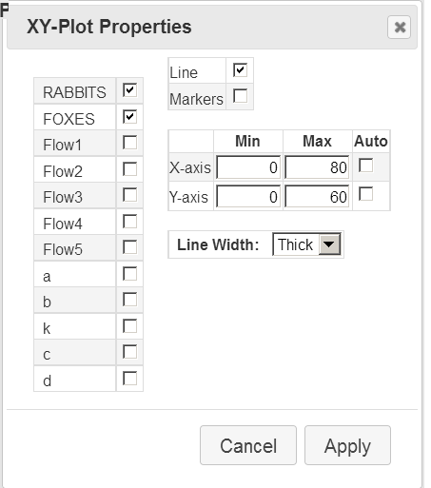
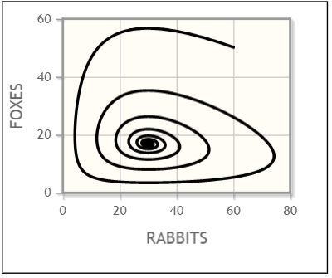
Figure 8.6. A XY-Pplot of Rabbis versus Foxes in a prey-predator model.

In the XY-Plot all combination between Stock, Flow, Auxiliary, Parameter and Converter will be drawn with a solid line.

In the XY-Plot markers can be valuable to indicate the time, because you get one mark per time step.
9. Examples

Example 9.1: Filling a bathtub with an open outlet
Construct the following model to see what happens when water flows into and out from a bathtub.

We here assume the following:
1) The BATHTUB is empty at Start Time.
2) The InFlow is regulated from the Valve.
3) The Valve handle is opened to give 30 litres/minute for 5 minutes and then closes.
4) The OutFlow is open. For simplicities sake, we assume that 15% of the amount of water in the BATHTUB will leave the tub each minute through the OutFlow.

The equations generated from the model are:
[Valve] = 30
[c] = 0.15
[BATHTUB] = [BATHTUB]+DT()*([InFlow] – [OutFlow])
[BATHTUB] = 0 (* Initial value *)
[InFlow] = IfThenElse(T()<5, [Valve], 0) (* See Section 10.2.1 *)
[OutFlow] = [c]*[BATHTUB]

The model is repeatedly updated time-step by time-step until the simulation is complete.

Using the time unit = 1 minute, the time-step (DT) is set to 0.1 minute, so the equation system becomes updated for each 6 seconds.

You can choose the time unit to be e.g. 1 second, 1 minute or 1 hour. But you have to be consistent and recalculate all time data to the selected one!

The content of the bathtub is shown for 30 minutes in a Time Plot in Figure 9.1 above.
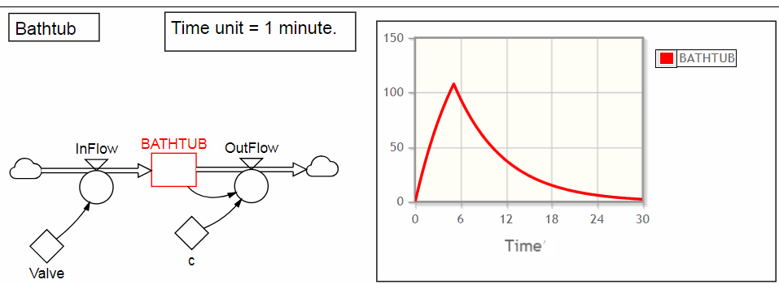
Figure 9.1. A simple bathtub model and its behaviour. 

Example 9.2: Rabbits on an isolated island.

Figure 9.2. Picture of the system under study when dropping the carrots.
We wish to study the progress of a rabbit population on an isolated island in the sea where 10 rabbits are introduced. They eat, breed and die of old age.
Studies of the system have shown that the food supply available is parameter and is estimated to 100 kg of carrots per month. It has also been shown that the number of rabbits born per month is proportional to the size of the population and to the square root of the amount of food per rabbit and month. The fertility parameter has been calculated to 0.2. Further, it has been found that the average length of life is 20 months, which is about the same as 5% of the population dying each month.

A so-called causal-loop diagram for the model is shown in the figure below.
−
Square root of Food supply per month & rabbit
(−)
+
Food supply per month & rabbit
Food supply per month
RABBIT POPULATION
Deaths per month
Births per month
Fertility
Mortality
(+)
(−)
+
+
+
+
+
−
+

Figure 9.3. A causal-loop diagram of the rabbit system.

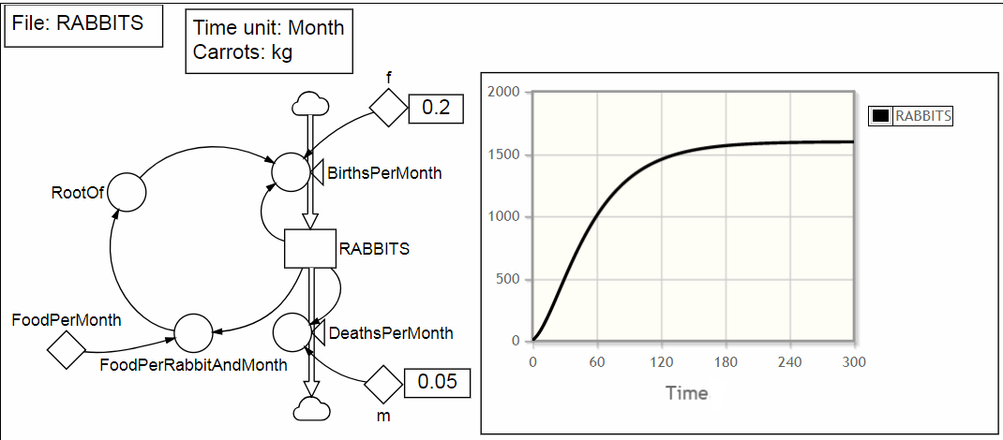
Building the model structure and filling in all relations and parameters (the fertility and mortality parameters are f = 0.2 and m = 0.05, respectively) gives the following StochSD model:

Figure 9.4. A StochSD diagram of the rabbit system and the result.

Select the Simulation Settings menu and set the Simulation Length to 300, chose Months as Time unit and set the Simulation Time-Step to 0.5 (months).

When the model is complete, and the Run button is pressed, we choose the Time Plot, here only showing RABBITS, see Figure 9.4, above. We could also choose Table and e.g. select RABBITS, BirthsPerMonths, DeathsPerMonths, and FoodPerRabitAndMonth. 
10. Functions

In StochSD there are a large number of library functions. You find them to the right in the Dialog box of a Stock, Flow, Auxiliary or Parameter. The functions are first listed as an overview. A more detailed presentation is given below.

The arithmetic operators are: + − ∗ / ^ ( ) for addition, subtraction, multiplication, division, power (x^{n}) and parentheses. As always, the calculation order is: power, then multiplication and division, and last addition and subtraction. Parentheses ‘( )’ can be used to alter this order.

The categories of functions in StochSD
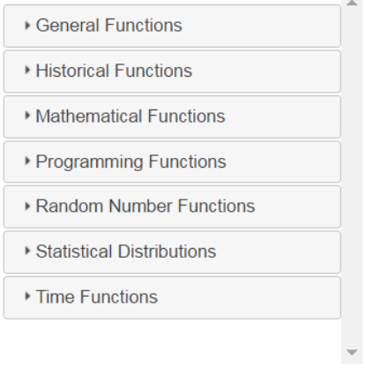
Figure 10.1. The categories of functions.

Below, we will shortly present the most commonly used functions sorted into different categories.

Only the most useful functions of a category will be discussed. Sorted by category, these are:

1. General Functions
- If Then Else
- PulseFcn
- Step
- Ramp
- Stop (Terminates the simulation run at an event)

2. Historical Functions
- Delay1 (Dynamic delay of order 1)
- Delay3 (Dynamic delay of order 3)
- PastMax
- PastMin
- PastMean
- PastStdev
- PastCorrelation
- Fix (A device to sample and hold values for regular periods of time)

3. Mathematical Functions
- Abs (Absolute number)
- Sqrt (Square root)
- Sin (Argument in radians)
- Cos (Argument in radians)
- Tan (Argument in radians)
- Log (Logarithm base 10)
- Ln (Logarithm base e)
- Exp (Exponential)

4. Programming Functions
- If-Then-Else (A more advanced version than that in General Functions.)

5. Random Number Functions
- PoFlow (Simplified expression for Poisson flows)
- Rand (Uniform distribution)
- RandNormal
- RandBinomial
- RandPoisson
- RandExp
- RandBoolean
- RandDist (Custom distribution)

6. Statistical Distributions
In ‘Statistical Distributions’ you find Pdfs, Cdfs and Inversions of Normal, Lognormal, t, F, Chi square, Exponential and Poisson distributions. These distributions can be used in some advanced statistical studies. However, these distributions will not be further discussed in this manual.

7. Time Functions
- Current Time
- Time Start
- Time Step
- Time Length
- Time End

8. Converter
- The often-useful empirical graph function (sometimes called table-look-up function) where you can enter an x-value to obtain the y-value has its own element button located in the row of building blocks (see Section 3.2). This element is named a Converter. However, since it is a function it is discussed (last) in this chapter.

Note that functions have a pair of parenthesis – fcn(…) – to tell StochSD that they are functions. This applies even if the function has no argument (e.g. T() and DT() for Time and Time Step).
The only exception from the user’s perspective is the Converter where the relation described by (x₁,y₁; x₂,y₂; … x_{n},y_{n}) must not have parentheses entered at the Definition field of the Converter.

Below you find a detailed description of the functions.
10.1 General Functions

IfThenElse – If Then Else function
Syntax: IfThenElse(Test Condition, Value if True, Value if False)

Result: If the logical Condition is True then the first Expression (Value) is evaluated and returned, if it is False then the second Expression is evaluated and returned.

Example: If(A < B, A, B) returns the smallest of A and B.

Example: If(A < B, 5, 2*Sqrt(25)) returns 5 if A < B, otherwise 10.

Logical operators are: <, >, <=, >=, = and <> (‘not equal to’), AND, OR.

Syntax: A < B, A > B, A <= B, A >= B, A = B, A <> B, X>=A AND X>B

Example: A <> B will return True if A ≠ B and False if A = B.

PulseFcn – Pulse function
Syntax: PulseFcn(Start, Volume, Repeat)

Result: Creates a pulse input at the specified Time with the specified Volume. Repeat is optional and will create a pulse train with the specified Repeat as interval if positive. With a negative Repeat value you get only a single pulse at Start.

Example: Pulse(2, 1, 4) generates repeated pulses with the Volume: 1, starting at time=2 and then repeating each 4 time units, see Figure.
Time
Volume
Time-step
Start

Interval

Time-step
Figure 10.2. A PulseFcn.

An ideal pulse is infinitely high and infinitesimally wide, so that the Height*width equals the specified Volume. The smaller time-step -the better the approximation of an ideal pulse.

The graph in the figure is shown for the time-step = 1 time unit. (For e.g. time-step = 0.1 the pulse will be 10 times higher and have a tenth of the width. The interval between the pulses will still be 4 time units – which now is 40 time-steps.)

Note the difference between what happens mathematically (grey rectangles) and what it looks like in a graph where the lines (dashed) are connected to the values (dots) at each time-step.

[The PulseFcn replaces the awkward Pulse in Insight Maker where the pulse-content (volume) changes when you adjusted the time-step.]

Syntax: Step(Start, Height)
Step - Step function

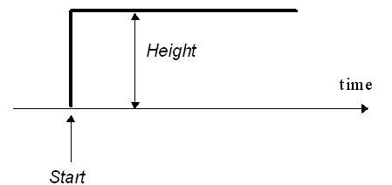
Result: Generates a step at time Start with amplitude Height. That is, it returns 0 if TIME < Start, and Height otherwise.

Figure 10.3. The Step function.

Syntax: Ramp(Start, Finish, Height)
Ramp - Ramp function

Result: Generates a ramp, which moves linearly from 0 to Height between the Start and Finish times. Before Start the value is 0; after Finish the value is Height.

Syntax: Stop()
Stop – Stop function

Result: Immediately terminates the simulation run when executed. The Stop function can be used in an IfThenElse function.

Example: IfThenElse([X] < 0, Stop(), 0)
[When the [X] goes below a certain value (e.g. 0.5) the simulation run terminates.]

Stop() ends promptly without letting the end values to be displayed. If you want to see the results from the last time step causing the stop in table or plot write:
IfThenElse(Delay([X], DT())<0, Stop(), 0)

10.2 Historical Functions

Short Introduction to delays
A delay is, for example, the time from which a product is ordered until it is delivered, or the time from which a person becomes infected until he becomes sick. Also information can be delayed, for example, the time to deliver a message.

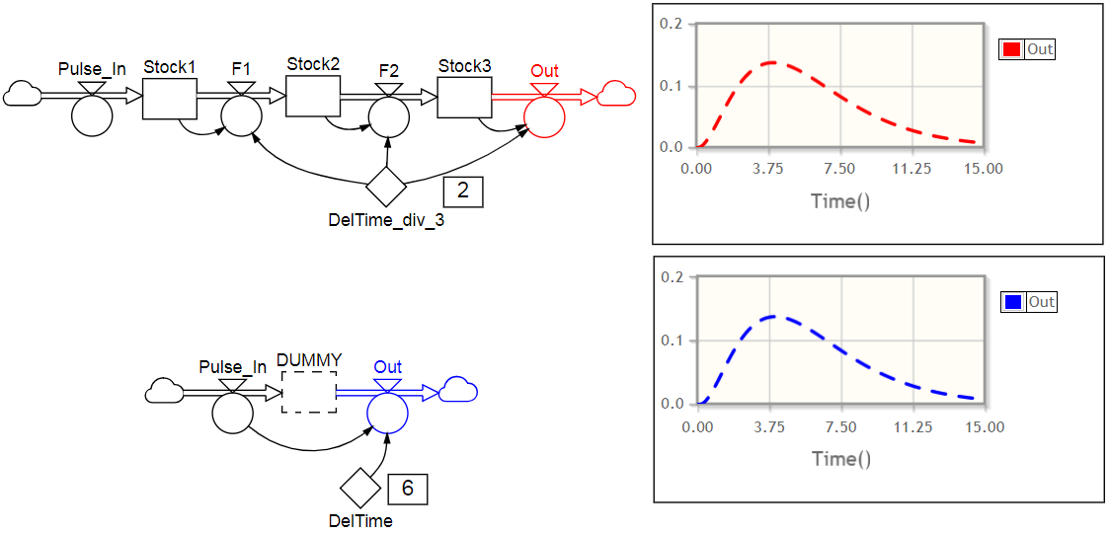
A delay is a dynamic subsystem that contains a series of stocks and flows. The number of stocks in that subsystem is the order of the delay. See the Figure 10.4.
2)
1)

Figure 10.4. A delay of order 3 (with e.g. a total delay time of 6 time units) can be obtained in two ways: 1) By connecting three stocks in a series, where each of the three stocks is delayed for Del/3 time units.
2) By using the Delay3 function for the outflow ‘Out’, so [Out]= Delay3([Pulse_In], [Del], 0). This connects Pulse_In to Out. (A stock, here called DUMMY because it is not involved in the delaying, may or may not be included. It is merely placed between the inflow and the outflow, so that it is filled by Pulse In and drained by Out. DUMMY will then have the same content as Stock1+Stock2+Stock3.)

The order of the delay determines how quickly its output starts to change after a change in the input. Low-order delays start to respond more quickly than high-order delays having the same average delay time Del. See Figure 10.4, above.

Syntax: Delay1([Element], Delay Length, Initial Value)
Delay1 – Delay function of order 1

Example: Delay1([Inflow], 6, 0)

Syntax: Delay3([Element], Delay Length, Initial Value)
Delay3 – Delay function of order 3

Example: Delay3([Inflow], 6, 0)

Syntax: PastMax([Element], Period = All Time)
PastMax – Maximal value over a past period.
– For statistics over (a part of) a simulation

Results: Calculates the maximal value of an element over the specified past Period. If the Period is omitted, it shows the maximum sofar over the whole replication.

Example: PastMax([X]) will create a function that displays the first value of X after one time-step, the largest value of X in the past two time-steps, and so on until the replication is over when the largest value of X is shown.

Example: PastMax([X], 2) will create a function that starts as in the example above, but after 2 time units and more displays the largest value during the last 2 time units.

Syntax: PastMin([Element], Period = All Time)
PastMin – Minimal value over a past period.
– For statistics over (a part of) a simulation

Results: Calculates the minimal value of an element over the specified Period.

Syntax: PastMean([Element], Period = All Time)
PastMean – Mean value over a past period.
– For statistics over (a part of) a simulation

Results: Calculates the mean value of an element over the specified Period.

Syntax: PastStdev([Element], Period = All Time)
PastStdev – Standar deviation over a past period.
– For statistics over (a part of) a simulation

Results: Calculates the standard deviation of an element over the specified Period.

Syntax: PastCorrelation([Element], Period = All Time)
PastCorrelation – Correlation between two quantities over a past period.
– For statistics over (a part of) a simulation

Results: Calculates the correlation between two quantities over the specified Period.

Syntax: Fix(Value, Period)
Fix – A device to sample and hold values for regular periods of time.

Results: A device to sample and hold values for regular periods of time.

Example: Fix(Rand(0,10), 5) will draw a random number that remains fixed for the following 5 time units.

10.3 Mathematical Functions

Syntax Function Comment

Round([X]) Rounds a number to its nearest integer

Abs([X]) abs(X) The absolute value of X

Sqrt([X]) 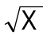

Sin([X]) sin X Note: X in radians

Log([X]) log₁₀ X The 10-logarithm

Ln([X]) ln X The e-logarithm

Exp([X]) e^{x}

[X] mod [Y] X (mod Y) Returns the remainder of X/Y
Example: 13 (mod 5) = 3

10.4 Programming Functions

Syntax: If Condition Then
IfThenElse – Structured If-Then-Else function
Expression
Else If Condition Then
Expression
Else
Expression
End If

Result: Tests one or more conditions and selectively executes code based on these tests.
.
Example: In a SIR model the initial number of Infectious (I) at time zero is
unknown. In 60% it is I(0)=1, in 30% it is I(0)=2 and in10% it is I(0)=3 infectious persons. Then you can draw a uniformly distributed random number between 0 and 1 and use this distribution to initialise the I-stage at time zero.

If Rand() < 0.6 Then
1
Else If Rand() < (0.6+0.3) Then
2
Else
3
End If

See also IfThenElse in Section 10.1.

10.5 Random Number Functions

Here the most common random number functions are presented. In many simulation languages, random number functions include a seed that defines the initial value of the random number sequence. In StochSD the seed is set globally, which can be done by a macro. See example in Chapter 11. Macros.

Stocks, Flows, Auxiliaries and Parameters can all contain randomness. When this is the case, a dice will be shown in those primitives.

Syntax: PoFlow(FlowRate)
PoFlow - Poisson distributed flow
(This function is an addition to the Insight Maker functions.)

Result: Generates Poisson distributed random flow with a mean of FlowRate. The result is always an integer ≥ 0.

Example: PoFlow([c]*[X]) is a shorter, more practical and mor readable form for RandPoisson(DT()*([c]*[X])/DT().

PoFlow() can be used to produce a random number of events during a time-step in a flow.

Syntax: Rand(Min, Max)
Rand - Uniformly distributed random numbers

Result: Generates uniformly distributed random numbers between Min and Max. Rand() gives uniformly distributed random numbers between 0 and 1.

Example: Rand(5, 17) gives uniformly distributed random numbers between 5 and 17.

Syntax: RandNormal(Mean, Standard Deviation)
RandNormal - Normally distributed random numbers

Result: Generates normally distributed random numbers with a specified Mean and Standard Deviation.

Example: RandNormal(3, 0.5) gives normally distributed random numbers with a mean of 3 and a standard deviation of 0.5.

Syntax: RandBinomial(Count, Probability)
RandBinomial - Biomially distributed random numbers

Result: Generates binomially distributed random numbers from Count trials, each with the specified Probability. The result is always an integer
≥ 0.

Example: RandBinomial(10, 0.3) gives binomially distributed random numbers between 0 and 10 with an expected value of 10⋅ 0.3=3.

Syntax: RandPoisson(Lambda)
RandPoisson - Poisson distributed random numbers

Result: Generates Poisson distributed random numbers with a mean of Lambda. The result is always an integer ≥ 0.

Example: RandPoisson(5) gives Poisson distributed random numbers with a mean of 5.

RandPoisson can be used to obtain the number of events during a time interval.

Syntax: RandExp(Beta)
RandExp - Exponentially distributed random numbers

Result: Generates exponentially distributed random numbers with a rate Beta. The result is always an integer ≥ 0.

Example: RandExp(10) gives exponentially distributed random numbers between 0 and infinity with a mean of Beta=10.

RandExp can be used to obtain the distance in time (or space) between successive events when the rate of events is Beta.

Syntax: RandBoolean(Probability)
RandBoolean - Binary distributed random numbers

Result: Generates exponentially distributed random numbers that returns 1 with the specified Probability, and 0 otherwise.

Example: RandBoolean(0.5) can be used for the flipping of a symmetric coin.

Syntax: RandDist(x, y)
RandDist - Custom distributed random numbers

Result: Generates random numbers according to a custom distribution (an empirical distribution, usually obtained from measurements.). The customised distribution is specified by a sequence of x-values {x₁, x₂, …, x_{n}} and a sequence of the same number of y-values {y₁, y₂, …, y_{n}} where the sequences ar separated by a comma. The Points between the defined coordinates are linearly interpolated. The distribution does not have to be normalised such that the area under the curve is 1, but the points must be sorted from the smallest to the largest value of x_{i} ; i=1, 2, …, n.

Example: RandDist({0, 1, 2, 3, 4}, {0, 2, 1, 7, 3})

10.6 Statistical Distributions

In ‘Statistical Distributions’ you find Pdfs, Cdfs and Inversions of Normal, Lognormal, t, F, Chi square, Exponential and Poisson distributions. These distributions can be used in some advanced statistical studies. However, these distributions will not be further discussed in this manual.

10.7 Time Functions

Syntax: T()
T – Current time

Result: Gives the current time for the simulation.

Syntax: TS()
TS – Start time for the simulation

Result: Gives the start time for the simulation. This value is specified in the Simulation Settings form.

Syntax: DT()
DT – Step-size

Result: Gives the step-size used for the simulation. This value is specified in the Simulation Settings form.

Syntax: TL()
TL – Time length of simulation

Result: Gives the length in time for the simulation. This value is specified in the Simulation Settings form.

Syntax: TE()
TE – End time for simulation

Result: Gives the End time for the simulation.
TE() = TS() + TL().


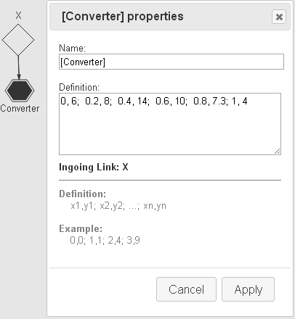
10.8 Converter
(Table look-up function)

The Converter is implemented as an element with its own button. Click on the converter button, which gives you a six-cornered figure. Double-click the Converter to Define the data pairs x_{i} ,y_{i}. The data pairs should be separated by semicolon. (Space between each pair is inserted to make the table more readable.)

Converter – A table function (graph) that converts from input X to output Y
Syntax: Specify the X to Y conversions as a table in the Definition field.

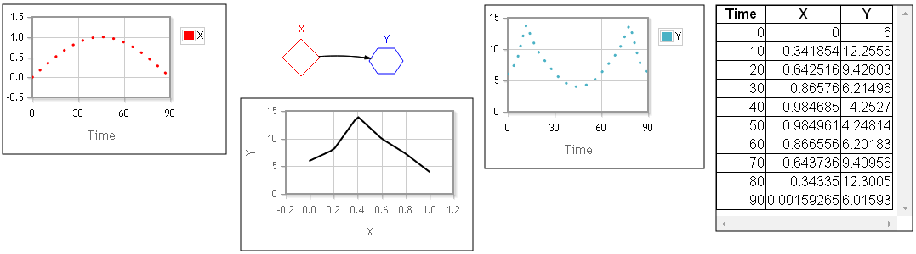
Example: You may want to use the empirically known Temperature as function of Time, Energy consumption as function of day of week or Fertility as function of Food supply in your model. Then you define the empirical function between an input X and an output Y. This relationship is expressed in tabular form. Consider for example the following relationship between X and Y: For example: 0,6; 0.2,8; 0.4,14; 0.6,10; 0.8,7.3; 1.0,4 (Shown in Figure 10.5.)
Figure 10.5. Empirical relation between input X and Output Y. Input to the converter is:
[X] = Sin(3.14*T()/90), which is converted to [Y] during 90 time units.

By using more points in the table, you can describe the reality more accurately.

Creating empirically distributed random numbers

One important use of a Converter (together with the Rand() function) is that you can create empirically distributed random numbers according to the Inversion Method. (See Wikipedia: ‘Inverse transform Sampling’ or W.H. Press et al., Numerical Recipes, Chapter 7.2.). The procedure is the following (see also Figure 10.6):

Assume that you have observed the varying occurrence of something (e.g. passengers arriving with buses [an integer] or the load of sand on arriving trucks [a real number]) and tabulated this discrete or continuous amount x on the x-axis and the frequency x occurs on the y-axis. (In the continuous case you must of course use intervals of x.) Now you want to draw random numbers giving the amount x (of e.g. the content at arriving vehicles). In other words, we want to draw random numbers from an empirically measured distribution f(x), where f(x) is the probability of the outcome x and that you have statistics about the number of times, y’, something happens as function of x.
- Make a table in the Converter ‘Graph’ for {x₁,y’₁ x₂,y’₂ … x_{n},y’_{n}}. This converter takes the input from an element x. We have now created the empirical function Graph: y’=fcn(x) (that you can plot if you set x=T()).
- Normalise Graph so that you have a unit area under the y’-values. This can be done by cumulating a flow into an empty compartment to see its final content ‘NormFactor’, see Figure 10.6. Then divide all y’-values of Graph by dividing by the NormFactor. We now have a new normalised graph y=f(x) with the value pairs {x₁,y₁ x₂,y₂ … x_{n},y_{n}}, which we call f_x.
- Accumulate f_x into an empty compartment F_x producing Y=F(x) and tabulate F_x in a Converter giving the pairs {x₁,Y₁ x₂,Y₂ … x_{n},Y_{n}}.
- Create the inverse of Y=F(x) which is x=F⁻¹(Y). This is easily done for tabulated value pairs – just change place of the values in each pair to obtain {Y₁,x₁ Y₂,x₂ … Y_{n},x_{n}} and write them into a new Converter F_inverse.
- Feed the Converter F_x with Uniform(0,1) distributed random numbers (using Rand()) as input). Now you have a random number generator for the empirical function f(x).

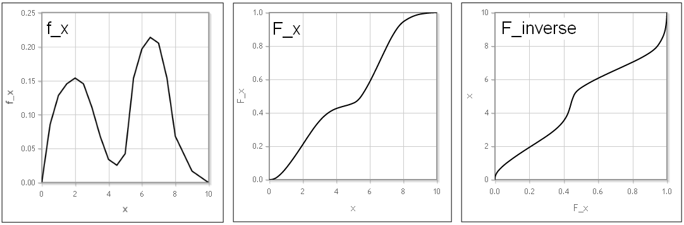
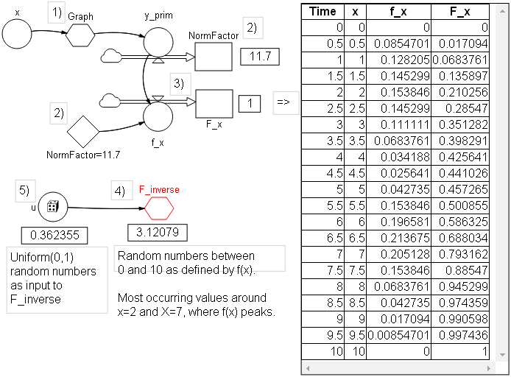
Use a sufficiently short time steps and be accurate when creating the tables.

Figure 10.6. The creation process of an Empirical random number generator.

11. Macros

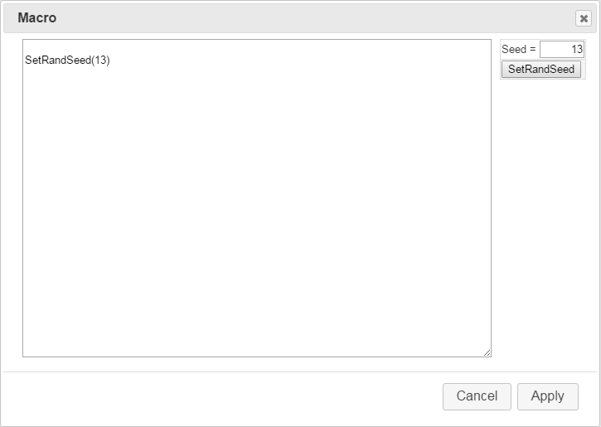A Macro allows you to define model code that can be included in the model. Click the Macros menu to open a form to write the code.

Figure 11.1. The Macro form. To the right, you can easily make a stochastic simulation reproducible by selecting a Seed and click the button SetRandSeed. To unlock the Seed you must manually delete the SetRandSeed(Seed) statement.

Example 11.1 Making a stochastic simulation run reproducible
To make a stochastic simulation model reproducible, you have to lock the seed for the random number generators in the model. Then the same sequences of random numbers will be generated for each simulation run. Just click the Macros button, define the Seed and click the SetRandSeed button, or write e.g.:
SetRandSeed(13)

By changing the argument, you will get another (reproducible) simulation run.

To unlock the Seed you must manually delete the SetRandSeed(Seed) statement.

Note: You don’t find SetRandSeed(Seed), where Seed is a number, in the Function lists of the primitives, because this function does not belong to any primitive but is a global function of the model. Instead SetRandSeed(Seed) is defined in a macro by specifying the argument of the SetRandSeed function.

(The SetRandSeed(Seed) can also be set in the Simulation Settings menu and will then appear the macro.) 

A macro can be created in two forms (Example from the Insight Maker manual).

A single-line macro has the syntax: Myfcn <- functional expression.
myFcn(a, b, c) <- sin((a+b+c)/(a*b*c))

A multi-line macro has the syntax:
Function myFcn(a, b, c)
x <- (a+b+c)
y <- (a*b*c)
return sin(x/y)
End Function

Macros can also be used to define an auxiliary or a parameter that will be available in the model.

Example 11.2 Defining a Poisson flow in a simplified way
In Section 10.4 we added PoFlow(lambda) as a simpler to write function for Poisson(Dt()*Lambda)/DT(). If this function had not been available, you could have introduced it as a macro:
PoFlow(Lambda) <- RandPoisson(Dt()*Lambda)/DT(). 

12. Practical tips
- Perhaps the most common trouble originates from confusion about the units used. In particular this applies to time. Therefore, StochSD will force you to define your one-and-only time unit to use in all equation of the actual model before you can start the model building. In a generic model showing the principles of e.g. exponential growth or the behaviour of a feedback loop you want to stay with e.g. ‘Time Units’ or ‘t.u.’. Also be careful with other unit used. This can be specified in plain text in the Model Window. For example: ‘Rabbits in 1000’s, Food in kg.’
- When you connect a Flow to a Stock, be sure that the connecting flow will be attached. The Cloud at the connected end will then disappear.
- Give each element a proper name. This will support your thinking and make it easier to communicate the model and its results to others.
- The arrow of a flow points in the positive direction. This means that when a flow has a positive value it goes in the direction of the arrow, and when its value is negative it goes in the opposite direction. For example, the direction of the flow [Flow]=Sin(T()) will alternate over time.
- A Flow should preferably only be drawn in x- and y-directions (although it can get other directions if it first applied to Stock in each end and you move the Stock). However, you can break the flow in right angles by clicking the right mouse button while drawing the flow. This is particularly useful when you have several flows between stocks.
- A link is represented by a so-called Bézier-curve that can be bent into a smooth curve. You can use this of aesthetic reasons – for example, you don’t want to cross over other symbols. To do so, click on the link and use its handles to form the link.
- Sometimes the displayed model will suffer from links crossing the model because the elements to be connected are far away. In such a case you may create a ‘Ghost’ of an element at a proper place and draw a link from this ghost instead. (Remember that a Ghost can only have outgoing links and no flows.) To use a ghost, mark the element you want to ghost before clicking the Ghost button.
- An undefined primitive (no formula in the definition field), or that all links are not used in the formula, or an unlinked primitive is used in the formula will cause a question mark ‘?’ in the primitive. However, the absence of a question mark does not guarantee that the formula is syntactically correct.
- If you have problem to open a Plot by double-clicking the left mouse button, you can always open it by (single) clicking the right mouse button.
- Also remember that the colour of an element will be used for the plot of this element in a Time Plot if you mark the ‘Colour from Primitive:’ box. Furthermore, remember that, Stocks will produce solid lines, Flows will produce dashed lines and the other elements will produce dotted lines.
- If the model becomes slow, open the Help menu and click Restart and Keep Model, and run the model again. (Some minor specifications that are not saved in StochSD in the Plots and Table are then set to default values and have to be respecified.)
13. References to deterministic modelling

[1] [ Forrester, J.W. (1961) Industrial Dynamics. Cambridge, MIT Press, MA. (The book where System Dynamics was introduced.)

[2] Meadows, D.H., and Wright D. (2008) Thinking in systems: a primer. White River Junction, Vt: Chelsea Green Pub. (An excellent first introduction to System Thinking and System Dynamics.)

[3] Fortmann-Roe, Scott. (2014) Insight Maker: A General-purpose tool for web-based modeling & simulation. Simulation Modelling Practice and Theory, 47, 28-45.
http://www.sciencedirect.com/science/article/pii/S1569190X14000513

[4] The Manual for Insight Maker. (Here you find more features (e.g. functions) that are supported but not described in StochSD. Note however that only the System Dynamics part of Insight Maker is supported in StochSD.)
https://insightmaker.com/book/export/html/40

[5] Home page for Insight Maker: https://insightmaker.com/

Part II. Stochastic modelling in StochSD

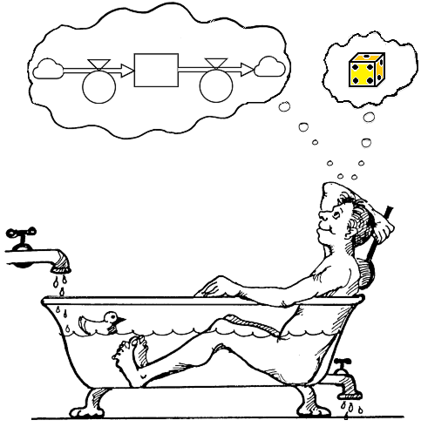
Extended purpose: To build dynamic and stochastic models and simulate their behaviours.

Extended worldview: The world consists of two kinds of fundamental elements: Stocks and Flows. However, lack of detailed information requires stochasticities to be included!

Stochastic modelling is an extension of deterministic modelling where you can handle the uncertainties in a statistically correct way. This extension has several important consequences:

- It makes Compartment Based Modelling (such as StochSD) consistent with other types of simulation.
- You can include uncertainties in a statistically correct way, rather than using average estimates in a deterministic model, to avoid biased results.
- With a stochastic model you can estimate variations in the results, and also calculate confidence intervals.
- A stochastic model will produce different results for each run that reflects the underlying uncertainties of the model’s behaviour. Therefore, many simulations of the model are required followed by a statistical analysis of the results. StochSD has a tool, StatRes, which does this.

14. Stochastic modelling

14.1 A historic note and the motivation for StochSD

Simulation languages on digital computers were introduced from around 1960. There are two main forms Discrete Event Simulation (DES) that is based on a micro approach where each individual or entity is to be represented and Continuous System Simulation (CSS) of which StochSD is an example. In this macro approach the individuals or entities are lumped into compartments (stocks). Only the number or amount in each compartment is then represented.

However, when modelling the same system under study, the results from a DES and a CSS model were often inconsistent (i.e. not contradiction-free). During the remaining of the 20ies century this has been an issue of concern and discussion.

In a series of papers between 2000 and 2017, see references [6] to [11], how to handle different types of stochasticity, methods for handling queues and how to achieve sojourn times from different distributions in CSS were presented. It was also demonstrated that following some rules for CSS modelling regarding these issues, CSS and DES models will produce consistent results.

It was even shown that different types of simulation (Agent-based, Entity-based, Compartment-based (i.e. CSS) and state-based (e.g. Markov) models) could all produce mutually consistent results. Furthermore, it was demonstrated how these types are related and how they can be translated into each other. Finally, the pros and cons of choosing one of these types instead of another were investigated.

Furthermore, the conditions for a deterministic CSS model to produce unbiased results were investigated [12].

Although, this knowledge can be applied using other CSS languages where proper random number generators are included, stochasticity will require multiple simulation runs followed by a statistical analysis. Therefore, different modelling devices were also created, see [13] to [16]. These tools (presented in Chapter 16) are now implemented in StochSD. Especially StatRes (see Section 16.3) is in practice necessary for analysing multiple runs of a stochastic model.

That StochSD is open source also gives the possibility to provide each student his or her own simulation software for free.

14.2 What is stochasticity?

Every modelling study must have a well-defined purpose. The art of modelling is based on only describing what is relevant for this purpose. However, in modelling you often have to deal with incomplete information.

Lack of information (uncertainty) can be handled in two ways:

1) You can ignore that you have incomplete information. For example, unknown variations are replaced by an average, and hope that not too much damage is done, and that no one will notice. For example, if there is a dice involved, the possible outcomes 1, 2, 3, 4, 5, or 6 are always replaced by the average value (3.5). This is a common, stupid and dishonest way to operate.

2) You can handle lack of information by at least including the information you have, often in form of a probability density (or distribution) function (pdf). Then random numbers can be drawn from this pdf to produce stochasticity in the model. For example, a dice is described by a probability distribution function that has equal probabilities for the outcomes 1, 2, 3, 4, 5, and 6. A random number is then used to decide the outcome for each throw. This is the correct way of handling incomplete information. Then the model includes the information you actually have!

14.3 Five types of uncertainty

Five types of uncertainty about a system under study have to be handled in the model building process. These are:
- Structural uncertainty – incomplete knowledge about the structure of the
system under study and about how the components
interact.

- Initial value uncertainty – incomplete information about the initial conditions
at ‘time zero’.

- Transition uncertainty – incomplete information about when an event will
happen (e.g. a customer arrives, a car will pass a
bridge, a person gets sick).

- Parameter uncertainty – incomplete information about the value of a
parameter or how it varies over time (e.g. when and
how much will it rain).

- Signal uncertainty – incomplete knowledge about transferred
information. A signal can be delayed or distorted.

Each of these uncertainties will affect the results of a model study. The more uncertain you are about structure, initial conditions, transitions, parameter values and signals, the more uncertain your results will become. A deterministic model would deny this fact!

While a deterministic model always will produce the same behaviour, while a stochastic model will produce a different behaviour for each replication (simulation run). Therefore, a stochastic model must be by executed a large number of times so that the uncertainty of the model behaviour can be studied by probability density/distribution functions of important outcomes. (Only if the important results of a deterministic model agree with those of a stochastic one, the deterministic model is consistent with the stochastic one. But event then, you will lose a lot of information about variations.)

One way to measure uncertainty in results is to use confidence intervals, which are easy to obtain by simulation. For example, a two-sided 95% confidence interval is estimated in the following way: Just run the model, say, 1000 times. Sort the 1000 outcomes of a quantity you are interested in. Remove the 25 (2.5%) lowest and the 25 highest replications. The remaining 950 replications will span a two-sided 95% confidence interval. (This extensive procedure is of course automatically achieved in StocSD when using the tool StatRes.)

14.4 Uncertainties in a model

A compartment-based model is constructed by stocks, flows, parameters (auxiliaries and parameters), and links. There can be uncertainty related to each of these (in addition to the uncertainty of the structure used for arranging the just mentioned elements).

We use an example to demonstrate how and where different types of stochasticity can enter in a model.

Example 14.1 A classical SIR model
A classical SIR model is an epidemic model composed of three stages: S (for Susceptible), I (for Infectious), and R (for Recovered). The following is assumed:
A Susceptible person has the probability p to become infected by an Infectious one at each time unit. Furthermore, an Infectious person will recover and become immune after on average T time units.

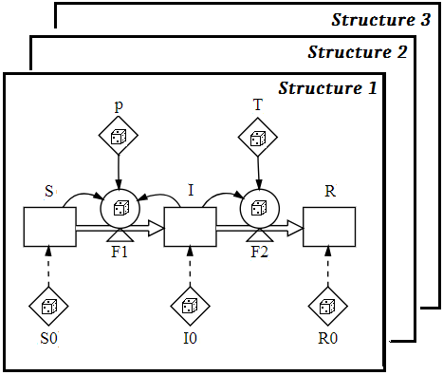
A classical SIR model, where each stage is represented by a single compartment, is shown in Figure 14.1. This (oversimplified) model is used to discuss the five types of uncertainty mentioned above.

Figure 14.1. A classical SIR model where the stages S, I and R are represented by single compartments. The stocks are initiated to S0, I0 and R0. The transition flows are denoted F1 and F2, and the parameters are denoted p and T. Dice show where randomness to describe uncertainty can be located.

The five possible types of uncertainty, Structural, Initial value, Transition, Parameter, and Signal uncertainties, will all be recognised for this example. The structural uncertainty affects how to describe the system under study in terms of an appropriate model structure of stocks, flows, parameters and links, while the other four uncertainties appear at different elements within the chosen model. Initial uncertainty relates to stocks, Transition uncertainty relates to flows, Parameter uncertainty relates to auxiliaries or parameters, and Signal uncertainty relates to (information) links.

1. Structural uncertainty
The description of the SIR model can be questioned. Especially, the time in the Infectious stage (the so-called sojourn time) is on average T time units. But some persons will recover sooner and other will require a longer time. By modelling the Infectious stage by a single compartment, we have implicitly assumed an exponential sojourn-time distribution. (Other assumptions about this distribution can be realised by using several compartments in parallel and/or series.)

Another structural possibility is that an infected person does not immediately become infectious. The exposed person may require a latent period before he enters the Infectious stage. This can be accomplished by including an Exposed (E) stage between the Susceptible and the Infectious stages (giving a so-called SEIR model).

A third possibility is that the Recovered (immune) persons loose their immunity after some time, which means that they return to the Susceptible stage (giving a so-called SIRS model).

Structural uncertainty is handled by exploring alternative models to find the one behaving most similar to the studied system.

2. Initial value uncertainty
The information about the number of persons in the three compartments at time zero may be approximate. Say that we know that the population in a village is N=1000 persons. Three persons from this village returns from a trip abroad bringing home a new disease, but we don’t know whether 1, 2 or all 3 of them were infectious. The initial value for the stock I(0) is then 1, 2 or 3 according to some probability distribution.

Example:
In a SIR model the initial number of Infectious (I) at time zero is
unknown. In 60% it is I(0)=1, in 30% it is I(0)=2 and in10% it is I(0)=3 infectious persons. Then you can draw a uniformly distributed random number between 0 and 1 and use this distribution to initialise the I-stage at time zero. (See If-Then-Else in Section 10.4.)

If Rand() < 0.6 Then
1
Else If Rand() < (0.6+0.3) Then
2
Else
3
End If
Because initial stochasticity only affects the model at time zero means that it will not be influenced by the choice of the time step DT.

3. Transition uncertainty
There is almost never enough information to decide the exact event times for transitions between stages. Therefore, transition uncertainties in the flows F1 and F2 must be included in the description of the flows, using available statistical information

Transition uncertainty is usually the most fundamental and important uncertainty. It is easy and straightforward to implement and it will change the nature of the model from continuous mass flows to transition of distinct individuals, which in turn can have a number of consequences (described in Section 14.6).

In a the SIR model in Figure 14.1, the Flows F1 and F2 in a deterministic model would have the forms: F1 := p⋅S⋅I and F2 := I/T. To more clearly see the randomisation when including transition stochasticity, we multiply both hand sides by DT.

Deterministic model Stochastic model
DT⋅F1 := DT⋅p⋅S⋅I ⎯→ DT⋅F1 := Po[DT⋅p⋅S⋅I]
DT⋅F2 := DT⋅I/T ⎯→ DT⋅F2 := Po[DT⋅I/T]
In StochSD DT⋅F1 & DT⋅F2 is not allowed to the left of the assignment sign (:=), why we have to divide both sides with DT, and follow the syntax od StochSD. Thus:
[F1] := RandPoisson(DT()*[p]*[S]*[I])/DT()
[F2] := RandPoisson(DT()*[I]/[T])/DT()
or shorter, using the PoFlow function (see Section 10.4):
[F1] := PoFlow([p]*[S]*[I])
[F2] := RandPoisson([I]/[T]).

DT⋅F is the expected number of transferred during a time-step DT. The Poisson Random Number Generator will always produce an integer number of transitions that on average amounts to DT⋅p⋅S⋅I or DT⋅I/T.

Thus if you start with integer numbers in the Stocks, and the transitions add or subtract integer numbers, then the Stocks will remain integers.

WARNING: In a deterministic case, you may add or subtract flow equations to or from a stock:

Say that Stock := DT⋅F1 + DT⋅F2 or Stock := DT⋅F1 - DT⋅F2 giving:
Stock := DT⋅F1 + DT⋅F2 = DT⋅SumFlow or
Stock := DT⋅(F1 - F2) = DT⋅NetFlow.

For the corresponding stochastic case this is only valid for addition: Thus:
Stock := Po[DT⋅F1] + Po[DT⋅F2] = Po[DT⋅SumFlow].

That addition is valid and the fact that the Poisson distribution has the unique property that Po[DT⋅argument] has the same distribution as Po[½DT⋅argument] + Po[½DT⋅argument] means that it is allowed to change the time step DT without harming the validity of transition stochasticity.

However, subtraction is not valid in the stochastic case. Here you cannot subtract the arguments. You must then stay with two Poisson terms:
Stock := Po[DT⋅F1] – Po[DT⋅F2]. Stock := Po[DT⋅F1 – DT⋅F2] IS WRONG!
An argument for this is: Say that DT⋅F1=3 and DT⋅F2=2 (so that DT⋅F1 – DT⋅F2 =1), then Po[1] ≥ 0, but Po[3] may be 1 and Po[2] may be 3 by chance, implying Po[3] –Po[2] to be 1-3=-2, while PO[3-2] = Po[1] can never be negative.

4. Parameter uncertainty
Unexplained irregularly varying values of the parameters p and T should often be described in statistical terms to generate realistic inputs. In this case there is no given form to describe this uncertainty. Only statistical knowledge about the parameter variations can guide you here.

A problem with parameter stochasticity is that its influence will change with the size of the time step DT. If you reduce DT, more random numbers with be drawn per time unit. The effect of this is smoothing because of the law of large numbers.

One way of handle this problem is to pulse the changes of the parameter (using Pulse(Start, Volume, Repeat) in Section 10.1). This allows DT to be equal to or less than the time distance (Repeat) between pulses.

5. Signal uncertainty

Before we discuss signal uncertainty we have to clarify that information links in a model can be of two different types:

- Artificial link – a technical concept to communicate logic between artificially separated model parts. For example when a radioactive atom decays, there is one radioactive atom less in the system under study. In a compartment-based model this is accomplished by a construction of a stock and an outflow. An artificial link from the stock to the valve regulating the outflow has here to be included. Its only function is to transfer information about the content (value) of the stock to the flow equation. There is no counterpart to such a link in the real system under study, and no uncertainty or delay can be involved.
- Signal link – a description of a real information link that communicates information in the system under study. This communicated information we call ‘signal’. A signal can be distorted and/or delayed.

In this example there are no signals. However, we could assume that there is a responsible authority for epidemics that collects information about the number of Infectious persons (which takes time and is never exact). This authority may issues recommendations about avoiding contacts and to use sanitary measures, which may affect the infection rate, F1, when the message later on is received by some fraction of the population.

Signals require time to reach the receiver that may vary in an unpredictable way. (The information may be sent by post, it may arrive during the weekend but noticed first on the following Monday, etc.), and the information may be distorted because of various reasons (imperfect information, typing error, distortion of the signal, misinterpretation, not reaching all subjects, etc.).

The length of a delay can be generated by drawing a random number from a proper distribution and the distortion may be treated as stochastic parameter for the information about the number of Infectious. In this way, uncertainty about signals can be handled.

Initial uncertainty, Transition uncertainty, Parameter uncertainty and Signal uncertainty are all treated in a similar way. First you describe the uncertainty by a statistical distribution. Then you draw a random number from this distribution. 

14.5 What can happen if you ignore stochasticity?

There is a widespread misconception that you should ignore information you don’t know exactly and e.g. replace it with an average value, ending up with a deterministic model. This is a stupid, dishonest and dangerous attitude that often leads to biased results, exclusion of phenomena, erroneous conclusions and no insight in the precision of the estimates.

A dynamic and stochastic model should be based on all relevant information – even though this information may not be complete!

When a population system under study is modelled as a deterministic population model, various types of distortions may occur. For example:

- Information about irregular variations, risks, extremes and correlations are eliminated.
- The possibility to calculate confidence intervals, etc. is lost.
- The elimination of transition stochasticity may introduce a bias behaviour and result in biased estimates.
- Important phenomena, such as extinction of a population or elimination of an epidemic, which can happen in the system at study and is reflected in stochastic modelling, will be lost.
- A deterministic model produces categorical answers, e.g. that a force X will win over a force Y, whereas a stochastic model will give the probabilities of X and Y as winners.
- Oscillations might disappear in a deterministic model although they should be excited by transition stochasticity.
- In a deterministic model, the lack of transition stochasticity may erroneously prevent queues from building up.
- The time until a specific event occurs should vary between replications in a stochastic population model, but will be the same in a deterministic one. A deterministic model may introduce bias in the estimates. For example, in a deterministic model the time to all radioactivity is decayed will erroneously become infinitely long, even when it should be finite and short.

In short, using a deterministic population model will also mean that we only are aiming for average estimates – loosing all insight in variations and extreme behaviours. Unless this average will equal the average value obtained by a corresponding discrete and stochastic model, the use of a deterministic model will produce biased results and prevent interesting phenomena to be displayed.

14.6 A warning example – Comparing the results from a deterministic and a stochastic SIR model

Assume the following for the classical SIR model, presented in Example 4.1 in Section 14.4 above. The initial population N=S+I+R consists of 1000 susceptible persons, a single infectious person and no recovered persons. The infection risk parameter is p=0.0003 per person and time unit and the sojourn time in the infectious stage is T=4 time units.

10 000 replications of the (transition) stochastic SIR model to study the cumulated number of susceptible individuals being infected, give an ensemble of results with the average value of 53.1 persons that got the disease [95% confidence interval: 50.8 – 55.5 persons]. However, the corresponding deterministic model produces 318.5 persons getting the disease. An error of about 500 percent was introduced by dropping the transition stochasticity.

The reason why the deterministic model distorts the results is because the initial infectious subpopulation I(0)=1 is small. There is then a large chance that the single infectious person will recover before infecting another susceptible, so that no epidemic will occur.

14.7 Making a stochastic model reproducible

Making a stochastic model reproducible may seem to be a contradiction. However, this is a legitimate technique that has many advantages in certain situations. The background is that stochasticity is generated by random number generators (RNGs), where each RNG produces a sequence of random numbers of a specified statistical distribution. A RNG generates a very long sequence of random numbers that have virtually all the statistical properties of the specified statistical distribution. When the sequence finally ends (which will not happen in your practice) it starts over and repeats the cycle. When you define a Seed you tell where in the cycle to start, which gives you the opportunity to exactly repeat your simulation. The Seed set in StochSD is a ‘superseed’ that controls all the seeds for the different RNGs and makes it easier for you.

Reproducibility can be used in the following cases:
- You want to demonstrate a particularly interesting or illustrative replication.
- You want to reconstruct a simulation run because something of particular interest happened, e.g. a species died out, or a water dam was destroyed because of overflow of water and you want to understand why.
- You want to compare two choices under similar conditions. Say that you choose between two crops that react different to temperature and precipitation. Then you will try to eliminate that your results depends on different amounts of heat and precipitation. You still want to make many simulations with stochastic weather, but for each simulation with Crop1 you want to make one with Crop2 with the same weather. This is called variance reduction using common random numbers.
Anther example is the design of a queuing system with several stations. The
different designs should preferably be compared under the same (stochastic) sequences of arriving customers.

To make a stochastic simulation model reproducible, you have to lock the seed for the random number generators in the model. Just click the Macros button, define a Seed and click the SetRandSeed button, or write e.g.: SetRandSeed(17) in the definition field of the macro. By changing the argument, you will get another (reproducible) simulation run. See Section 11.

To unlock the Seed you must manually delete the SetRandSeed(Seed) statement.

15. A stochastic StochSD model

Example 15.1. Radioactive decay
A specimen contains N=60 radioactive atoms will decay with a time constant T=10 minutes is studied during 30 minutes.

A model can be mathematically described by the equations:

N(t+DT) = N(t) - DT⋅F(t) (where N(0) = 60)
F(t) = Po[DT⋅N(t)/T]/DT (In a deterministic model: F(t) = N(t)/T.)

Po[.] stands for a Poisson distributed random sample.

A StochSD model and a replication are shown below.
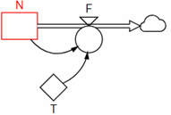
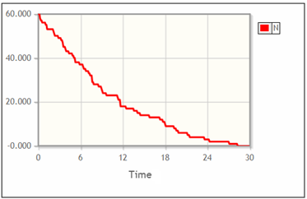
Model equations
N: 60
T: 10
F: RandPoisson(DT()*[N]/[T])/DT()
Alternatively:
F: PoFlow([N]/[T])

Figure 15.1. A stochastic model of radioactive decay and a possible outcome.

Note that the definition of the Flow [F] as ’RandPoisson(DT()*[N]/[T])/DT()’ can be simplified by using the function PoFlow as: ’PoFlow([N]/[T])’.

Note that in this stochastic model, there might be no radioactive atoms left after half an hour, while a corresponding deterministic model will never reach zero radioactive atoms. 

Of the same reason a stochastic SIR model can reach zero infectious persons and the epidemic is over (unless more infectious persons are imported). However, a corresponding deterministic model only asymptotically approaches zero why a new epidemic may arise after a long while.

Further, in a stochastic ecological model a species can get extinct, while in a deterministic model it can recover from a tiny fraction of an animal.
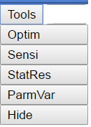
16. Tools in StochSD

StochSD contains four tools:, Optim, Sensi, StatRes and ParmVar (for Optimisation, Sensitivity analysis, Statistical analysis & result presentation, and Parameter estimation variations). These tools are found in the Tools menu. The selected tool will show up in a separate window to the right on the screen, and it works on the model displayed in the Model window. Each of these four tools also has its own documentation. Here we only indicate what they are used for. Figure 16.1. The
Tools menu.

16.1. The Optim tool

Optim (Optimisation) is a simplex optimiser for finding the optimum (maximum or minimum) of an objective function defined in a deterministic model with respect to a number of model parameters.

An optimiser has two main purposes in a deterministic model. First, an optimiser can be used to find the optimal strategy for a model, e.g. minimise costs or maximise benefits. To do this, an objective function is defined in the model. This function depends on some model parameters. When the objective function and the parameters are specified, the optimiser can systematically vary the values of the specified parameters to find the optimal set of parameter values.

Second, it can be used for parameter estimation. Then you construct a function that measures the difference between the system’s and model’s behaviours. This function is then minimised with respect to a set of parameters. The set of parameter estimates obtained are those which produce the model behaviour that best reproduces the behaviour of the system under study. Parameter estimation is often a necessary part of the construction of a model.

Optimisation is easy to perform a on deterministic model – and much trickier on a stochastic one.

The simplex optimiser is reasonable fast and has the advantage that you easy can include boundaries in the parameter space. For more information, see the Optim manual [13].

16.2. The Sensi tool

Sensi (Sensitivity Analysis) is a tool for sensitivity analysis. With this tool you can study the effect on an outcome from changing a parameter or initial value. For example you may study how the price of a commodity will affect the revenue of a company. For more information, see the Sensi manual [14].

16.3. The StatRes tool

The price to pay for using a stochastic simulation model, is that many replications are required, which must be followed by a statistical analysis.

StatRes (Statistical Results) orders StochRes to run a model a specified number of times. Then a statistical analysis of specified quantities (Stocks, Flows or Auxiliaries) is performed. The Average, Standard deviation, Min, Max, and Percentiles for the performed number of replications are presented for each specified quantity. You can also present the quantities from the replications in a tabular form, or as a histogram. Further you can plot two outcomes in an XY-Plot and also obtain an estimate of the correlation between the two quantities. For more information, see the StatRes manual [15].

16.4. The ParmVar tool

ParmVar (Parameter Variations) is a tool for assessing the accuracy of previously estimated parameters. After parameter estimation (with e.g. Optim) an important question remains: How accurately are the set of parameters values estimated? This question can be addressed with ParmVar.

Parameter estimation is tricky to perform on a stochastic model. It requires a large number of replication for each tested set of parameter values (as compared to a single replication in the deterministic case). However, for two important classes of models the expected outcome from a stochastic model is the same as the outcome from a corresponding deterministic one. Then you can find the optimal set of parameter values with Optim.

This is a more advanced tool that usually will not be used in an introductory course. For more information, see the ParmVar manual [16].

16.5. Hiding the tool

The Hide option hides a displayed tool and lets the Model window occupy the whole width of the screen.

17. References to stochastic CSS modelling

[6] Gustafsson, L. (2000) Poisson Simulation – A Method for Generating Stochastic Variations in Continuous System Simulation. Simulation, 74, 264-274. http://dx.doi.org/10.1177/00375497000740050

[7] Gustafsson, L. (2003) Poisson Simulation as an Extension of Continuous System Simulation for the Modeling of Queuing Systems. Simulation, 79, 528-541. http://dx.doi.org/10.1177/003759703040234

[8] Gustafsson, L. and Sternad, M. (2007) Bringing Consistency to Simulation of Population Models-Poisson Simulation as a Bridge between Micro and Macro Simulation. Mathematical Biosciences, 209, 361-385.
http://dx.doi.org/10.1016/j.mbs.2007.02.004

[9] Gustafsson, L. and Sternad, M. (2010) Consistent Micro, Macro and State-Based Modelling. Mathematical Biosciences, 225, 94-107. http://dx.doi.org/10.1016/j.mbs.2010.02.003

[10] Gustafsson, L. and Sternad, M. (2013) When Can a Deterministic Model of a Population System Reveal What Will Happen on Average? Mathematical Biosciences, 243, 28-45. http://dx.doi.org/10.1016/j.mbs.2013.01.006

[11]
Gustafsson, L. and Sternad, M. (2016), A guide to population modelling for simulation. OJMSi, 4, 55-92. http://file.scirp.org/pdf/OJMSi_2016042717425486.pdf

[12] ]
Gustafsson, L., Sternad, M. and Gustafsson E. (2017), The full potential of Continuous System Simulation modelling, (2017) OJMSi, 5, 253-299. http://www.scirp.org/JOURNAL/PaperInformation.aspx?PaperID=80104

[13] Gustafsson, L., and Gustafsson E. (2018) Optim – An optimiser for deterministic StochSD models. https://stochsd.sourceforge.io/homepage/docs/Optim.pdf

[14] Gustafsson, L., and Gustafsson E. (2018) Sensi – A sensitivity analyser for StochSD models. https://stochsd.sourceforge.io/homepage/docs/Sensi.pdf

[15] Gustafsson, L., and Gustafsson E. (2018) StatRes – A tool for statistical analysis of stochastic StochSD models. https://stochsd.sourceforge.io/homepage/docs/StatRes.pdf

[16] Gustafsson, L., and Gustafsson E. (2018) ParmVar – A tool for studying the variation of parameter estimates in StochSD models. https://stochsd.sourceforge.io/homepage/docs/ParmVar.pdf

Appendix A. Installation of StochSD

StochSD is available in two versions: StochSD Desktop and StochSD Web.

A.1 StochSD Desktop

System requirements
StochSD Desktop can be used under the operative systems Windows, Mac OS X or GNU/Linux.

Installation instructions
The Desktop version is downloaded from StochSD’s homepage and runs as a normal program. Download it from StochSD’s home page: https://stochsd.sourceforge.io/homepage

Find the StochSD.zip file and unzip it into a folder of your choice on your computer.

A.2 StochSD Web

System requirements
StochSD Web can be used under any operative system that can run a modern web browser. We recommend Mozilla Firefox and Google Chrome. (StochSD does not work on Internet Explorer.)

Running instructions:
Go to https://stochsd.sourceforge.io/software in Firefox or Google Chrome.

Appendix B. About License and Responsibility

B1. About License

Copyright StochSD version 190901

StochSD is based on the open source part of Insight Maker. StochSD’s source code (including the open source part of Insight Maker) is released under a custom license called Insight Maker Public License, which is based on the Affero GPL. Insight Maker’s Public License is available at: https://insightmaker.com/impl.

However, the graphic package of Insight Maker is replaced to make StochSD open for use as well as modifications and extensions. The file handling system is also rewritten. Finally, tools for optimisation, sensitivity analysis and statistical analysis are supplemented.
Third party libraries

Insight Maker Public License thus covers all StochSD’s JavaScript, HTML and CSS (Cascading Style Sheets) code. The original non-open source code in Insight Maker, such as ExtJS and mxGraph are completely eliminated and replaced by jquery-ui and jqPlot in StochSD. StochSD also uses NW.js and jStat, both of which use the MIT-license.

The licences are found under Help→About in StochSD.

B2. Responsibility

The user is fully responsible for the use of StochSD. The producer and the supplier of this code take no responsibility for the use or functioning of StochSD and its tools.

Insight Maker is a simulation package developed by Scot Fortmann-Roe. We have taken the open System Dynamics part: simulation engine, function library, error detection facility, macro facility etc. from Insight Maker. However, the non-open parts based on mxGraph (for model flowchart and result diagrams) and Ext JS (for the modelling window and buttons etc.) have been replaced in order to make StochSD completely open. Furthermore, the file handling has been rewritten. Finally, we have made some modifications to conform to the System Dynamics conventions. (Insight Maker is available at: http://InsightMaker.com.)
In different System Dynamics languages, the Auxiliary and the Parameter are defined a little different. In some  is restricted to a constant value, in some the  changes it shape to  when it holds a function or is dependent of other quantities, and in some there is just one common symbol for Auxiliaries and Parameters.

