Find node id HTML-DOM and use get_object(id) function to get Visual object
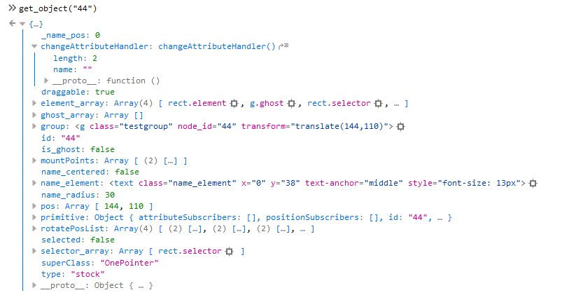
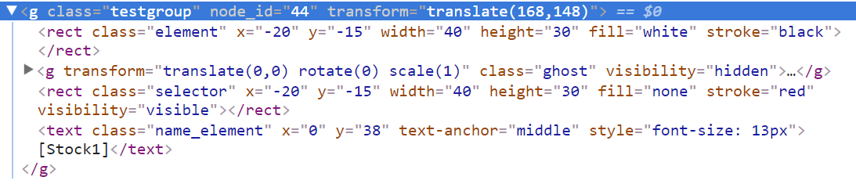
OBS: Only works in opensystemdynamics/index.html

