PAGE 1 — HOME

HERO SECTION (Above the Fold)
📷 Hero Banner — Financial Freedom Journey  Concept:  A confident Indian family (parents + one child) standing on a hilltop at sunrise, looking at a glowing city skyline on the horizon. Visual metaphor for 'journey to financial independence.' Warm sunrise tones (#FFD580) blending into Stockstrail brand green. Clean, aspirational, stock-photo style.  Alt Tag:  Indian family standing on hilltop at sunrise representing journey to financial freedom with Stockstrail  SEO Filename:  stockstrail-home-hero-financial-freedom-journey-india.webp | 📷 Abstract Growth Chart Illustration  Concept:  A minimalist flat-design illustration of an upward-trending chart with rupee symbols (₹) rising along the curve. Soft gradient green background. Icons of SIP, FD, and Mutual Fund float around the chart. Suitable for a clean hero background or side visual.  Alt Tag:  Abstract upward trending investment growth chart with rupee symbols for Stockstrail homepage  SEO Filename:  stockstrail-home-funds-comparison-investors-india

PAGE 2 — SERVICES
MUTUAL FUNDS
📷 SIP Jar / Piggy Bank Growth  Concept:  A glass jar filled with gold coins that gradually becomes a growing plant. Each coin is labeled '₹500 SIP'. The plant grows into a money tree with rupee leaves. Flat-design illustration on a white/light green background. Conveys: 'Small amounts grow big.'  Alt Tag:  SIP monthly investment of Rs 500 growing into wealth tree symbolising mutual fund returns in India  SEO Filename:  stockstrail-services-sip-investment-growth-jar-india.webp | 📷 Portfolio Diversification Pie Chart  Concept:  A clean, colourful pie chart divided into Equity, Debt, and Gold segments, each labelled. Surrounding the chart are small icons: stocks ticker, building (real estate), gold bar, and mutual fund document. Flat-design infographic style on white background.  Alt Tag:  Mutual fund portfolio diversification across equity debt and gold asset classes at Stockstrail  SEO Filename:  stockstrail-services-mutual-fund-portfolio-diversification-chart.webp


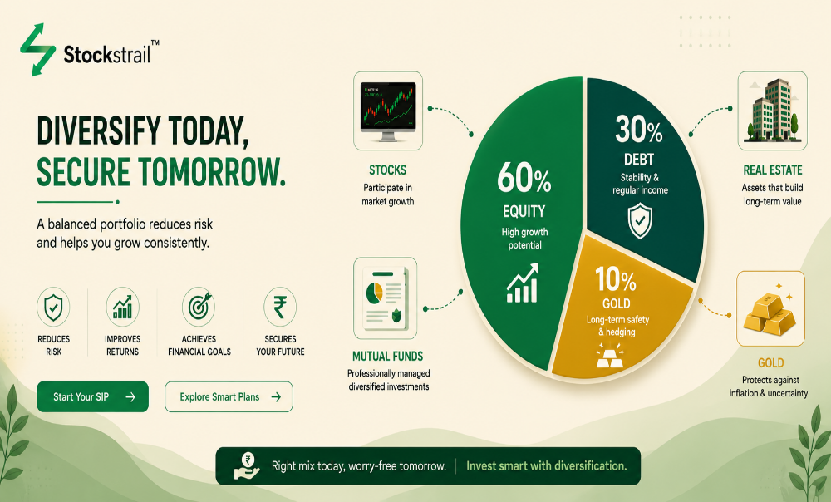

FIXED DEPOSIT
📷 FD Lock & Key — Security Visual  Concept:  A golden padlock sitting on stacks of coins with a green shield icon overlay. Text watermark: '7.5% p.a. Guaranteed.' Background: subtle graph pattern. Communicates safety and guaranteed returns.  Alt Tag:  Fixed deposit secure guaranteed returns 7.5 percent per annum with Stockstrail India  SEO Filename:  stockstrail-services-fixed-deposit-guaranteed-returns-india.webp | 📷 FD Tenure Timeline  Concept:  A horizontal timeline ribbon from '7 Days' to '10 Years' with milestone markers. At each milestone, the deposited rupee amount visually grows larger. Clean infographic style with brand green color. Shows flexible tenure options.  Alt Tag:  Fixed deposit tenure options from 7 days to 10 years flexible investment timeline at Stockstrail  SEO Filename:  stockstrail-services-fd-tenure-flexible-timeline-india.webp

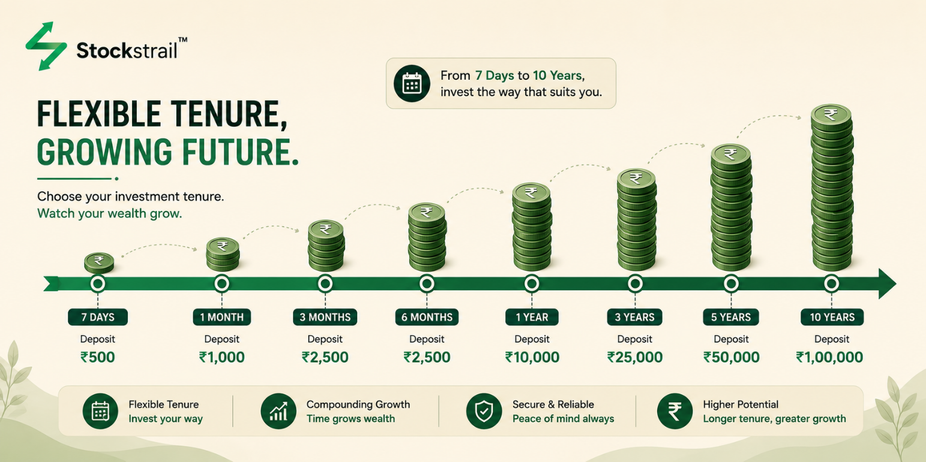

INSURANCE
📷 Family Protection Shield  Concept:  An Indian family of four (parents and two children) standing inside a glowing green shield. Soft bokeh background with a warm sunset. Symbolises comprehensive life and health coverage. Clean, emotional, brand-aligned.  Alt Tag:  Indian family protected under comprehensive life and health insurance coverage with Stockstrail  SEO Filename:  stockstrail-services-insurance-family-protection-shield-india.webp | 📷 Health Insurance Card Visual  Concept:  A stylised health insurance card (like a credit card) with a green cross, heartbeat line, and 'Stockstrail' branding. Surrounded by medical icons (stethoscope, pills, hospital). Flat-design, clean white background.  Alt Tag:  Health insurance plan card for families and individuals offered by Stockstrail India  SEO Filename:  stockstrail-services-health-insurance-card-india.webp




LOANS
📷 Quick Loan Approval Handshake  Concept:  A businessman and banker shaking hands across a table with a 'APPROVED' stamp in the foreground. Minimalist document icons (home, car, briefcase) float around the handshake. Clean, professional, trust-building.  Alt Tag:  Quick loan approval for home personal and business loans with minimal documentation at Stockstrail  SEO Filename:  stockstrail-services-loan-approval-handshake-india.webp | 📷 EMI Breakdown Calculator Visual  Concept:  An isometric illustration of a calculator with EMI breakdown numbers on its screen. Icons of a house, car, and briefcase sit above it connected by dotted lines. Brand green and white palette.  Alt Tag:  Loan EMI breakdown calculator for home personal and business loans at Stockstrail India  SEO Filename:  stockstrail-services-emi-calculator-loan-types-india.webp



DEMAT ACCOUNT
📷 Stock Market Trading Screen  Concept:  A laptop screen displaying a real-time stock trading dashboard with green upward candles and market ticker. An Indian hand rests on a mouse beside the laptop. Clean desk setup. Communicates: 'Your gateway to the stock market.'  Alt Tag:  Demat account stock trading dashboard for buying and selling shares with Stockstrail India  SEO Filename:  stockstrail-services-demat-account-stock-trading-india.webp | 📷 Paperless Digital Onboarding  Concept:  A smartphone showing a 'Account Opened Successfully ✅' screen on a mutual fund app. Confetti falling. A green checkmark tick. 'Zero paperwork, 100% digital' label. Modern, app-style flat illustration.  Alt Tag:  100 percent paperless demat account opening process digital onboarding with Stockstrail India  SEO Filename:  stockstrail-services-demat-paperless-digital-account-opening.webp


PAGE 3 — ABOUT US
OUR STORY / PHILOSOPHY SECTION
📷 Clarity & Transparency Visual  Concept:  A magnifying glass hovering over a document labelled 'Financial Plan' with all jargon crossed out and replaced with simple words. Clean flat-design on white background. Green accent color. Symbolises 'clarity over complexity' — Stockstrail's core promise.  Alt Tag:  Simple transparent financial planning document showing clarity over financial jargon at Stockstrail  SEO Filename:  stockstrail-about-transparent-financial-planning-clarity-india.webp | 📷 Long-Term Partnership Road  Concept:  A winding road stretching into the distance lined with financial milestones: 'First SIP', '1 Lakh Portfolio', 'Dream Home', 'Retirement'. The road is green and lush. A small figure walks confidently along it. Represents Stockstrail's long-term partner philosophy.  Alt Tag:  Long-term financial planning journey roadmap showing SIP milestones retirement and wealth goals at Stockstrail  SEO Filename:  stockstrail-about-longterm-financial-journey-roadmap-india.webp

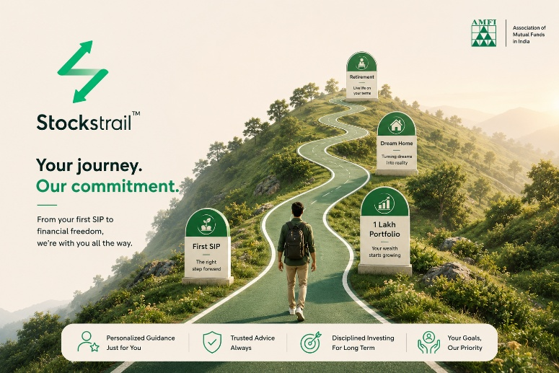
PAGE 4 — BLOG

BLOG LISTING PAGE Hero Section Image
📷 Blog Hero — Education & Insights Banner
Concept:
A flat-design banner showing an open book with financial icons emerging from its pages: mutual fund logos, SIP graph, insurance shield, FD calculator. Text overlay reads 'Financial Insights' in Stockstrail brand green. Clean, editorial style, suitable as a blog section header.
Alt Tag:
Stockstrail financial blog with investment insights on mutual funds SIP insurance and tax planning India
SEO Filename:
stockstrail-blog-financial-insights-banner-india.webp

PAGE 5 — CALCULATORS OVERVIEW

CALCULATOR HUB PAGE
📷 Investor Using Calculator on Phone
Concept:
An Indian person (25–35 years, professional) using a financial calculator app on their smartphone. A growth chart is visible on screen. Soft natural light. A notebook with investment goals is visible on the desk beside them.
Alt Tag:
Indian investor using Stockstrail online financial calculator on smartphone for SIP and FD planning
SEO Filename:
stockstrail-calculators-investor-using-phone-calculator.webp


