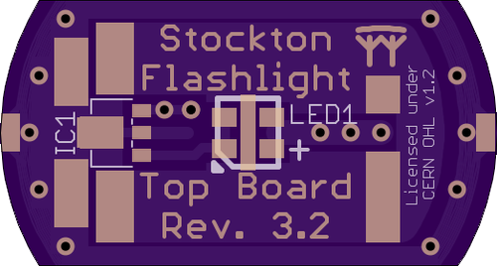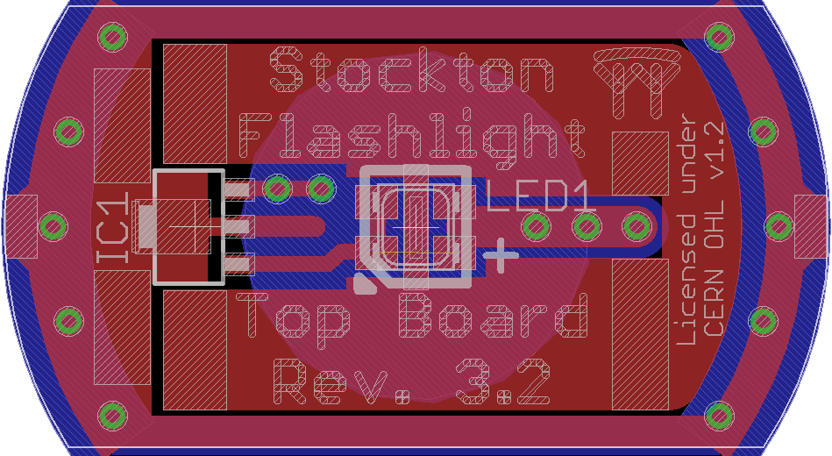

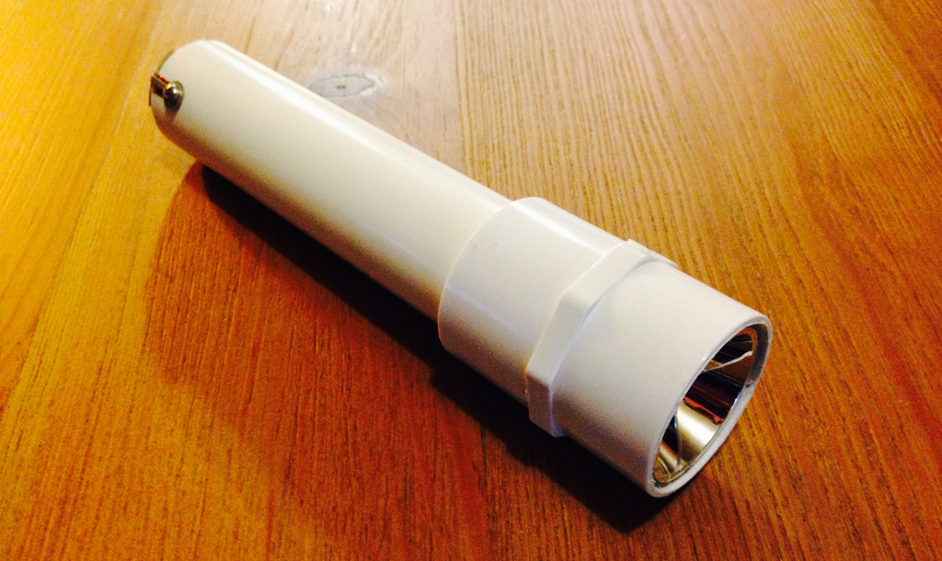

Chris Luke

Revision 3.2

Stockton Flashlight

Build Instructions

This document contains the build instructions for the Stockton Flashlight.

These instructions are intended for Revision 3.2 of the flashlight kit. The latest version of this documentation and of the Flashlight project is available at <https://github.com/stockton-flashlight/flashlight> or <https://git.flirble.org/flashlight/flashlight>.

Copyright © 2015 Chris Luke.

This project is licensed with the CERN Open Hardware License v1.2.

You may redistribute and modify this documentation under the terms of the

CERN OHL v.1.2. (<http://ohwr.org/cernohl>). This documentation is distributed

WITHOUT ANY EXPRESS OR IMPLIED WARRANTY, INCLUDING OF

MERCHANTABILITY, SATISFACTORY QUALITY AND FITNESS FOR A

PARTICULAR PURPOSE. Please see the CERN OHL v.1.2 for applicable

Conditions.

**Contents**

Introduction 3

Design 3

Parts 4

Large plastic bag 4

Anti-static bag 4

Small plastic bag 4

Tools 4

Assembly 5

Building the components 5

Bottom board 5

Top board 6

Body 8

Combining the components 9

Attach the top board 9

Attach the bottom board 10

Reflector 10

Testing 10

Battery installation 10

Final assembly 11

Top-end coupler 11

Secure the reflector 11

Troubleshooting 13

General 13

Bottom board 13

Top board 13

Body 13

# Introduction

This project is intended to introduce some basic concepts from electronic and mechanical design. There is a small amount of soldering and a small amount of assembly the result of which is a working and powerful flashlight.

The design is not without flaws however, and deliberately so. As you build the flashlight you should pay attention to the steps and ask yourself how you might improve it.

# Design

The project is centered on using a length of 1 inch Schedule 40 PVC pipe which has the desirable characteristic of its internal diameter being just a little greater than the diameter of ordinary “C” cell batteries. As part of the design we settled on using a small printed circuit board at each end of the tube to hold components, to hold the batteries in place and to make electrical contact with the batteries.

The primary element of the flashlight is its light source and we have selected an extremely bright LED (*Cree® XLamp® ML-E*). Whilst ideally suited for use in a flashlight, LEDs require some consideration; they must be soldered to a circuit board, powerful LEDs generate lots of heat and LEDs require some type of current limited to prevent them from burning out.

To limit the current supplied to the LED we use an inexpensive 350mA current regulator (*ADDtek® AMC7135*) that can operate on an input voltage of up to 6V.

Since LEDs tend to have a wide light distribution angle and for a flashlight we need a more focused beam, we use a plastic reflector. The reflectors in this design are inexpensive plastic devices but are effective enough to provide very good value.

To hold the LED board and the reflector in place we use a simple 1 inch PVC coupler machined at one end with a large countersink tool to accept the reflector. Any such coupler will work but the female NPT coupler gives the flashlight a particularly rugged look. The positive (+) terminal of the batteries makes direct contact with the underside of the LED circuit board.

The other end of the flashlight has a copper spring soldered to a circuit board to make contact with the negative (-) terminal of the batteries. On the opposite side of this board there is a simple pushbutton toggle switch to turn the flashlight on and off.

To secure this board to the flashlight, and to enable removal to change batteries, two solder lugs are screwed to the side of the body and their ends soldered to the board.

To provide an electrical connection between the two boards we use self-adhesive copper tape which runs along the inside of the PVC tube. It makes contact with the LED board using plated pads on the underside of the board. The button board contacts the tape using, the solder lugs used to hold the board in place.

# Parts

## Large plastic bag

1. Flashlight body (150mm length of 1” Schedule 40 PVC tube)
2. Flashlight reflector coupler (1” Schedule 40 PVC coupler modified to hold the reflector)
3. Flashlight reflector (Plastic, 35mm or 40mm diameter)
4. Anti-static bag (see below)
5. Small plastic bag (see below)

## Anti-static bag

1. LED (High-brightness)
2. Current regulator (350ma)

## Small plastic bag

1. Top printed circuit board
2. Bottom printed circuit board
3. Two solder lugs
4. Two small screws
5. Two pieces of copper tape (~180mm long, adhesive-backed, ¼” wide)
6. Copper spring
7. Push-button switch

# Tools

* Soldering iron
* Solder
* Wire cutters
* Phillips screwdriver
* Long-nose pliers
* Tweezers
* Magnifying glass
* Silicone adhesive
* Mallet (or a hammer and small piece of wood)
* Flat file

[PICS OF ALL THE COMPONENTS, NUMBERED]

# Assembly

These instructions are divided into two groups. The first group builds the components of the flashlight and we recommend they be done in the order presented, but can be done in any order if necessary. The second group puts these components together and should be performed in the indicated order.

## Building the components

The printed circuit boards (PCBs) in this project are small purple boards that have a mixture of gold and white shapes and writing on them. The gold really is gold; the circuit board is made of fiberglass that has copper traces on its surface which form the circuits and this copper is then plated with a very thin layer of gold. Why gold? Because it tarnishes slower than copper does and makes soldering easier.

[PIC OF THE TWO PCBS]

The purple color comes from what is called a *solder mask*; this hides the copper/gold traces and exposes them only where we want to be able to solder to them. The exposed sections are often called *solder pads* – they’re where the solder goes. The gold writing is just using the solder mask to expose the gold underneath. Why purple? The company we use to make the boards happens to like it. Most PCBs in the world use green because it’s easier to manufacture with.

The white shapes are called the *silkscreen*, so named because it uses the same techniques as silkscreen printing to deposit ink onto the surface. PCBs commonly use the silkscreen to indicate where components go, which way round and to document other features.

### Bottom board

The bottom board hosts two components: A spring on one side and a push-button switch on the other.

[PIC OF PCB ON FILE]

Before soldering anything to the board, first cut off any tabs sticking out from the sides and file the edges of the board smooth. This is usually easiest by placing the flat file on the bench (if it has a handle, have the handle hang over the edge of the bench so the file stays flat) and, holding the PCB in one hand, rub it against the file. To file the curved ends a sweeping motion of the wrist may be necessary. You may also need to hold the file still with your other hand (or the help of a friend) if it’s prone to moving.

#### Attach the spring

The spring pushes against the batteries to ensure firm electrical contact with them.

It’s usually easier to install the spring first; it also helps if you have a friend who can use the pliers to hold the spring in place while you solder it.

[PIC OF SPRING SOLDERED TO BOARD]

The spring-side of the board is marked with the word “*SPRING*” and a star-like pattern in the exposed trace. The spring should be centered and soldered to the board at four or more points around its base.

#### Attach the button

The push-button switch turns on and off the electrical current that powers the flashlight.

The push-button switch goes on the other side of the board. This will be easier to do if you have something to rest the board on which has a hole in it that the spring can rest inside.

The button has two legs that protrude straight out from one side of the body. These need to be carefully bent to go straight down (the top of the button being the side that has the part you press). The legs should then be cut flush with the bottom of the button body.

[PIC OF ORIGINAL BUTTON][PIC OF BUTTON WITH LEGS FORMED]

Glue the button to the center of the board with the two legs aligning with the solder pads labeled *1* and *3*. Then solder the legs to these traces.

[PIC OF BUTTON ON BOARD]

Note that if you use silicone adhesive for this it takes some time to set; be careful when handling this board – you do not want to dislodge the button!

### Top board

The top board holds two components: The LED (Light Emitting Diode) and a current regulator. The LED is the part that produces the light and the regulator controls the electrical voltage to prevent the LED from burning out. These two components are sensitive and should be handled with care, usually only with the tweezers. These components are also very small; you may find it easier to install them using a magnifying glass.

The underside of the top board also acts as the contact with the positive (+) terminal of the batteries.

[PIC OF PCB FITTING INSIDE COUPLER]

Before soldering anything to the top board, first cut off any tabs sticking out from the sides and file the edges of the board smooth. The board needs to fit snugly, but not tightly, inside the PVC coupler; file the rounded ends of the board until you achieve that fit. This may take a while, but be patient and don’t try to rush it, you could damage the board.

#### Attach the LED

The LED is the component that produces light. LEDs are available in all sorts of shapes, sizes and colors and are some of the most efficient components available to turn electricity into light.

The LED has four legs that protrude ever so slightly near the corners of the case. The LED must be installed a specific way round: On the board the location is marked with the word “*LED1*” and the orientation is marked with a diagonal and a small triangle on one corner of the white outline; on the LED a similar shape is molded into one corner of the package which may be easier to see by rotating the component. It is important that the LED is installed the correct way round; it will not work if reversed.

[CLOSEUP OF LED; INDICATE ORIENTATION MARK][PIC OF LED UNDERSIDE]

The LED also has a pad across the center on its underside that is used to conduct heat away; The LED will become very hot during use and this allows it to dissipate much of that heat.

The footprint for the LED on the board has five exposed solder pads; four small pads for the LED legs and one oblong pad for the heat pad.

[PIC OF PCB; INDICATE LED LOCATION AND ORIENTATION MARK]

Techniques for hand-soldering this type of device vary, but one that often works for beginners is to pick one of the corner pads on the board and then apply some solder to it. Then pick up the component with tweezers and, whilst keeping the solder on the board molten, slide the component into place; once positioned, and being careful to ensure the component is flat on the board, remove the soldering iron. Try not to heat the LED for too long. If the component is not flat, melt the solder again and push gently on the top of the white case of the LED with tweezers; the yellow part of the LED is soft and may be easily damaged.

[PIC OF LED BEING SOLDERED]

Once the solder has cooled, proceed to solder the remaining legs to the board

Soldering the heat-dissipation pad is a little trickier, since it is under the LED package. To help with this the footprint on the board has been extended beyond the edge of the LED. Simply apply solder to this pad on each side of the LED; Feed in the solder fairly generously, allowing a bit of a blob to form. After a few seconds some of the molten solder will be drawn under the LED by capillary action; it may not seem like much but it is enough. Be careful not to keep the LED hot for much more than about five seconds or you may damage it.

#### Attach the regulator

This type of regulator controls the voltage supplied to the LED to maintain a constant current, in this case 350mA. Why 350mA? That is because the LED is designed to operate at that current continuously.

The regulator is a three-legged device with a large solder tab. The large solder tab is for heat dissipation. On the board its location is indicated by “*IC1*” where you should see solder pads for the three legs and one bigger pad for the tab.

[PIC OF REG BEING SOLDERED]

Similar to the LED, a reasonable technique for soldering the regulator to the board is to pick one leg, apply solder to its pad and then use tweezers to slide the component into place ensuring the device is flat against the board. Once set, solder the other two legs and the big solder tab.

#### Testing the top board

If a bench power supply is available you can use it to test the top board at this stage. Set the voltage output to about 4.5V (the regulator will function from about 3V up to 6V, but do not exceed this). If the PSU has a current limit you can set it to about 400mA.

With the top board pointing away from you or anyone else (because it is really bright, you don’t want to blind anyone!) touch the negative (-) terminal to one of the two outer pads on the underside of the board and the positive (+) terminal to the central circular pad. Be *very* careful not to get these backwards; doing so can destroy the regulator.

[PIC OF BOARD BEING HELD, WITH WIRES, ILLUMINATED]

The LED should illuminate. If it does not then skip ahead to the Troubleshooting section on page 13.

### Body

The body has two holes drilled into it on opposite sides of the tube; the end with the holes is the bottom end of the tube and of the flashlight.

[PIC OF BODY]

If for some reason your tube has two sets of holes, one pair at each end, you get to choose which end is the bottom.

#### Attach copper tape

The copper tape carries the negative (-) terminal of the batteries up to the light. There are two, on opposite sides of the tube, for reliability.

The tape runs along inside of tube, aligned with the screw holes. The tape has an adhesive backing that is exposed by removing the white backing material. It’s a good idea to keep the tape flat when removing the backing to reduce curling.

You want the tape to start just below the screw hole on the outside (you do not want to cover the hole but you do want it to be close), fold over the end of the tube, then run the length on the inside and finally fold over the lip at the top end. Trim the tape flush with the outside of the tube at the top end. Run your fingers along the length of the tape, inside and out, to ensure adhesion.

[PIC OF BOTTOM END OF TUBE WITH TAPE][PIC OF TOP END OF TUBE]

Repeat for the other side.

#### Attach solder lugs

There are two holes at the bottom end of the tube. These are to accept screws that hold solder lugs in place. These solder lugs will later attach to the bottom board.

First you must start the thread on the holes. The holes are drilled smaller than the screws so that a thread will form the first time you insert the screw; the screws are a kind that will cut their own thread into plastic. This can be difficult, though it may be easier if you have a friend who will hold the tube steady for you.

If the copper tape covers the holes you will need to either poke a hole in the tape (being careful not to damage the copper tape on the inside of the tube), or trim it to reveal the holes. Ideally you want the tape close to the holes but not covering it.

Whilst holding the tube, try to insert the threaded end of a screw into the hole with your fingers; it won’t go far, but should hold in place enough to being the screwdriver to it. Whilst applying a moderate amount of force, turn the screwdriver clockwise to start threading the screw into the hole.

[PIC OF THREADING THE HOLE][PIC OF SOLDER LUG SCREWED TO TUBE]

When the head of the screw gets close to the body be *very* careful not to over-tighten! This would strip the thread in the hole and make it useless. Stop at this point and remove the screw.

Repeat this exercise for the opposite side.

Once both holes are threaded, place a solder lug over each screw and then affix these to the body, again being very careful not to over–tighten the screws. Leave the screws loose for now, so that the solder lugs move freely.

## Combining the components

### Attach the top board

The PVC coupler has two distinct ends. One end has been machined to accept the reflector; this is obvious because the inside of this end is angled and may feel rough. The other end of the coupler holds the top board in place when fitted over the top end of the body.

Stand the body of the flashlight on the bench with the bottom-end down. Place the top end PCB on the top of the tube so that the copper tape, which should fold over the end of the tube, aligns with either side of the board. The LED should be up.

[PIC OF TOP BOARD RESTING ON END OF BODY; MAKE COPPER TAPE OBV]

Place the PVC coupler over the top of this, with the machined end up. The coupler may be tight in which case use a mallet (or a hammer and a piece of wood to even out the impact) to tap the coupler into place; do not hit the coupler too hard or you could damage the flashlight. If the coupler ends up being loose even after a tap from the mallet then, after testing the flashlight, you may need a spot of adhesive to keep it in place – see below.

[PICS OF COUPLER ON BODY; SIDE VIEW AND FROM END]

A tight fit is important to ensure a good connection between the top board and the two strips of copper tape – this is how the board connects the LED to the (-) end of the batteries! The PCB must be held firmly in place.

### Attach the bottom board

First tighten the screws just enough to restrain the solder lugs; you want the tabs parallel to the body and pointing towards the bottom; they should protrude past the bottom by about 5mm. Be very careful not to over-tighten the screws.

[PIC OF BOTTOM END WITH LUGS STRAIGHT UP]

Stand the body so that the bottom-end is up and place the bottom board on the end between the solder lugs. The button should be visible and the spring should be inside the tube. Center the board on the tube and note that there are solder pads on the board for the lugs. Carefully bend the lugs onto the pads on the board; you want them to lay as flat as possible onto the board and you may want to use pliers to do this. Then solder both lugs to the board when you’re happy you have everything centered nicely.

[PIC OF BOTTOM END WITH LUGS SOLDERED]

The solder joint must be a strong one; try to make sure the whole length of the lug that covers the solder pad is soldered down.

### Reflector

The reflectors’ job is to focus the light from the LED into a relatively narrow beam.

Check the fit of the reflector by inserting it into the machined end of the PVC coupler; the larger reflectors may protrude beyond the end but this is not important. What you are checking is whether the reflector reaches all the way to the LED. You should be able to position the reflector such that when you view it straight on the yellow part of the LED fills what you can see in the reflector. Try not to touch the inside of the reflector; finger prints are very hard to remove from it!

[PICS OF REFLECTOR IN PLACE; ANGLED AND END-ON]

It doesn’t matter if the reflector is loose inside the coupler; it’s only important that it reaches all the way to the LED and reflects the light from it.

Do not glue the reflector in yet; you should test and make absolutely sure the flashlight works first!

# Testing

### Battery installation

To test the flashlight we will need batteries. It takes three “C”-sized cells.

Undo the screws that hold the bottom board in place and insert three batteries into the tube. The correct polarity is with the positive (+) end of the batteries pointing toward the top end of the flashlight. It is *very* important that the batteries are inserted the correct way; reversing it can destroy the regulator on the top board!

The spring on the bottom board holds the batteries firmly in place; to re-attach the bottom board some force may need to be applied before the screw holes line up and you may need a friend to hold the board down to achieve it the first time.

If the flashlight comes on immediately as you reassemble it, great! That means the switch is already in the *on* position.

One you have screwed the bottom board in place, test the flashlight by operating the push-button switch several times. Remember to not look directly at the LED when lit, nor point it at anyone else. It’s very bright!

If it does not illuminate then skip ahead to the Troubleshooting section on page 13.

# Final assembly

### Top-end coupler

If the flashlight works and you discover the top-end coupler is a little loose then now is a good time to glue it in place; remove the batteries (so the spring doesn’t work against you) and the top end, place a small amount of adhesive on the outside of the pipe, near the end but away from the copper tape and then replace the top end coupler, ensuring the top board is where it needs to be.

[PIC OF BODY AND SMALL SPOTS OF GLUE WITH COUPLER NEARBY]

Use the mallet to ensure a tight fit between the board and the copper tape. Gently tap on the end of the coupler; hitting it too hard could damage the flashlight. The PCB needs to be held firmly in place and pushed against the folded end of the two strips of copper tape.

Use a rag or paper towel to wipe away any excess glue, if you used any.

### Secure the reflector

Once you are satisfied that the flashlight works reliably and you are happy with the fit of the reflector, place a couple of blobs of silicone adhesive on opposite sides of the machined part of the coupler and then insert the reflector with a slight twist to spread the adhesive. Align the reflector and then leave it alone!

Try not to touch the inside of the reflector, especially not with the adhesive! Finger prints and glue are very hard to remove from the reflector.

[PIC OF FLASHLIGHT WITH BLOBS OF GLUE AND THE APPROACHING REFLECTOR]

The adhesive will take some time to set, but it should hold it well enough. If the reflector is a little loose in the coupler then the high viscosity of the adhesive should hold it in place. If not, you may want to temporarily pad the space around the reflector with some scrap paper; though try not to get the paper stuck in the glue!

Make sure no adhesive gets on to the top board or the LED; this will make it difficult to repair the flashlight later if necessary and may even prevent it from working at all!

Use a rag or paper towel to wipe away any excess glue.

# Troubleshooting

It is possible that your flashlight does not work; but do not panic! Here’s a list of troubleshooting tips that may help identify the ailing components.

### General

* Verify the batteries are usable, either by measuring the voltage from them (expect a nominal 1.5V from fresh alkaline cells; anything down to 1V per cell should work) or by trying them in another device.

### Bottom board

* Make sure that the solder tabs that secure the bottom board are making contact with the copper tape.
* Visually inspect the soldering of the button; make sure the legs are secured to the two outer solder pads labelled *1* and *3*.
* Use a continuity tester to verify operation of the switch and connectivity between the spring and the solder lug when the switch is “*on*”.

### Top board

If you have assembled the top end of the flashlight, the top board is held in place by the coupler and you need to troubleshoot the top board you will have to disassemble the top end. If this is made difficult by a particularly tight coupler you may need to clamp the flashlight body, perhaps in a vise, and tap the underside of the coupler firmly with a mallet or a hammer.

* Visual inspection – check that things appear soldered properly
* Test reg – same as in blurb
* Test LED – resistance check
* Test LED – apply volts

### Body

If none of the above prove conclusive, the issue may be conductivity between the two boards via the copper tape.

This is most likely an issue between the tape and the top board.

* Check alignment of board to tape.
* Check tape is not damaged in the tube.
* Coupler may not have been on tight enough.