MAX Tracker

Matthew Stoecklein

CS449 Fall 2017

Revision History
Last User to make Changes | Date | Summary of Changes
Matthew | 09/04/2017 | Initial commit
Matthew | 09/12/2017 | Map working as a separate activity
Matthew | 09/21/2017 | Map switched to fragment of main activity
Matthew | 09/22/2017 | Route drawn on map
Matthew | 09/23/2017 | Stops and added to map
Matthew | 09/29/2017 | Functions for getting time added
Matthew | 10/07/2017 | Current location added with button to update

Table of Contents
Vision Statement 4
Requirements 5
Categories of Users 5
Actor-Goal List 5
User Stories 5
Product Backlog 7
Shalls 8
[Step #4: Write Use Cases] 8
Sprint #1 12
Review 12
Retrospective 14
Sprint #2 16
Review 16
Retrospective 17
Sprint #3 18
Review 18
Retrospective 18
Design 17
Coding Standards 18

Vision Statement

For smartphone users that frequently use the MAX bus line in Kansas City, and need quick access to route information, the MAX Tracker will let them view the route via map, locate stops, see when the next bus is coming, and receive notifications when it is close. Unlike other bus tracking apps such as Transit, this app is local to Kansas City and delivers more useful and accurate information about the MAX line.

Requirements

Categories of Users
Anyone with a smartphone that uses the MAX bus line and has enough knowledge to download phone applications.

Actor-Goal List
Actor | Goal
MAX Rider | View map
 | Locate stops
 | View current location
 | View arrival information
 | North and south routes
 | Receive notification of arrival
 | Receive push notifications

User Stories
As a rider, I want to see a map of the region that the MAX route operates in.
Estimated Effort: 4 Story Points
A MAX rider should be able to view a map of the KC region.

As a rider, I want to view the MAX route in relation to a map.
Estimated Effort: 4 Story Points
The MAX rider should be able to view entire MAX route via the map.

As a rider, I want to view stops on a map of the MAX route.
Estimated Effort: 4 Story Points
The MAX rider should be able to view the bus stops in relation to the map.

As a rider, I want to view my current location on a map in relation to the MAX route.
Estimated Effort: 8 Story Points
The user should see his or her location in context of the route on the map

As a rider, I want to know when the last bus is coming.
Estimated Effort: 2 Story Points
The MAX rider see when my next bus is coming, and how far away.

As a rider, I want contextual information about stops, such as intersections.
Estimated Effort: 2 Story Points
The MAX rider should be able to see contextual information about each stop, such as what intersection.

As a rider, I want to view arrival times.
Estimated Effort: 10 Story Points
The MAX rider should see the arrival times of the next coming bus.

As a rider, I want to be able to view northbound and southbound routes (UI)
Estimated Effort: 5 Story Points
The MAX rider should be able to switch which direction he or she is traveling.

As a rider, I want to be able to change current location if needed.
Estimated Effort: 6 Story Points
The MAX rider should be able to change the location that the arrival time is based on, if needed.

As a rider, I want to receive push notifications about coming buses
Estimated Effort: 6 Story Points
The MAX rider should be able to choose to receive push notifications, if the bus is near.

The map implements the riders location to show data about stops
Estimated Effort: 4 Story Points
The data about the location of the user decides which stop he or she is shown.

Product Backlog
Story ID | Story | Story Points | Priority | Status
1 | As a rider, I want to see a map of the region that the MAX route operates in. | 4 | 5 | Done
2 | As a rider, I want to view the MAX route in relation to a map. | 4 | 6 | Done
3 | As a rider, I want to view stops on a map of the MAX route. | 4 | 1 | Done
4 | As a rider, I want to view my current location on a map in relation to the MAX route. | 8 | 4 | Done
5 | As a rider, I want to know when the last bus is coming. | 2 | 10
6 | As a rider, I want contextual information about stops, such as intersections. | 2 | 8 | Done
7 | As a rider, I want to view arrival times. | 10 | 2
8 | As a rider, I want to be able to view northbound and southbound info (UI) | 5 | 7
9 | As a rider, I want to receive push notifications about coming buses | 6 | 9
10 | The map implements the rider’s location to show data about the stops | 4 | 3

Shalls
- The system shall automatically show arrival time based on location.
- The user shall be able to change current location, as needed.
- The user shall be given the choice to bring up the map at any time.
- The user shall be able to choose if they wish to receive push notifications.

[Step #4: Write Use Cases]
[Writing use cases this semester is option. Sometimes it’s helpful to define more detailed project requirements up front.]
Use cases describe how users will interact with the system. They are an excellent way of capturing detailed functional requirements. Use cases may be written at the beginning of the project or during the iteration in which the features they describe are implemented.
Example:
Title: | Find and subscribe to quizzes
Use case ID: | UC001
Actor: | Quiz Taker
Description: | This use case describes the system interactions needed to find and subscribe to a new quiz.
Basic Flow:
- This use case begins when a quiz taker elects to search for a new quiz.
- The system responds by showing a complete list of available quizzes. Quizzes that the quiz taker is currently subscribed to are shown but not selectable. Quizzes the user has never taken, or has taken in the past but is not currently subscribed to, are selectable. The system shows the title of available quizzes.
- The quiz taker selects one of the selectable quizzes.
- The system shows the selected quiz as selected.
- The quiz taker elects to exit the search function. The quiz taker is now subscribed to the selected quizzes.
Alternate Flows:
2a. There are no quizzes available.
1. The system displays a message that no quizzes are available.
3a. The quiz taker selects more than one quiz.
1. All selected quizzes are shown as selected.
3b. The quiz taker wants to unselect a quiz.
1. The quiz taker repeats the select operation on the quiz he or she wants to unselect.
2. The quiz is shown as unselected.
Exceptions:
2. There is a format error in quiz data.
- The quiz taker is presented with an error message identifying the quiz or quizzes that are incorrectly formatted. The error message identifies the incorrectly formatted quiz without giving away any of the data on specific questions. Service continues with data from correctly formatted quizzes.
Open issues:
- If there are no quizzes available, should the quiz taker be given instructions on how to gain access to quizzes? This could be useful in situations where the quiz data files have been misplaced, moved or deleted.

When documenting detailed requirements at the beginning of a project, consider using system shalls to specify requirement detail that isn’t conveniently captured by stories and use cases.
There are an incredible amount of detailed decisions that have to be made even for simple applications. For example:
- If a user enters a valid ID but invalid password should the system be helpful and respond that only the password was incorrect or report back a generic “logon attempt failed”?
- How many logon attempt failures for a valid ID are allowed before the system blocks attempts? During what timeframe?
- Should blocking be temporary? If so, how long is “temporary”?
That’s 5 questions that need to be answered and we haven’t even got past the login. Documenting these decisions in use case specifications will likely make them unreadable. These detailed requirements that aren’t part of the abstract or logical behavior of the system can be specified in a long list of “system shalls”.

- The system shall automatically suggest current location.
- The system shall automatically show arrival time.
- The user shall be able to change current location, as needed.
- The user shall be given the choice to bring up the map at any time.

The UI should be intuitive and deliver information so that little prior experience of public transit is needed to use.
Example:
- While taking a quiz, a quiz taker shall be able to save partial results.
- The system shall provide the quiz author the ability to create multiple choice, true/false and multiple selection questions.
- The system shall automatically grade multiple choice, true/false and multiple selection questions.
- The system shall provide the quiz author the ability to create essay questions.
- The system shall automatically grade essay questions.
- The system shall give authors the ability to create pass/fail quizzes.
- The system shall give the author the ability to limit the feedback given to quiz takers. (For example, the quiz author might want to prevent the quiz taker from seeing his or her score.)
- The system shall keep quiz answers confidential. Users should not be allowed unauthorized access to answers.

It may also be helpful to document decisions or facts from the problem domain that might be useful in specifying requirements. Doing so helps avoid repeatedly asking the customer and can avoid reopening discussions/debates. For example, here are some general business rules for a loyalty rewards program:
- Customer earns points on every purchase at participating merchants at a rate of 1 point per $1 spent.
- Points are redeemed in units of 100. Every 100 points is worth $5 off select items
- Merchants can decide what items can be purchased at a discount using points
- Customers are not allowed to earn points when redeeming points (on cash balance of transition)

If there are important non-function requirements, consider documenting them separately.
Example:
The system shall be easy to use. A representative user fitting the profile of Volunteer described above without any prior experience with the application should be able to find and subscribe to a specific quiz in less than 2 minutes.

Sprint #1
Sprint Backlog
Story ID | Story / Task | Estimated  Hours | Actual  Hours
S1 | Implement Google mapping API | 6 | 2
 | Design UI | 3 | 2
 | Map fragment in main activity | 2 | 14
S3 | Import all stop locations | 5 | 4
 | Get longitude/latitude data of stops | 1 | 1
S2 | Draw MAX route in relation to a map. | 2 | 2
 | Get longitude/latitude data of route | 3 | 2
S6 | Import stop names | 1 | 1

Review
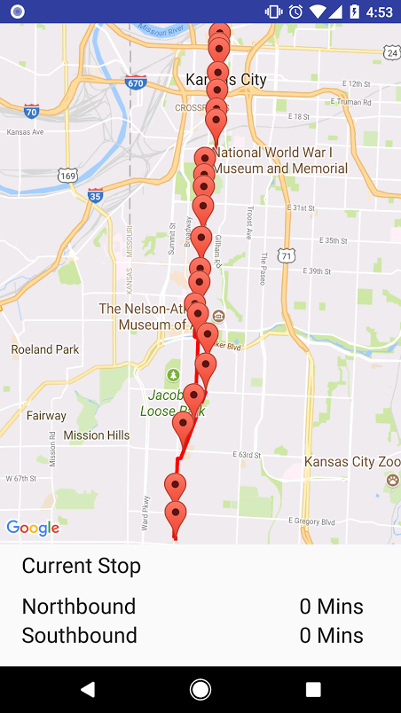
The app as it first opens, with the main activity is broken into two sections. The top is a map that helps the user find their position and decide if they need the northbound or southbound time information. The map opens to just the portion of Kansas City that the MAX line runs, with the entire route drawn out so that the user doesn’t need to find it each time.
Sample code of the route line:

PolylineOptions rectOptions = new PolylineOptions()
.width(10)
.color(Color.RED)
.add(new LatLng(39.110462, -94.580374))
.add(new LatLng(39.110344, -94.580961))//3 & Grand
.add(new LatLng(39.109730, -94.580757))
.add(new LatLng(39.108806, -94.580432))
.add(new LatLng(39.108454, -94.580325))
.add(new LatLng(39.107863, -94.580140))
// Get back the mutable Polyline
Polyline polyline = mMap.addPolyline(rectOptions);
}

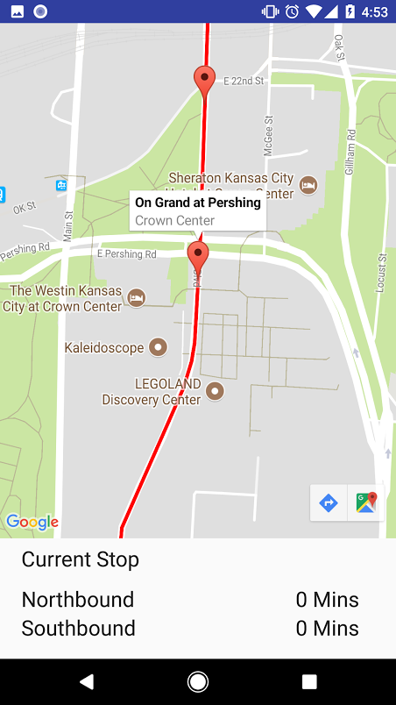
If zoomed in on a stop, you see the location of each and click on it to reveal more information, such as the stop name, and the intersection.
Sample code of each stop:

Marker Grand3 = mMap.addMarker(new MarkerOptions()
.position(new LatLng(39.110462, -94.580374))
.title("On Grand at 3rd")
.snippet("River Market"));
Marker Grand5 = mMap.addMarker(new MarkerOptions()
.position(new LatLng(39.108897, -94.580481))
.title("On Grand at 5th")
.snippet("City Market"));

Retrospective
This first iteration I selected two stories that I thought the details of each would have implications for other stories in the project. While the map only serves to give context about user location, the UI of it, and information that can be drawn from it impacts the design decisions of the main section of the app. I knew that importing the information for the stops would not be difficult, but was an opportunity to work with outside data provided by RideKC and see how I could use that to later make design decisions about how to implement the time remaining information.
This is the first type of project I’ve done where I decided the requirements, and the first I’ve done with Android/Java, so I added extra time to each task, but I underestimated the learning curve of displaying the map in the way I thought would best suit the user. These accidental complexities are where I fell behind and wasn’t able to finish some of the other tasks that I wanted to, such as UI refinements.
What went well and what helped to contribute to the overall success of the first sprint was starting the project by looking at the UI. I compared competing apps and decided what worked and what didn’t. These notes are found in the file “UI notes”. This helped me decided what information to abstract and what could be throw out altogether, such as asking to the user to input their stop by using a menu. It’s helped to compartmentalize tasks and see how each story related. Things that could have gone better were the accidental complexities of learning the software, and implementing the map. In the future, I think it would be helpful to split these tasks into smaller ones to best understand the complexity of each and make it easier to estimate time.

Project velocity: 14

Sprint #2
Sprint Backlog
Story ID | Story / Task | Estimated  Hours | Actual  Hours
S4 | Use Google mapping API to show location | 3 | 16
 | Use location data to tie into current stop | 6 | 4
S7 | Import stop times | 4 | 2
 | Search stop times | 5 | 3
 | Use algorithm to calculate time | 2 | 2
 | UI work | 2 | 1

Review
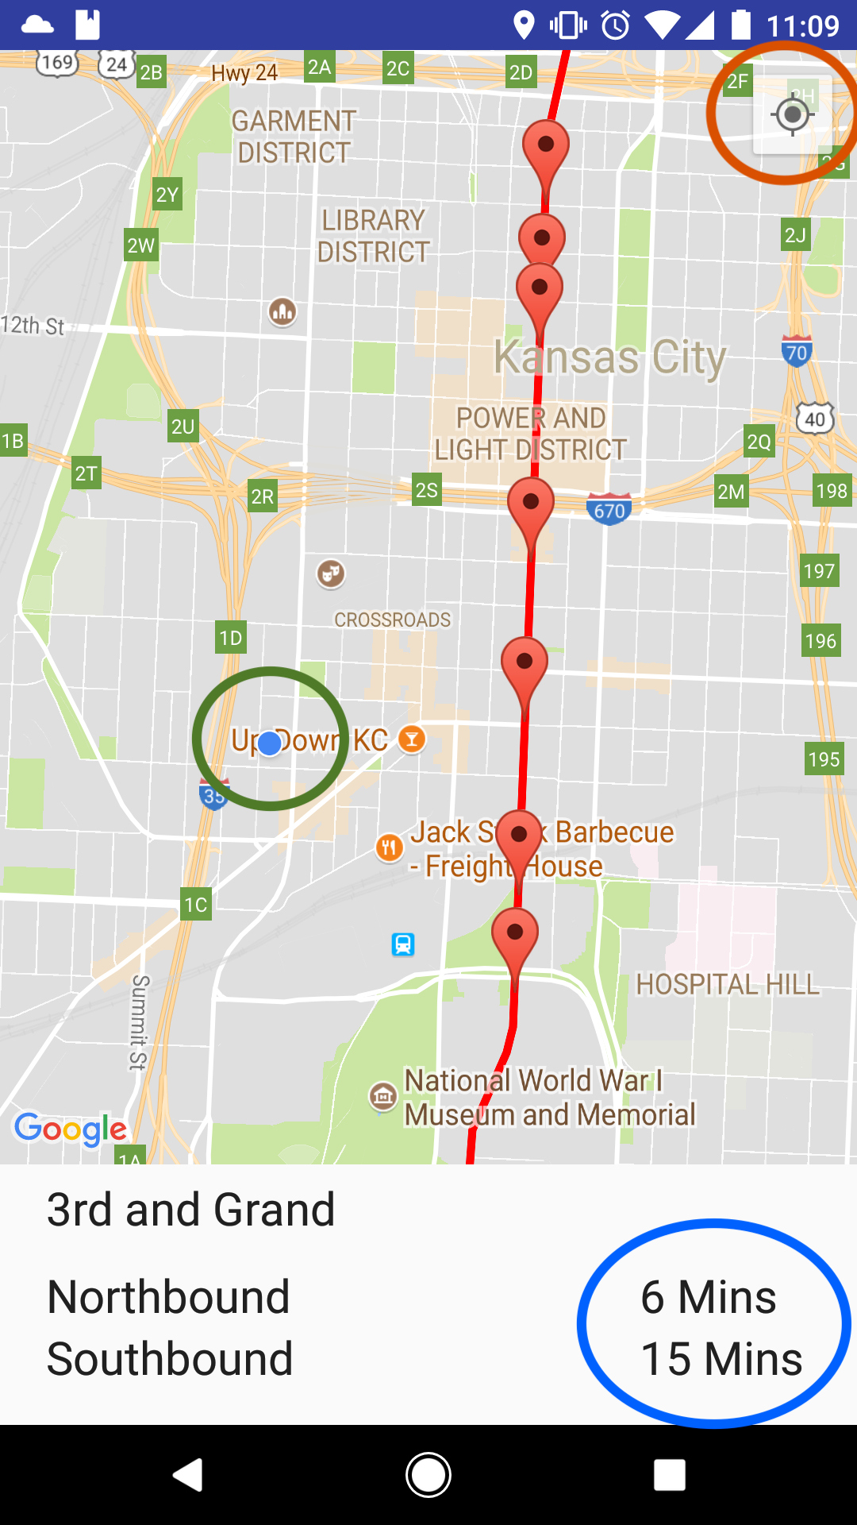
The app now opens and shows the users current location (green circle), and allows the user to relocate the location if it is off or changes (red circle). It uses the longitude information to evaluate the nearest stop.
The frequency for the bus is every 15 minutes, so the time remaining until the next bus is calculated by fetching the current minute, dividing it by 15 and subtracing it from the first highest bus frequenct. For example, if the first bus comes at 12:04, then the frequency would be 12:19, 12:34, and 12:49. If the current minute is 44 past the hour, then the remainder after dividing by 15 is 14. And 14 > 4 so then I would use |14 - 19| which results in the bus arriving in 5 minutes.

Retrospective
Much like working with the fragment activity in the first iteration, this second iteration had a lot of complications relating to the Google Map API. Most of my time was spent trying to get the current location working, because all of the other information depended on the user’s current longitude.
While I had everything working, the section to calculate the time remaining was really just a prototype and shouldn’t be implemented. I didn’t give enough thought early on to how the data for each stop should be handled to best reuse code. This story will be added back to the product log so that I can give it more thought, and refactor it so it’s implemented in a way where modules have low coupling and are easier to maintain.
While I tried from the first iteration to split tasks up to better calculate time, I feel I still have a lot more room for improvement, because I don’t think my velocity in this iteration reflects on the work that was actually done. I also underestimated how much good design impacts time management later in the project. Bad design decisions made in the first iteration slowed down my velocity in the second. In future iterations, I will break tasks up with design principles in mind, and budget in time for best practices. For example, the story that I am adding back to the backlog will be broken up into more modular stories for this next sprint.

Project velocity: 8

Sprint #3
Sprint Backlog
Story ID | Story / Task | Estimated  Hours | Actual  Hours
S7 | Create class for stops | 3
 | Import stop data | 3
 | Search stops | 4
 | UI work | 2
S10 | Tie current latitude data to stop object | 4
S5 | Check hour | 2
 | Display “last” | 1

Review

Retrospective
Project velocity:

Design
[What is the overall structure of the solution? What are the major modules of code? What are the dynamics of communication between these modules? The most common way of depicting this information is with static and dynamic models augmented with short narrative descriptions of design.]

Coding Standards
Coding standards improve readability. They make it easier to understand code written by others. Good coding standards also improve reliability.

