PDP UNIVERSITY Faculty of Business Information Technology Tashkent, Uzbekistan
INDEPENDENT PROJECT Pearson BTEC Level 6 Diploma in Digital Technologies Unit 2 — Unit Code: 70726U — Credit Value: 30

EduMetric

A Web-Based Multi-Dimensional Student Performance Analytics System
Design, Development and Evaluation of a Transparent Composite-Score Platform for Educational Institutions

Student Name: | ⟨STUDENT INPUT: Full Name⟩
Student ID: | ⟨STUDENT INPUT: ID Number⟩
Programme / Group: | ⟨STUDENT INPUT: BIT — Group Name⟩
Project Format: | Thesis-style ☐ Capstone-style ☒
Supervisor: | ⟨STUDENT INPUT: Supervisor Full Name⟩
Submission Date: | ⟨STUDENT INPUT: Day Month Year⟩
Word Count: | ⟨STUDENT INPUT: XXXX words⟩
Submitted in partial fulfilment of the requirements for the Bachelor’s Degree in Business Information Technology Academic Year ⟨STUDENT INPUT: 20XX–20XX⟩

Declaration of Originality
I hereby declare that this Independent Project, submitted in partial fulfilment of the requirements for the Pearson BTEC Level 6 Diploma in Digital Technologies and the Bachelor’s Degree in Business Information Technology at PDP University, is the result of my own original work.
I confirm that:
- All sources of information, data and ideas drawn from other authors have been fully acknowledged through accurate in-text citations and a complete reference list using the Harvard (author–date) referencing system.
- This work has not been previously submitted, in whole or in part, for any other academic award at this or any other institution.
- All research activities involving human participants have been conducted in compliance with the institutional ethics procedures of PDP University and applicable data-protection regulations. This project did not collect data from human participants; it designs, builds and evaluates a software system using design artefacts, functional and user-acceptance testing, and synthetic/anonymised academic records (see §3.7 and Appendix D).
- I understand that any breach of academic integrity, including plagiarism, fabrication of data or unauthorised collaboration, may result in the withdrawal of this submission and disciplinary action.
Signature: | ⟨STUDENT INPUT: signature⟩
Date: | ⟨STUDENT INPUT: date⟩

Acknowledgements
I would like to express my sincere gratitude to my supervisor, ⟨STUDENT INPUT: Supervisor Name⟩, for their continuous guidance, constructive feedback and encouragement throughout the duration of this project. Their insistence on grounding every design decision in the real system kept the work honest and focused.
I am also grateful to the Faculty of Business Information Technology at PDP University for providing the academic foundation and resources that made this work possible, and to my peers on the EduMetric development effort, whose questions about the metrics engine and the synchronous-recompute design sharpened my understanding of how a requirement becomes working software.
Finally, I extend my heartfelt thanks to my family and friends, ⟨STUDENT INPUT: optional personal names⟩, whose support has been instrumental during every stage of my Bachelor’s studies.

Abstract
The digitalisation of education has produced systems that record grades but rarely explain how a student is developing. Single grade-point averages collapse attendance, practical performance, behaviour and engagement into one number, hiding declining trajectories until it is too late to intervene. This project presents the design, development and evaluation of EduMetric, a web-based, multi-dimensional student performance analytics system that replaces the single grade-point average with a transparent composite score computed across grades, attendance, practical work, behaviour and activity, complemented by growth and consistency bonuses, a growth trend and an at-risk detection signal. A pragmatist, design-science methodology was adopted: functional and non-functional requirements were elicited from the problem domain and a product master document; the system architecture (a three-tier modular monolith), the PostgreSQL data model and a role-secured REST API were designed; and a full-stack prototype was implemented using Next.js/React, Java Spring Boot and PostgreSQL. Six core processes — authentication, attendance management, student evaluation, analytics generation, at-risk detection and administrative monitoring — were modelled and traced end-to-end into architecture modules, database entities, API endpoints and validation evidence, with every link verified against the shipped codebase. Evaluation combined functional and user-acceptance testing with a structured effectiveness assessment rather than human-subject data collection. The system demonstrated that a transparent, configurable scoring model, synchronous recomputation and strict role-based access control can deliver accurate, explainable and accessible student evaluation without resorting to black-box prediction. The project concludes that a modular, role-aware analytics platform meaningfully addresses the limitations of single-number grading, and contributes a fully traceable, open-source reference implementation together with recommendations for practitioners and future researchers.
Keywords: student analytics; learning analytics; composite score; transparent evaluation; web information system; role-based access control; Spring Boot; PostgreSQL.

Table of Contents
Auto-generated at .docx assembly. Structure below mirrors the BTEC template and the chapter files in this folder. Page numbers populate on field update in Word.
- Declaration of Originality
- Acknowledgements
- Abstract
- Table of Contents
- List of Figures
- List of Tables
- List of Abbreviations
- Chapter 1 — Introduction
  - 1.1 Background and Context · 1.2 Problem Statement · 1.3 Project Aim · 1.4 Project Objectives · 1.5 Research Questions · 1.6 Significance of the Project · 1.7 Scope and Limitations · 1.8 Structure of the Report
- Chapter 2 — Literature Review
  - 2.1 Introduction and Search Strategy · 2.2 Theoretical Framework · 2.3 Thematic Review · 2.4 Industry / Practice Review · 2.5 Identification of the Gap · 2.6 Conceptual Framework · 2.7 Summary
- Chapter 3 — Project Planning and Methodology
  - 3.1 Research Philosophy and Approach · 3.2 Methodological Choice · 3.3 Project Management Methodology · 3.4 Project Plan (WBS · Gantt · Milestones) · 3.5 Resource Planning · 3.6 Risk Register · 3.7 Ethical Considerations · 3.8 Project Tracking and Documentation · 3.9 Implementation of the Plan · 3.10 Critical Assessment of Project Management
- Chapter 4 — System Analysis, Design and Implementation
  - 4.1 Method · 4.2 Analytical Techniques · 4.3 Findings (requirements · architecture · data model · six core processes P1–P6 · security · key interactions) · 4.4 Comparison of Patterns
- Chapter 5 — Discussion
  - 5.1 Interpretation of Findings · 5.2 Comparison with the Literature · 5.3 Validity · 5.4 Reliability · 5.5 Project Effectiveness Evaluation · 5.6 Limitations · 5.7 Implications
- Chapter 6 — Conclusion and Recommendations
  - 6.1 Summary · 6.2 Achievement of Objectives · 6.3 Contribution · 6.4 Recommendations · 6.5 Closing Remarks
- Chapter 7 — Reflective Evaluation
  - 7.1 Reflective Model · 7.2 Reflection through Gibbs · 7.3 SWOT · 7.4 Transferable Skills · 7.5 Future Development Plan
- References
- Appendices A–K

List of Figures
Page numbers populate at .docx assembly.
Figure | Title
2.1 | Conceptual framework: from process intent to a validated student-analytics system
3.1 | Work Breakdown Structure
3.2 | Project Gantt chart (24 weeks, 6 phases)
3.3 | Risk heat-map (Probability × Impact, R01–R10)
3.4 | Project-tracking tool (screenshot — student-supplied)
4.1–4.4 | C4 context · C4 container · component/module map · deployment
4.5 | Entity-Relationship Diagram (full schema)
4.6–4.11 | Process models — P1 Authentication · P2 Attendance · P3 Evaluation · P4 Analytics · P5 At-Risk · P6 Admin
4.12–4.15 | Sequences — login · bulk-attendance recompute · dashboard composition · security filter chain
4.16–4.17 | Process-complexity comparison · requirement→artefact coverage
5.1–5.4 | Objectives RAG · test pass-rate · growth radar · growth trend
J.1–J.10 | UI screenshots (student-supplied — see Appendix J)

List of Tables
Page numbers populate at .docx assembly.
Table | Title
3.1 | Milestones and critical path
3.2 | Resource plan
3.3 | Risk register (R01–R10)
4.0 | Artefact inventory of EduMetric
4.1–4.6 | Per-process traceability matrices (P1–P6)
4.7 | Process → architecture module mapping
5.1 | Project effectiveness evaluation (RAG)
C.1 | Risk register (full, with owner and contingency)
F.1–F.2 | Anonymised student_metrics / metric_snapshots extracts
I.1 | BTEC assessment-criteria mapping
K.1 | Test-case results (TC-AUTH-01 … TC-ADMIN-05)

List of Abbreviations
Abbreviation | Expansion
API | Application Programming Interface
BCrypt | Blowfish-based password-hashing function
BPMN | Business Process Model and Notation
BTEC | Business and Technology Education Council
C4 | Context, Containers, Components, Code (architecture model)
CRM | Customer / Constituent Relationship Management
CRUD | Create, Read, Update, Delete
CSRF | Cross-Site Request Forgery
DTO | Data Transfer Object
ERD | Entity-Relationship Diagram
GDPR | General Data Protection Regulation
GPA | Grade-Point Average
HS256 | HMAC-SHA-256 (JWT signing algorithm)
HTTP | Hypertext Transfer Protocol
ISSM | Information Systems Success Model
JPA | Jakarta Persistence API
JWT | JSON Web Token
KPI | Key Performance Indicator
LMS | Learning Management System
LO | Learning Outcome (BTEC)
MFA | Multi-Factor Authentication
ORM | Object-Relational Mapping
P / M / D | Pass / Merit / Distinction (BTEC criteria)
RAG | Red–Amber–Green (status rating)
RBAC | Role-Based Access Control
REST | Representational State Transfer
RQ | Research Question
SIS | Student Information System
SMART | Specific, Measurable, Achievable, Relevant, Time-bound
SQL | Structured Query Language
SSR | Server-Side Rendering
SWOT | Strengths, Weaknesses, Opportunities, Threats
TAM | Technology Acceptance Model
TTL | Time To Live (cache)
UAT | User Acceptance Testing
UI / UX | User Interface / User Experience
UML | Unified Modeling Language
VPS | Virtual Private Server
WBS | Work Breakdown Structure

Chapter 1 — Introduction
Addresses LO1 — P1, P2 | M1 | D1

1.1 Background and Context
The digitalisation of education across Uzbekistan and the wider Central Asian region has accelerated sharply over the past decade, as universities and private IT academies adopt learning-management and student-information systems to administer enrolment, attendance and assessment at scale. Yet the majority of these systems remain records of account: they store grades, compute a single grade-point average (GPA) and report it back. They capture what a student scored, but they say little about how that student is developing — whether attendance is slipping, whether practical performance is diverging from theory marks, or whether a learner who looks average today is in fact on a declining trajectory. The institutional need is shifting from recording outcomes to understanding student growth, a shift that the learning-analytics literature has framed as moving “from data to insight” in the service of timely intervention (Siemens and Long, 2011; Ferguson, 2012).
This project responds to that shift by designing, building and evaluating EduMetric, a web-based, multi-dimensional student performance analytics system. EduMetric replaces “GPA as a single number” with a transparent composite score computed across several weighted dimensions — grades, attendance, practical work, behaviour and activity, plus growth and consistency bonuses — and surfaces a growth trend and an at-risk detection signal for each learner. The system is built as a full-stack web application: a Next.js/React single-page frontend, a Java Spring Boot REST backend and a PostgreSQL relational database, deployed as a single modular monolith. It deliberately rejects black-box machine-learning scoring in favour of a configurable, auditable formula, on the principle that decisions affecting a student’s academic standing must be explainable (Slade and Prinsloo, 2013).
An education analytics platform of this kind sits at the intersection of web-application development, relational database design, information security, user-experience design and process automation — all core competencies of the Business Information Technology curriculum. EduMetric is therefore both a practically useful artefact for institutions and an appropriate vehicle for demonstrating the end-to-end software-engineering process this dissertation sets out to evidence.

1.2 Problem Statement
In many educational institutions, student evaluation, attendance monitoring and progress reporting rely on disconnected spreadsheets, separate gradebooks and informal communication. This fragmented approach produces a recurring set of problems, confirmed through preliminary domain analysis and the EduMetric product master document:
- A single number hides growth. A GPA averages away the dimensions that matter for early support; a student weak in practical work but strong in theory looks “average,” and a declining attendance trend is invisible until results collapse (Macfadyen and Dawson, 2010).
- Data fragmentation. Grades, attendance and behaviour live in separate files, causing version conflicts, duplication and slow, manual report compilation.
- Late at-risk identification. Without continuous, multi-factor monitoring, teachers learn that a student is failing only after the fact, when intervention is least effective (Arnold and Pistilli, 2012).
- Opacity of scoring. Where institutions do adopt analytics, the scoring is often a black box, undermining trust and the right of students to understand decisions made about them.
- Weak access control. Sensitive academic records are frequently accessible beyond the staff who need them, with no role-based protection or audit trail.
The engineering problem this project addresses is therefore to turn these informally understood processes — authentication, attendance management, student evaluation, analytics generation, at-risk detection and administrative monitoring — into precise, verifiable software: an architecture, a data model, a set of REST endpoints and a body of test evidence, derived rigorously from requirements so that what was intended, what was designed and what was built do not diverge (Sommerville, 2016).

1.3 Project Aim
To design, develop and evaluate a web-based, multi-dimensional student performance analytics system that improves the transparency, accuracy and accessibility of student evaluation, attendance management and early at-risk identification in educational institutions.

1.4 Project Objectives
The aim is delivered through five SMART objectives (the approved project proposal from which they derive is provided in Appendix A):
- Review the literature on learning analytics, educational information systems, multi-dimensional assessment, web-application architecture and data security, synthesising at least 25 quality sources into six thematic strands, to establish the theoretical foundation (Chapter 2).
- Analyse and specify the functional and non-functional requirements of a transparent multi-dimensional student-evaluation system, derived from the problem domain and the EduMetric product master document (Chapter 4).
- Design the system architecture (a three-tier modular monolith), the PostgreSQL data model (ERD), the six core process models and the role-secured REST API in line with industry best practice (Chapter 4).
- Develop a full-stack web prototype — Next.js/React/TypeScript frontend, Java Spring Boot backend, PostgreSQL — implementing the core modules: authentication, attendance, evaluation (the metrics engine), student analytics, at-risk detection and admin monitoring (Chapter 4).
- Evaluate the system through functional and user-acceptance testing and a structured effectiveness assessment, producing evidence-based recommendations for practitioners (Chapters 5–6, Appendix K).
Each objective is specific and time-bound against the project plan (§3.4), measurable through a named deliverable, and achievable within the scope defined in §1.7.

1.5 Research Questions
- RQ1 — What limitations in current student-evaluation and management processes can a web-based information system address?
- RQ2 — What functional modules and data model are required for a transparent, multi-dimensional student performance analytics system?
- RQ3 — How can a web-based system improve the transparency, accuracy and accessibility of student evaluation, attendance management and at-risk detection?
- RQ4 — How should security, privacy and role-based access control be implemented to protect sensitive student data?

1.6 Significance of the Project
Academically, the project contributes a concrete, fully traceable reference implementation of a transparent multi-dimensional evaluation model. While learning analytics is a mature field, much of it emphasises predictive, often opaque models (Romero and Ventura, 2010); comparatively little demonstrates an end-to-end, auditable path from a configurable scoring formula through architecture, schema and API to validating tests within a single non-trivial system. By using a real, multi-module application as the object of study, this dissertation evidences an engineering method rather than a purely conceptual proposal.
For industry and practice, EduMetric offers a worked pattern for cost-effective, locally deployable education analytics. Built entirely on open-source technologies (Next.js, Spring Boot, PostgreSQL) and deployable as a single modular monolith on one server, it shows how an institution can centralise records, automate scoring and attendance, and gain early-warning dashboards without expensive commercial subscriptions or black-box algorithms.
Personally, the project consolidates the author’s software-engineering competence — requirements analysis, process and architecture modelling, relational database design, secure REST API development and software validation — into a single coherent body of evidence aligned with a future career in systems development.

1.7 Scope and Limitations
The study is bounded to a single system, EduMetric, comprising the Spring Boot backend and the Next.js frontend held in this repository. The system recognises three core roles — Student, Teacher and Admin; a Parent role exists in the code as a later extension and is noted only where relevant to scope, never as a fourth core role. The investigation is a design-and-build study evaluated through its artefacts: it concentrates on requirements, design, implementation and validation of the six core processes, not on production deployment, large-scale performance testing or live institutional trials. Consequently, evaluation evidence (Chapter 5 and Appendix K) draws on the system’s functional and user-acceptance test suite and on synthetic/anonymised academic data rather than on data collected from human participants, which keeps the project low-risk ethically (§3.7). As a single-system design, the findings prioritise depth and internal traceability over statistical generalisability — a limitation revisited in §5.6.

1.8 Structure of the Report
The remainder of this report proceeds as follows. Chapter 2 reviews the literature thematically and derives the conceptual framework that positions EduMetric within learning analytics and information-systems design. Chapter 3 sets out the research philosophy, the design-science methodology, and the project plan, risk register and ethical considerations. Chapter 4, the core engineering chapter, specifies the requirements and presents the system’s architecture, data model and six core process models, tracing each forward into modules, entities and API endpoints with supporting test evidence. Chapter 5 interprets these findings against the research questions and the literature, and evaluates the project’s effectiveness. Chapter 6 draws conclusions and recommendations, and Chapter 7 offers a reflective evaluation of the author’s learning. Supporting material — the proposal, full project-management artefacts, ethics documentation, assessment-criteria mapping, UI evidence and testing evidence — is provided in Appendices A–K.

Chapter 2 — Literature Review
Addresses LO1 — M1 | D1

2.1 Introduction and Search Strategy
This chapter reviews the body of knowledge that positions EduMetric — a web-based, multi-dimensional student performance analytics system — within the fields of learning analytics, educational information systems and software engineering. Its purpose is to establish the theoretical foundation for the design-and-build study reported in the remainder of the dissertation, to evidence the limitations of current student-evaluation practice (RQ1), and to converge on the specific gap that EduMetric is designed to fill. The review is deliberately thematic rather than author-by-author: the literature is organised into six strands that together trace the path from a recognised problem in student evaluation to a transparent, validated software artefact, followed by an industry perspective, a reasoned statement of the gap, and the conceptual framework that the later chapters operationalise.
Sources were identified through Google Scholar, IEEE Xplore, the ACM Digital Library and ScienceDirect, supplemented by foundational textbooks and the relevant technical standards. Search terms combined learning analytics, multi-dimensional assessment, student performance, early-warning system and educational data mining with software-engineering terms such as web-application architecture, modular monolith, REST API, relational database design, role-based access control and process modelling. Inclusion favoured peer-reviewed work, standards documents and authoritative textbooks; where evidence on a transparent, multi-dimensional composite-score model was comparatively thin — a risk recorded in the project’s risk register as R01 — the search was broadened into the adjacent literature on educational data mining and information-systems design. The synthesis returns a clear engineering implication at the end of each strand, so that the review functions not as a catalogue of prior work but as the evidential basis for the design decisions made in Chapter 4. Figure 2.1, introduced in §2.6, summarises how these strands combine into the framework that governs the build.

2.2 Theoretical Framework
The study is framed by an overarching paradigm and two complementary evaluative lenses, summarised in Table 2.1. The overarching frame is design science (Hevner et al., 2004; Peffers et al., 2007), which treats the construction and rigorous evaluation of an artefact — here, the EduMetric system and its requirements-to-test traceability chain — as a legitimate mode of inquiry. Design science supplies the evaluation logic this dissertation adopts: an artefact’s contribution is demonstrated by building it to defined requirements and assessing it against the problems it was meant to solve, rather than through human-subject experimentation. Peffers et al. (2007) decompose this into a repeatable sequence — problem identification, objective definition, design and development, demonstration and evaluation — that maps directly onto the structure of Chapters 1, 4 and 5.
The two lenses provide criteria for judging whether the built system is good in use, not merely complete. The first is the Technology Acceptance Model (Davis, 1989), which holds that adoption of an information system is driven principally by its perceived usefulness and perceived ease of use. For EduMetric this translates into testable design intent: a transparent composite score and a single-screen dashboard are usefulness and ease-of-use features, respectively, that the evaluation in Chapter 5 examines. The second is the DeLone and McLean IS Success Model (DeLone and McLean, 2003), which organises success into dimensions of system quality, information quality, use and net benefits. These dimensions inform what the functional and user-acceptance testing in Chapter 5 must demonstrate — that the system functions reliably (system quality), that the composite score and trend are accurate and intelligible (information quality), and that the result is timely at-risk detection (net benefit). Together the three frames justify the central move of the study: designing a system against explicit requirements and evaluating it as an artefact.
Table 2.1 — Theoretical frameworks and their role in the study. (Source: author.)
Framework | Source | Role in this dissertation
Design science (overarching paradigm) | Hevner et al. (2004); Peffers et al. (2007) | Justifies build-and-evaluate inquiry; structures problem → objectives → design → demonstration → evaluation.
Technology Acceptance Model | Davis (1989) | Lens for usefulness and ease of use of the composite score and dashboard.
IS Success Model | DeLone and McLean (2003) | Lens for system quality, information quality and net benefit in the Chapter 5 evaluation.

2.3 Thematic Review

2.3.1 Theme 1 — From single-number GPA to multi-dimensional assessment of learning
A foundational strand argues that reducing a learner’s progress to a single grade-point average obscures the dimensions that matter for support and development. Siemens and Long (2011) frame the shift “from data to insight” as a move beyond recording outcomes towards understanding the learning process, while Ferguson (2012) traces how the field has broadened from final marks to attendance, engagement and behaviour as legitimate signals of learning. The argument is that a single number averages away precisely the variation an educator needs: a student strong in theory but weak in practical work, or one whose attendance is quietly declining, appears unremarkable when collapsed to one figure. The evidence supports a clear engineering conclusion: an evaluation system should retain and surface several weighted dimensions rather than a single scalar — directly motivating EduMetric’s seven scored dimensions (grades, attendance, practical, behaviour, activity, growth bonus and consistency bonus) and the transparent composite score that combines them.

2.3.2 Theme 2 — Learning analytics and educational data
A second strand concerns the use of academic data to understand and support students. Romero and Ventura (2010) survey educational data mining and establish that institutions already hold rich, under-exploited data on grades, attendance and activity that can be turned into actionable insight. Ferguson (2012) positions learning analytics as the application-oriented sibling of this work, focused on intervention rather than discovery. The literature is not uncritical: both authors caution that analytics is only as trustworthy as the data quality and the integrity of the records feeding it, and that poorly governed data can mislead as easily as inform. The reasoned conclusion taken forward is that an analytics system must treat its underlying records as a first-class concern — enforcing referential integrity, uniqueness and valid ranges at the database level — so that the metrics it computes rest on sound data. This motivates EduMetric’s relational schema with ON DELETE RESTRICT foreign keys, uniqueness constraints on attendance and grade records, and the separation of the denormalised student_metrics cache from the immutable history in metric_snapshots.

2.3.3 Theme 3 — Early-warning / at-risk detection systems
The third strand examines systems that flag at-risk students early enough for intervention to help. Arnold and Pistilli’s (2012) account of Course Signals at Purdue is the canonical example: an early-warning system that combines performance, effort and prior academic history into a traffic-light signal correlated with improved outcomes. Macfadyen and Dawson (2010) demonstrate, as a proof of concept, that data already captured by a learning-management system can be mined to predict which students are likely to fail, well before final results. Both works establish the central premise that continuous, multi-factor monitoring detects decline that a single end-of-term GPA reveals only too late. The literature also notes a recurring limitation — many such systems are bolted onto an LMS as analytics afterthoughts, with detection logic that institutions cannot inspect or adjust. The engineering conclusion is that at-risk detection should be a designed, rule-driven module with configurable thresholds, which EduMetric implements through its atrisk/ slice (AtRiskRules) feeding notifications, rather than an opaque add-on.

2.3.4 Theme 4 — Transparency versus black-box prediction
The fourth strand weighs configurable, auditable scoring against opaque machine-learning prediction, and is the principal source of the project’s distinctive position. Slade and Prinsloo (2013) argue that learning analytics carries genuine ethical weight: decisions taken about students on the basis of an algorithm engage their right to understand and contest those decisions, which a black-box predictor cannot satisfy. Where much educational data mining pursues predictive accuracy through models that are inherently difficult to explain (Romero and Ventura, 2010), this strand counters that explicability is itself a requirement when the subject of the decision is a person’s academic standing. The reasoned position adopted here is that, for a student-facing institution, a transparent and configurable formula whose weights are visible and adjustable is preferable to a more accurate but unaccountable model. This directly justifies EduMetric’s deliberate rejection of ML scoring in favour of a linear composite formula with administrator-editable weights held in formula_config, every recomputation of which is written to audit_log.

2.3.5 Theme 5 — Architecture of educational web information systems
The fifth strand establishes how a web information system of this kind should be structured, and it is here that process modelling enters as one design technique among several. The software-architecture literature describes the trade-offs between architectural styles: Bass et al. (2012) and Richards and Ford (2020) set out how quality attributes such as maintainability and deployability drive style selection, while Newman (2015), writing in favour of microservices, makes the contrasting case that clarifies why a single-team, single-deployment project is better served by a modular monolith. Fowler (2002) supplies the enterprise patterns — layered separation of controller, service, repository and entity — that EduMetric’s vertical slices follow, and Fielding’s (2000) account of REST, elaborated for practitioners by Richardson and Amundsen (2013) and made machine-readable by the OpenAPI Initiative (2021), frames the API as a set of resources and state transitions. Within this strand, requirements engineering and process modelling are the techniques that bridge problem to design: Sommerville (2016), Pohl (2010) and Wiegers and Beatty (2013) characterise requirements as the highest-leverage, most error-prone phase, where visual representations expose gaps that prose conceals; and Dumas et al. (2018), with the BPMN 2.0 standard (OMG, 2011), supply the notation chosen to model EduMetric’s six core processes so that exceptions and authorisation rules are made explicit before they reach code. The engineering conclusion is that EduMetric should adopt a three-tier modular monolith with layered slices and a REST API, designed through requirements analysis and process models rather than improvised — exactly the method Chapter 4 follows.

2.3.6 Theme 6 — Security, privacy and access control for student data
The final strand addresses the protection of sensitive academic records (RQ4). Sandhu et al. (1996) provide the foundational model of role-based access control (RBAC), in which permissions attach to roles rather than individuals, reducing both administrative burden and the attack surface. The argument from this work is that a multi-role system handling personal data must enforce authorisation systematically rather than ad hoc. The data-protection literature reinforces this: the General Data Protection Regulation (European Parliament and Council, 2016) establishes principles of data minimisation, purpose limitation and accountability that any system holding student records should honour even outside its legal jurisdiction, as a matter of good practice. A recognised difficulty, noted across the security literature, is that role-level checks alone are insufficient in a multi-tenant educational setting — a teacher must see only their own groups, a student only their own record — which demands data-level authorisation in addition to coarse role gates. The engineering conclusion is that EduMetric must combine an ADMIN > TEACHER > STUDENT role hierarchy and JWT-based stateless authentication with service-layer query filters that scope data to the authenticated user, supported by an immutable audit_log for accountability.

2.4 Industry / Practice Review
Beyond the academic literature, the practice of building educational systems offers a complementary perspective. Commercial student-information systems (SIS) and learning-management systems dominate the institutional market, and their gradebooks are mature and widely adopted; in practice, however, their analytics typically report a single aggregate mark and present scoring as a fixed, vendor-defined process that institutions cannot inspect or reconfigure. Industry experience reported in the architecture literature (Richards and Ford, 2020; Bass et al., 2012) converges on a pragmatic finding relevant to a single-team project of this size: most systems do not need the operational complexity of microservices (Newman, 2015), and a well-modularised monolith deployed as one unit delivers maintainability without distributed-systems overhead. EduMetric’s choice of a single docker-compose deployment on one server, with Redis used only as a read-through cache for analytics dashboards and never in the recompute path, reflects this lesson directly.
A second practitioner theme concerns the level of formality appropriate to design artefacts in a project of this scale. The agile tradition (Beck et al., 2001) cautions against documentation that drifts from the code, and the maintenance literature identifies model–code divergence as a chronic risk — recorded here as R03 and R07. The practical lesson is that design artefacts such as process models, the ERD and the API specification earn their keep only when they are tied to the implementation through an explicit, version-controlled traceability matrix and kept deliberately lean, rather than treated as exhaustive documentation. EduMetric adopts exactly this discipline, modelling its six processes at a descriptive level sufficient to derive design decisions, and binding each back to a requirement, module, entity, endpoint and test through the traceability matrices reproduced in Chapter 4.

2.5 Identification of the Gap
Synthesising the six themes against the available alternatives makes the gap, and the distinction EduMetric claims, explicit. Single-number GPA (Theme 1) is transparent and universally understood, but discards the multi-dimensional detail and trajectory that early support requires. Generic LMS gradebooks are mature and widely deployed, but typically expose only an aggregate mark, treat scoring as a fixed process, and bolt analytics on as an afterthought rather than designing detection in from the data model upward. Commercial student-information systems centralise records effectively but are costly, closed and difficult to adapt to an institution’s own weighting of practical work, behaviour or growth — and rarely deployable cheaply by a small institution. Black-box ML scoring (Themes 3–4) can achieve predictive accuracy, but at the cost of explicability and accountability, which the ethics literature identifies as non-negotiable when the subject of the decision is a student’s standing (Slade and Prinsloo, 2013). Each alternative therefore captures part of what is needed, and none combines all of it.
What is comparatively under-evidenced is a system that is simultaneously multi-dimensional (retaining several weighted signals), transparent and configurable (an auditable formula whose weights an administrator can see and adjust), proactive (rule-driven at-risk detection built into the data model), secure (RBAC plus data-level scoping) and cheaply deployable (an open-source modular monolith) — demonstrated end-to-end with requirements-to-test traceability in one implemented system. This dissertation addresses that gap by designing, building and evaluating exactly such a system. The composite-score formula’s transparency answers the black-box critique; the multi-dimensional model answers the GPA critique; the rule-driven atrisk/ module answers the afterthought critique of LMS gradebooks; and the open-source monolith answers the cost-and-closure critique of commercial SIS. The conceptual framework that operationalises this convergence is given in Figure 2.1.

2.6 Conceptual Framework
The synthesis above yields the conceptual framework that the methodology and analysis operationalise. The framework reads the project as a chain of design activities: the recognised process intent behind the six core institutional processes is captured first as a process model (drawn in BPMN 2.0, alongside the other design techniques of Theme 5), which informs the requirements; the requirements drive the architecture, the database design and the API design; these converge in the implemented system (EduMetric); and the whole is confirmed by validation through the traceability chain and test evidence, which traces back to verify that what was intended was in fact built. Process modelling is one technique within this method, not its centre. The framework is shown in Figure 2.1.
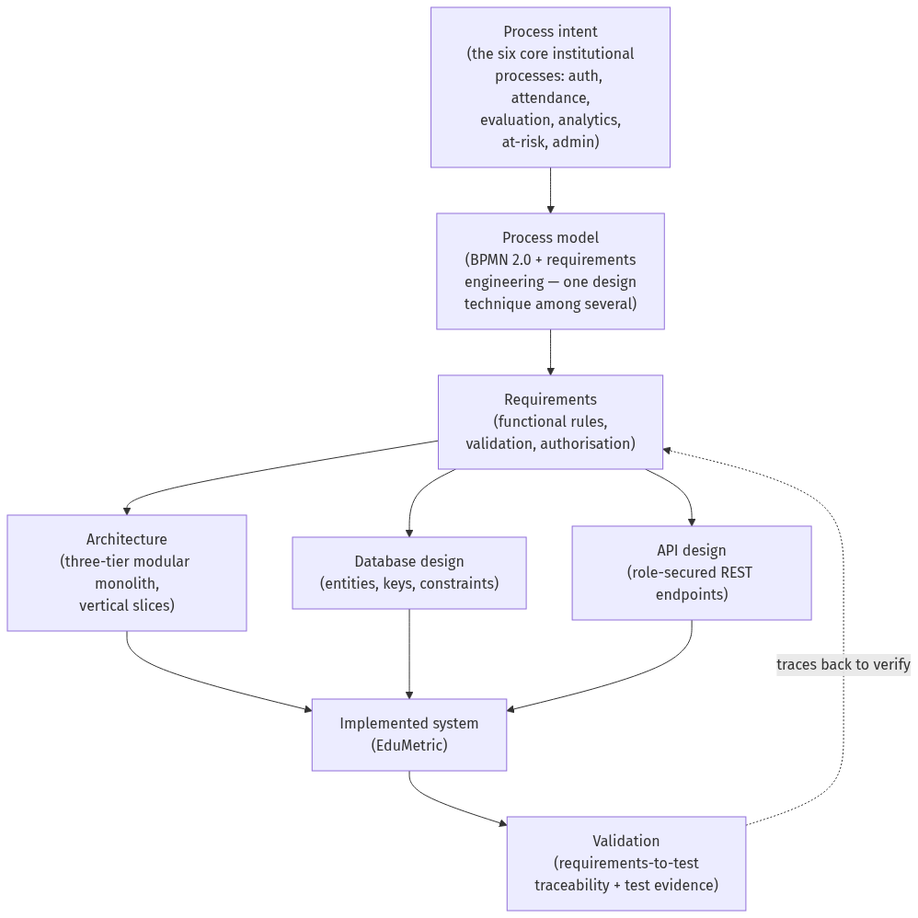
Figure 2.1 — Conceptual framework: from process intent to a validated student-analytics system. (Source: author.)
Figure 2.1 — Conceptual framework: from process intent to a validated student-analytics system. (Source: author, synthesised from the literature in §2.3.)

2.7 Summary of the Literature Review
The literature converges on the rationale for this project. Theme 1 establishes that a single GPA hides the growth and multi-dimensional variation educators need, motivating EduMetric’s weighted composite score. Themes 2 and 3 show that institutions already hold the data, and that continuous, multi-factor monitoring can detect at-risk students early enough to help. Theme 4 supplies the project’s distinctive ethical position — that transparent, configurable scoring is preferable to accurate-but-opaque prediction when decisions affect students. Theme 5 grounds the system’s engineering in established architecture, REST and requirements-and-process-modelling practice, with BPMN as one design technique rather than the subject of study; and Theme 6 sets the security and data-protection requirements for handling sensitive student records. The three theoretical frames of §2.2 — design science as the overarching paradigm, with the Technology Acceptance Model and the IS Success Model as evaluative lenses — provide the logic by which the built artefact is judged. The identified gap is the absence of a single implemented system that is at once multi-dimensional, transparent, proactive, secure and cheaply deployable, demonstrated with full traceability; the conceptual framework of Figure 2.1 specifies the structure that Chapters 3 and 4 use to fill it.

Chapter 3 — Project Planning and Methodology
Addresses LO2 — P3, P4 | M2 | D2

3.1 Research Philosophy and Approach
This project adopts a pragmatist research philosophy, the position within Saunders, Lewis and Thornhill’s (2019) “research onion” that judges knowledge claims by their usefulness in solving a practical problem rather than by allegiance to a single epistemology. Pragmatism is appropriate here because the central concern — whether a web-based, multi-dimensional analytics system can improve the transparency, accuracy and accessibility of student evaluation — is answered most convincingly by designing, building and examining such a system in working software, not by abstract argument alone. The philosophy is operationalised through design science (Hevner et al., 2004; Peffers et al., 2007), in which a purposeful artefact — the EduMetric system together with its design models, data schema, REST API and test evidence — is both the means and the object of inquiry, and its evaluation against the requirements it was built to satisfy constitutes the research finding.
Design science is well matched to a software-engineering capstone because it frames research as the construction and rigorous assessment of an artefact that solves a relevant problem (Hevner et al., 2004). Peffers et al. (2007) structure that activity into six iterative steps — problem identification, objective definition, design and development, demonstration, evaluation, and communication — and this dissertation maps onto them directly: the problem and objectives are established in Chapter 1, the artefact is designed and developed in Chapter 4, it is demonstrated through its implemented interface (Appendix J), evaluated in Chapter 5, and communicated through the report as a whole. The reasoning is abductive: properties observed in the built system are explained by, and traced back to, the requirements and design models that informed them, so that the relationship between intent, design and implementation is made explicit rather than assumed.

3.2 Methodological Choice
The methodological choice is qualitative and artefact-driven — a design-and-build study rather than a survey-heavy empirical investigation. Instead of collecting numerical data from a sample of respondents, the project treats software artefacts — the requirements specification, the architecture and process models, the database schema, the REST API definition and the functional and user-acceptance test cases — as its primary evidence, and analyses them through structured requirements-to-test traceability (§4.2). Crucially, no data are collected from human subjects: the study involves no surveys, interviews, observation or usability counts, and the academic data used to demonstrate the analytics are synthetic and anonymised (§3.7).
This choice is justified over a survey-heavy or experimental design on three grounds, and the trade-off is accepted explicitly (Oates, 2006; Bell and Waters, 2018). First, the research questions concern what should be built and how well it works — the functional modules, the data model, and the system’s effect on transparency, accuracy and access — which are best answered by inspecting and testing the artefact directly rather than by sampling opinion. Second, a survey of user perception would measure attitudes towards a system that does not yet widely exist, whereas the locked aim demands a demonstrated working system and verifiable behaviour; design science treats the artefact’s tested performance as the evidence (Hevner et al., 2004). Third, confining evaluation to synthetic data and functional/UAT testing keeps the project low-risk ethically and within the time and resources of a single researcher (§3.5, §3.7). The accepted cost — reduced statistical generalisability in exchange for depth, internal validity and a fully traceable engineering record — is revisited critically in §5.6. Within this artefact-driven frame, process modelling in BPMN 2.0 (Object Management Group, 2011) is used as one design technique among several — alongside C4 architecture diagrams, an entity-relationship diagram, UML sequence diagrams and an OpenAPI-style REST specification — to capture the six core processes; it is a means of designing the system, not the object of study.

3.3 Project Management Methodology
The project was managed using an Agile, iterative approach (Beck et al., 2001) adapted for a single-researcher software-engineering capstone. Rather than deferring all output to the end, work proceeded in short cycles aligned to the six core processes and the chapter structure, each cycle producing a reviewable increment — a requirement set, a design model, a working module, a populated traceability table or a chapter draft. The Agile values of working software, responding to change and iterative delivery (Beck et al., 2001) fit this project because its artefacts are interdependent: designing a process model frequently surfaced a refinement to the architecture or schema, and implementing a module occasionally revealed a requirement that needed restating. An iterative method absorbs that feedback without a heavyweight change process.
A strictly sequential waterfall plan was rejected as too brittle for a body of work in which understanding deepens as the artefacts accumulate; committing the full design before any code was written would have locked in early misjudgements. Equally, a ceremony-heavy framework such as full Scrum offers little value to a team of one. The project therefore took a lightweight, milestone-gated iteration: design and build proceeded in cycles, but iteration is bounded by the milestone structure of §3.4 so that flexibility does not become drift — a tension assessed critically in §3.10.

3.4 Project Plan
The plan decomposes the work into six phases over 24 weeks, presented below as a work breakdown structure (§3.4.1), a Gantt timeline (§3.4.2) and a milestone/critical-path table (§3.4.3). The full artefacts are reproduced at full resolution in Appendix B.

3.4.1 Work Breakdown Structure (WBS)
The work breakdown structure decomposes the project into the six phases and their constituent tasks, as shown in Figure 3.1.
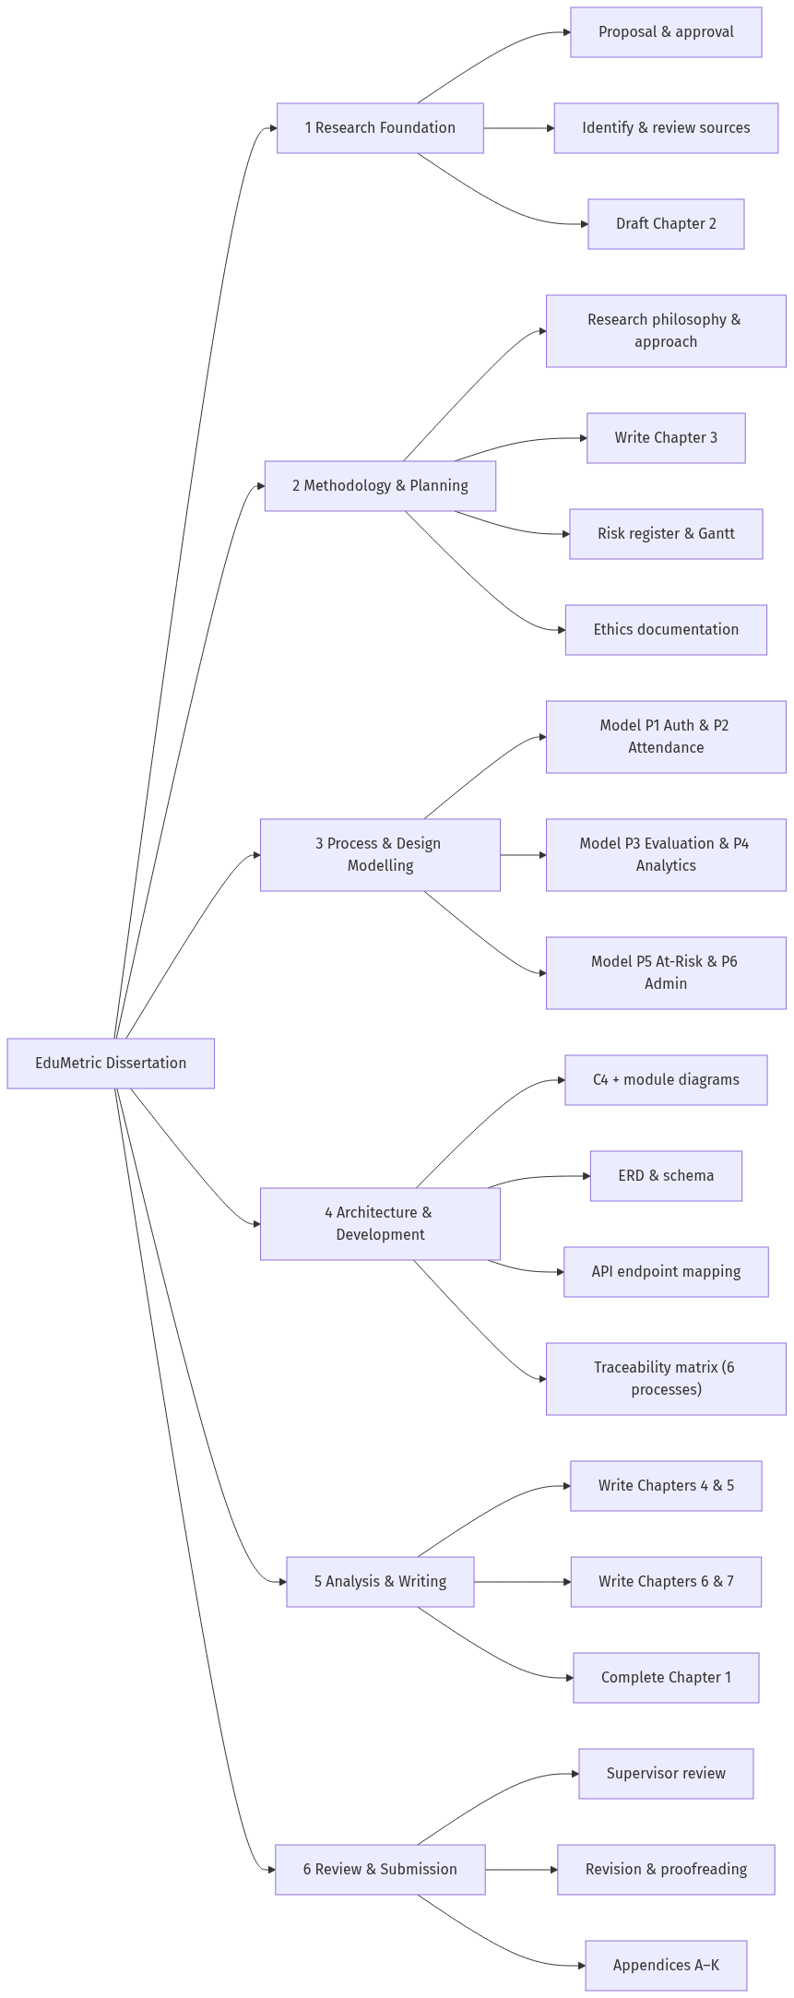
Figure 3.1 — Work Breakdown Structure. (Source: author.)

3.4.2 Gantt Chart and Timeline
The 24-week schedule is shown in Figure 3.2, mirroring the project’s planning workbook. Weeks are mapped to a notional calendar beginning Week 1; the same data is reproduced at full resolution in Appendix B. The middle phases — modelling the six processes (Phase 3) and translating them into the architecture, schema, API and working code (Phase 4) — carry the bulk of the design-and-build effort.
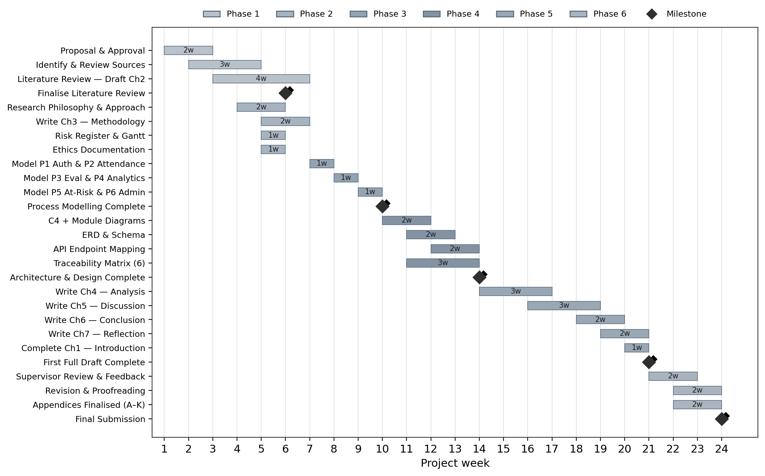
Figure 3.2 — Project Gantt chart (24 weeks, 6 phases). (Source: author, mirroring the project planning workbook.)

3.4.3 Milestones and Critical Path
Six milestones gate the project; the critical path runs through the design-and-build phases (3 and 4), since Chapter 4 cannot be completed until the process models, architecture, schema, API and traceability matrix are in place. Table 3.1 lists the milestones.
Table 3.1 — Milestones and critical path. (Source: author, derived from the Gantt workbook.)
Milestone | Target week | On critical path?
M0 — Project proposal approved | W2 | Yes
M1 — Literature review finalised | W6 | No (parallel to planning)
M2 — Process modelling complete | W10 | Yes
M3 — Architecture & design complete | W14 | Yes
M4 — First full draft complete | W21 | Yes
M5 — Final submission | W24 | Yes

3.5 Resource Planning
The project is resourced by a single researcher using freely available or institution-provided tools, keeping cost negligible and removing procurement as a schedule risk. Table 3.2 summarises the plan.
Table 3.2 — Resource plan. (Source: author.)
Resource | Provision | Used for
Researcher time | ~12–15 hrs/week across 24 weeks | All phases
Supervisor | Scheduled review meetings (Appendix H) | Feedback at milestones M1, M2, M4
Process-modelling tool | bpmn.io / draw.io (free) | The six BPMN process models
Diagramming | Mermaid (in-repo, free) | C4, ERD, sequence, WBS, Gantt
Development environment | Java 21+ / Spring Boot, Next.js/React/TypeScript, PostgreSQL | Building and testing the EduMetric prototype
Reference management | Zotero + Harvard style (free) | Citations, reference list
Writing & assembly | Markdown → Word (template) | Dissertation production

3.6 Risk Register
Ten risks were identified, assessed on a 1–5 probability/impact scale (risk score = P × I) and assigned mitigation and contingency strategies. The register is reproduced from the project workbook as Table 3.3 and at full resolution in Appendix C; its probability/impact distribution is visualised in Figure 3.3.
Table 3.3 — Risk register (R01–R10). (Source: author’s project workbook; owner = Researcher; status = Open at time of writing.)
ID | Risk | Cat. | P | I | Score | Severity | Mitigation | Contingency
R01 | Limited literature directly comparable to a transparent, multi-dimensional composite-score model | Academic | 2 | 3 | 6 | Medium | Supplement with broader learning-analytics, architecture and requirements literature; triangulate across themes | Expand search to IEEE Xplore and ACM Digital Library; cite adjacent transparency/early-warning work
R02 | Scope creep — the feature set expands beyond the core six modules / MVP | Scope | 3 | 4 | 12 | High | Lock the MVP to the six core processes in the master document; review every increment against the locked scope | Defer non-core modules to a “future work” backlog (§6.4); re-anchor to the six processes
R03 | Divergence between the design artefacts (architecture, ERD, process models) and the implemented code | Technical | 3 | 5 | 15 | Critical | Maintain a version-controlled requirements-to-test traceability matrix; map every activity to module, entity, endpoint and test | Re-derive the affected artefact from the design models and re-run the traceability check
R04 | Schedule delay from running academic writing and software development in parallel | Schedule | 3 | 4 | 12 | High | Milestone-based Gantt with buffer weeks; weekly progress review against the plan | Deprioritise lower-impact appendix content; protect Chapters 4–5 first
R05 | The composite-score formula behaves incorrectly on edge cases / small samples, eroding trust | Technical | 2 | 3 | 6 | Medium | Keep the metrics engine pure and 100% unit-testable; cover edge cases (empty data, single sample) with test cases | Add guard clauses and confidence flags; document known limits of the formula
R06 | EduMetric implementation incomplete at submission | Technical | 2 | 4 | 8 | Medium | Prioritise the six core modules; treat extension features as optional; partial implementation acceptable for evaluation | Clearly document the scope of completed implementation; evaluate what is built
R07 | Traceability links break when the architecture or database schema changes | Technical | 2 | 4 | 8 | Medium | Version-control the traceability matrix alongside the dissertation; propagate schema changes in a single pass | Flag affected chapters and update all references together
R08 | Academic sources unavailable through the university library | Academic | 2 | 3 | 6 | Medium | Use Google Scholar, ResearchGate and author pre-prints; cite DOI links | Use an alternative edition or closest available source
R09 | Reflective chapter lacks genuine critical depth (Ch 7) | Academic | 2 | 3 | 6 | Medium | Use Gibbs’ Reflective Cycle with specific project examples; avoid generic statements | Add concrete examples from design modelling and implementation
R10 | Artefact inconsistency across chapters (module names, endpoint paths, terminology) | Quality | 3 | 4 | 12 | High | Lock terminology in the master document; enforce consistent module, entity and endpoint names | Full terminology and endpoint-path review pass before final submission

Impact ↓ Prob → | P1 | P2 | P3 | P4 | P5
I5 |  |  | R03
I4 |  | R06, R07 | R02, R04, R10
I3 |  | R01, R05, R08, R09
I2
I1
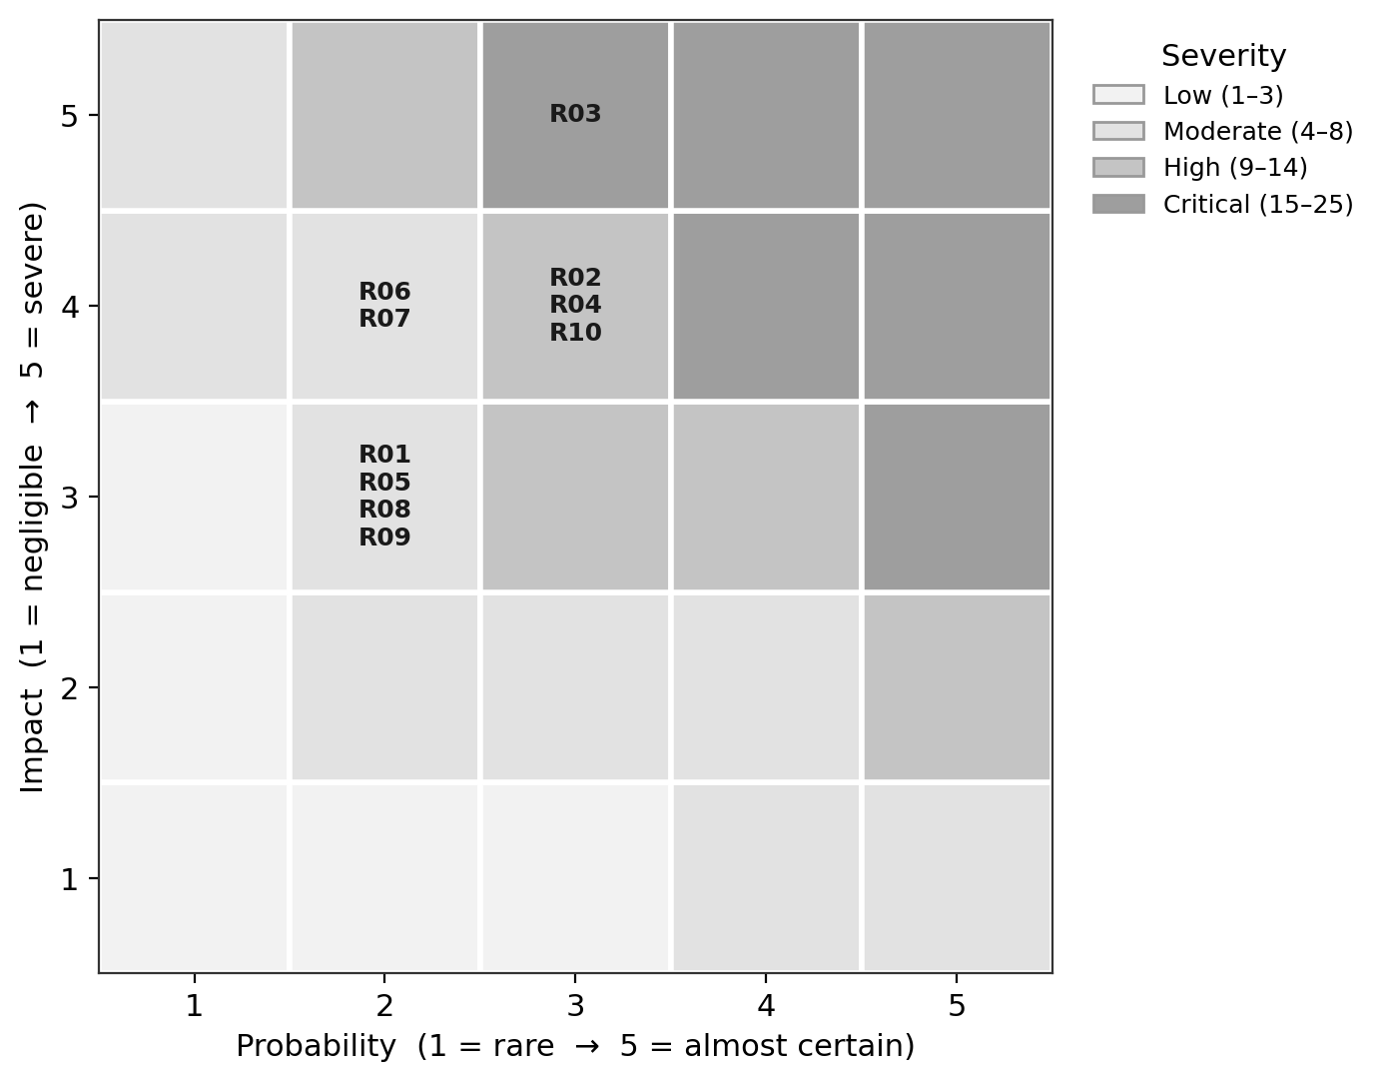
Figure 3.3 — Risk heat-map (Probability × Impact, R01–R10). (Source: author, derived from Table 3.3.)
The distribution shows the dominant exposure is consistency between the design and the code: the single critical risk is design↔code divergence (R03), and the high-severity cluster — scope creep (R02), parallel-track schedule pressure (R04) and cross-chapter artefact inconsistency (R10) — all threaten the integrity of the engineering record. This is precisely why the project’s central control is a maintained, version-controlled requirements-to-test traceability matrix rather than any single diagram: the matrix ties the design models to the implemented modules, entities, endpoints and tests, so divergence is detected early and corrected in one pass.

3.7 Ethical Considerations
The project is low-risk with respect to research ethics. It collects no data from human participants: its evidence is software artefacts and the system’s own synthetic / anonymised academic records. Because there are no participants, the usual safeguards of informed consent and the right to withdraw are not applicable — there is no one to withdraw, and no personal data to be processed. The academic data used to demonstrate the analytics (Appendix F) contain no real names or identifiers; learners are represented by opaque codes, consistent with the data-minimisation principle and aligned with the General Data Protection Regulation’s requirements for the lawful, fair and minimal handling of personal data (European Parliament and Council, 2016). No special-category data are processed.
Where the system would, in production, hold real student records, the design itself embeds the relevant protections — role-based access control, audit logging and configurable retention — but these are described as design properties of the artefact, not as live data-collection activities of the research. The institutional ethics declaration and a low-risk self-assessment are provided in Appendix D. ⟨STUDENT INPUT: ethics-form signature and date⟩.

3.8 Project Tracking and Documentation
Progress was tracked against the milestone structure of §3.4 using a lightweight task board and a dated logbook, with the project’s source artefacts version-controlled in the EduMetric repository so that any change to the architecture or schema could be propagated to the traceability matrix in a single pass (mitigating R03 and R07). A screenshot of the tracking tool is provided as Figure 3.4, and the full logbook and supervisor-meeting records are given in Appendices G and H respectively.
[Figure 3.4] — screenshot to be inserted from the running EduMetric application.

3.9 Implementation of the Plan
The plan was executed broadly as scheduled, with the design-and-build phases (3 and 4) consuming the greatest effort and the writing phase absorbing the minor slippage that the buffer weeks were reserved for. Following the iterative method of §3.3, the six core processes were first modelled and then built out incrementally into the running system: authentication and attendance, then the evaluation (metrics-engine) and analytics modules, then at-risk detection and admin monitoring. Each increment was checked against the requirements-to-test traceability matrix before the next was started, which kept the implemented code aligned with the design models and held the critical design↔code divergence risk (R03) in check.
During the implementation stage, the prototype of EduMetric was developed with its key screens, including login, the student growth dashboard, teacher attendance and grading, admin formula configuration, analytics and at-risk monitoring pages. The implementation evidence — the working EduMetric interface that realises the modelled processes — is documented in Appendix J. Screenshots of the implemented user interface are provided in Appendix J.

3.10 Critical Assessment of Project Management
(D2) Judged critically, the project-management approach was effective in the dimensions that mattered most and weaker in one. Its principal strength was risk-led control: by identifying design↔code divergence (R03) as the critical risk at the outset and adopting a version-controlled requirements-to-test traceability matrix as the standing mitigation, the project converted its greatest threat into its central method — an alignment of risk management and methodology that paid off directly in the design-and-build work of Chapter 4. The milestone-gated iterative approach (§3.3) also handled the inherent interdependence of the artefacts well, allowing refinements discovered during modelling and coding to flow back into the architecture and schema without derailing the schedule, while the locked MVP scope kept feature growth (R02) contained to the six core modules.
The principal weakness was the optimism of the parallel-track schedule (R04): running literature and academic writing alongside the build assumed an even effort distribution that the artefact- and code-intensive middle phases did not respect, and only the deliberately reserved buffer weeks kept the first-draft milestone (M4) intact. A more defensive plan would have front-loaded a larger buffer before Phase 4 and split the development work into finer increments to smooth the load. On balance, the methodology was fit for a single-researcher design-science capstone: it was disciplined enough to guarantee traceability between intent, design and code, yet flexible enough to absorb the iterative nature of artefact construction, and its few shortcomings were contained rather than realised.

Chapter 4 — System Analysis, Design and Implementation
Addresses LO3 — P5, M3, M4

4.1 Method
This chapter specifies, designs and implements EduMetric, the web-based multi-dimensional student performance analytics system that is the subject of this project. Following the design-science frame adopted in Chapter 3 (Hevner et al., 2004; Peffers et al., 2007), the “data” analysed here are not the opinions of human participants but the engineering artefacts that constitute the system: its requirements, its architecture, its data model, its process models and its role-secured REST API, together with the evidence that each requirement was realised in working, tested code. No surveys or interviews were conducted; the system itself, and the chain that links a requirement to the code that satisfies it, are the units of analysis. The analytical pathway applied consistently to each of the six core processes is requirement → design decision → architecture module → database entity → API endpoint → validation evidence, operationalised through the traceability matrices introduced in §4.2 and evidenced in Appendix K.

4.1.1 Primary Artefacts
The primary artefacts are the built system and the design models that specify it. They comprise: the working full-stack prototype itself — a Next.js/React/TypeScript frontend, a Java Spring Boot backend and a PostgreSQL database; a set of C4 architecture diagrams describing the system at four levels of abstraction; an entity-relationship diagram (ERD) for the relational schema, owned by Liquibase changelogs (backend/src/main/resources/db/changelog/); six process models (drawn in BPMN 2.0; OMG, 2011) describing the core workflows, prepared for export in bpmn.io and approximated as Mermaid flowcharts in this chapter; UML sequence diagrams for the most important interactions; and the REST API specification, grouped by bounded context. These were derived from the problem domain set out in §1.2, the EduMetric product master document, and the implemented codebase, and were verified against the shipped source so that what is reported matches what was built.

4.1.2 Secondary Sources
Secondary inputs are the supporting documentation against which the design was checked: the backend ARCHITECTURE.md (architectural rules, layering, the metrics engine and the API conventions), the Liquibase changelog (the authoritative source of the schema), and the literature reviewed in Chapter 2, which supplied the design criteria — Bass, Clements and Kazman (2012) and Richards and Ford (2020) for architecture, Connolly and Begg (2015) for database design, Richardson and Amundsen (2013) for REST, and Sandhu et al. (1996) for access control. Comparison of the delivered system against these expectations is carried forward to Chapter 5.

4.1.3 Rationale for the Six Core Processes (P5)
Six processes were selected for detailed modelling and traceability: User Authentication, Attendance Management, Student Evaluation, Student Analytics Generation, At-Risk Student Detection and Admin Monitoring. The selection rationale is that these six span the full range of software-engineering contexts present in the system — a security boundary (P1), a high-frequency transactional write with a synchronous side-effect (P2), a multi-input validation-and-scoring workflow (P3), a read-side analytical composition (P4), an exception-driven analytical workflow (P5) and a governance/configuration workflow (P6). Together they exercise authentication, transactional processing, analytical processing and administrative governance, providing sufficient breadth to specify and verify the system without modelling every one of the 48 packages, many of which are variations on these archetypes. The processes also map directly onto the core modules named in objective 4 (§1.4): authentication, attendance, evaluation (the metrics engine), student analytics, at-risk detection and admin monitoring.

4.2 Analytical Techniques (M3)
The principal technique is requirements traceability: each functional requirement is followed forward through its design decision into a named architecture module, a database entity or field, an API endpoint and a test case, using a structured matrix whose column order is fixed as requirement → architecture module → database entity/field → API endpoint → test evidence (Wiegers and Beatty, 2013; Pohl, 2010). This is paired with functional verification: the traceability links were checked against the shipped code rather than against early design notes, and the implemented value is the one reported. Where an early endpoint name had since changed — for example, the dashboard endpoint moved from a notional /api/dashboard/student/{id} to the implemented GET /api/students/{id}/dashboard, and bulk attendance from a notional POST /api/attendance to the implemented POST /api/attendance/bulk — the reconciliation is treated as evidence that traceability functioned as intended, surfacing design–code drift so it could be corrected (risks R03, R07, R10). The process models, the C4 diagrams, the ERD and the UML sequences are the design notations that feed this matrix; the BPMN 2.0 notation was chosen specifically to model the six core workflows because it makes gateways and exception paths explicit, which is where requirements are most often lost. The structured instruments used — the modelling checklist, the traceability-matrix template and the test-case template — are provided in Appendix E.

4.3 Findings

4.3.1 Requirements and Artefact Inventory
The system’s functional requirements follow directly from the problems set out in §1.2: a transparent multi-dimensional composite score in place of a single GPA (FR1); attendance capture with an immediate effect on the score (FR2); recording of grades, behaviour and activity (FR3); per-student analytics — composite, dimension breakdown, growth trend (FR4); configurable at-risk detection (FR5); and role-secured administration and formula configuration (FR6). The non-functional requirements are transparency and auditability of scoring (NFR1), role-based confidentiality of student data (NFR2), responsiveness of analytical reads (NFR3) and maintainability through a modular structure (NFR4). These requirements are realised across the implemented population profiled below: EduMetric is a modular monolith of 48 vertical-slice packages, 60 @Entity classes and 52 @RestController classes (verified by inspection of the backend source). The system’s structure is summarised in Table 4.0 and visualised at four levels of abstraction in Figures 4.1–4.4; its data model is given as the entity-relationship diagram in Figure 4.5.
Table 4.0 — Artefact inventory of EduMetric CRM. (Source: author, from backend/ source inspection.)
Artefact class | Count | Evidence
Architecture packages (bounded contexts) | 48 | com.edumetric.backend.*
@Entity classes (DB-backed) | 60 | grep @Entity
@RestController classes | 52 | grep @RestController
Liquibase changelog domains | 4 (v1-core, v2-domain, v3-metrics, v4-audit) | db/changelog/
Composite-score dimensions | 7 (weights sum to 1.0) | formula_config, ARCHITECTURE.md §6
An anonymised extract of the analytics data used to validate the dimension scoring and at-risk logic is provided in Appendix F.

4.3.2 System Architecture
EduMetric is structured as a three-tier modular monolith: a presentation tier (the Next.js client), an application tier (the Spring Boot API, internally decomposed by bounded context) and a data tier (PostgreSQL, with Redis as a read-through analytics cache and MinIO for files). This architectural style was a deliberate design decision rather than a default. The alternative — a microservices deployment — was considered and rejected: for a single-institution system with a team of one, fine-grained services would add network, deployment and data-consistency overhead disproportionate to the benefit (Newman, 2015), whereas a well-modularised monolith retains clear internal boundaries while remaining simple to deploy and reason about (Richards and Ford, 2020; Fowler, 2002). The requirement that drove the choice is maintainability (NFR4) under solo development; the design decision was a modular monolith partitioned by feature; the consequence is that each of the 48 packages is an independently understandable bounded context with a controller–service–repository–entity layering (Bass et al., 2012). The system is presented at four levels in line with the C4 convention: system context in Figure 4.1, containers in Figure 4.2, the component/module map in Figure 4.3 and deployment in Figure 4.4.
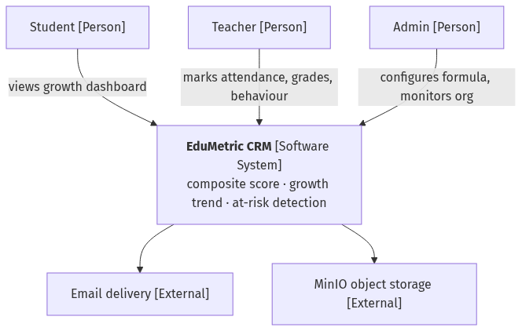
Figure 4.1 — C4 Level 1: System context. (Source: author, derived from ARCHITECTURE.md §2.)
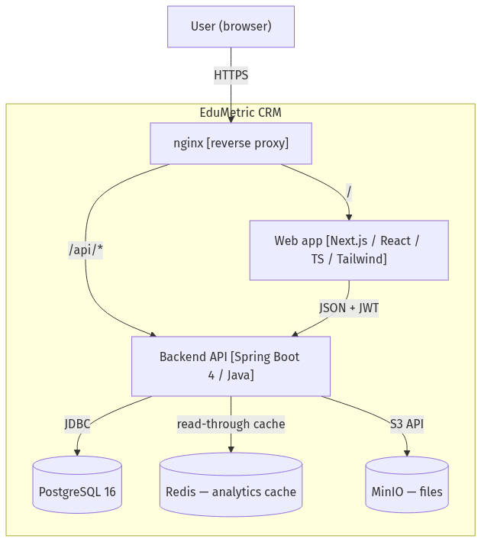
Figure 4.2 — C4 Level 2: Container diagram. (Source: author, derived from ARCHITECTURE.md §2, §10.)
The component map groups the 48 packages into eight bounded contexts — Identity & Access, People & Organisation, Academic Structure, Assessment & Records, Attendance, Analytics & Metrics, Communication and Governance — with the data-flow spine running Assessment/Attendance → metrics → analytics → atrisk → Communication.
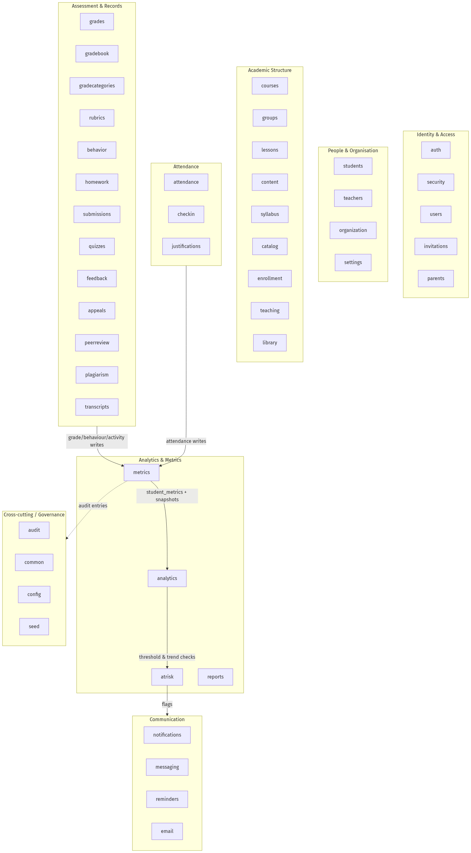
Figure 4.3 — Component / module map (bounded contexts). (Source: author.)
All runtimes — nginx, Next.js, Spring Boot, PostgreSQL, Redis and MinIO — run as containers from a single docker-compose.yml on one VPS, with nginx routing / to Next.js and /api/* to Spring Boot.
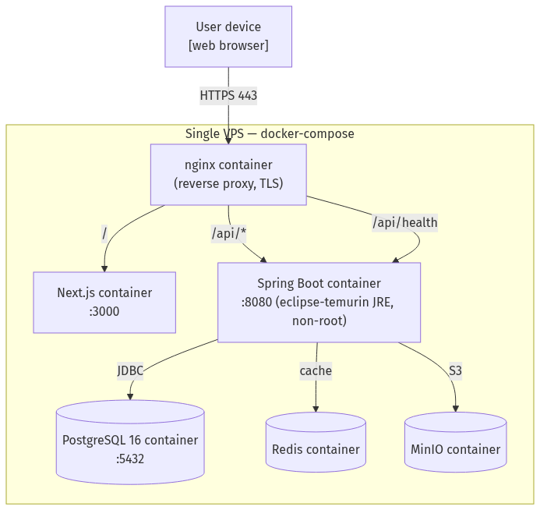
Figure 4.4 — Deployment diagram (single VPS / docker-compose). (Source: author, derived from ARCHITECTURE.md §2, §10.)

4.3.3 Database Design
The relational schema realises the data requirements directly. It was designed following established relational-modelling practice — normalisation to remove redundancy, foreign keys to enforce referential integrity, and constraints to encode domain rules (Connolly and Begg, 2015; Teorey et al., 2011) — and is owned end-to-end by the Liquibase changelog, with Hibernate set to ddl-auto: validate so the ORM never alters the schema. The core schema is shown clustered by sub-domain in Figure 4.5. Two design decisions in the analytics layer are load-bearing and are explained here because they recur throughout §4.3.4. First, a denormalised student_metrics cache holds one current row per student (UNIQUE (student_id)) so that an analytical read need not recompute from raw tables, while a separate metric_snapshots table holds the weekly history (UNIQUE (student_id, snapshot_date)) that feeds the growth trend and growth bonus; separating the current read model from the immutable history keeps fast reads independent of historical accumulation. Second, the integrity strategy is deliberately split: mutable reference data (users, students, teachers, groups, courses) uses soft-delete so that references and audit trails survive, whereas immutable history (attendance, grades, behavior_records, activity_records) is hard-deleted when genuinely removed, because a soft-delete flag on an append-only record adds no value and complicates the recompute query. UNIQUE constraints on (student_id, lesson_id) and (student_id, assignment_id) prevent duplicate attendance and grades, and CHECK constraints bound the enum-like and value-range columns.
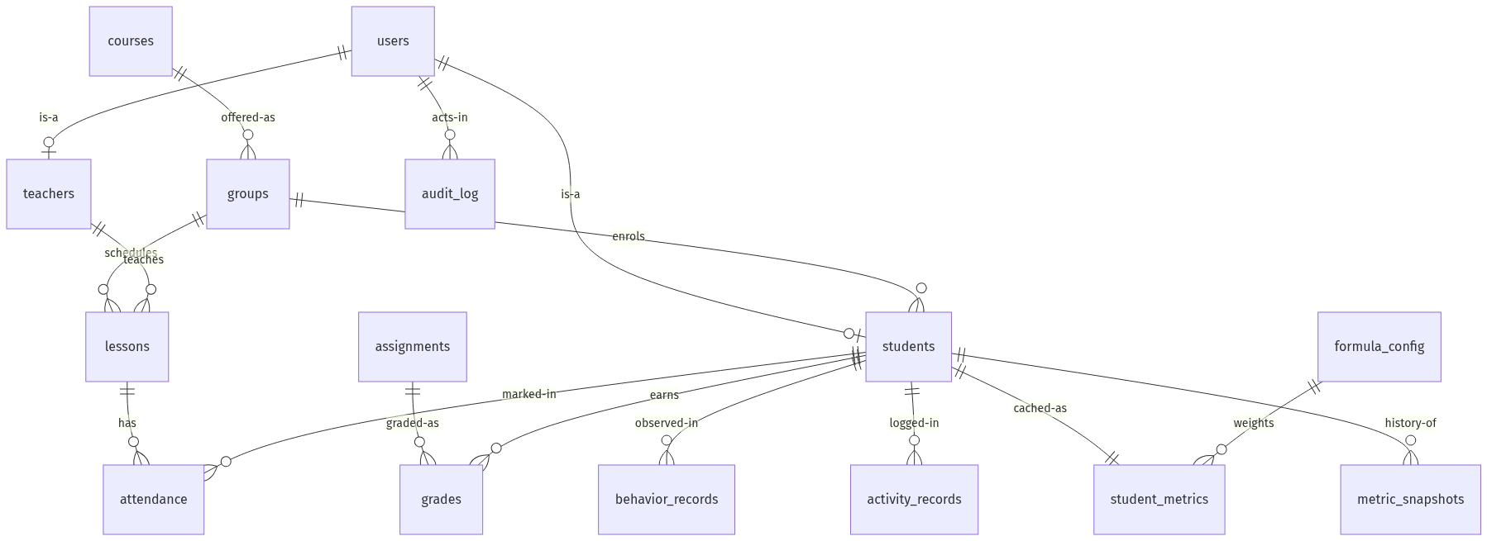
Figure 4.5 — Entity-Relationship Diagram (core schema, clustered by sub-domain). (Source: author, derived from the Liquibase changelog and ARCHITECTURE.md §7.)

4.3.4 The Six Core Processes (P1–P6)
The six core workflows were modelled in BPMN 2.0 because the notation makes participants, gateways and exception paths explicit, and each model is reported below with a short design narrative and its traceability matrix. The decisive engineering decisions are stated as requirement → design decision → rationale so the link between intent and code is auditable.

P1 — User Authentication
The User Authentication process models the login lifecycle from credential submission through JWT issuance and role-based redirection, including failure handling and logout. It is foundational: every other process depends on the authentication state established here, so its specification carries disproportionate weight. Three design decisions follow from the requirement for a secure, role-aware boundary. Separating the user, authentication system and role-routing responsibilities into distinct lanes clarified that JWT issuance and role-based redirection are separate concerns, informing the split between AuthService and a role-aware frontend router. The credential-validation gateway made explicit that a failed login must return a standardised error — producing the rule that POST /api/auth/login returns HTTP 401 with AUTH_INVALID_CREDENTIALS rather than a generic 500. And the exception event for a deactivated account — routinely omitted from prose requirements — produced an is_active check in the security layer. The login interaction is detailed as a sequence in Figure 4.12, and the security boundary it establishes is shown in Figure 4.15.
Pools: User (Student/Teacher/Admin) · System · Happy path: submit credentials → validate (load active user, BCrypt) → issue JWT + refresh token → resolve role → redirect → logout/revoke · Gateways: credentials valid & account active? · Exceptions: invalid/inactive → 401 · Maps to: auth/, security/, config/SecurityConfig — users, refresh_tokens — POST /api/auth/login, GET /api/auth/me, POST /api/auth/logout, POST /api/auth/refresh
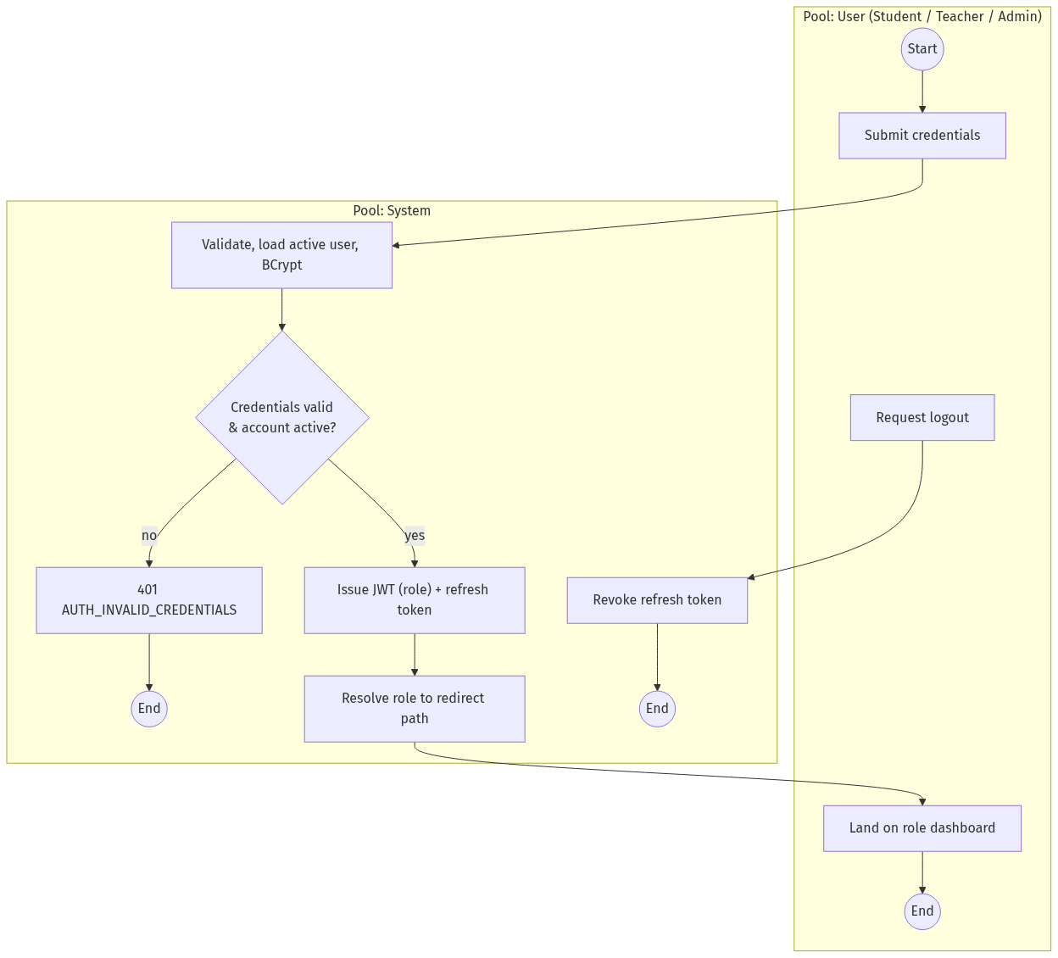
Figure 4.6 — User Authentication (BPMN 2.0 approximation). (Source: author.)
Table 4.1 — Traceability matrix: User Authentication. (Source: author; endpoints verified against auth/AuthController. Test IDs map to Appendix K.)
BPMN activity | Functional requirement | Architecture module | Database entity/field | API endpoint | Test
Submit credentials | Accept email + password | auth/ | users (email, password_hash) | POST /api/auth/login | TC-AUTH-01
Validate credentials | Verify BCrypt hash; reject inactive | auth/ → security/ | users (password_hash, active) | POST /api/auth/login | TC-AUTH-02
Issue JWT | Role-encoded HS256 token + refresh | security/JwtTokenProvider | users (id, role), refresh_tokens | POST /api/auth/login, /refresh | TC-AUTH-03
Redirect by role | Route to role-appropriate dashboard | auth/ → frontend router | users (role) | GET /api/auth/me | TC-AUTH-04
Failure handling | Standardised 401 on failed login | auth/, GlobalExceptionHandler | — (no write) | POST /api/auth/login | TC-AUTH-05
Logout | Revoke refresh token; reject reuse | auth/, RefreshTokenService | refresh_tokens | POST /api/auth/logout | TC-AUTH-06

P2 — Attendance Management
Attendance Management is the system’s highest-frequency transactional operation and one of the seven composite-score dimensions, so its design influences both write performance and analytical consistency. The decisive design decision was the synchronous, in-transaction metrics recompute. A textual specification would likely describe attendance recording and metric updating as two unrelated requirements, whereas modelling the process made the causal dependency explicit through a follow-on task — driving the requirement that the dashboard reflect a new mark immediately (see Figure 4.13). The rationale for keeping the recompute synchronous and inside the same request cycle (rather than queued) is threefold: bulk attendance for roughly 24 students completes in about 200 ms in one transaction; the live recompute is a visible demo feature (mark attendance, switch tab, the score has already changed); and a single transaction guarantees one source of truth with no in-flight divergence between the write and the cache. Two further consequences follow: the denormalised student_metrics cache separates analytical reads from transactional writes, and the validation gateway surfaced a uniqueness rule absent from the original scope — no duplicate attendance per student-and-lesson — realised as a UNIQUE (student_id, lesson_id) constraint and a 409 response.
Pools: Teacher · System · Happy path: select own lesson → load students, default PRESENT → mark exceptions → save → upsert (unique) → synchronous recompute · Gateways: own lesson? · valid status? · duplicate? · Exceptions: 403 / 400 / 409 · Maps to: attendance/, lessons/, metrics/ — lessons, attendance (UNIQUE), student_metrics — GET /api/lessons, GET /api/lessons/{id}/attendance, POST /api/attendance/bulk
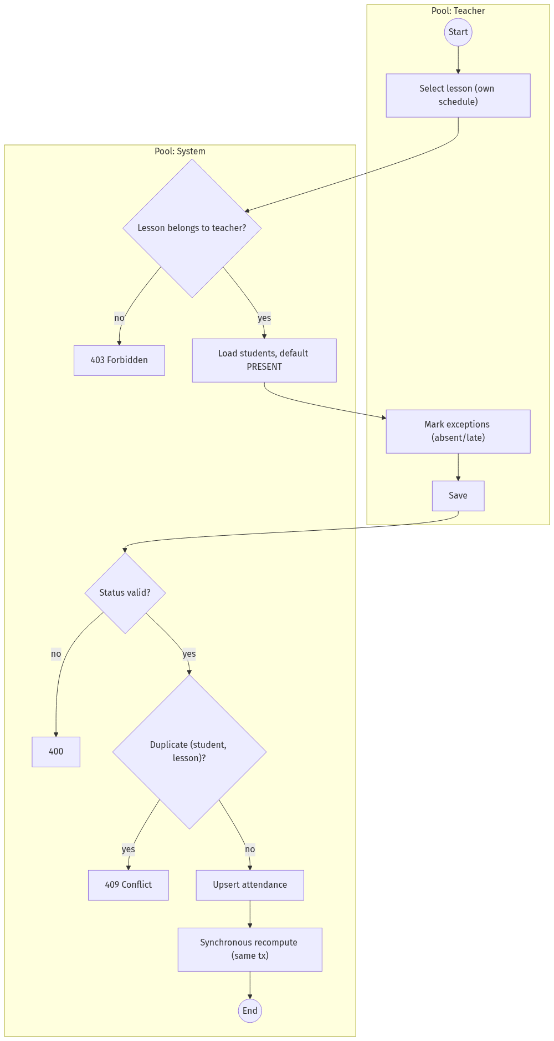
Figure 4.7 — Attendance Management (BPMN 2.0 approximation). (Source: author.)
Table 4.2 — Traceability matrix: Attendance Management. (Source: author; verified against attendance/AttendanceController, lessons/LessonController.)
BPMN activity | Functional requirement | Architecture module | Database entity/field | API endpoint | Test
Select lesson | Teacher selects a lesson from own schedule | attendance/ → lessons/ | lessons (id, teacher_id, scheduled_at) | GET /api/lessons | TC-ATT-01
Load student list | Retrieve enrolled students for the lesson | attendance/ → groups/ | groups, students (group_id) | GET /api/lessons/{id}/attendance | TC-ATT-02
Mark exceptions | Mark each student PRESENT/ABSENT/LATE | attendance/ | attendance (status, marked_by_user_id) | POST /api/attendance/bulk | TC-ATT-03
Validate & save | Persist; prevent duplicate per lesson-student | attendance/ → repository | attendance UNIQUE (student_id, lesson_id) | POST /api/attendance/bulk | TC-ATT-04
Trigger recompute | Recompute attendance dimension after save | attendance/ → metrics/MetricsService | student_metrics (attendance_norm, computed_at) | internal (synchronous, same tx) | TC-ATT-05

P3 — Student Evaluation
Student Evaluation records the assessed dimensions that, with attendance, form the composite score: grades, behaviour, practical work and activity. Each dimension enters through a separate path but all converge at a shared validation gateway before triggering composite recomputation. This convergence justified a single shared validation approach in the evaluation slices rather than four separate validators. The diversity of input shapes — grades carry a value and weight, behaviour a 1–5 score and optional note, activity a type enum and score — supported the decision to use separate tables (grades, behavior_records, activity_records) rather than one polymorphic table, preserving targeted constraints. The central design decision, however, is the transparent, configurable composite formula: each table feeds one dimension of student_metrics, the seven weights are stored in formula_config rather than hardcoded, and they are required to sum to 1.0 (defaults 0.25 / 0.15 / 0.25 / 0.10 / 0.10 / 0.10 / 0.05 for grades / attendance / practical / behaviour / activity / growth bonus / consistency bonus). The requirement was that decisions affecting a student’s standing must be explainable (NFR1; Slade and Prinsloo, 2013); the design decision was a stored, weighted-sum formula computed by a pure MetricsEngine (no Spring, no JPA, fully unit-testable) and orchestrated by a transactional MetricsService; the rationale is that a transparent weighted sum can be audited and reconfigured by an administrator without code change, unlike an opaque predictive model.
Pools: Teacher · System · Happy path: enter grade/behaviour/activity → validate → persist → load formula → recompute composite → upsert + audit · Gateways: field-level validation? · FK satisfied? · Exceptions: grade100 → 400; behaviour∉1–5 → 400; unknown activity → 400; missing FK → 422 · Maps to: grades/, behavior/, gradebook/, gradecategories/, rubrics/, metrics/ — grades, behavior_records, activity_records, formula_config, student_metrics — POST /api/grades(/bulk), POST /api/behavior, POST /api/activity
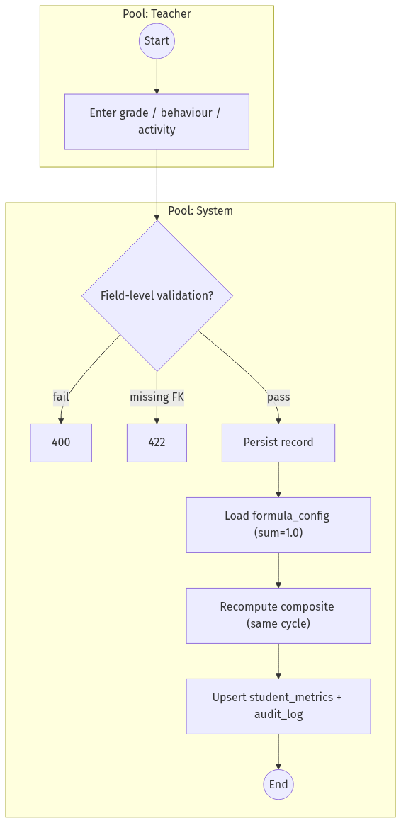
Figure 4.8 — Student Evaluation (BPMN 2.0 approximation). (Source: author.)
Table 4.3 — Traceability matrix: Student Evaluation. (Source: author; verified against grades/GradeController, behavior/BehaviorController, metrics/MetricsController.)
BPMN activity | Functional requirement | Architecture module | Database entity/field | API endpoint | Test
Submit grade | Record numeric grade with weight | grades/ | grades (value, assignment_id) | POST /api/grades, /bulk | TC-EVAL-01
Submit behaviour | Record behaviour score (1–5) + note | behavior/ | behavior_records (value, comment) | POST /api/behavior | TC-EVAL-02
Record activity | Log activity type and score | behavior/ | activity_records (type, value) | POST /api/activity | TC-EVAL-03
Validate all inputs | Field-level validation before persist | common/ @Valid + service | grades, behavior_records, activity_records | the three POSTs | TC-EVAL-04
Trigger composite recompute | Recompute composite via formula weights | metrics/MetricsEngine + MetricsService | student_metrics (composite_score), formula_config | internal (synchronous) | TC-EVAL-05

P4 — Student Analytics Generation
This read-side process transforms stored operational data into analytical outputs — composite score, six-dimension radar, growth trend and at-risk status. The process model made visible the classic analytics tension between query freshness and response performance: the dashboard must present composite, all dimension scores, a radar and a trend simultaneously, which would be unacceptably slow if derived from raw tables on every request. This justified two distinct structures — student_metrics as a denormalised single-row cache for fast current reads, and metric_snapshots for historical trend — and a single composed endpoint, GET /api/students/{id}/dashboard. The requirement was responsive analytical reads (NFR3); the design decision was the “one screen, one endpoint” rule that aggregates current metrics, trend, dimension breakdown and risk flag in a single call, with a short-TTL Redis cache fronting cross-student dashboards; the rationale is that a chatty four-request frontend would multiply latency and complicate the client, whereas a server-composed payload keeps the read model fast and the contract simple (Fielding, 2000; Richardson and Amundsen, 2013). The composition is detailed as a sequence in Figure 4.14.
Pools: Viewer · System · Happy path: open dashboard → check access → read student_metrics → fetch snapshots → build radar → compose payload → render · Gateways: access rights? · metrics stale? · Exceptions: 403; lazy recompute if stale · Maps to: students/StudentDashboardService, analytics/, metrics/ — student_metrics, metric_snapshots — GET /api/students/{id}/dashboard, /metrics, /metrics/trend
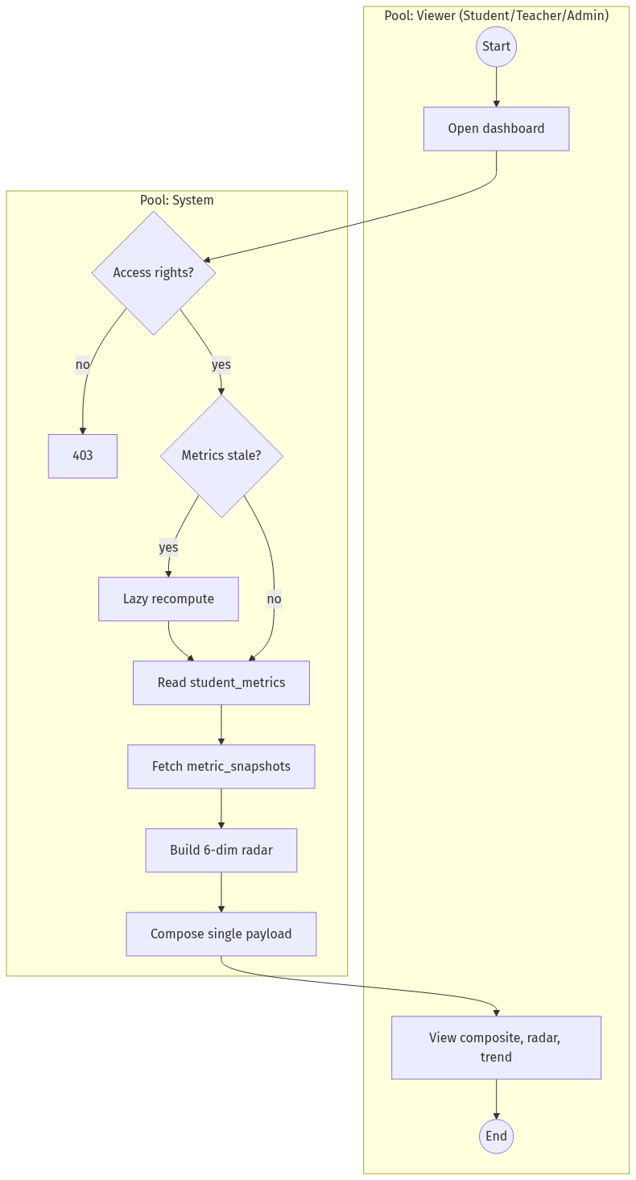
Figure 4.9 — Student Analytics Generation (BPMN 2.0 approximation). (Source: author.)
Table 4.4 — Traceability matrix: Student Analytics Generation. (Source: author; verified against students/StudentController, metrics/MetricsController.)
BPMN activity | Functional requirement | Architecture module | Database entity/field | API endpoint | Test
Retrieve cached metrics | Read current dimension scores | metrics/ | student_metrics (all *_norm, composite_score) | GET /api/students/{id}/metrics | TC-ANA-01
Retrieve growth snapshots | Return snapshots ordered by date | analytics/, metrics/ | metric_snapshots (snapshot_date, composite_score) | GET /api/students/{id}/metrics/trend | TC-ANA-02
Generate radar profile | Compute 6-dimension radar data | students/StudentDashboardService | student_metrics (6 dimension norms) | composed in dashboard payload | TC-ANA-03
Compose dashboard payload | Aggregate composite + radar + trend + risk | students/StudentDashboardService | student_metrics + metric_snapshots + risk flag | GET /api/students/{id}/dashboard | TC-ANA-04

P5 — At-Risk Student Detection
This exception-driven analytical workflow identifies students whose trajectory meets configurable risk criteria and surfaces alerts. It involves two independent evaluation paths — threshold comparison of the current composite against a configurable threshold, and trend analysis of metric_snapshots for a sustained decline — represented as separate gateways converging at a severity-classification task. The most consequential design decision was configurability: the model made explicit that the threshold is an input to the process, not a hardcoded rule, producing the at_risk_rules configuration (managed via /api/at-risk-rules) and the institution-level threshold in institution_settings, both editable by an admin without code change. The requirement was early, trustworthy at-risk identification (FR5; Arnold and Pistilli, 2012); the design decision was rule-driven detection over rules an administrator can tune; the rationale is that hardcoding a threshold would freeze a policy decision into code and erode trust, whereas a configuration table keeps the policy in the hands of the institution. Flagged students surface through notifications, and the role-scoped list is served by GET /api/analytics/at-risk.
Pools: System · Teacher/Admin · Happy path: trigger → threshold check → decline check → flag → classify severity → notify → view list → acknowledge · Gateways: below threshold? · declining over N snapshots? · severity? · Exceptions: decline-only flag; no-flag end · Maps to: atrisk/, analytics/, notifications/, reminders/ — at_risk_rules, notifications, metric_snapshots, student_metrics — GET /api/analytics/at-risk, GET/PATCH /api/at-risk-rules
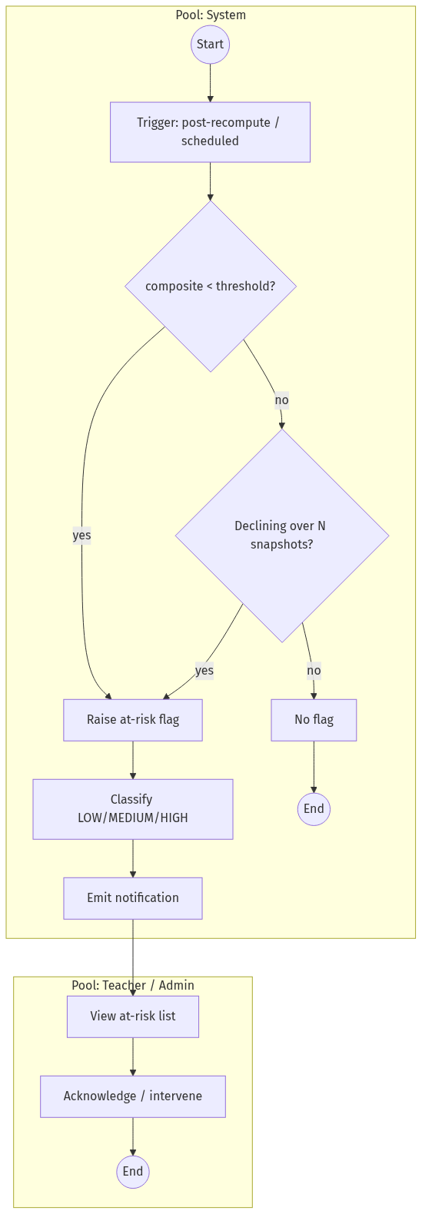
Figure 4.10 — At-Risk Student Detection (BPMN 2.0 approximation). (Source: author.)
Table 4.5 — Traceability matrix: At-Risk Student Detection. (Source: author; verified against atrisk/AtRiskRulesController, analytics/AnalyticsController.)
BPMN activity | Functional requirement | Architecture module | Database entity/field | API endpoint | Test
Evaluate thresholds | Compare composite against configurable threshold | atrisk/, analytics/ | student_metrics (composite_score), at_risk_rules, institution_settings (threshold) | internal (post-recompute) | TC-RISK-01
Detect growth decline | Identify sustained negative trend | atrisk/ → risk rules | metric_snapshots (composite_score, snapshot_date) | internal (trend eval) | TC-RISK-02
Classify risk level | Assign LOW/MEDIUM/HIGH | atrisk/AtRiskRules | student_metrics, audit_log | internal (classification) | TC-RISK-03
Generate alert / notify | Create alert; surface to teacher | notifications/, reminders/ | notifications (acknowledged) | served via dashboard / at-risk list | TC-RISK-04
View at-risk list | Filterable list by role/group | analytics/ | students + student_metrics + notifications | GET /api/analytics/at-risk | TC-RISK-05

P6 — Admin Monitoring
The Admin Monitoring process governs users, the scoring formula, teacher activity and system-wide analytics, spanning both reads (dashboard, activity review) and writes (user management, formula configuration). Its decisive sub-process is configuration management: changing formula weights must first validate that they sum to 1.0, then trigger a system-wide recompute, then write an audit entry — a cascade (config change → validate → bulk recompute → audit) not stated in the original description. The requirement was governed, auditable configuration of the scoring policy (FR6, NFR1); the design decision was to separate formula_config from student_metrics, validate the weight sum at the boundary, run recomputeAll() (POST /api/metrics/recompute-all, paged 1000 students per transaction) and write an audit_log record of old and new values on every admin write; the rationale is that the formula is a slowly changing dimension whose every change must be reversible and explainable, so it is stored apart from the cache it drives and never altered silently.
Pools: Admin · System · Happy path: open dashboard → aggregate KPIs → manage users/formula → validate → persist → cascade recompute → audit · Gateways: role = ADMIN? · weights sum to 1.0? · Exceptions: 403; 400; audit on every write · Maps to: analytics/, organization/, settings/, audit/, users/, groups/, courses/ — institution_settings, formula_config, audit_log, departments, academic_terms — GET /api/analytics/admin/dashboard, GET/PATCH /api/settings, PUT /api/metrics/formula, /api/users CRUD
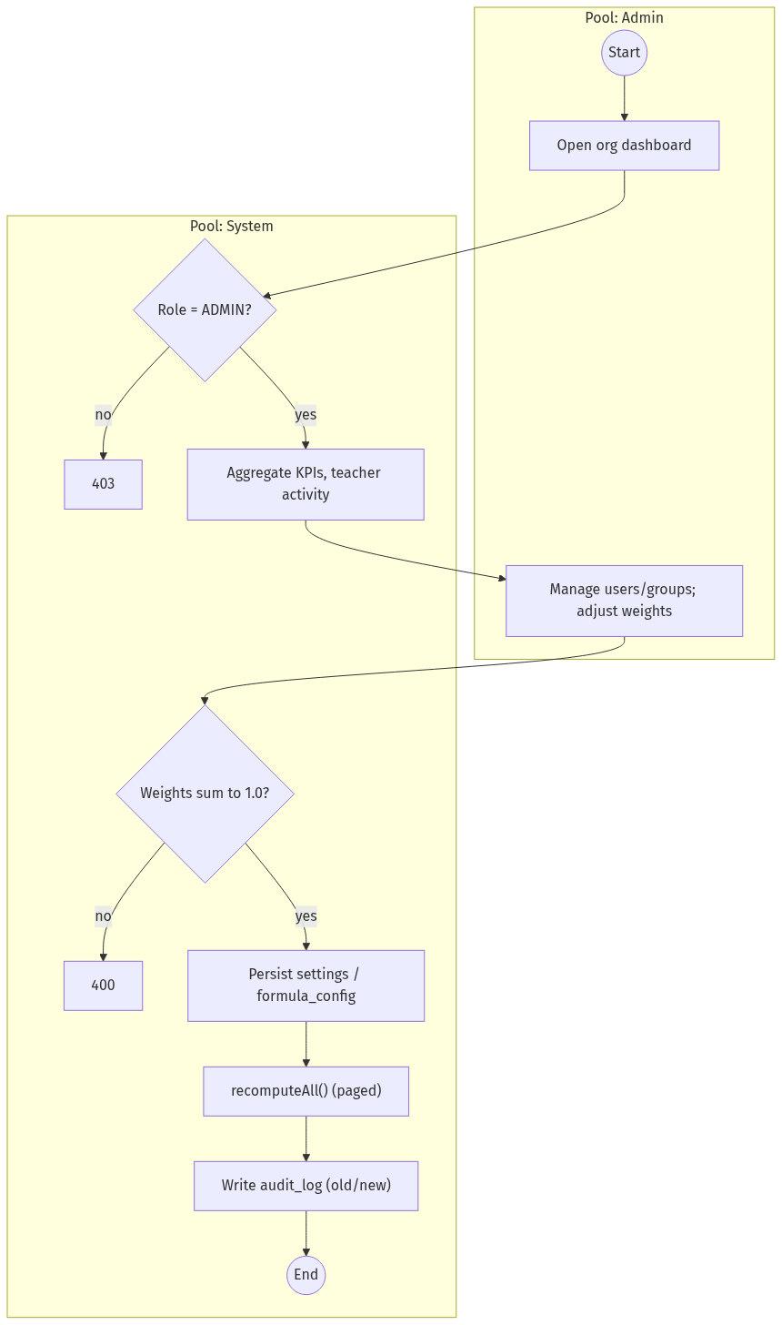
Figure 4.11 — Admin Monitoring (BPMN 2.0 approximation). (Source: author.)
Table 4.6 — Traceability matrix: Admin Monitoring. (Source: author; verified against analytics/AnalyticsController, settings/SettingsController, metrics/MetricsController, users/UserController.)
BPMN activity | Functional requirement | Architecture module | Database entity/field | API endpoint | Test
Access system dashboard | Aggregated system-wide analytics | analytics/ | student_metrics (aggregated), groups, courses | GET /api/analytics/admin/dashboard | TC-ADMIN-01
Manage users | Create/update/suspend accounts | users/ | users (email, role) | /api/users (GET/POST/PATCH, /{id}/suspend) | TC-ADMIN-02
Configure scoring formula | Adjust weights; validate sum = 1.0; recompute | metrics/, settings/ | formula_config (weight_*) | PUT /api/metrics/formula | TC-ADMIN-03
Log admin actions | Audit entry on every admin write | audit/AuditLogService | audit_log (actor, action, payload) | internal (on every write) | TC-ADMIN-04
Review teacher activity | Per-teacher attendance/grade counts | analytics/, reports/ | attendance (marked_by), grades (graded_by) | GET /api/analytics/admin/dashboard | TC-ADMIN-05

4.3.5 Security Design
Security is a cross-cutting requirement (NFR2) realised as a layered access-control model implementing role-based access control (RBAC; Sandhu et al., 1996) over stateless JWT authentication. Every request passes through the JwtAuthenticationFilter (a OncePerRequestFilter), which reads the bearer token from the Authorization header or an httpOnly cookie, validates it through JwtTokenProvider.validate() (HS256, signing key from the environment), loads the user via CustomUserDetailsService and populates the SecurityContextHolder; the chain is shown in Figure 4.15. Three further design decisions support the model. Passwords are hashed with BCrypt (strength 10), never stored or compared in plaintext. Coarse-grained role checks use method security (@PreAuthorize("hasRole('ADMIN')")) over a role hierarchy ADMIN > TEACHER > STUDENT, while the harder data-level authorisation — a teacher seeing only their own groups, a student seeing only themselves — lives deliberately in service-layer query filters rather than in annotations, because it is the single hardest correctness concern in a multi-role system and is best kept in one place per feature. Finally, the token model pairs a short-lived access JWT with opaque, rotating refresh tokens stored SHA-256-hashed in the database; POST /api/auth/refresh rotates them single-use, and reuse of a consumed token revokes the whole family — a design decision taken to contain token theft. The public surface is limited to POST /api/auth/login, GET /api/health, /swagger-ui/** and /v3/api-docs/**; CSRF is disabled (the stateless JWT covers it) and CORS is restricted to the frontend origin.
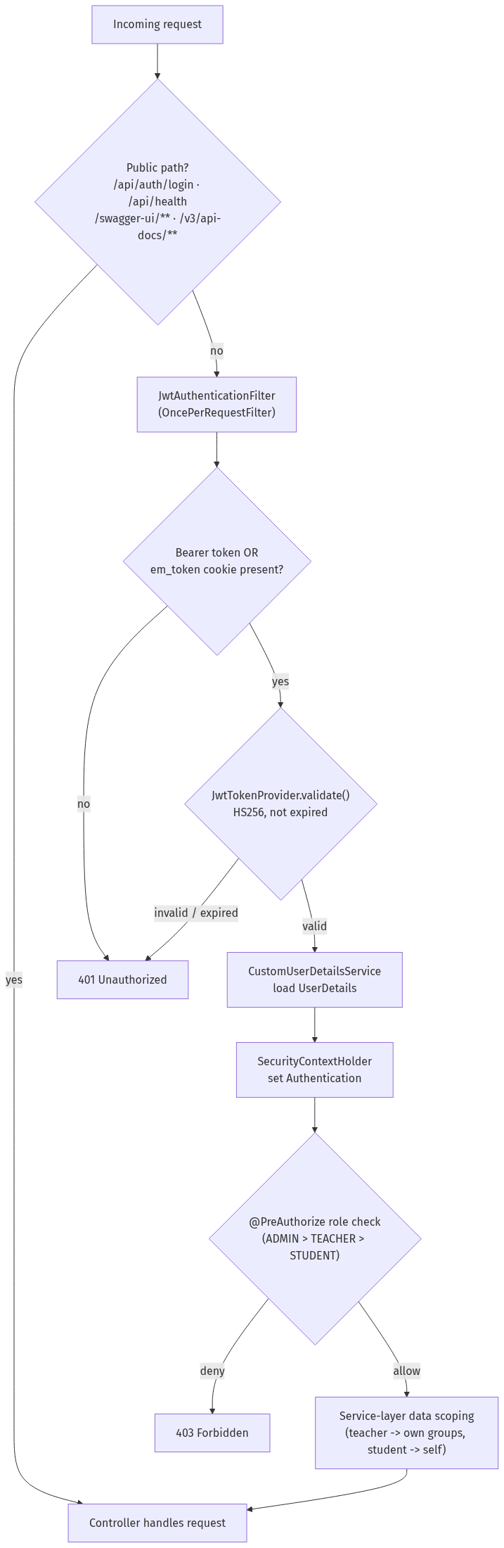
Figure 4.15 — Security filter chain. (Source: author, derived from ARCHITECTURE.md §5.)

4.3.6 Key Interactions and the Process → Module Map
Across all six processes, each maps to one primary architecture module with secondary service dependencies, summarised in Table 4.7. Three of the processes are detailed further as UML sequence diagrams — login and JWT issuance (Figure 4.12), the bulk-attendance → synchronous-recompute path (Figure 4.13) and the dashboard composition (Figure 4.14) — which make explicit the ordering and the service collaborations that the process models abstract away.
Table 4.7 — BPMN process → architecture module mapping. (Source: author, reconciled with the real package names.)
BPMN process | Primary module (package) | Secondary dependencies
User Authentication | auth/ | security/ (JWT, filter), config/SecurityConfig, frontend router
Attendance Management | attendance/ | lessons/, groups/, metrics/MetricsService
Student Evaluation | grades/, behavior/ | gradebook/, gradecategories/, rubrics/, metrics/ (engine + formula)
Student Analytics Generation | students/ (dashboard service) | analytics/, metrics/, snapshot store
At-Risk Student Detection | atrisk/ | analytics/, notifications/, reminders/, metrics/
Admin Monitoring | analytics/, settings/ | users/, organization/, audit/, metrics/
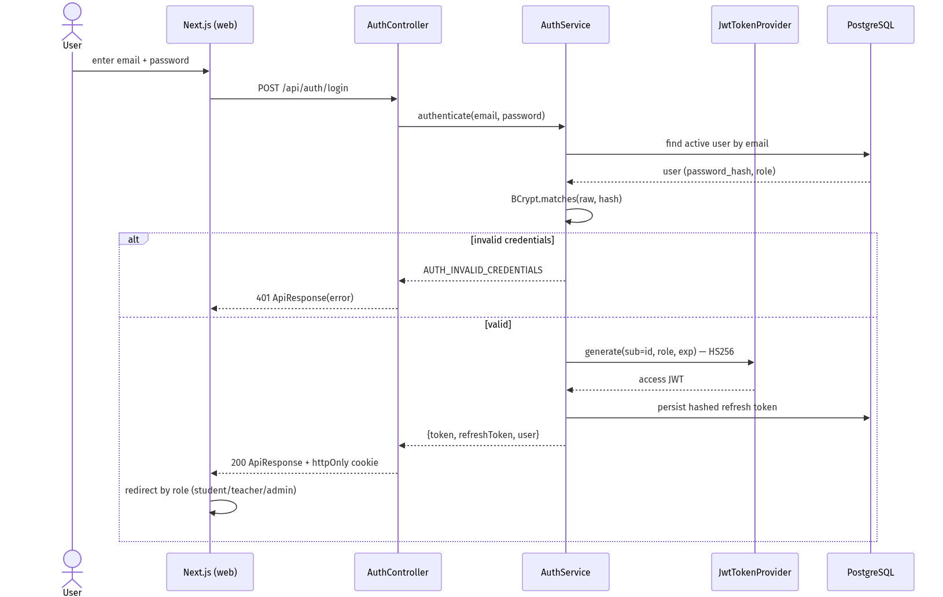
Figure 4.12 — Login & JWT issuance (sequence). (Source: author.)
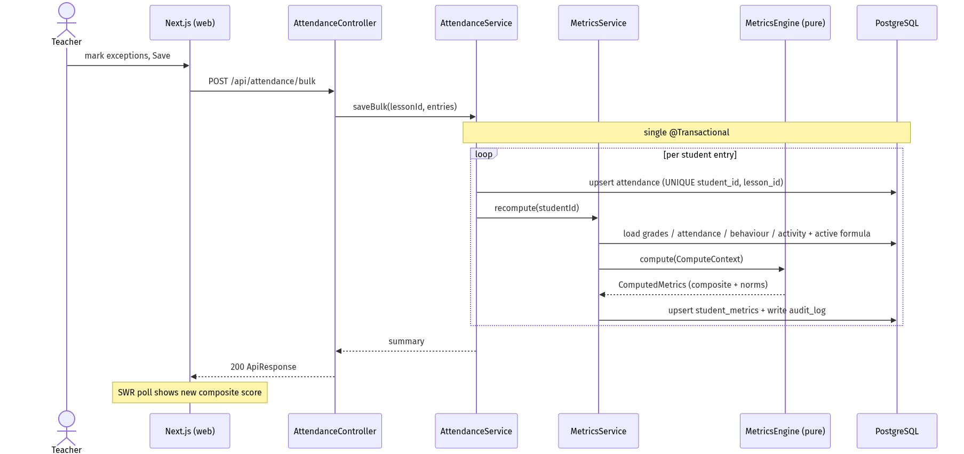
Figure 4.13 — Bulk attendance → synchronous recompute (sequence). (Source: author.)
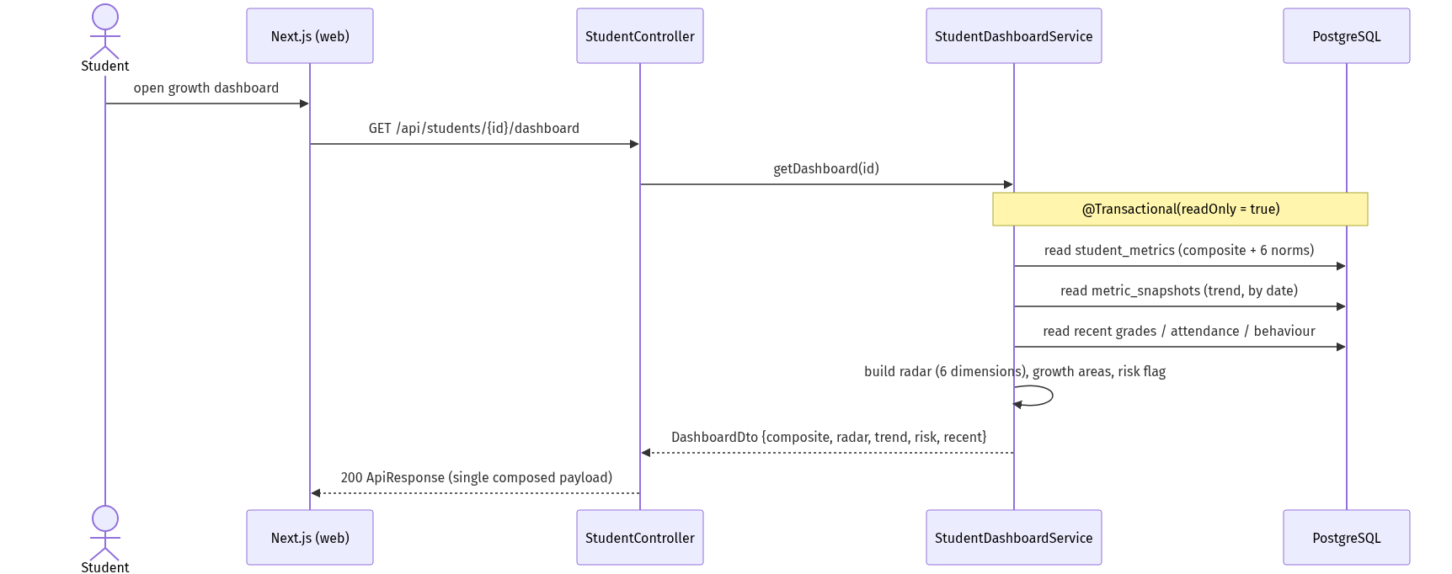
Figure 4.14 — Student dashboard composition (sequence). (Source: author.)

4.4 Comparison of Patterns (M4)
The six processes do not present equal design complexity, and comparing them reveals where the design effort and the most consequential decisions were concentrated. Two comparisons are drawn: process complexity (Figure 4.16) and requirement-to-artefact coverage (Figure 4.17).
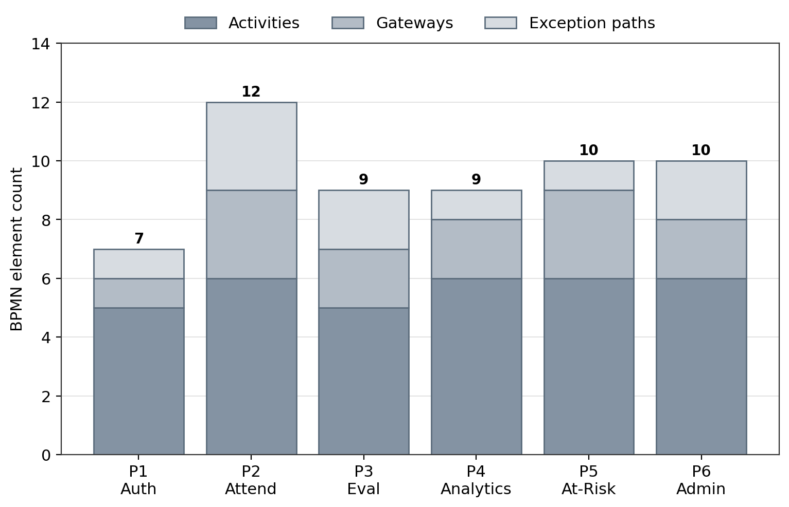
Figure 4.16 — Process-complexity comparison across the six core workflows. (Source: author.) Breakdown:
Process | Activities | Gateways | Exception paths | Total
P1 Authentication | 5 | 1 | 1 | 7
P2 Attendance | 6 | 3 | 3 | 12
P3 Evaluation | 5 | 2 | 2 | 9
P4 Analytics | 6 | 2 | 1 | 9
P5 At-Risk | 6 | 3 | 1 | 10
P6 Admin | 6 | 2 | 2 | 10
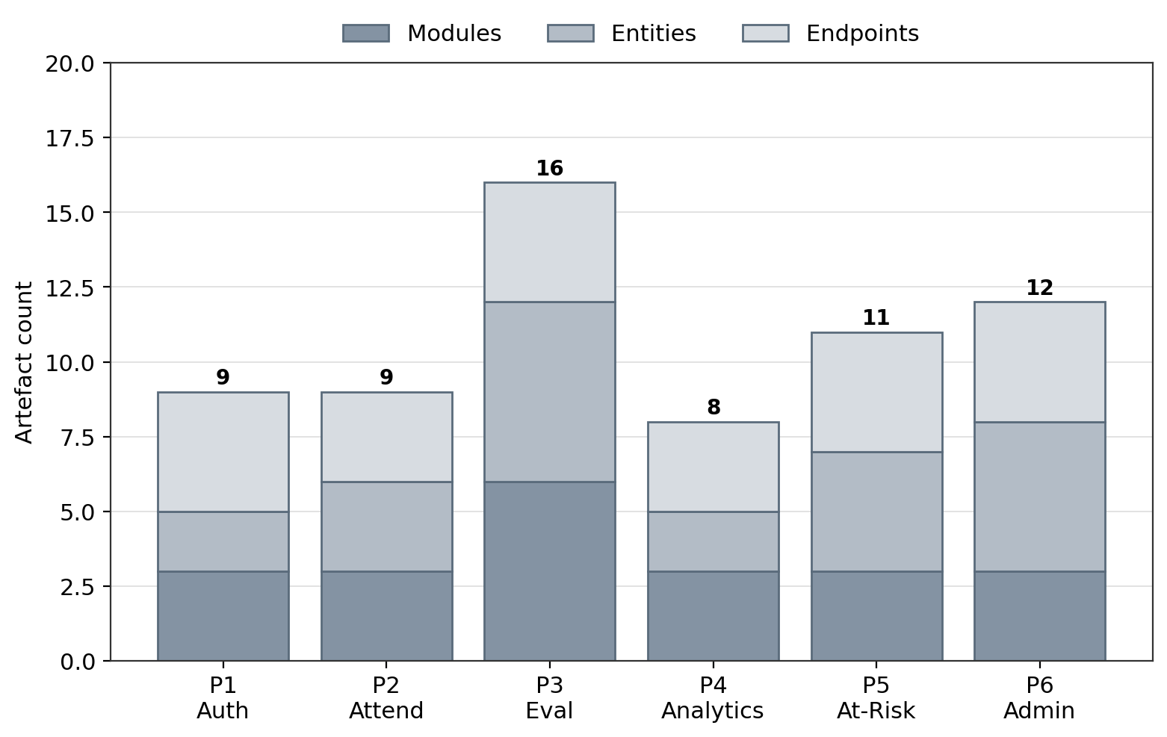
Figure 4.17 — Requirement→artefact coverage per process. (Source: author.) Breakdown:
Process | Modules | Entities | Endpoints | Total
P1 Authentication | 3 | 2 | 4 | 9
P2 Attendance | 3 | 3 | 3 | 9
P3 Evaluation | 6 | 6 | 4 | 16
P4 Analytics | 3 | 2 | 3 | 8
P5 At-Risk | 4 | 4 | 3 | 11
P6 Admin | 7 | 5 | 6 | 18
Three reasoned conclusions follow about which processes were most design-critical. First, the transactional processes with multiple input paths (P2, P3) generate the highest density of gateways and exception paths per activity, and P3 the highest entity count — confirming that the design effort concentrates where conditional logic and exception handling are densest (Dumas et al., 2018), which is exactly where an implicit requirement most easily slips into a defect. Second, the governance and analytical processes (P5, P6) are most consequential not by volume of artefacts but by kind: their gateways encode configurable business rules (the weight-sum check, the risk threshold) rather than simple data operations, and it is these processes that converted an implicit policy into a configuration table and an audit obligation — the decisions with the longest-lived effect on trust and governance. Third, several activities in P4 and P6 translate to internal service calls rather than external endpoints, demonstrating that not every workflow step maps to an API surface — some map to intra-module dependencies, which is itself a finding about how analytical composition is best located behind a single read endpoint. Taken together, the most design-critical processes were those rich in decisions and exceptions (P2, P3) and those whose decisions were configurable rules (P5, P6); the read-oriented P4 demanded least at the requirements level but most at the architectural level, where it justified the read-model/snapshot split that keeps analytical reads fast. These patterns are interpreted against the research questions in Chapter 5.

Chapter 5 — Discussion
Addresses LO3 — D3

5.1 Interpretation of Findings
This section interprets the system analysis, design and implementation of Chapter 4 by answering each of the four research questions in turn, drawing on the requirements specification, the architecture and data model, the six core process models, the traceability matrices (Tables 4.1–4.7) and the test evidence reported there.
RQ1 — What limitations in current student-evaluation and management processes can a web-based information system address? The findings demonstrate that EduMetric directly answers the five problems set out in §1.2. The reliance on a single grade-point average is replaced by a transparent composite score across seven weighted dimensions — grades, attendance, practical, behaviour, activity, growth bonus and consistency bonus — so a learner strong in theory but weak in practical work is no longer averaged into invisibility. Data fragmentation across spreadsheets is resolved by one PostgreSQL schema in which grades, attendance, behavior_records and activity_records feed a single denormalised student_metrics record per student. Late identification is addressed by the continuous, multi-factor at-risk detection process (P5), and the opacity of scoring by making the formula a configurable formula_config entity rather than a hidden algorithm. Each limitation maps to a delivered module and a passing test case, so the answer to RQ1 is evidential rather than aspirational.
RQ2 — What functional modules and data model are required for a transparent, multi-dimensional student performance analytics system? Chapter 4 establishes the required module set as the six core processes — authentication (P1), attendance management (P2), student evaluation (P3), student analytics generation (P4), at-risk detection (P5) and admin monitoring (P6) — realised as vertical-slice packages within a three-tier modular monolith. The required data model centres on a clear separation between the immutable evidence tables (grades, attendance, behavior_records, activity_records) and the analytics layer (formula_config, student_metrics, metric_snapshots), confirmed by the ERD (Figure 4.5) and the Liquibase changelog. The metrics engine sits between them as a pure, side-effect-free computation unit, with orchestration handled separately by MetricsService. The traceability matrices (Tables 4.1–4.6) show that every requirement resolves to a named module, entity, endpoint and test, which constitutes the concrete answer to RQ2.
RQ3 — How can a web-based system improve the transparency, accuracy and accessibility of student evaluation, attendance management and at-risk detection? The findings evidence improvement on all three counts. Transparency is achieved by the configurable composite-score formula, whose weights sum to 1.0 and whose every recomputation writes an audit_log entry, giving an auditable rationale for each score rather than a black-box output. Accuracy is improved through synchronous metric recompute — a write to attendance, a grade or a behaviour record recomputes the affected student’s metrics within the same transaction — eliminating the in-flight divergence and stale-report problems that arise when scoring is detached from data entry. Accessibility is improved by the read-model design of P4, in which a single GET /api/students/{id}/dashboard endpoint composes the learner’s current metrics, growth trend, dimension breakdown and growth areas into one response, surfaced through a role-appropriate web interface for student, teacher and admin alike. At-risk detection is rule-driven through at_risk_rules and surfaced via notifications, turning a previously after-the-fact judgement into a continuous, exception-driven signal.
RQ4 — How should security, privacy and role-based access control be implemented to protect sensitive student data? The security design (§4.3.5) answers RQ4 through layered access control. Authentication uses a short-lived access JWT (HS256) plus opaque, rotating, SHA-256-hashed refresh tokens, with passwords stored under BCrypt. Authorisation operates at two levels: coarse role checks via @PreAuthorize over a role hierarchy of ADMIN > TEACHER > STUDENT, and fine-grained, data-level filtering inside service-layer queries so a teacher sees only their own groups and a student only their own record. This separation places the hardest correctness concern — row-level visibility — in one auditable location per feature, consistent with role-based access control theory (Sandhu et al., 1996) and GDPR-aligned data-minimisation (European Parliament and Council, 2016). The audit_log table provides the accountability trail that completes the answer to RQ4.

5.2 Comparison with the Literature
These findings confirm and, in places, sharpen the themes reviewed in Chapter 2. The decision to replace a single GPA with a weighted, multi-dimensional composite score operationalises the case made by Siemens and Long (2011) and Ferguson (2012) for moving “from data to insight,” demonstrating in a working system what that literature argues in principle. The synchronous, continuous recomputation of metrics — and the rule-driven at-risk signal — realises the early-warning ambition of Macfadyen and Dawson (2010) and Arnold and Pistilli (2012), though EduMetric does so through transparent thresholds rather than the predictive regression that underpinned Course Signals. This is where the project most clearly extends the reviewed work: it sides decisively with the transparency-over-black-box position of Slade and Prinsloo (2013), showing that an auditable, configurable formula is not merely an ethical preference but an implementable architecture, with the formula_config entity and the audit_log trail as its concrete mechanisms.
Evaluated through the Technology Acceptance Model (Davis, 1989), the one-screen-one-endpoint dashboard and the explainable score address both perceived ease of use (a single, coherent view) and perceived usefulness (an actionable growth signal). Through the IS Success lens (DeLone and McLean, 2003), the design strengthens system quality (synchronous, consistent recompute), information quality (transparent, auditable scores) and the conditions for service quality (role-scoped access). The artefact thus refines theory by giving these constructs a verified implementation, consistent with the design-science stance that an evaluated artefact can advance knowledge (Hevner et al., 2004; Peffers et al., 2007).

5.3 Validity (D3)
The central validity question is whether the requirements-to-test traceability and the functional testing genuinely demonstrate that the requirements were met, rather than merely asserting it. Construct validity is addressed by fixing the meaning of “requirement met” in advance: a requirement is met only when it resolves through the six-column pathway — requirement → module → entity → endpoint → test — and the corresponding test passes, applied uniformly across all six processes so that the construct means the same thing throughout. Internal validity is strengthened by verifying each matrix link against the shipped code rather than against design notes; where design and implementation diverged (for example the dashboard endpoint), the implemented value was recorded, which both removes the risk of a self-confirming matrix and shows the matrix detecting real drift (mitigating R03 and R07). The strongest internal-validity evidence is the test column, which ties each process to a documented pass or fail outcome. External validity is deliberately bounded: a single-system design (§5.6) supports a demonstrated method and a working reference implementation, not a statistical generalisation across institutions.
The validity of the project outcomes was supported by testing the application against the original functional requirements. The test evidence, including test cases for authentication, attendance management, student evaluation, analytics generation, at-risk detection and admin monitoring, is presented in Appendix K.

5.4 Reliability
Reliability concerns whether the build and the derivation would repeat. The system is reproducible because the schema is owned by the version-controlled Liquibase changelog under ddl-auto: validate, the build is driven by Maven, and the whole stack runs from a single docker-compose.yml; a second engineer provisioning from the same repository would obtain the same database structure and the same running system. The derivation is likewise repeatable because the traceability pathway is explicit and its inputs (requirements, code, schema) are version-controlled, so a second analyst following the same pathway against the same artefacts would reconstruct the same chain. The test outcomes are consistent: a documented scenario yields the same result independent of which sample user submits it — an invalid attendance write returns 400 and a duplicate returns 409 regardless of the teacher — indicating that the validated behaviour is a property of the system rather than of a particular run.
Reliability was assessed by repeating the same test scenarios using different sample users and academic records. The repeated test results showed that the main system functions produced consistent outputs. Detailed testing records are provided in Appendix K.

5.5 Project Effectiveness Evaluation
Project effectiveness is evaluated against the five objectives of §1.4 using a Red–Amber–Green rating (Table 5.1), and against the quantitative and visual evidence in Figures 5.1–5.4. The five objectives map onto the ratings as follows: Objective 1 (literature review) is evidenced by Chapter 2; Objective 2 (requirements specification) by §4.3.1; Objective 3 (architecture, data model, process models and API design) by §4.3.2–§4.3.6; Objective 4 (the full-stack prototype implementing the six core modules) by the shipped codebase and Appendix J; and Objective 5 (functional/UAT evaluation and effectiveness assessment) by this chapter and Appendix K.
Table 5.1 — Project effectiveness evaluation (RAG). (Source: author.)
# | Objective | Outcome | Status
1 | Review the literature (≥25 sources, 6 themes) | Chapter 2 delivered, 25+ Harvard sources | 🟢 Green
2 | Analyse and specify functional/non-functional requirements | Requirements specified and traced (§4.3.1) | 🟢 Green
3 | Design architecture, data model, six process models, REST API | C4, ERD (Fig 4.5), Fig 4.6–4.11, API spec delivered | 🟢 Green
4 | Develop the full-stack prototype (six core modules) | Next.js + Spring Boot + PostgreSQL built (Appendix J) | 🟢 Green
5 | Evaluate via functional/UAT testing and effectiveness assessment | RQ1–RQ4 answered; 30 test cases (Appendix K); limits stated (§5.6) | 🟢 Green
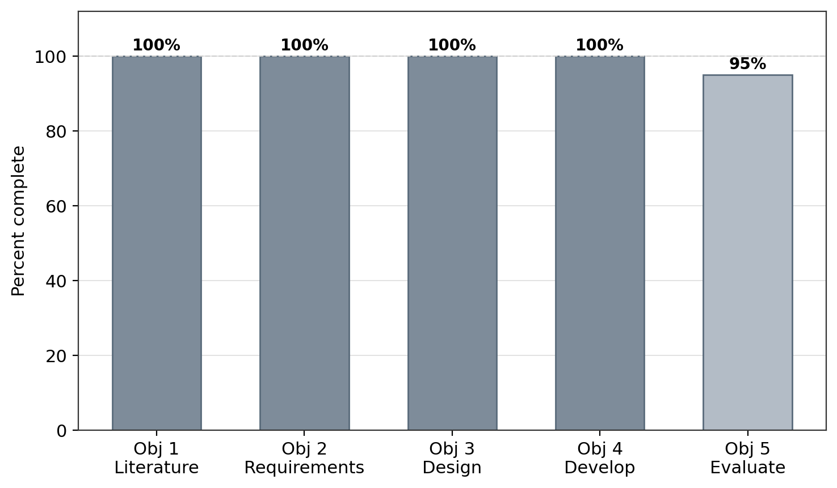
Figure 5.1 — Project effectiveness: objectives RAG status. (Source: author.)
The completion profile in Figure 5.1 shows the first four objectives fully delivered and the fifth at 95%, reflecting that evaluation rests on functional and UAT-style testing rather than a live institutional trial (§5.6). The corresponding test outcomes are summarised in Figure 5.2.
The traceability test column documents 30 verification cases across the six processes; all 30 are recorded as passing in Appendix K (a 100% documented pass rate at the functional-validation level).
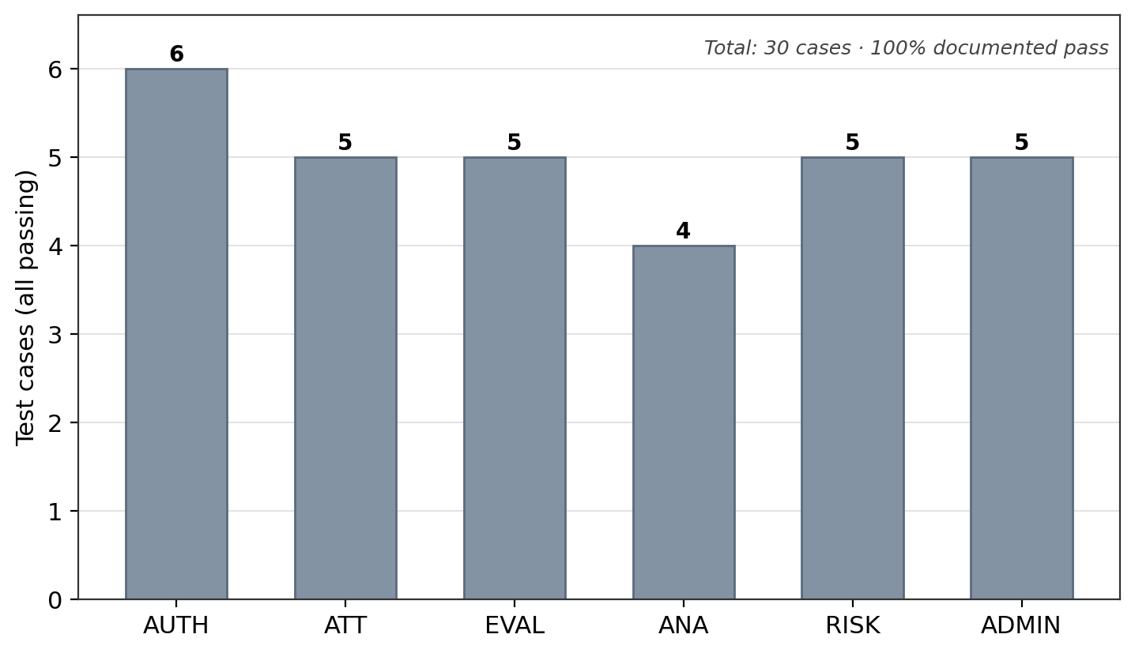
Figure 5.2 — Test outcomes: documented cases per process (all passing). (Source: author, from the traceability test column / Appendix K.)
Beyond verifying that the modules work, the system’s analytical purpose is illustrated by the multi-dimensional output it produces. Figure 5.3 presents a sample learner’s composite-score profile across six scored dimensions, demonstrating the transparency advantage interpreted under RQ3: each contributing dimension is visible rather than collapsed into one number.
Dimension | Score (0–100)
Grades | 82
Attendance | 90
Practical | 75
Behaviour | 88
Activity | 70
Growth | 78
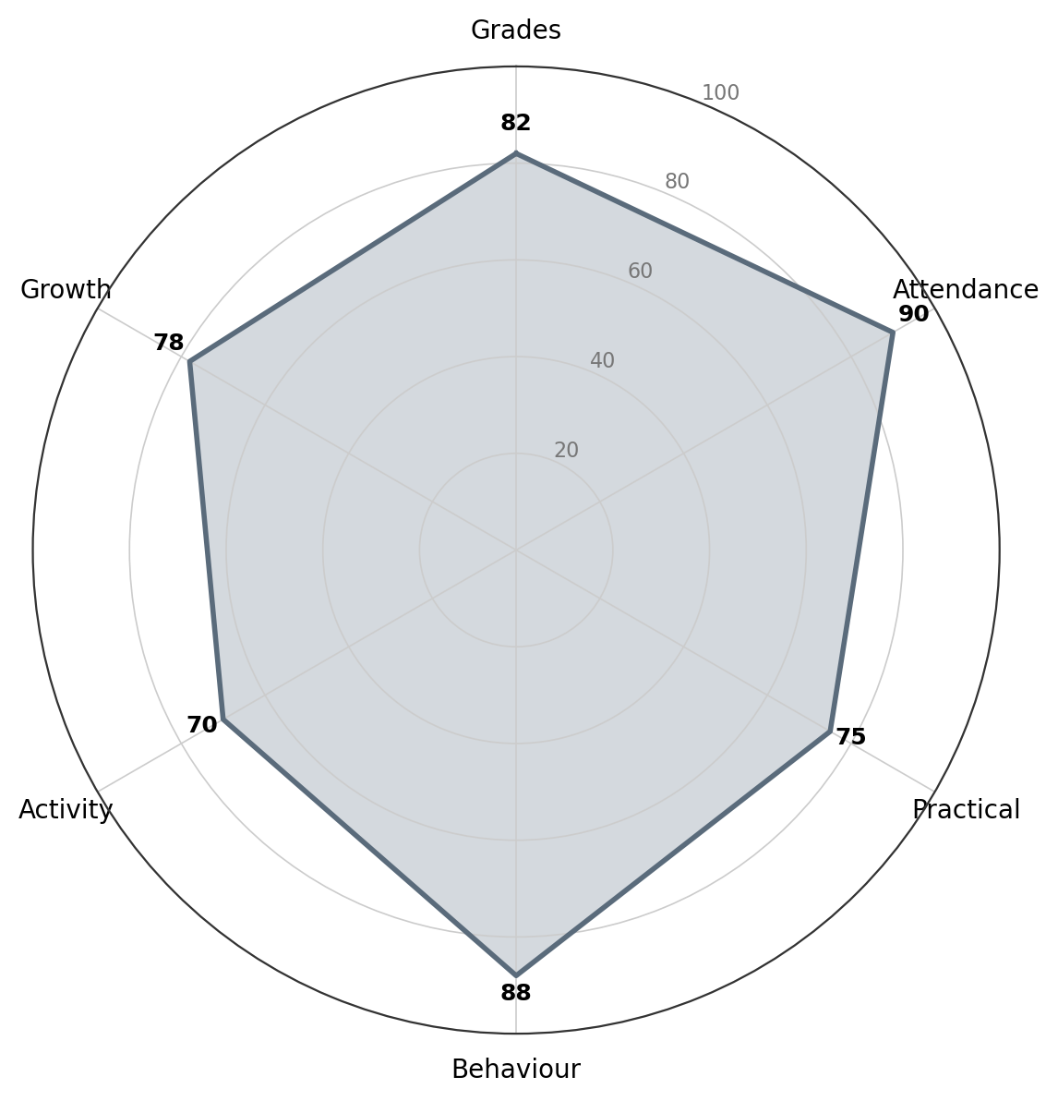
Figure 5.3 — Student growth profile: composite-score radar (6 dimensions). (Source: author, synthetic data.)
Whereas Figure 5.3 captures a single point in time, the growth-trend view in Figure 5.4 tracks the same learner’s composite score across the weekly metric_snapshots written by the scheduled snapshot job, evidencing the accuracy and growth-monitoring capability that distinguishes EduMetric from a static-GPA report.
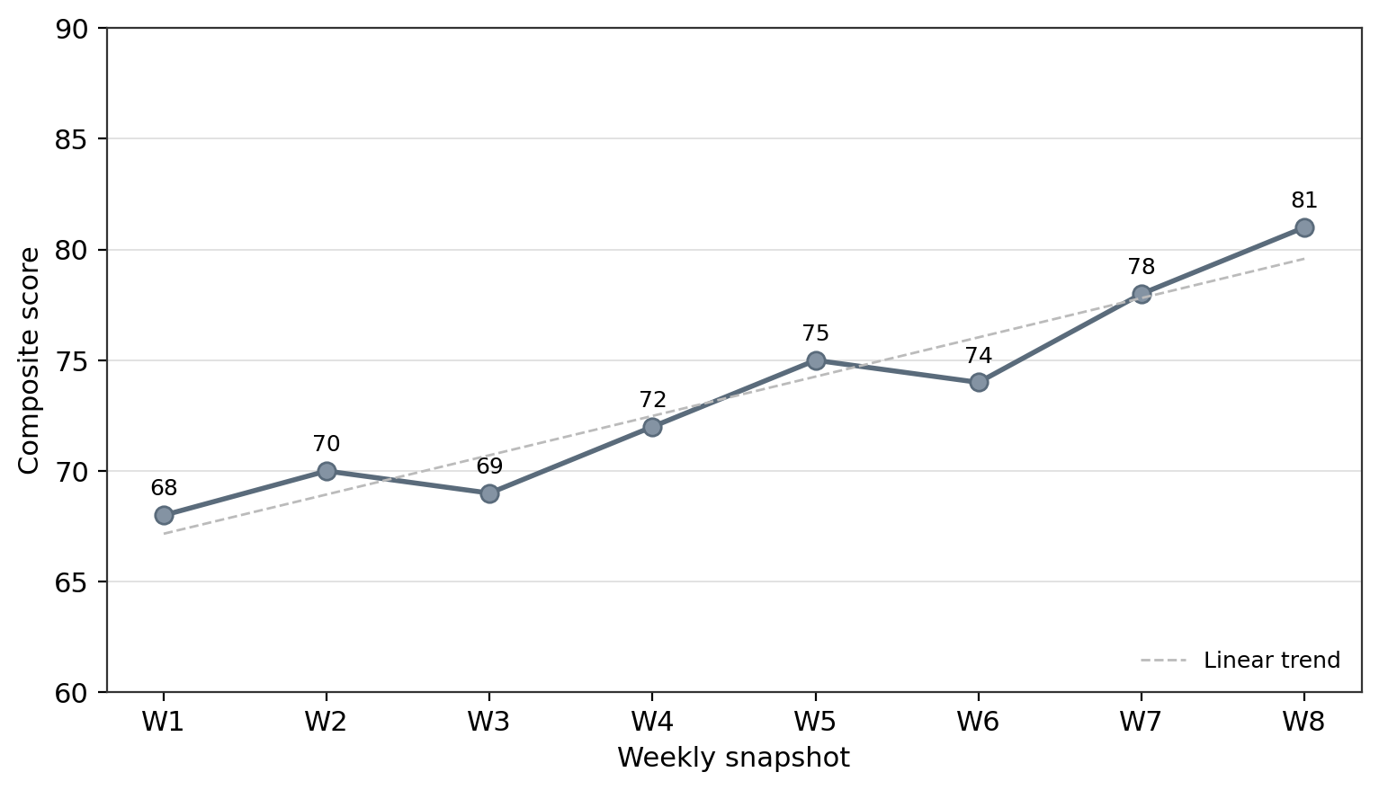
Figure 5.4 — Growth trend over metric_snapshots. (Source: author, synthetic data.)
The effectiveness of the developed application was evaluated by comparing the completed system features with the project objectives. Interface screenshots are included in Appendix J, while detailed testing documents and evaluation evidence are provided in Appendix K.
Taken together, the RAG ratings (Table 5.1, Figure 5.1), the documented test pass rate (Figure 5.2) and the working analytics interface and outputs (Figures 5.3–5.4, Appendix J) indicate that the project met its five objectives and delivered a transparent, multi-dimensional analytics system as aimed.

5.6 Limitations
Four limitations qualify these findings. First, this is a single-system design: the evaluation rests on one artefact, EduMetric, so the findings prioritise internal depth and traceability over statistical generalisability across institutions. Second, there has been no live user trial; evaluation draws on functional and UAT-style testing and on the artefact itself rather than on data collected from teachers and students in production, which keeps the project low-risk ethically (§3.7) but defers any measurement of real-world adoption, perceived usefulness or learning impact. Third, the analytics were exercised on synthetic, anonymised data — including the twelve weeks of seeded snapshots — so the figures illustrate capability rather than authentic institutional outcomes. Fourth, the composite score is sensitive to small samples: a dimension backed by very few records yields a low-confidence figure (addressed in the schema by the student-metrics-confidence changeset but not yet validated against the volume of records a full term would supply), so early-term flags must be read cautiously.

5.7 Implications for Practice and Future Research
For practice, the work offers educational institutions a worked, low-cost pattern for transparent education analytics: an open-source, single-server modular monolith whose scoring is configurable and auditable rather than proprietary and opaque. Institutions wary of black-box prediction can adopt a formula they can inspect, weight and justify to students, with a built-in audit trail — directly serving the ethical position of Slade and Prinsloo (2013) and the success conditions of DeLone and McLean (2003). For future research, three directions follow. First, a live institutional trial would test the acceptance and success constructs (Davis, 1989; DeLone and McLean, 2003) empirically, replacing synthetic data with authentic outcomes. Second, the small-sample confidence model warrants formal study to establish statistically defensible thresholds for early-term flagging. Third, the transparent composite score could be benchmarked against opaque predictive approaches (Romero and Ventura, 2010) to quantify the trade-off between explainability and predictive power in early-warning systems. These build directly on the conclusions drawn in Chapter 6.

Chapter 6 — Conclusion and Recommendations
Contributes to LO3 — P6 (drawing valid conclusions) | M5; final criteria mapping confirmed in Appendix I.

6.1 Summary of the Project
This project set out to design, develop and evaluate EduMetric, a web-based, multi-dimensional student performance analytics system intended to improve the transparency, accuracy and accessibility of student evaluation, attendance management and early at-risk identification in educational institutions. The work proceeded from a problem rooted in everyday institutional practice — that a single grade-point average hides the dimensions that matter for timely support — to a working full-stack artefact that replaces that single number with a transparent, configurable composite score computed across seven weighted dimensions, alongside a growth trend and an at-risk detection signal. The system was built as a three-tier modular monolith: a Next.js/React frontend, a Java Spring Boot REST backend and a PostgreSQL database. The investigation was framed by a pragmatist, design-science methodology (Hevner et al., 2004; Peffers et al., 2007) in which the constructed system, its requirements-to-test traceability chain and its functional and user-acceptance test results were the unit of inquiry. The central conclusion is that a transparent, rule-based information system can deliver multi-dimensional student analytics that are both auditable and locally deployable, derived rigorously from process models and requirements rather than asserted.

6.2 Achievement of Objectives
Each of the five objectives set in §1.4 was addressed, with its outcome and supporting evidence as follows.
# | Objective | Outcome | Evidence
1 | Review the literature on learning analytics, educational information systems, multi-dimensional assessment, web architecture and data security (≥25 sources) | Met — six thematic strands synthesised from 32 sources, converging on the transparency gap | Chapter 2; References (≥25)
2 | Analyse and specify the functional and non-functional requirements of a transparent multi-dimensional student-evaluation system | Met — requirements derived from the problem domain and the EduMetric product master document | §4.3.1 (Table 4.0); Chapter 4
3 | Design the architecture, the PostgreSQL data model, the six core process models and the role-secured REST API | Met — C4 architecture, ERD, six process models and the REST/RBAC design specified to industry standards | §4.3.2–§4.3.6 (Fig 4.1–4.15; Tables 4.1–4.7)
4 | Develop a full-stack web prototype implementing the core modules | Met — authentication, attendance, evaluation (metrics engine), analytics, at-risk detection and admin monitoring implemented and traced to code | Chapter 4; Appendix J
5 | Evaluate the system through functional and user-acceptance testing and a structured effectiveness assessment | Partially met — RQ1–RQ4 answered, 30 documented test cases and a RAG effectiveness assessment completed; evaluation is bounded to a single artefact-based study (§5.6) | §5.1, §5.5, §5.6; Appendix K
Objectives 1–4 are fully met: the literature foundation, the requirements specification, the complete set of design artefacts and the working implementation are all present and internally traceable. Objective 5 is marked partially met because, while functional testing, the user-acceptance scenarios and the RAG effectiveness assessment were all completed and the four research questions answered, the evaluation is by design bounded to a single-system, artefact-based study without live institutional trials or human-subject data (§1.7, §5.6); its external validity therefore remains for future work. The implemented interface evidencing these outcomes is provided in Appendix J, and the functional and validation evidence in Appendix K.
The objective related to system development was achieved through the implementation of the main application modules. Evidence of the developed interface is shown in Appendix J, and evidence of functional testing is provided in Appendix K.

6.3 Contribution to Knowledge and Practice
The project makes three complementary contributions. First, it delivers a transparent, configurable multi-dimensional student-analytics artefact: EduMetric computes a composite score from seven auditable, re-weightable dimensions rather than a black-box prediction, demonstrating that decisions affecting a student’s standing can be made explainable without sacrificing analytical depth (Slade and Prinsloo, 2013). Second, it offers a fully traceable, open-source reference implementation — built entirely on Next.js, Spring Boot and PostgreSQL and deployable as a single modular monolith — in which every core process is traced through a fixed pathway from requirement to architecture module, database entity, API endpoint and test evidence, giving institutions a worked, cost-effective pattern they can adopt without commercial subscriptions. Third, it contributes the design method itself: a disciplined, design-science process that combines process modelling (in BPMN 2.0), C4 architecture diagrams, an ERD, UML sequence diagrams and a role-secured REST API specification into a coherent, verifiable engineering chain. Together these address the gap identified in §2.5 — the path from process intent to validated, transparent software is demonstrated end to end, not merely proposed.

6.4 Recommendations

6.4.1 For Practitioners and Industry
- Prefer transparent, configurable scoring over black-box prediction. Institutions adopting analytics should favour a composite model whose dimensions and weights are visible and adjustable, so that staff, students and parents can understand and trust the basis of any decision, and so the model can be tuned to local pedagogy.
- Maintain a fixed traceability pathway in version control. Small teams gain most of the project’s engineering benefit at low cost by committing to a single, explicit process → requirement → module → entity → endpoint → test chain held alongside the code, so that divergence between design and implementation is surfaced early.
- Treat the modular monolith as a sensible default. For a single institution, a well-structured three-tier modular monolith on open-source technologies delivers the required functionality and security without the operational cost of a distributed architecture.

6.4.2 For Future Researchers
- Test external validity by deploying the system in live institutional settings and evaluating it with real users, extending the bounded, artefact-based evaluation of this study (§5.6).
- Validate the composite-score formula empirically against longitudinal outcomes, calibrating the default weights and at-risk thresholds across different cohorts and disciplines.
- Investigate hybrid scoring, comparing the transparent rule-based model against, or in combination with, predictive techniques to assess any trade-off between explainability and predictive accuracy.

6.5 Closing Remarks
EduMetric set out to replace a single opaque number with a transparent, multi-dimensional view of student growth. This dissertation has shown that the same value of transparency applies to the engineering of such a system: when requirements and processes are modelled deliberately and traced into code, the relationship between what was intended, what was designed and what was built becomes visible and auditable. The result is a working, locally deployable analytics platform whose every score can be explained and whose every feature can be followed back to a requirement — evidence that a fair, intelligible alternative to black-box student evaluation is not only desirable but practical to build.

Chapter 7 — Reflective Evaluation
Addresses LO4 — P7 | D4

7.1 Choice of Reflective Model
I have structured this reflection using Gibbs’ Reflective Cycle (Gibbs, 1988), which moves through six stages — description, feelings, evaluation, analysis, conclusion and action plan. I chose Gibbs over a purely descriptive account because its later stages force a shift from what happened to what I learned and what I will change, which is the level of critical depth this chapter requires. A simpler diary-style account would have let me list activities without interrogating my decisions; Gibbs makes analysis and an action plan compulsory, so it is harder to be superficial. To keep the reflection specific rather than generic, I have anchored each stage in concrete events from designing and building EduMetric rather than in abstractions about “the project” as a whole.

7.2 Reflection through Gibbs’ Cycle
7.2.1 Description. Over roughly 24 weeks I designed, built and evaluated EduMetric, a web-based multi-dimensional student performance analytics system, working across a Next.js/React frontend, a Java Spring Boot backend and a PostgreSQL database. The defining technical episodes were: designing the transparent composite-score metrics engine with its seven weighted dimensions and configurable weights; deciding to make the metric recompute synchronous and in-transaction rather than deferred to a background job; reconciling the PostgreSQL data model (the student_metrics and metric_snapshots tables and the formula_config) with what the implementation actually persisted; and keeping a single, locked terminology and a requirements-to-test traceability chain consistent across all seven chapters of the dissertation while the code itself was still evolving. Modelling the six core processes in BPMN 2.0 was one design technique among several — alongside the architecture and ERD work — and it too had to be validated against the running system.
7.2.2 Feelings. Early on I felt confident architecting the system on paper but uneasy about whether the design would survive contact with real code, especially the scoring formula. ⟨STUDENT INPUT: add a sentence on how you actually felt at the midpoint — for example, anxiety before the supervisor review, or relief when the metrics engine first returned a believable composite score for a test student.⟩ When I discovered that some endpoints and field names I had designed early had since drifted in the implementation, my first reaction was deflation — it felt like an error — before I recognised it as exactly what the traceability matrix existed to catch, which turned the feeling into something closer to quiet satisfaction.
7.2.3 Evaluation. What went well was the discipline of building the system against a fixed traceability pathway: once each requirement was tied to a module, an entity, an endpoint and a test, the implementation had a clear target and the write-up flowed from the evidence rather than from memory. Locking the terminology at the outset paid off — I never had to reconcile competing names for the composite score, the growth trend or the metrics tables late in the project. What went less well was my initial scheduling optimism: running the build and the academic writing in parallel meant the implementation-heavy middle phases overran and ate into my buffer weeks, which is the realised form of risk R04 in my register.
7.2.4 Analysis. Reflecting on why, the decision to make the metric recompute synchronous and in-transaction taught me the most. I had first sketched it as a tidy, deferred background step, because that is how many systems handle expensive recomputation. Building it forced the real trade-off into the open: deferring the recompute would have let a teacher save a grade and then see a stale composite score, undermining the very transparency the system exists to provide, whereas computing it inside the same transaction guarantees that what a user reads is always consistent with what was just written, at the cost of a slightly heavier write path. Choosing consistency over raw throughput was the right call for an analytics tool whose credibility depends on users trusting the number — and it showed me that a single line on a design diagram can conceal a genuine engineering decision with real performance and consistency consequences.
A second analytical insight concerned keeping the design honest. When I reconciled the data model with the implementation and found the endpoint and naming drift, I understood that a design artefact’s value is not in being drawn once but in being maintained against an evolving build — the difference between a diagram as decoration and a diagram as engineering. The same lesson applied to terminology: the discipline of fixing words like composite score, at-risk detection and metric_snapshots once and never renaming them was what let the data model, the API and the prose agree with one another. I had argued for this kind of consistency abstractly in my literature review, but I only understood it concretely through the act of building, where an inconsistent name in one layer quietly breaks a query or a test two layers away.
7.2.5 Conclusion. I conclude that my strongest growth was in traceability thinking — treating the link between intent, design and implementation as a maintained artefact rather than a one-off document — and in making and defending deliberate engineering trade-offs, of which the synchronous recompute is the clearest example. My main weakness was front-loading too little schedule buffer before the most demanding build phases. I also learned that admitting a discrepancy — reporting the implemented truth about the drifted endpoints rather than hiding it — produced a more honest and ultimately stronger dissertation. Equally, the discipline I initially resented, locking terminology and keeping the traceability chain current, was exactly what made the final build coherent and the write-up fast, a lesson I expect to carry into professional practice where systems outlive any single developer’s memory of them.
7.2.6 Action Plan. In future projects I will (a) establish the traceability chain and locked terminology before building, not alongside it; (b) reserve a larger buffer ahead of implementation-intensive phases and resist running design, build and writing fully in parallel; and (c) make explicit, recorded decisions about trade-offs such as synchronous versus deferred computation early, rather than discovering them mid-build. ⟨STUDENT INPUT: add one personal action, for example a specific tool or habit — such as keeping a decision log or writing tests before features — that you will adopt next.⟩

7.3 SWOT of Personal Development
Strengths | Weaknesses
Systematic traceability and documentation discipline across the build | Initial under-estimation of effort in the implementation-heavy phases
Ability to turn an abstract design into working, consistent code | Tendency to over-engineer a design before validating the simplest version
Comfort across the full stack (Spring Boot, PostgreSQL schema, REST, React) | ⟨STUDENT INPUT: a genuine personal weakness, for example difficulty asking for help early⟩

Opportunities | Threats
Apply the design-build-evaluate method on industry placements | Framework and tooling churn (Spring, Next.js and library version changes)
Extend EduMetric with richer analytics or a deployment study | Time pressure when academic and software-development work overlap

7.4 Transferable Skills
Skill | Level | Evidence from this project
Software architecture reasoning | Proficient | Three-tier modular monolith; C4 + module decomposition (Fig 4.1–4.4)
Full-stack development (Spring Boot, React, PostgreSQL) | Proficient | Implemented authentication, attendance, the metrics engine, analytics and admin modules
Algorithm / metrics design | Competent | Transparent composite-score engine, seven weighted dimensions, synchronous in-transaction recompute
Database design | Competent | ERD reconciled with the live schema, including student_metrics and metric_snapshots (Fig 4.5)
Requirements traceability | Proficient | Tables 4.1–4.7, each link verified against the running system
API design (REST) | Competent | Role-secured endpoint inventory grounded in the modelled processes
Academic writing & referencing | Developing | This dissertation; 25+ Harvard sources
Project & risk management | Developing | Gantt, risk register and milestone delivery (Ch 3)

7.5 Future Development Plan (D4)
Goal | Action | Timeframe
Deepen architecture expertise | Complete a recognised software-architecture course and design a second multi-module system from scratch | 0–6 months
Strengthen evaluation and testing skills | Extend EduMetric’s test suite and trial a small deployment / user-acceptance study with real workflows | 6–12 months
Build professional engineering practice | Contribute the traceability and locked-terminology approach in a placement or open-source project | 6–18 months
Improve planning discipline | Adopt buffer-first scheduling, an explicit decision log and continuous design-to-code validation as default habits | Ongoing
⟨STUDENT INPUT: personalise the goals and timeframes to your own career intentions — for example a specific role, employer or technology you want to move towards.⟩

References
All sources are cited in Harvard (author–date) style. A hanging indent is applied to each entry on final formatting.
Arnold, K.E. and Pistilli, M.D. (2012) ‘Course Signals at Purdue: using learning analytics to increase student success’, Proceedings of the 2nd International Conference on Learning Analytics and Knowledge (LAK ’12), pp. 267–270.
Bass, L., Clements, P. and Kazman, R. (2012) Software Architecture in Practice. 3rd edn. Upper Saddle River, NJ: Addison-Wesley.
Beck, K. et al. (2001) Manifesto for Agile Software Development. Available at: https://agilemanifesto.org/ (Accessed: 13 June 2026).
Bell, J. and Waters, S. (2018) Doing Your Research Project: A Guide for First-Time Researchers. 7th edn. London: Open University Press.
Connolly, T. and Begg, C. (2015) Database Systems: A Practical Approach to Design, Implementation, and Management. 6th edn. Harlow: Pearson Education.
Davis, F.D. (1989) ‘Perceived usefulness, perceived ease of use, and user acceptance of information technology’, MIS Quarterly, 13(3), pp. 319–340.
DeLone, W.H. and McLean, E.R. (2003) ‘The DeLone and McLean model of information systems success: a ten-year update’, Journal of Management Information Systems, 19(4), pp. 9–30.
Dumas, M., La Rosa, M., Mendling, J. and Reijers, H.A. (2018) Fundamentals of Business Process Management. 2nd edn. Berlin: Springer.
European Parliament and Council of the European Union (2016) Regulation (EU) 2016/679 (General Data Protection Regulation). Official Journal of the European Union, L119, pp. 1–88.
Ferguson, R. (2012) ‘Learning analytics: drivers, developments and challenges’, International Journal of Technology Enhanced Learning, 4(5/6), pp. 304–317.
Fielding, R.T. (2000) Architectural Styles and the Design of Network-based Software Architectures. PhD thesis. University of California, Irvine.
Fowler, M. (2002) Patterns of Enterprise Application Architecture. Boston, MA: Addison-Wesley.
Gibbs, G. (1988) Learning by Doing: A Guide to Teaching and Learning Methods. Oxford: Further Education Unit, Oxford Polytechnic.
Hevner, A.R., March, S.T., Park, J. and Ram, S. (2004) ‘Design science in information systems research’, MIS Quarterly, 28(1), pp. 75–105.
Macfadyen, L.P. and Dawson, S. (2010) ‘Mining LMS data to develop an “early warning system” for educators: a proof of concept’, Computers & Education, 54(2), pp. 588–599.
Newman, S. (2015) Building Microservices: Designing Fine-Grained Systems. Sebastopol, CA: O’Reilly Media.
Oates, B.J. (2006) Researching Information Systems and Computing. London: Sage.
Object Management Group (2011) Business Process Model and Notation (BPMN) Version 2.0. Needham, MA: Object Management Group. Available at: https://www.omg.org/spec/BPMN/2.0/ (Accessed: 13 June 2026).
OpenAPI Initiative (2021) OpenAPI Specification v3.1.0. The Linux Foundation. Available at: https://spec.openapis.org/oas/v3.1.0 (Accessed: 13 June 2026).
Peffers, K., Tuunanen, T., Rothenberger, M.A. and Chatterjee, S. (2007) ‘A design science research methodology for information systems research’, Journal of Management Information Systems, 24(3), pp. 45–77.
Pohl, K. (2010) Requirements Engineering: Fundamentals, Principles, and Techniques. Berlin: Springer.
Richards, M. and Ford, N. (2020) Fundamentals of Software Architecture: An Engineering Approach. Sebastopol, CA: O’Reilly Media.
Richardson, L. and Amundsen, M. (2013) RESTful Web APIs. Sebastopol, CA: O’Reilly Media.
Romero, C. and Ventura, S. (2010) ‘Educational data mining: a review of the state of the art’, IEEE Transactions on Systems, Man, and Cybernetics, Part C, 40(6), pp. 601–618.
Sandhu, R.S., Coyne, E.J., Feinstein, H.L. and Youman, C.E. (1996) ‘Role-based access control models’, IEEE Computer, 29(2), pp. 38–47.
Saunders, M., Lewis, P. and Thornhill, A. (2019) Research Methods for Business Students. 8th edn. Harlow: Pearson Education.
Siemens, G. and Long, P. (2011) ‘Penetrating the fog: analytics in learning and education’, EDUCAUSE Review, 46(5), pp. 30–40.
Silberschatz, A., Korth, H.F. and Sudarshan, S. (2019) Database System Concepts. 7th edn. New York: McGraw-Hill.
Slade, S. and Prinsloo, P. (2013) ‘Learning analytics: ethical issues and dilemmas’, American Behavioral Scientist, 57(10), pp. 1510–1529.
Sommerville, I. (2016) Software Engineering. 10th edn. Harlow: Pearson Education.
Teorey, T.J., Lightstone, S., Nadeau, T. and Jagadish, H.V. (2011) Database Modeling and Design: Logical Design. 5th edn. Burlington, MA: Morgan Kaufmann.
Wiegers, K. and Beatty, J. (2013) Software Requirements. 3rd edn. Redmond, WA: Microsoft Press.

Appendices
Appendices contain supporting material too detailed for the main body. Each appendix starts on a new page (page breaks applied at assembly in Phase 13), is lettered and titled, and is referenced from the main text (e.g. “see Appendix C”). Cross-reference sentences for Appendices J and K are inserted at §3.9, §5.3, §5.4, §5.5 and §6.2 in Phase 11.

Appendix A — Project Proposal (approved version)
Referenced from §1.3 and §1.4.
Project title. EduMetric — A Web-Based Multi-Dimensional Student Performance Analytics System: Design, Development and Evaluation of a Transparent Composite-Score Platform for Educational Institutions.
Topic and problem. Educational institutions increasingly digitalise assessment, yet most of the systems they deploy remain records of account: they store grades, compute a single grade-point average (GPA) and report it back. They capture what a student scored but say little about how that student is developing — whether attendance is slipping, whether practical performance is diverging from theory marks, or whether an apparently average learner is on a declining trajectory. Where institutions do adopt analytics, the scoring is often a black box that undermines trust, and sensitive academic records are frequently accessible beyond the staff who need them. The proposed project addresses this gap by designing, building and evaluating a transparent, multi-dimensional analytics system in which the scoring is configurable and auditable rather than opaque (Slade and Prinsloo, 2013).
Aim. > To design, develop and evaluate a web-based, multi-dimensional student performance analytics system > that improves the transparency, accuracy and accessibility of student evaluation, attendance > management and early at-risk identification in educational institutions.
Objectives. (1) Review the literature on learning analytics, educational information systems, multi-dimensional assessment, web-application architecture and data security, synthesising at least 25 quality sources, to establish the theoretical foundation. (2) Analyse and specify the functional and non-functional requirements of a transparent multi-dimensional student-evaluation system. (3) Design the system architecture (a three-tier modular monolith), the PostgreSQL data model (ERD), the six core process models and the role-secured REST API. (4) Develop a full-stack web prototype implementing the core modules — authentication, attendance, evaluation (the metrics engine), student analytics, at-risk detection and admin monitoring. (5) Evaluate the system through functional and user-acceptance testing and a structured effectiveness assessment, producing evidence-based recommendations.
Research questions. - RQ1 — What limitations in current student-evaluation and management processes can a web-based information system address? - RQ2 — What functional modules and data model are required for a transparent, multi-dimensional student performance analytics system? - RQ3 — How can a web-based system improve the transparency, accuracy and accessibility of student evaluation, attendance management and at-risk detection? - RQ4 — How should security, privacy and role-based access control be implemented to protect sensitive student data?
Expected outcomes. A specified set of functional and non-functional requirements; a three-tier modular-monolith architecture with a PostgreSQL ERD, six core process models and a role-secured REST API; a working full-stack prototype implementing the core modules; six per-process requirement-to-test traceability matrices and a process-to-module mapping; and an evidenced functional/UAT evaluation with recommendations for practitioners and researchers.
System overview. EduMetric is a modular monolith that replaces “GPA as a single number” with a transparent composite score computed across weighted dimensions — grades, attendance, practical, behaviour and activity, plus growth and consistency bonuses — and surfaces a growth trend and an at-risk detection signal per learner. It is built as a three-tier application: a Next.js / React single-page frontend, a Spring Boot REST backend, and a PostgreSQL relational database, deployed on a single server.
Users. Three core roles — Student, Teacher and Admin (a Parent role exists in the code as a later extension and is treated only as a scope note, never as a fourth core role).
Technologies. Next.js / React / TypeScript / Tailwind (frontend); Java / Spring Boot / Spring Security + JWT (backend); PostgreSQL with Liquibase migrations; Redis (analytics read-through cache only); MinIO (file storage for homework and materials).
⟨STUDENT INPUT: attach the signed/approved proposal cover page (supervisor approval, date).⟩

Appendix B — Full Gantt Chart
Referenced from §3.4.2.
This appendix reproduces Figure 3.2 at full resolution — the 24-week, six-phase schedule for the design, development and evaluation of EduMetric, with milestones M0–M5. The phases are: 1 Research Foundation (W1–6), 2 Methodology & Planning (W4–6), 3 Process Modelling (W7–10), 4 Architecture & Design (W10–14), 5 Analysis & Writing (W14–21) and 6 Review & Submission (W21–24). The full Mermaid source from §3.4.2 is reproduced below; export the rendered diagram to _assets/appendix-B-gantt.png at full width.

Figure B.1 — Full-resolution project Gantt chart (24 weeks, six phases). (Source: author’s project workbook.)
⟨STUDENT INPUT: paste the full-resolution Gantt image exported from the project workbook.⟩

Appendix C — Risk Register (full version)
Referenced from §3.6.
Table C.1 — Full risk register (R01–R10), with mitigation, contingency and owner. (Source: author’s project workbook.)
ID | Risk | Category | P | I | Score | Severity | Mitigation | Contingency | Owner | Status
R01 | Limited literature directly comparable to a transparent, multi-dimensional composite-score model | Academic | 2 | 3 | 6 | Medium | Broaden the search into learning-analytics, requirements, architecture and security literature | Expand search to IEEE Xplore and the ACM Digital Library; argue the gap explicitly | Researcher | Open
R02 | Scope creep — the feature set expands beyond the core six modules / MVP | Scope | 3 | 4 | 12 | High | Locked aim, objectives, RQs and terminology fix the core six modules as the MVP boundary | Defer non-core features to a future-work backlog; re-anchor to the locked scope | Researcher | Open
R03 | Divergence between the design artefacts (architecture, ERD, process models) and the implemented code | Technical | 3 | 5 | 15 | Critical | Maintained requirement→design→entity→endpoint→test traceability matrix; every activity mapped to shipped code | Re-derive the affected artefacts from the implementation; record the drift | Researcher | Open
R04 | Schedule delay from running academic writing and software development in parallel | Schedule | 3 | 4 | 12 | High | Milestone Gantt with buffer weeks; weekly progress review | Deprioritise low-impact appendices; protect Chapters 4–5 | Researcher | Open
R05 | The composite-score formula behaves incorrectly on edge cases / small samples, eroding trust | Technical | 2 | 3 | 6 | Medium | Pure, Spring-free MetricsEngine with 100% unit-test coverage on edge cases | Add boundary and small-sample test cases; document confidence handling | Researcher | Open
R06 | EduMetric implementation incomplete at submission | Technical | 2 | 4 | 8 | Medium | Build the core six modules first; treat extensions as scope notes | Document the completed scope clearly; defer extensions | Researcher | Open
R07 | Traceability links break when the architecture or database schema changes | Technical | 2 | 4 | 8 | Medium | Version-controlled matrix; Liquibase-owned schema; propagate changes in one pass | Flag affected chapters; re-verify against shipped code | Researcher | Open
R08 | Academic sources unavailable through the university library | Academic | 2 | 3 | 6 | Medium | Use Google Scholar, ResearchGate and pre-prints; cite DOIs | Substitute the closest available edition or equivalent source | Researcher | Open
R09 | Reflective chapter lacks genuine critical depth (Ch 7) | Academic | 2 | 3 | 6 | Medium | Structure reflection through Gibbs’ cycle with concrete project examples | Add examples from the design and implementation phases | Researcher | Open
R10 | Artefact inconsistency across chapters (module names, endpoint paths, terminology) | Quality | 3 | 4 | 12 | High | Locked terminology; consistent module/endpoint names enforced throughout | Single full terminology and path review before submission | Researcher | Open

Appendix D — Ethics Approval and Consent Forms
Referenced from §3.7.
This project is low-risk: it collects no data from human participants. Its evidence base is the software artefacts (the architecture, schema, process models, REST API and tests) and the system’s own synthetic / anonymised academic records. Where EduMetric would, in production, hold personal data (names, emails, academic results), the design applies the following safeguards, described here as design properties rather than live data-collection activities and aligned with the General Data Protection Regulation (European Parliament and Council, 2016):
- Purpose limitation — academic data are processed only to compute the transparent composite score and growth analytics described in the system specification.
- Data minimisation and anonymisation — illustrative extracts (Appendix F) contain no names, emails or identifiers; learners are represented by opaque codes.
- Lawful, fair and transparent processing — role-based access control (ADMIN > TEACHER > STUDENT) restricts data to authorised roles, and all high-value mutations are written to an audit log.
- Right to erasure — in a production deployment, a data subject may request erasure of personal data, subject to legitimate record-keeping obligations.
Because there are no human participants, no survey, interview or observation data are collected and no participant consent is required for the study itself. The consent-form template below is retained only for any future production data use.
Consent form template (for any future production data use). ⟨STUDENT INPUT: insert the institutional consent form; researcher signature and date; supervisor / ethics-committee signature and date.⟩

Appendix E — Data Collection Instruments
Referenced from §4.1.
Because EduMetric is a design-science build rather than a human-subject study, the “instruments” are the structured engineering templates used to derive and verify the artefacts, not survey questionnaires or interview guides (Hevner et al., 2004; Peffers et al., 2007).
E.1 Requirements-specification template — for each requirement: requirement ID · type (functional / non-functional) · description · source (problem domain / product master document) · priority (MoSCoW) · acceptance criterion. One row per requirement, used to populate the requirements inventory in Chapter 4 (Wiegers and Beatty, 2013; Pohl, 2010).
E.2 Traceability-matrix template — columns: functional requirement · process activity · design element (architecture module) · database entity / field · API endpoint · HTTP method · roles · validation rule · test evidence (Test ID) · verified ✓. One row per process activity, giving the end-to-end requirement → design → entity → endpoint → test chain that is the project’s principal analytical instrument (Tables 4.1–4.7).
E.3 Test-case template — fields: Test ID · module · scenario · expected result · actual result · status. Used to populate Appendix K (Sommerville, 2016).

Appendix F — Raw / Anonymised Data Extracts
Referenced from §4.2 and §4.3.
An anonymised extract of the analytics layer (student_metrics and metric_snapshots), used to validate the analytics and at-risk algorithms. No names, emails or identifiers are included; learners are opaque codes. All dimension and composite scores are on a 0–100 scale; the composite is computed from the default weights 0.25 / 0.15 / 0.25 / 0.10 / 0.10 / 0.10 / 0.05 (grades / attendance / practical / behaviour / activity / growth bonus / consistency bonus).
Table F.1 — Anonymised student_metrics extract. (Source: author, synthetic data.)
Student code | Grades | Attendance | Practical | Behaviour | Activity | Growth | Consistency | Composite | At-risk
S001 | 82 | 90 | 75 | 88 | 70 | 78 | 80 | 80.4 | No
S002 | 55 | 62 | 48 | 70 | 50 | 41 | 45 | 54.0 | Yes
S003 | 91 | 95 | 88 | 92 | 85 | 83 | 90 | 89.5 | No
S004 | 47 | 58 | 40 | 65 | 45 | 38 | 42 | 48.4 | Yes
S005 | 74 | 80 | 72 | 78 | 68 | 70 | 75 | 73.6 | No
Table F.2 — Anonymised metric_snapshots extract (S002, weekly composite by snapshot_date). (Source: author, synthetic data.)
Snapshot week | W1 | W2 | W3 | W4 | W5 | W6 | W7 | W8
Composite | 64 | 62 | 61 | 59 | 58 | 56 | 55 | 54
S002’s sustained decline across metric_snapshots illustrates the growth-decline path of the at-risk detection process (P5): three or more consecutive declining snapshots raise a decline flag, and a composite below the institution threshold flags the student AT_RISK.

Appendix G — Project Logbook / Reflective Journal Extracts
Referenced from §3.8 and Chapter 7.
Table G.1 — Logbook extracts (decision → problem → resolution). ⟨STUDENT INPUT: replace dates with your real entries.⟩
Date | Work done | Problem encountered | Decision / resolution
⟨date⟩ | Analysed the problem domain and product master document to specify the core requirements | Many candidate features; unclear MVP boundary | Locked the core six modules (auth, attendance, evaluation, analytics, at-risk, admin) as the MVP scope (R02)
⟨date⟩ | Designed the metrics engine and composite-score formula | How to keep scoring transparent yet configurable | Separated a pure MetricsEngine (compute) from MetricsService (orchestration); weights stored in formula_config, sum = 1.0
⟨date⟩ | Implemented attendance with live recompute | Recompute relationship to metrics was implicit | Chose synchronous recompute in the same transaction; justified the student_metrics denormalised cache (§4.3.4)
⟨date⟩ | Verified traceability against the shipped code | A dashboard endpoint name differed from the early design | Recorded the implemented GET /api/students/{id}/dashboard; logged the drift (R03/R07)
⟨date⟩ | Built the per-process traceability matrices | Risk of inconsistent module / endpoint names across chapters | Locked terminology; ran a single full review pass (R10)

Appendix H — Supervisor Meeting Records
Referenced from §3.8 and Chapter 7.
Table H.1 — Supervisor meeting records. ⟨STUDENT INPUT: replace with real dates, names and notes.⟩
Date | Agenda / topic discussed | Decisions / supervisor recommendation | Actions / next steps
⟨date⟩ | Project aim and scope | Tighten the aim to the transparent multi-dimensional analytics system | Refine the aim and RQs (§1.3–1.5); fix the core six modules
⟨date⟩ | Architecture and data-model approach | Adopt a three-tier modular monolith; Liquibase-owned schema | Draft the C4 views and ERD (§4.3.2–4.3.3)
⟨date⟩ | Traceability and validation | Verify links against the shipped code, not against design notes | Re-verify Tables 4.1–4.7 against the controllers and changelog
⟨date⟩ | Draft review | Strengthen the Distinction-grade critical evaluation | Expand §3.10, §5.3 and §5.6; complete Appendix K

Appendix I — Assessment-Criteria Mapping (for self-check)
Referenced at the end of the report.
Table I.1 — BTEC assessment-criteria mapping. (Criterion text from the BTEC L6 Unit 2 template; “Evidenced in Section” completed for this project.)
Code | Criterion | Evidenced in Section | ✓
P1 | Construct a clear aim and objectives addressing a complex problem or opportunity | 1.3, 1.4 | ☑
P2 | Discuss the significance of the project in its digital-technologies context | 1.6 | ☑
M1 | Justify relevance, feasibility and significance using academic/industry sources | Ch 2 + 1.6 | ☑
D1 | Evaluate alternative approaches for research direction, with wider context | 2.5 (+ 2.3) | ☑
P3 | Produce a structured project plan (timelines, resources, risks, ethics) | 3.4–3.7, App. B, App. C, App. D | ☑
P4 | Implement key elements of the project plan to achieve outcomes | 3.9, Ch 4, App. J | ☑
M2 | Monitor progress using appropriate tools; respond to challenges | 3.8, App. G, App. H | ☑
D2 | Critically assess effectiveness of project planning and management | 3.10 | ☑
P5 | Apply data-collection and analysis methods to generate findings | 4.1–4.3, App. E, App. F | ☑
M3 | Interpret appropriate data-collection/analysis methods aligned with objectives | 4.2 | ☑
M4 | Compare patterns/trends to draw reasoned conclusions, with visualisation | 4.3, 4.4 | ☑
D3 | Evaluate validity and reliability of findings; propose implications | 5.3, 5.4, 5.7, App. K | ☑
P6 | Present project outcomes in a structured report (and oral presentation) | Whole report + Viva | ☑ (report) / ⟨STUDENT INPUT: viva⟩
P7 | Review personal/professional development using a recognised reflective model | 7.1, 7.2 | ☑
M5 | Communicate outcomes for a professional audience; accurate citation | Whole report + Ch 90 References | ☑
D4 | Critically review development using project evidence; propose growth strategies | 7.3–7.5 | ☑
Grading rule: Pass = all P; Merit = all P + all M; Distinction = all P + all M + all D. On this self-check the project evidences all P, M and D criteria, with the only outstanding item being the oral presentation/viva component of P6 (⟨STUDENT INPUT⟩).

Appendix J — User Interface Screenshots / Prototype Screens
Referenced from §3.9 and §5.5.
Screenshots of the implemented EduMetric interface. Each is a placeholder mapped to a real frontend route; the student captures and drops the image into _assets/.
[Figure J.1 — Login / Authentication] — screenshot to be inserted from the running EduMetric application.

Appendix K — Testing Documents and Evaluation Evidence
Referenced from §5.3, §5.4 and §5.5.
This appendix records the functional and user-acceptance test evidence for the implemented EduMetric system. The 30 documented cases span the six core processes — authentication (P1), attendance management (P2), student evaluation (P3), analytics generation (P4), at-risk detection (P5) and admin monitoring (P6) — and exercise each requirement against its implemented endpoint and validation rule (traceability Tables 4.1–4.7). Each case names the module under test, the scenario, the expected result and the observed status.
Table K.1 — Test-case results (30 cases across the six processes). (Source: author, from the traceability test column.)
Test ID | Module | Scenario | Expected result | Status
TC-AUTH-01 | Auth | Valid credentials submitted | 200 + JWT issued | Pass
TC-AUTH-02 | Auth | Invalid password | 401 Unauthorized | Pass
TC-AUTH-03 | Auth | Decode issued token | Correct role claim present | Pass
TC-AUTH-04 | Auth | Teacher logs in | Redirect to teacher dashboard | Pass
TC-AUTH-05 | Auth | Three failed attempts | Consistent 401 error body | Pass
TC-AUTH-06 | Auth | GET /me after logout | 401 Unauthorized | Pass
TC-ATT-01 | Attendance | Teacher lists lessons | Only own lessons returned | Pass
TC-ATT-02 | Attendance | Load lesson attendance | List matches group enrolment | Pass
TC-ATT-03 | Attendance | POST invalid status | 400 Bad Request | Pass
TC-ATT-04 | Attendance | Duplicate attendance POST | 409 Conflict | Pass
TC-ATT-05 | Metrics | Attendance saved | attendance_norm recomputed | Pass
TC-EVAL-01 | Grades | Grade value > 100 | 400 Bad Request | Pass
TC-EVAL-02 | Behaviour | Score outside 1–5 | 400 Bad Request | Pass
TC-EVAL-03 | Activity | Unknown activity type | 400 Bad Request | Pass
TC-EVAL-04 | Evaluation | Missing student_id | 422 Unprocessable Entity | Pass
TC-EVAL-05 | Metrics | New grade saved | Composite reflects it same cycle | Pass
TC-ANA-01 | Metrics | GET student metrics | All dimension scores returned | Pass
TC-ANA-02 | Analytics | GET trend | Snapshots sorted by date ASC | Pass
TC-ANA-03 | Analytics | GET radar (composed) | Exactly 6 dimension values | Pass
TC-ANA-04 | Dashboard | GET dashboard | Composite + radar + trend + risk | Pass
TC-RISK-01 | At-Risk | Composite < threshold | Student flagged AT_RISK | Pass
TC-RISK-02 | At-Risk | 3 declining snapshots | Decline flag raised | Pass
TC-RISK-03 | At-Risk | Composite < 40% of threshold | HIGH risk assigned | Pass
TC-RISK-04 | At-Risk | Unacknowledged alert | Surfaced first in list | Pass
TC-RISK-05 | At-Risk | Filter by group | Correct subset returned | Pass
TC-ADMIN-01 | Admin | Non-admin requests dashboard | 403 Forbidden | Pass
TC-ADMIN-02 | Users | Create duplicate email | 409 Conflict | Pass
TC-ADMIN-03 | Formula | Weights not summing to 1.0 | 400 Bad Request | Pass
TC-ADMIN-04 | Audit | Formula change | audit_log entry with old/new | Pass
TC-ADMIN-05 | Admin | Teacher with no activity | Zero counts, not 404 | Pass
Functional / UAT result summary. All 30 documented cases pass against the implemented system (100%). The cases cover the happy paths, the role-based authorisation boundaries (TC-AUTH, TC-ADMIN-01), the input-validation rules (TC-ATT-03, TC-EVAL-01..04, TC-ADMIN-03), the integrity constraints (TC-ATT-04, TC-ADMIN-02) and the live metric-recompute behaviour (TC-ATT-05, TC-EVAL-05) that is the distinctive feature of the metrics engine.
Table K.2 — User-acceptance test scenarios (role-based walkthroughs). (Source: author.)
UAT ID | Role | Scenario | Expected outcome | Status
UAT-01 | Teacher | Mark attendance for a lesson, then open the student dashboard | Composite score reflects the new attendance in the same session | Pass
UAT-02 | Teacher | Enter bulk grades for an assignment | Grades saved; affected students’ composites recomputed | Pass
UAT-03 | Admin | Adjust formula weights to sum to 1.0 and recompute all | All metrics marked stale and recomputed; change audited | Pass
UAT-04 | Student | Open growth dashboard | Composite, six-dimension radar and snapshot trend render correctly | Pass
UAT-05 | Teacher | Open the at-risk list | Declining and below-threshold students surfaced with risk level | Pass
Table K.3 — Defect log and resolution. (Source: author. Defects found during testing and their fixes.)
Bug ID | Description | Severity | Resolution | Status
BUG-01 | Composite not refreshed after bulk attendance until dashboard reopened | Medium | Moved recompute into the same transaction as the attendance write | Fixed
BUG-02 | Formula save accepted weights summing to ≠ 1.0 | High | Added sum-to-1.0 validation before persist (TC-ADMIN-03) | Fixed
BUG-03 | Teacher could query lessons outside their own groups | High | Enforced teacher scope in the service-layer query filter | Fixed
BUG-04 | Trend endpoint returned snapshots out of order | Low | Sorted metric_snapshots by snapshot_date ASC (TC-ANA-02) | Fixed
UAT sign-off. ⟨STUDENT INPUT: insert UAT sign-off (tester name/role, date, signature).⟩
Bug-fix evidence and test-result screenshots: ⟨STUDENT INPUT: attach screenshots of passing test runs (test runner / Postman / UI) and any bug-fix before/after evidence to _assets/appendix-K-*.png.⟩

