STUDENT INTERNSHIP-STYLE RESEARCH PROJECT
How can a consulting company grow without running short of cash?
A practical dashboard project using a fictional company, simple financial formulas and tested what-if experiments.
THE EXPERIMENT I tested what happens when the company hires 40 people, customers pay later, utilization changes, or the future becomes more uncertain.
NovaBridge Digital SRL | Fictional Romanian consulting company | EUR
Prepared in August 2026 | 15-page student edition
All people, companies, invoices and results in this report are synthetic.

1 | WHY I CHOSE THIS TOPIC

A simple business problem with a cash timing twist
A consulting company pays salaries every month, but customers often pay invoices several weeks after the work is completed. Hiring can increase future revenue, yet the company must pay the new salaries before every employee is fully productive. That makes growth a cash question as well as a profit question.
RESEARCH QUESTION Can the fictional company hire 40 people, earn more profit and still keep a comfortable cash balance while the new team ramps up?

My three goals
- Understand the main numbers: revenue, operating profit and cash.
- Build one dashboard where a beginner can change assumptions and see a financial result.
- Test the model so a control cannot look useful while doing nothing.

The practical idea
I treated the dashboard as a small laboratory. Each page asks a question, lets the user change one or more inputs, and then explains what moved and why. The aim is learning, not pretending that a fictional forecast is a real business decision.

2 | WHAT I BUILT

One project from data to conclusion
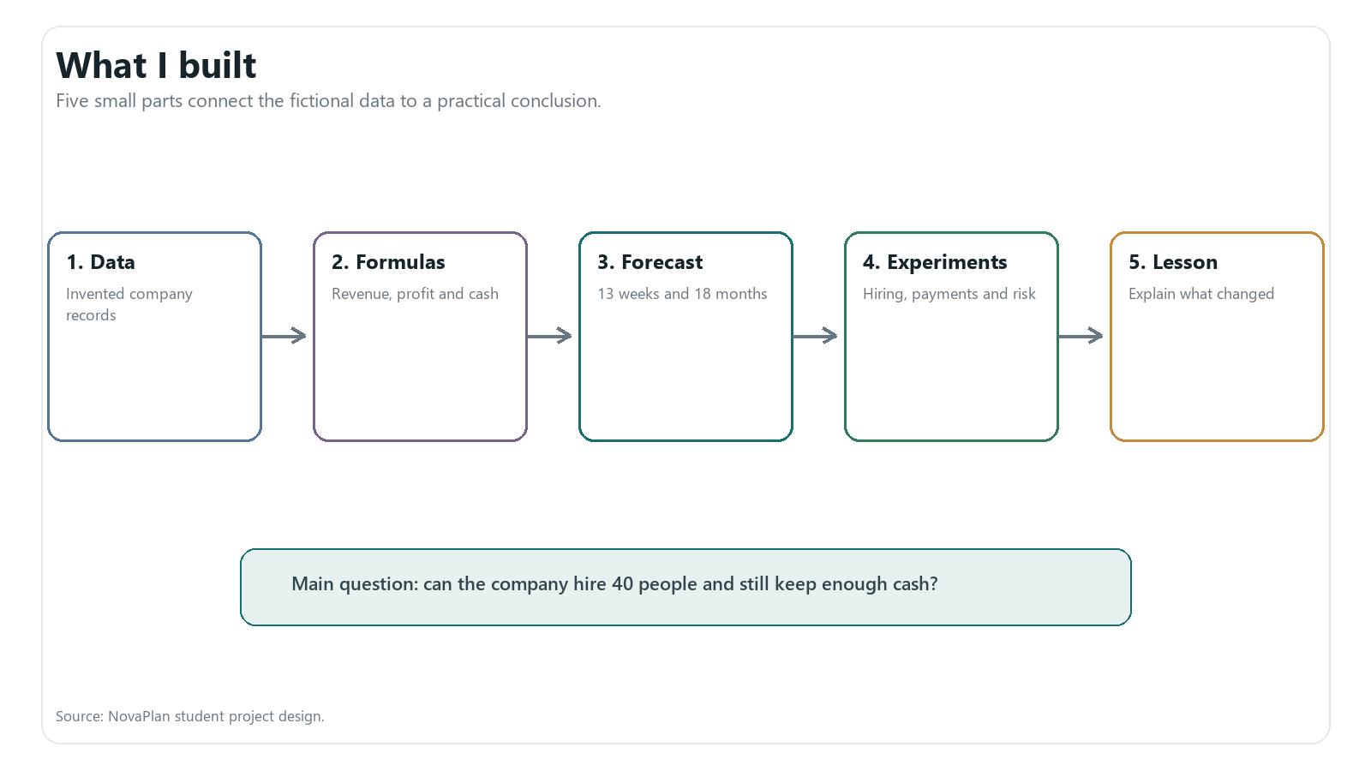
Figure 1. The project follows five steps instead of presenting many unrelated charts.
Dashboard page | Question it answers
Project Overview | What problem is the project studying?
What-if Experiment | What changes if I hire, sell more time, raise price or wait longer for cash?
13-Week Cash Check | Will the business have enough cash in the next three months?
Risk Simulation | What range appears when the future is uncertain?
How It Works | Where do the data, formulas and tests come from?

3 | THE FICTIONAL DATA

Useful for learning, safe for a student project
Synthetic data is invented data made to follow selected rules. It is useful here because I can show invoices, salaries and cash movements without using confidential company or client information. Seed 42 makes the same fictional history appear every time the generator runs.
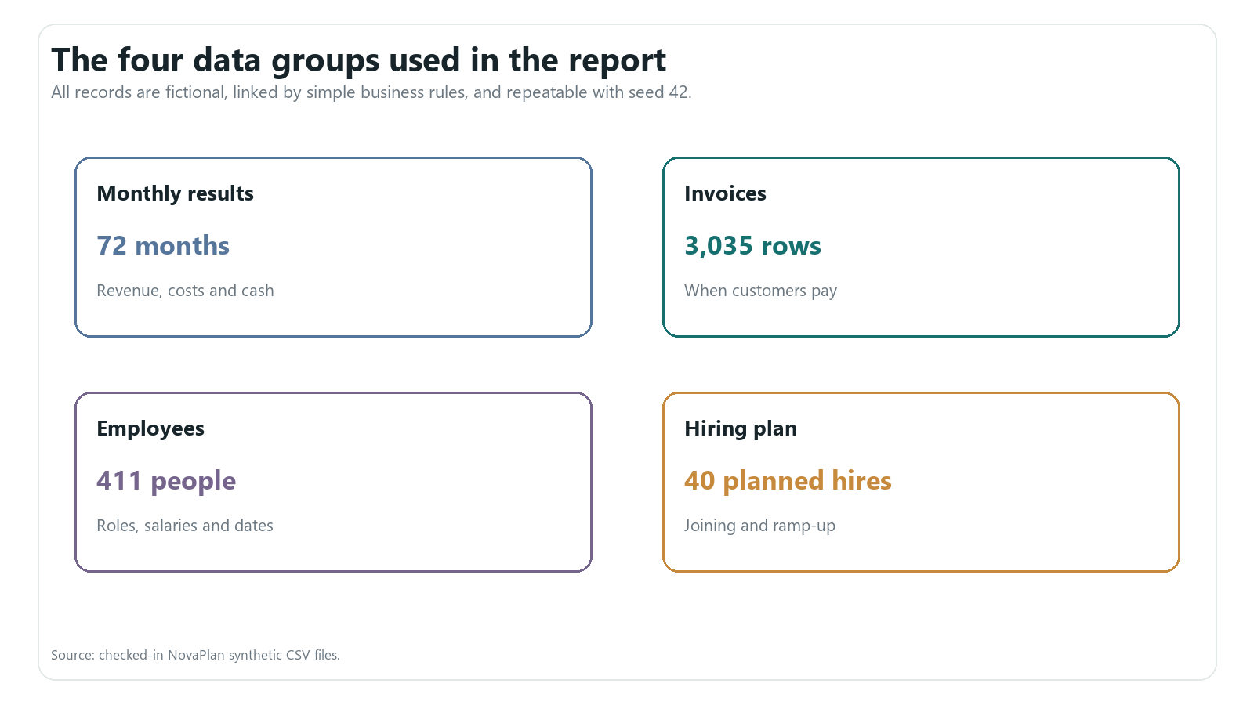
Figure 2. Four understandable data groups support the main student story.
A USEFUL RULE The data is invented, but it must still add up: invoice revenue matches monthly revenue, unpaid invoices become receivables, and opening cash plus the cash movement equals closing cash.

4 | THE COMPANY STORY

Six years of growth, pressure and recovery
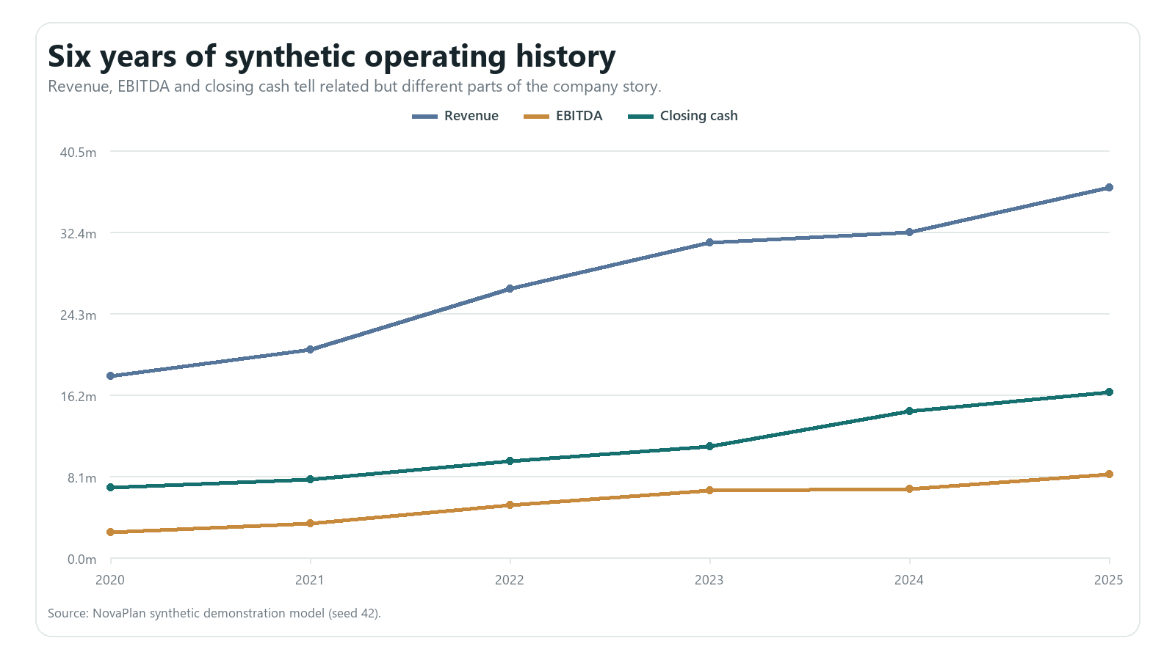
Figure 3. Revenue, operating profit and closing cash tell different parts of the 2020-2025 story.
2025 result | Value | Plain meaning
Revenue | EUR 36.8m | Value of consulting services delivered
Operating profit | EUR 8.3m | Revenue left after the main operating costs
Profit margin | 22.5% | Operating profit divided by revenue
Closing cash | EUR 16.4m | Money available at the end of 2025

The company begins the forecast with a strong cash balance. The project is therefore about funding growth, not rescuing a failing business.

5 | THREE IMPORTANT NUMBERS

Revenue, operating profit and cash are not the same
Number | Beginner definition | Small example
Revenue | Value of work completed for customers | Deliver EUR 100 of work -> EUR 100 revenue
Operating profit | Revenue minus the main operating costs | EUR 100 revenue - EUR 75 costs -> EUR 25 profit
Cash | Money actually received and still available | If the invoice is unpaid, the EUR 100 is not cash yet

Operating profit = Revenue - Payroll - Contractor cost - Other operating cost
Closing cash = Opening cash + Cash collected - Cash paid
THE KEY LESSON A profitable month can still use cash when customers have not paid yet, salaries are due now, or the company buys equipment.

Why the dashboard shows all three
Revenue explains business activity. Operating profit explains whether the work covers the operating costs. Cash explains whether bills can be paid on time. Looking at only one of them gives an incomplete answer.

6 | HOW THE COMPANY MAKES MONEY

People and productive time create service revenue
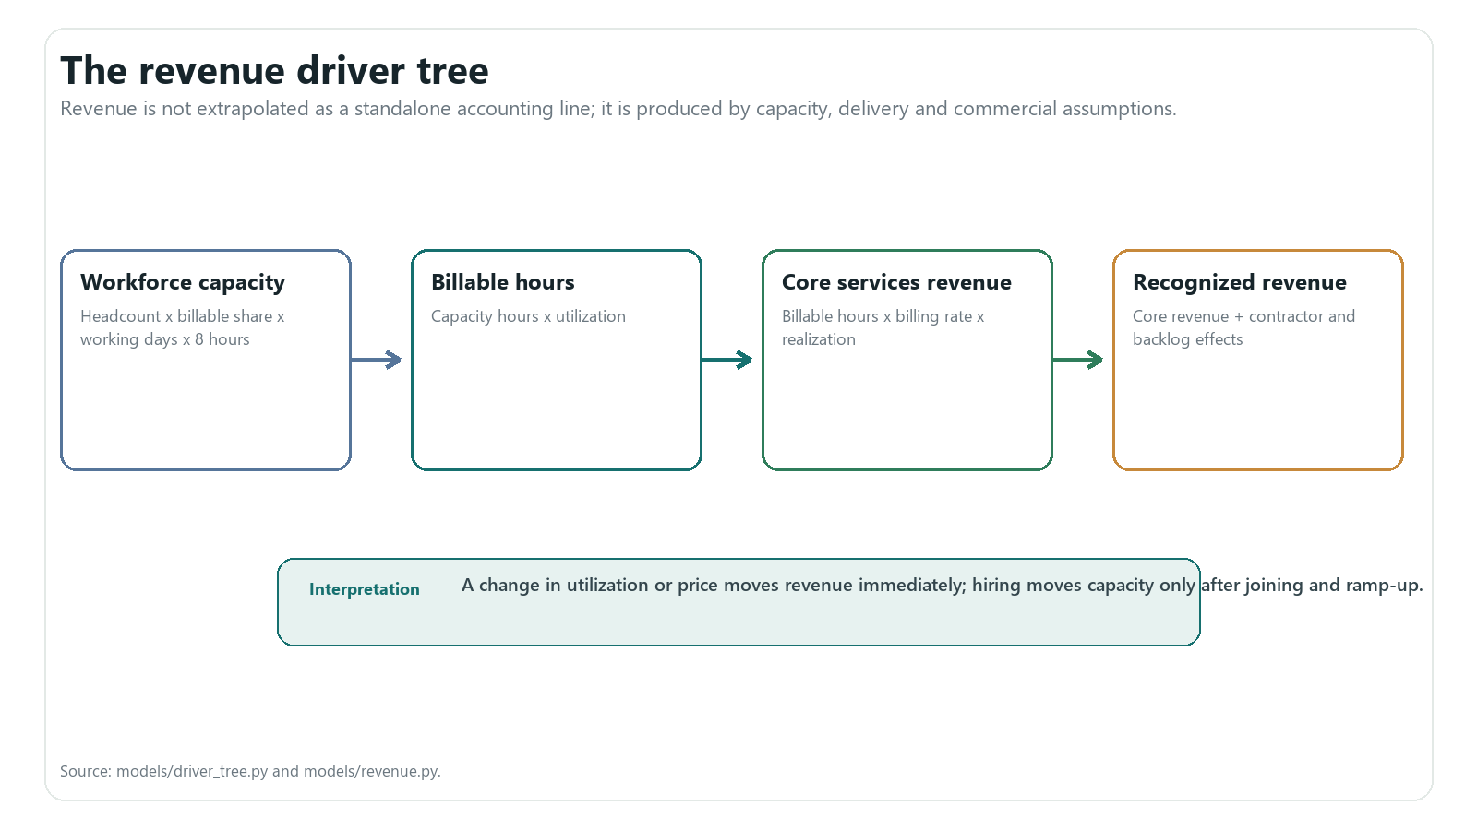
Figure 4. The revenue formula is a chain of understandable operating inputs.
Revenue = Employees x Billable share x Available hours x Utilization x Hourly rate

A worked example
Suppose 100 employees include 80 billable consultants. If each has 160 available hours, utilization is 75%, and the rate is EUR 75 per hour, the simple monthly revenue estimate is 80 x 160 x 75% x EUR 75 = EUR 720,000 before discounts or other adjustments.
WHY UTILIZATION MATTERS Hiring creates capacity, but capacity produces revenue only when customers buy the available time. That is why more employees do not create full revenue immediately.

7 | WHY PROFIT IS NOT CASH

Customer payment time creates the gap
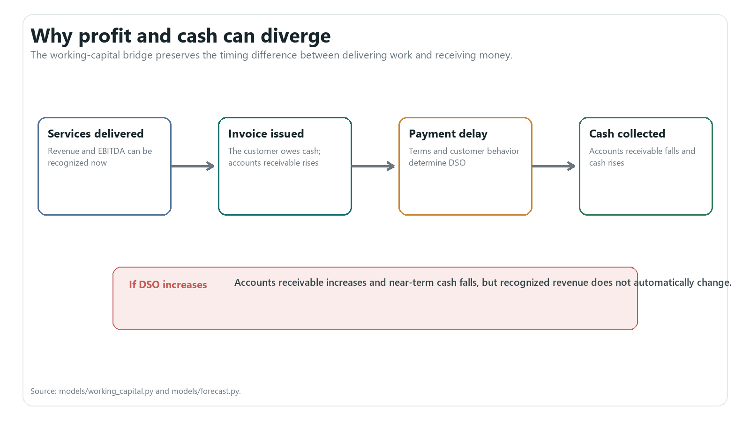
Figure 5. Revenue is recorded before cash when the customer pays later.
Term | Plain meaning
Invoice | A request for payment after work is delivered
Customer payment time | How many days the company waits to collect
Accounts receivable | Invoices that customers still owe
Cash collection | The moment money reaches the company

EXPERIMENT RULE Making customers pay 15 days later should reduce near-term cash, but it should not reduce revenue or operating profit that was already earned.

8 | THE STARTING FORECAST

Two time horizons answer two questions
Forecast | Question
13 weeks | Can the company pay near-term salaries, suppliers, taxes and one-time bills?
18 months | How do hiring, utilization, prices and customer payments affect profit and cash?

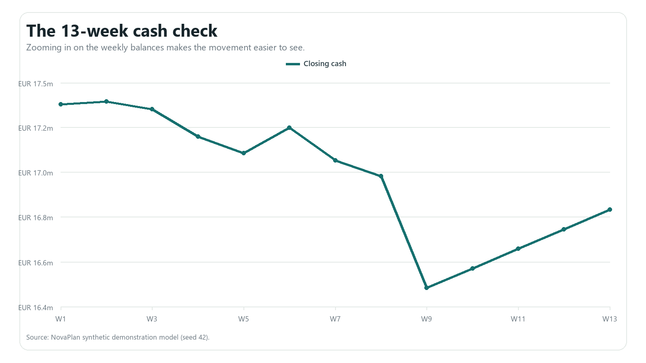
Figure 6. The weekly chart is zoomed to make the cash movement visible.
Cash check | Result
Opening cash | EUR 16.4m
Lowest weekly cash | EUR 16.5m
Cash after 13 weeks | EUR 16.8m

9 | EXPERIMENT 1

What happens if the company hires 40 people?
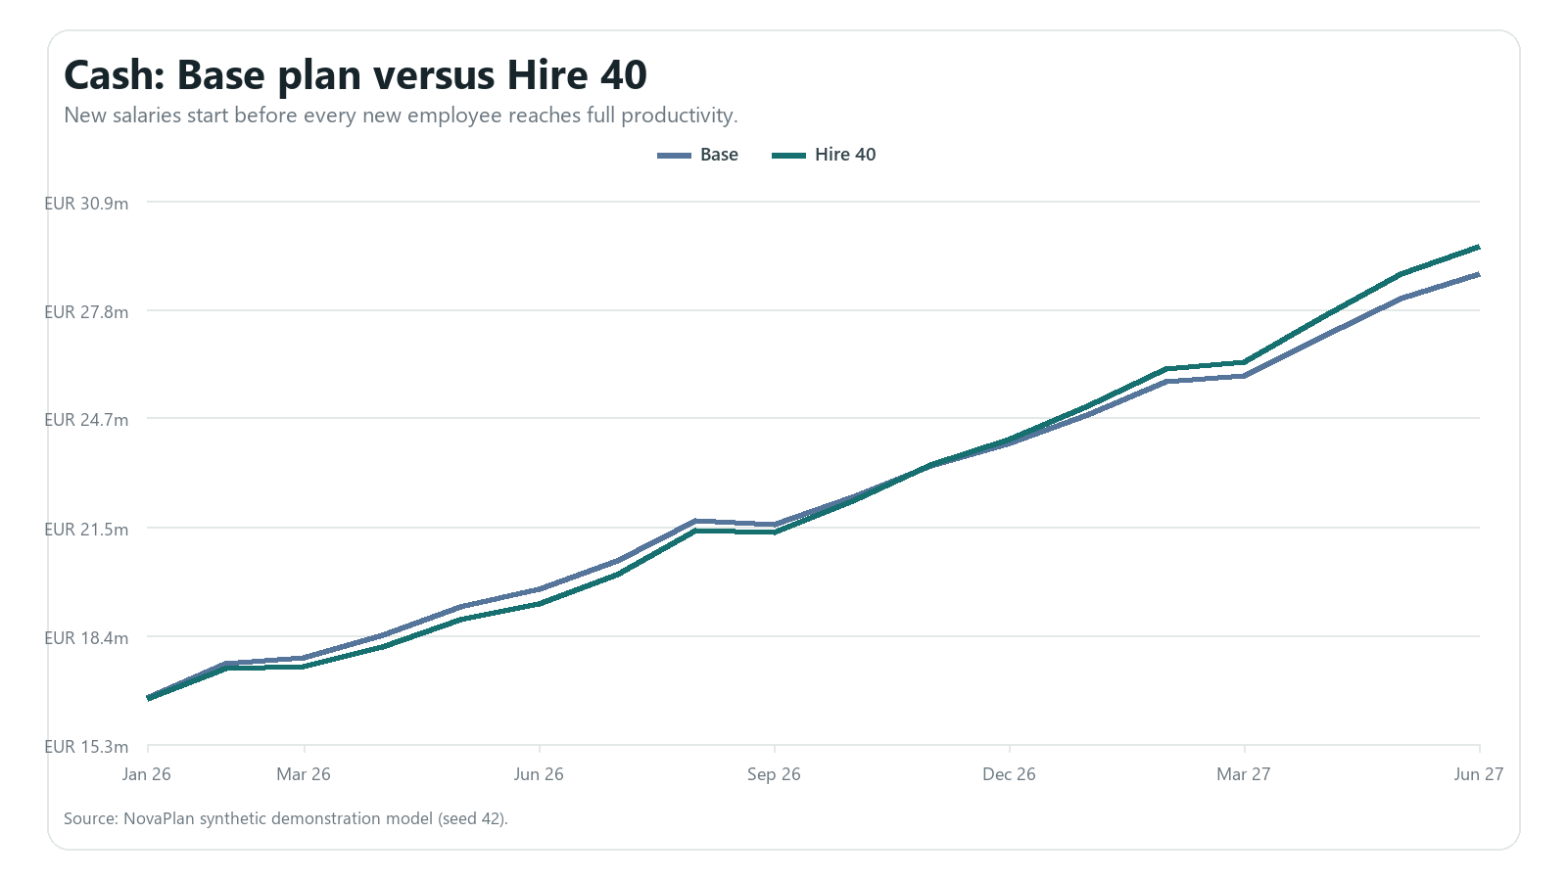
Figure 7. The hiring experiment uses the same assumptions as the dashboard's default What-if page.
What changed | Result compared with Base
Revenue | EUR 4.8m
Operating profit | EUR 1.7m
Lowest cash point | -EUR 43.6k
Employees at the end | 492

WHAT I LEARNED The 40-person plan improves revenue and profit over 18 months, while the lowest cash point is slightly lower during ramp-up. The result is a timing trade-off, not simply 'hiring is good' or 'hiring is bad.'

10 | EXPERIMENT 2

Which dashboard input changes cash the most?
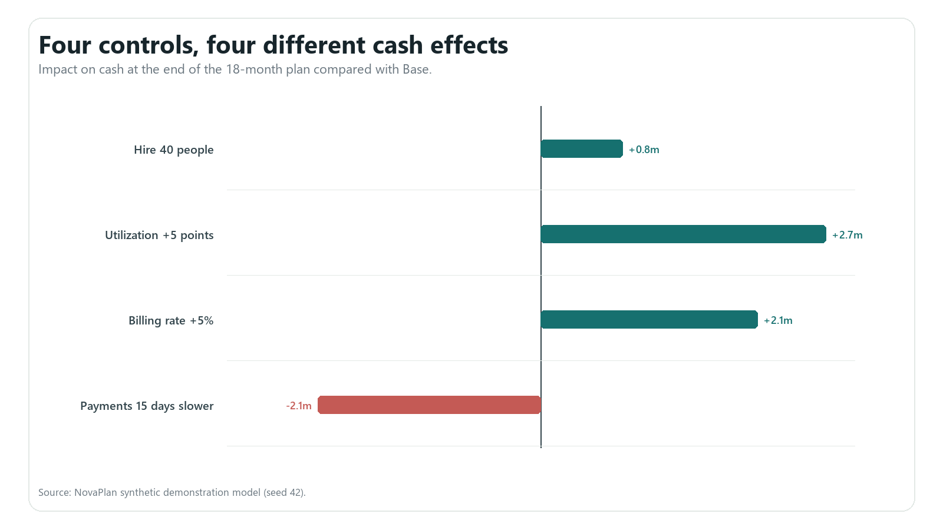
Figure 8. The four student-facing controls affect the 18-month cash result in different ways.
Experiment | Cash impact | Profit impact
Hire 40 people | EUR 787.6k | EUR 1.7m
Utilization +5 points | EUR 2.7m | EUR 3.8m
Billing rate +5% | EUR 2.1m | EUR 2.9m
Payments 15 days slower | -EUR 2.1m | EUR 0

PAYMENT-TIME CHECK The slower-payment experiment changes cash but leaves operating profit unchanged. That is a useful test because it proves the model separates earning revenue from collecting it.

11 | A SMALL FORECASTING COMPARISON

Two simple ways to estimate next month
The financial plan is driven by business assumptions. I also compared two small forecasting ideas as a research exercise. The test keeps the months in order so the model never learns from a future month before predicting it.
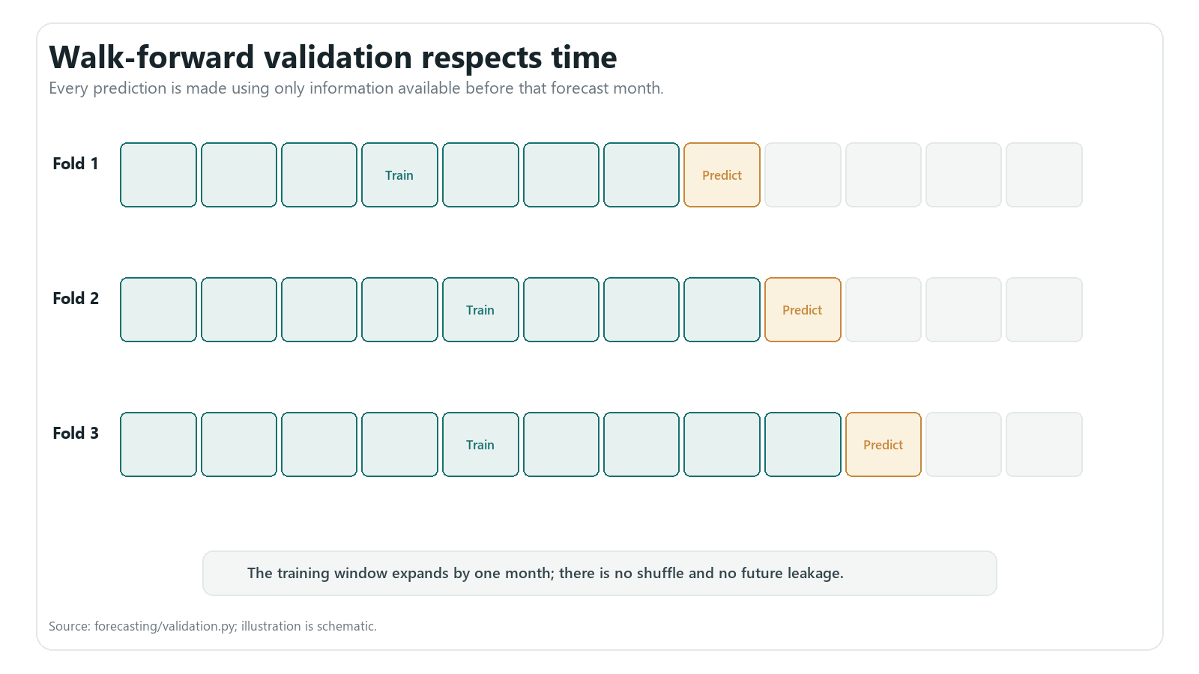
Figure 9. Walk-forward testing uses past months to predict the next month, then moves forward.
Method | How it works | Average revenue error
Seasonal repeat | Use revenue from the same month one year earlier | About EUR 330k
Simple driver regression | Use a straight-line relationship with planned business drivers | About EUR 183k

HONEST LIMIT The regression result assumes that its driver values are already known or planned. It is a useful comparison, not a fully automatic prediction of the whole company.

12 | MONTE CARLO

A range of possible futures instead of one answer
A normal forecast gives one answer. Monte Carlo repeats the forecast many times. In each run, the model makes small random changes to business drivers such as utilization, customer payment time, prices and salary costs. It then recalculates revenue, profit and cash.
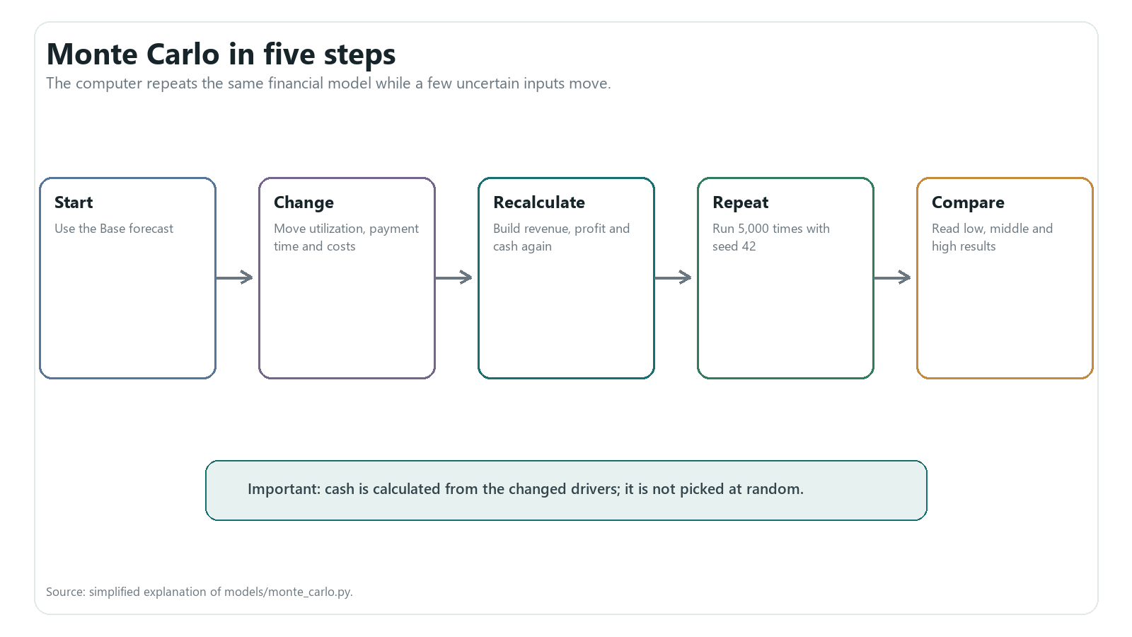
Figure 10. The calculation remains understandable even though it is repeated thousands of times.
Result | Plain meaning
Low result (P5) | Only about 5% of simulated ending cash results are lower
Middle result (P50) | Half of simulated ending cash results are lower and half higher
High result (P95) | Only about 5% of simulated ending cash results are higher

13 | TESTING MONTE CARLO

The controls now produce visible and logical changes
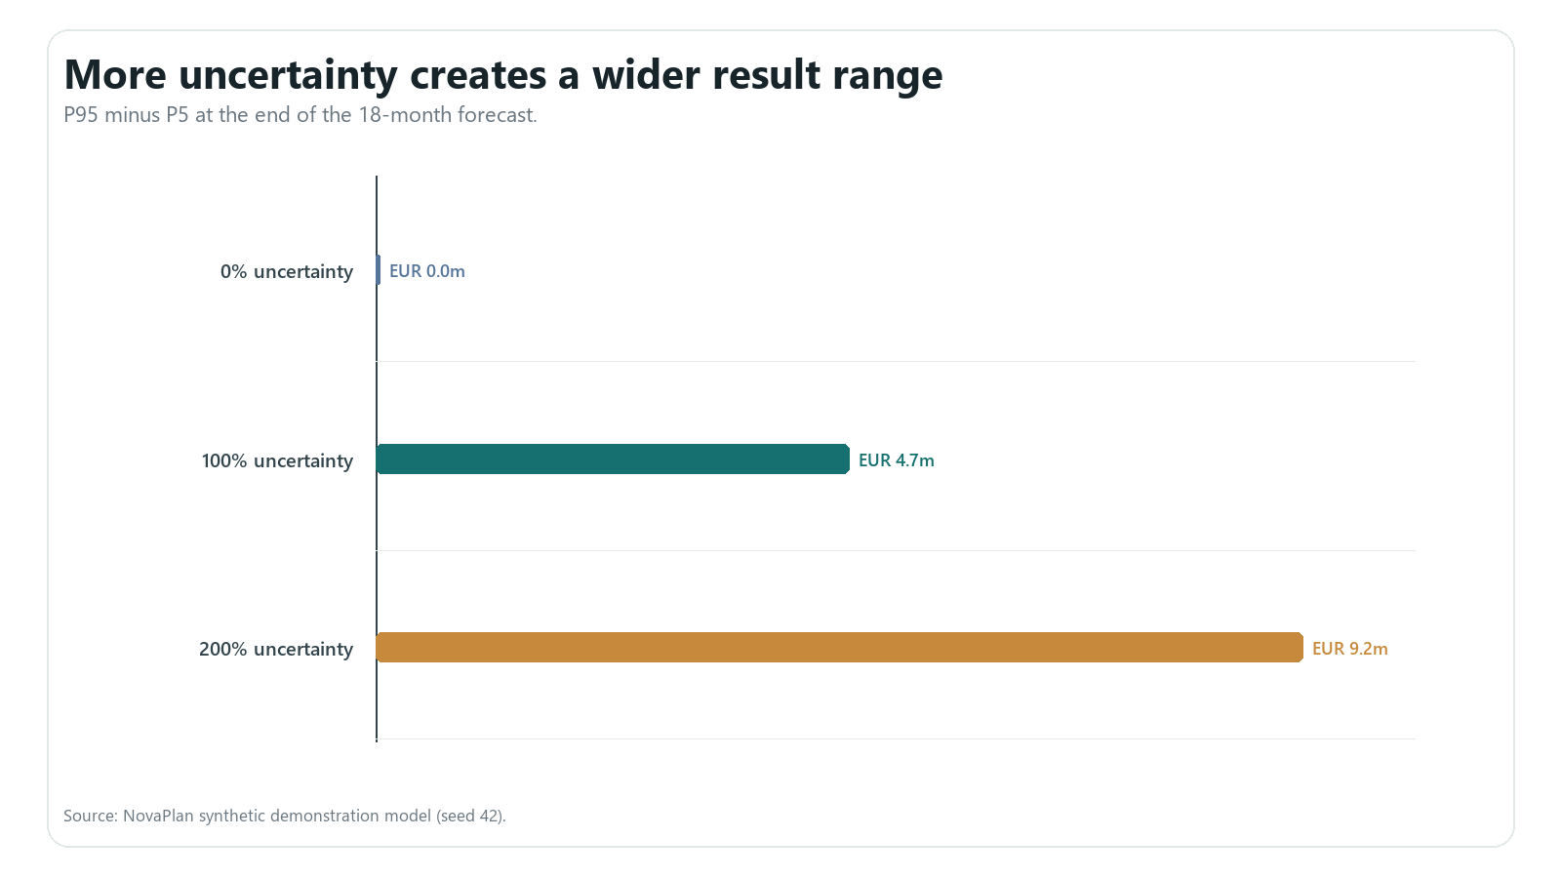
Figure 11. Setting uncertainty to zero collapses the range; doubling uncertainty makes it roughly twice as wide.
Uncertainty | P5 | Middle | P95 | Range
0% | EUR 28.8m | EUR 28.8m | EUR 28.8m | EUR 0
100% | EUR 26.5m | EUR 28.8m | EUR 31.2m | EUR 4.7m
200% | EUR 24.3m | EUR 28.8m | EUR 33.5m | EUR 9.2m

THE BUG I FOUND AND FIXED The first page exposed run count, seed and a cash target below every path, so it looked frozen. The revised page changes real uncertainty. At 200% uncertainty, raising the target from EUR 14m to EUR 18m changes the below-target result from 0.8% to 98.4% while the cash paths stay the same, which is the correct behavior.

14 | WHAT I LEARNED

A useful model is one that can be explained and tested
ANSWER TO THE QUESTION In this fictional Base case, the company can test a 40-person hiring plan without approaching the EUR 3m policy floor. The plan adds about EUR 1.7m of operating profit over 18 months, but timing still matters because salaries start before full productivity and customers may pay later.

What I tested
- Revenue rises when utilization or billing rate rises.
- Slower customer payment reduces cash but not earned operating profit.
- Hiring includes salary cost and a gradual productivity ramp.
- The weekly cash roll-forward conserves receipts at the forecast boundary.
- Zero Monte Carlo uncertainty produces one path; more uncertainty widens the range.
- All 48 automated tests pass, every route loads, and the five main pages show no browser errors.

Limitations and next steps
The numbers are fictional, the rules are simplified, and the future ranges are assumptions rather than proven probabilities. A next version could compare forecasts with later actual results, let users adjust a few uncertainty drivers separately, and use real data only after privacy and reconciliation checks.

Final reflection
The most important lesson was not a complicated algorithm. It was learning to connect a business action to revenue, profit and cash, then design a test that proves the control really reaches the calculation.
EDUCATIONAL USE ONLY NovaPlan is an educational proof-of-concept built using entirely synthetic data. It is not an official Deloitte product, does not represent Deloitte proprietary methods, and is not financial, tax, accounting or investment advice.

