**MoviesWizZz**

* **Frontend** **=> React, Tailwind CSS, Chakra UI, Next UI, universe.io**
* **USEPARAM()**
* 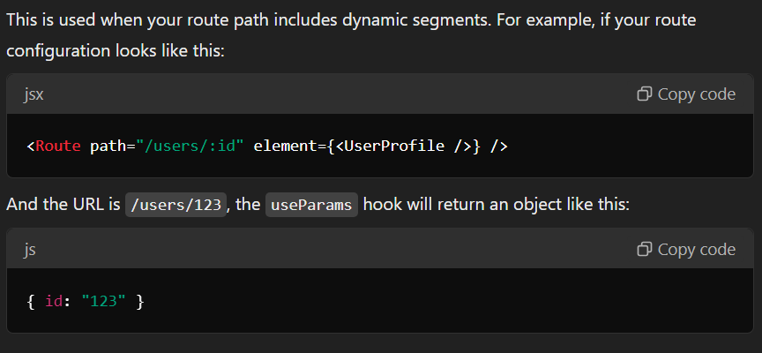
* **USEDROPZONE HOOK used in uploader.jsx**
* 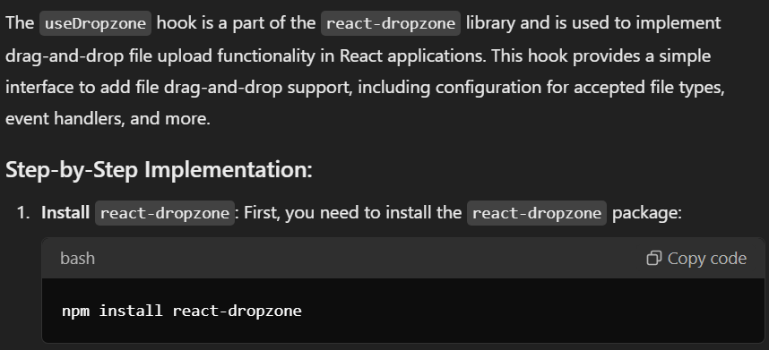
* **AOS used in sidebar.jsx**
* import 'aos';
* import 'aos/dist/aos.css';
* **has to import in main.jsx**
* 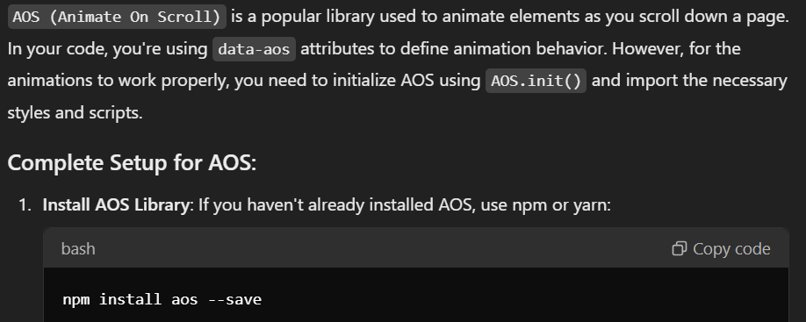

**BACKEND**

* **I used bcrypt, validator, cors, dotenv, express-async-handler,**