Day 13: Practicing with images

using **image.py,** **eiffel.gif, potato.gif** files up on Moodle

French Flag: template file french_flag.py up on Moodle



import image

#create empty image

width = 600

height = 400

flag = image.EmptyImage(width,height)

#grab colors

blue = image.Pixel(20,60,110)

white = image.Pixel(255,255,255)

red = image.Pixel(150,12,19)

#color everything white (can skip this step)

for col in range(0,width):

for row in range(0, height):

flag.setPixel(col,row,white)

#left blue rectangle

for col in range(0,width//3):

for row in range(0, height):

flag.setPixel(col,row,blue)

#right red rectangle

for col in range(width//3*2, width):

for row in range(0, height):

flag.setPixel(col,row,red)

#draw flag image to window

wn = image.ImageWin("French flag", width, height)

flag.draw(wn)

inverted eiffel: Reverse the intensity of red, green, and blue in each pixel. That is, if the original red intensity was red, the new red intensity would be 255-red (and similarly for green and blue). template file invert.py up on Moodle

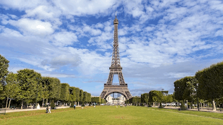

import image

#grab picture

img = image.Image("eiffel.gif")

#get dimensions of picture

width = img.getWidth()

height = img.getHeight()

#create blank canvas

new_img = image.EmptyImage(width, height)

for row in range(height):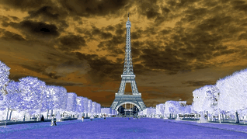

for col in range(width):

#grab individual pixel

v = img.getPixel(col,row)

#grab pixel's rgb intensities

red = v.getRed()

blue = v.getBlue()

green = v.getGreen()

#reassign rgb with 255 - color

v.red = 255 - red

v.green = 255 - green

v.blue = 255 - blue

#add to blank canvas

new_img.setPixel(col,row,v)

#create window with correct dimensions

win = image.ImageWin("Inverted Eiffel", width, height)

#display canvas to window

new_img.draw(win)

Exchanged eiffel: Exchange the intensity of red, green, and blue in each pixel, so that the old red intensity is the new green intensity, the old green intensity is the new blue intensity, and the old blue intensity is the new red intensity. Use temp variables



import image

#grab picture

img = image.Image("eiffel.gif")

#get dimensions of picture

width = img.getWidth()

height = img.getHeight()

#create blank canvas

new_img = image.EmptyImage(width, height)

for row in range(height):

for col in range(width):

#grab individual pixel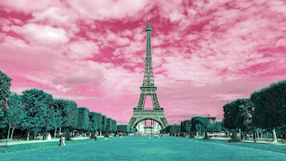

v = img.getPixel(col,row)

#grab pixel rgb intensities

red = v.getRed()

green = v.getGreen()

blue = v.getBlue()

#exchange intensities

v.red = blue

v.green = red

v.blue = green

#add to blank canvas

new_img.setPixel(col,row,v)

#create window with correct dimensions

win = image.ImageWin("Exchanged Eiffel", width, height)

#display canvas to window

new_img.draw(win)

greyscale: Starting with an empty image, create the grayscale image below. The image is 256 pixels by 256 pixels. The top row of the image is black, and the bottom row of the image is white.

"""

There are several ways to do this problem. Below is one solution.

You may have a different solution using an accumulation pattern.

"""

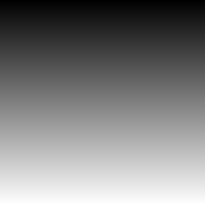

import image

#create dimension variables for reference later on

width = 256

height = 256

#create empty image

greyscale = image.EmptyImage(width,height)

for row in range(0, height):

for col in range(0,width):

#change pixel color depending on row you're on

color = image.Pixel(0+row, 0+row, 0+row)

#save to blank canvas (flip because of order of for loops)

greyscale.setPixel(width-1-col,row,color)

#draw greyscale image to window

wn = image.ImageWin("Greyscale", width, height)

greyscale.draw(wn)

greyscale big: Repeat the previous exercise, but make the image 512 pixels by 512 pixels. You can do this by doubling the dimensions, and then editing the colored pixel you created to be scaled to be a valid intensity (try using the // operator)

"""

Our goal here is to double our dimensions, and fill in a bigger grid.

To do this, we'll have to color essentially two pixels for every one

pixel in the 256*256 grid. Which means we'll have two rows of pixels

for every shade of grey rather than a single row

"""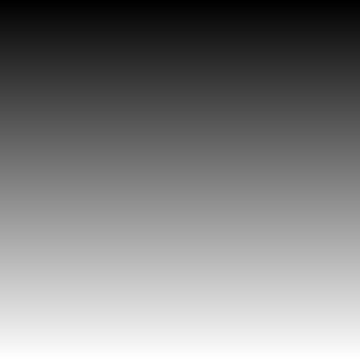

import image

#double earlier dimensions

width = 256*2

height = 256*2

#create empty image that is twice as big

greyscale = image.EmptyImage(width,height)

for row in range(0, height):

for col in range(0,width):

#create two pixels for every shade of grey

color = image.Pixel(row//2, row//2, row//2)

greyscale.setPixel(col,row,color)

#draw greyscale image to window

wn = image.ImageWin("Greyscale, But Bigger", width, height)

greyscale.draw(wn)

SMOL potato: Using the image potato.gif, create an image that is the potato but half the size. Notice the half size potato on the right is a lower resolution. We can scale this to half-size by skipping every other pixel. To do this, decrease your range arguments by half and get every other pixel (you’ll need to use the arithmetic operator * to do this)

import image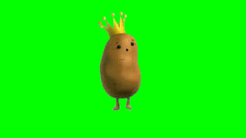

#grab picture

potato = image.Image("potato.gif")

#get dimensions of pictures

potato_width = potato.getWidth()

potato_height = potato.getHeight()

#create blank canvas with half dimensions

smol_potato = image.EmptyImage(potato_width//2, potato_height//2)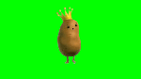

#make potato smol

for row in range(potato_height//2): #half height

for col in range(potato_width//2): #half width

#grab every other pixel

p = potato.getPixel(col*2, row*2)

#add to smaller canvas

smol_potato.setPixel(col, row, p)

#create window/canvas with correct dimensions

win = image.ImageWin("Smol Potato", potato_width//2, potato_height//2)

smol_potato.draw(win)

#saving out to use later on

smol_potato.save(“smol_potato.gif”)



french fry:

import image

#grab pictures

potato = image.Image("smol_potato.gif")

eiffel = image.Image("eiffel.gif")

#get dimensions of pictures

potato_width = potato.getWidth()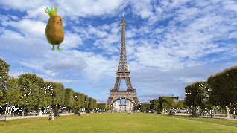

potato_height = potato.getHeight()

eiffel_width = eiffel.getWidth()

eiffel_height = eiffel.getHeight()

french_fry = eiffel #new canvas can be an image

#can edit col_start and row_start to move smol potato around

col_start = 0

col_end = col_start + potato_width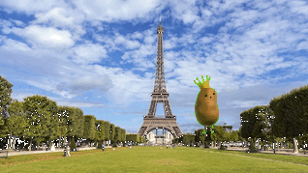

row_start = 0

row_end = row_start + potato_height

#put small po onto eiffel tower

for col in range(col_start, col_end):

for row in range(row_start, row_end):

p = potato.getPixel(col-col_start, row-row_start)

e = eiffel.getPixel(col, row)

if p.getGreen() < 240:

french_fry.setPixel(col, row, p)

else:

french_fry.setPixel(col,row,e)

#create window/canvas with correct dimensions

win = image.ImageWin("French Fry", eiffel_width, eiffel_height)

french_fry.draw(win)

french_fry.save("french_fry.gif")