ANA515- Assignment - Week 5

Sandeep Tom

11/21/2021

weather_data$date <- ymd(weather_data$date)  
ggplot(data = weather_data, aes(x= date, y = actual_mean_temp))+ geom_point()+theme_light()+  
 labs(x = "Date",y = "Mean Temperature",title = " Weather Data of Philadelphia", subtitle = "Actual Mean Temperature")

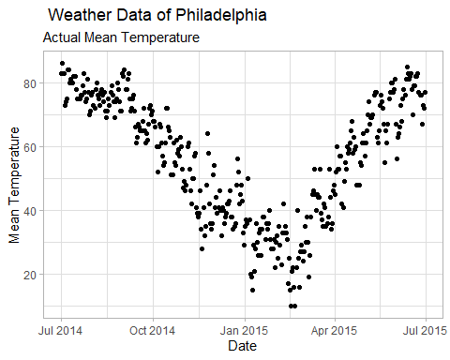

weather_data$date <- ymd(weather_data$date)  
ggplot(data = weather_data, aes(x= date, y = record_max_temp,))+ geom_point()+theme_dark()+  
 labs(x = "Date",y = "Reccord Max Temperature",title = " Weather Data of Philadelphia", subtitle = "Record Max Temperature")

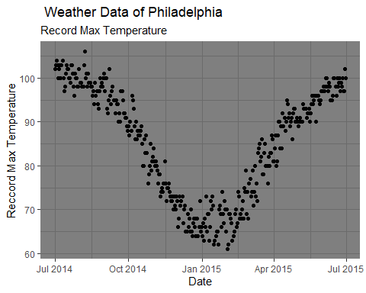

weather_data$date <- ymd(weather_data$date)  
ggplot(data = weather_data, aes(x= date, y = record_min_temp))+ geom_point()+theme_dark()+  
 labs(x = "Date",y = "Reccord Min Temperature",title = " Weather Data of Philadelphia", subtitle = "Record Min Temperature")

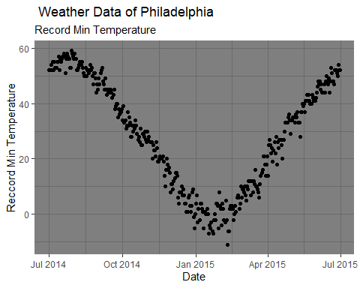

weather_data$date <- ymd(weather_data$date)  
ggplot(data = weather_data, aes(x= date, y = record_precipitation))+ geom_point()+theme_minimal()+  
 labs(x = "Date",y = "Reccord Precipitation",title = " Weather Data of Philadelphia")

