recursive shape fractal generator

Stomperusa

2019-08-20

### Intro

This function allows us to generate the Sierpinski Triangle and explore other recursive shapes with equal length sides following the same algorithm.

shape <- function(corners, trials = 100000){  
   
 corners <- as.integer(corners)  
 points <- list()  
  
 if (corners < 3) stop("Value should be 3 or greater")  
   
 for (n in 1:(corners)){  
 points$x[n] <- 0 + cos((2*pi*n)/corners)  
 points$y[n] <- 0 + sin((2*pi*n)/corners)  
 }  
  
 x <- points$x[1]  
 y <- points$y[1]  
  
 trials <- trials  
 sierpinski <- list()  
  
 for (t in 1:trials){  
 r <- sample(1:corners,1)  
 x <- (x + points$x[r]) / sqrt(corners + 1)  
 y <- (y + points$y[r]) / sqrt(corners + 1)  
 sierpinski$x[t] <- x  
 sierpinski$y[t] <- y  
 }  
  
   
 # I use these colors for random color selection. Update for your own desired selection.  
 color <- sample(c("royalblue2", "firebrick2", "gold2", "springgreen3", "purple2", "darkorange1"),1)  
  
 plot(sierpinski$x[corners:trials], sierpinski$y[corners:trials],  
 xlab = paste0(corners, " Sides Chosen"), ylab = "", xaxt = "n", yaxt = "n", col = color)  
  
}

When you run the function, you indicate the number of sides for the polygon and adjust the number of trials to change the resolution if desired. Here are some examples:

shape(3)

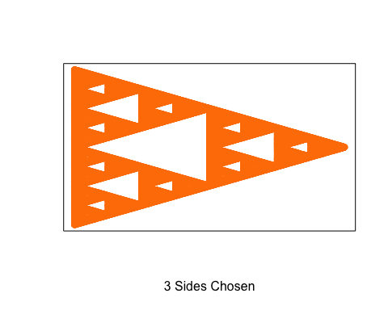

shape(4)

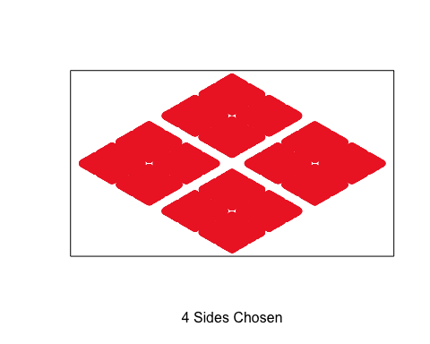

shape(6)

