Aura — User Manual
AI-Powered Habit Tracker & Routine Planner
Version 1.0.1 | February 2026
To install:
https://play.google.com/store/apps/details?id=com.aura.habittracker

1. Introduction

What is Aura?
Aura is an AI-powered habit tracking and routine planning mobile application. It helps users build positive daily routines by combining intuitive habit management with personalised artificial intelligence coaching. The AI analyses your habit data to provide tailored suggestions, weekly insights, behavioural pattern recognition, and actionable improvement steps.

Purpose
Aura is designed for anyone looking to build consistent habits, whether for health, fitness, learning, mindfulness, or productivity. The app reduces the friction of habit tracking through a clean interface and leverages AI to keep users motivated with personalised guidance.

Target Users
- Individuals seeking to establish or maintain daily routines
- Students and professionals aiming to improve productivity
- Health-conscious users tracking fitness and wellness habits
- Anyone interested in data-driven self-improvement

Supported Platforms
Platform | Status
Android | Supported
iOS | Supported

2. App Overview & Feature Breakdown

Navigation Structure
Aura uses a bottom navigation bar with four main tabs:
Tab | Icon | Description
Home | Home | Daily dashboard with habits, stats, and AI suggestions
Progress | Bar Chart | Analytics, trends, achievements, and weekly AI summary
AI Coach | Sparkle | Personalised AI suggestions, insights, scores, and actions
Settings | Gear | Profile, appearance, notifications, account, and help

Feature Summary
Feature | Description
Habit Tracking | Create, complete, edit, and delete daily/weekly habits
Goal Setting | Set time-based or count-based goals for each habit
Streak Tracking | Automatic streak counting for consecutive completions
Reminders | Configurable push notifications for each habit
AI Suggestions | Personalised habit recommendations based on your patterns
AI Weekly Insights | Weekly analysis with patterns, highlights, and next steps
AI Scores | AI-powered scoring of habit performance
AI Actions | Prioritised action items for habit improvement
AI Tips | Category-based guidance for habit building
Progress Analytics | Completion rates, trends, heatmaps, and category breakdowns
Achievements | Badges and milestones across multiple categories
Health Integration | Connect to Apple Health / Google Health Connect
Data Export | Export habit data in CSV or JSON format
Theme Support | Light, Dark, and System-default themes
Multi-Auth | Email/Password, Google Sign-In, Apple Sign-In

Navigation Flow
┌─────────────────────────────────────────────────────────┐
│ Login Screen │
│ (Email/Password · Google Sign-In · Apple Sign-In) │
└──────────────────────────┬──────────────────────────────┘
│ Authentication
▼
┌─────────────────────────────────────────────────────────┐
│ Main App (Bottom Nav) │
│ │
│ ┌──────┐ ┌──────────┐ ┌──────────┐ ┌──────────┐ │
│ │ Home │ │ Progress │ │ AI Coach │ │ Settings │ │
│ └──┬───┘ └────┬─────┘ └─────┬────┘ └──────┬───┘ │
│ │ │ │ │ │
│ ▼ ▼ ▼ ▼ │
│ ┌────────┐ ┌──────────┐ ┌──────────┐ ┌───────────┐ │
│ │ Daily │ │ Weekly │ │ 4 Tabs: │ │ Profile │ │
│ │ Habits │ │ Summary │ │Suggestion│ │ Appearance│ │
│ │ Stats │ │ Trends │ │ Insights │ │ Notif. │ │
│ │ Quote │ │ Heatmap │ │ Scores │ │ Health │ │
│ │ AI │ │ Category │ │ Actions │ │ Account │ │
│ │ Card │ │ Achieve. │ │ │ │ Help │ │
│ └──┬─────┘ └──────────┘ └────┬─────┘ │ About │ │
│ │ │ └───────────┘ │
│ ▼ ▼ │
│ ┌──────────────────────────────────────┐ │
│ │ Habit Creation Screen │ │
│ │ (from AI or FAB (+)) │ │
│ └──────────────────────────────────────┘ │
└─────────────────────────────────────────────────────────┘

3. Getting Started

Downloading the App
- Open the Google Play Store (Android) or Apple App Store (iOS).
- Search for "Aura Habit Tracker".
- Tap Install / Get and wait for the download to complete.
- Open the app once installation is finished.

Creating an Account
Aura offers three sign-up methods:

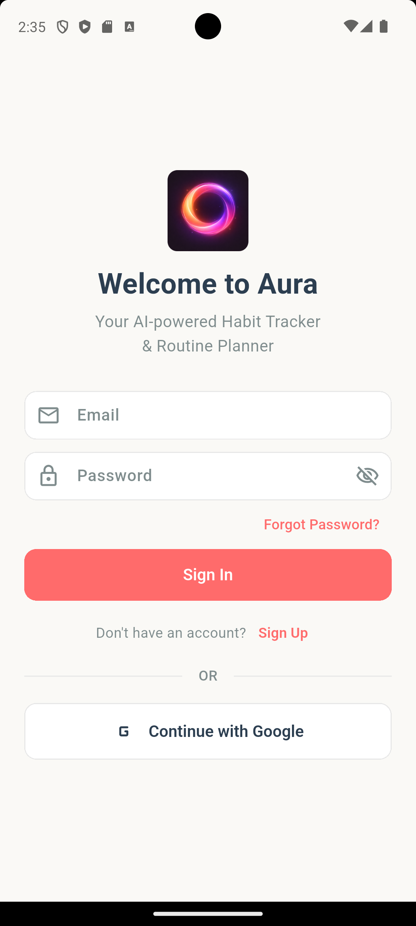
Login Screen — Sign Up mode

Option A: Email & Password
- Open the app to the Welcome to Aura screen.
- Enter your email address in the Email field.
- Enter a password (minimum 6 characters).
- Tap the "Sign Up" link at the bottom if you see "Don't have an account?".
- Tap the Sign Up button.
- You will be taken to the Home screen upon successful registration.

Option B: Google Sign-In
- On the login screen, tap "Continue with Google".
- Select your Google account from the system prompt.
- Grant the requested permissions.
- You will be signed in automatically.

Option C: Apple Sign-In (iOS only)
- On the login screen, tap "Continue with Apple" (visible on iOS devices only).
- Authenticate with Face ID, Touch ID, or your Apple ID password.
- Choose whether to share or hide your email address.
- You will be signed in automatically.

Signing In to an Existing Account
- Open the app.
- Enter your registered email and password.
- Tap Sign In.
- Alternatively, use "Continue with Google" or "Continue with Apple" if you originally signed up with those methods.

Forgot Password
- On the Sign In screen, enter your email address in the Email field.
- Tap "Forgot Password?" (shown below the password field).
- A password reset email will be sent to your inbox.
- Open the email and follow the link to reset your password.
- Return to the app and sign in with your new password.

4. Home Screen
The Home screen is your daily dashboard — the first thing you see when opening the app. It provides a quick overview of your habits, stats, and AI recommendations.
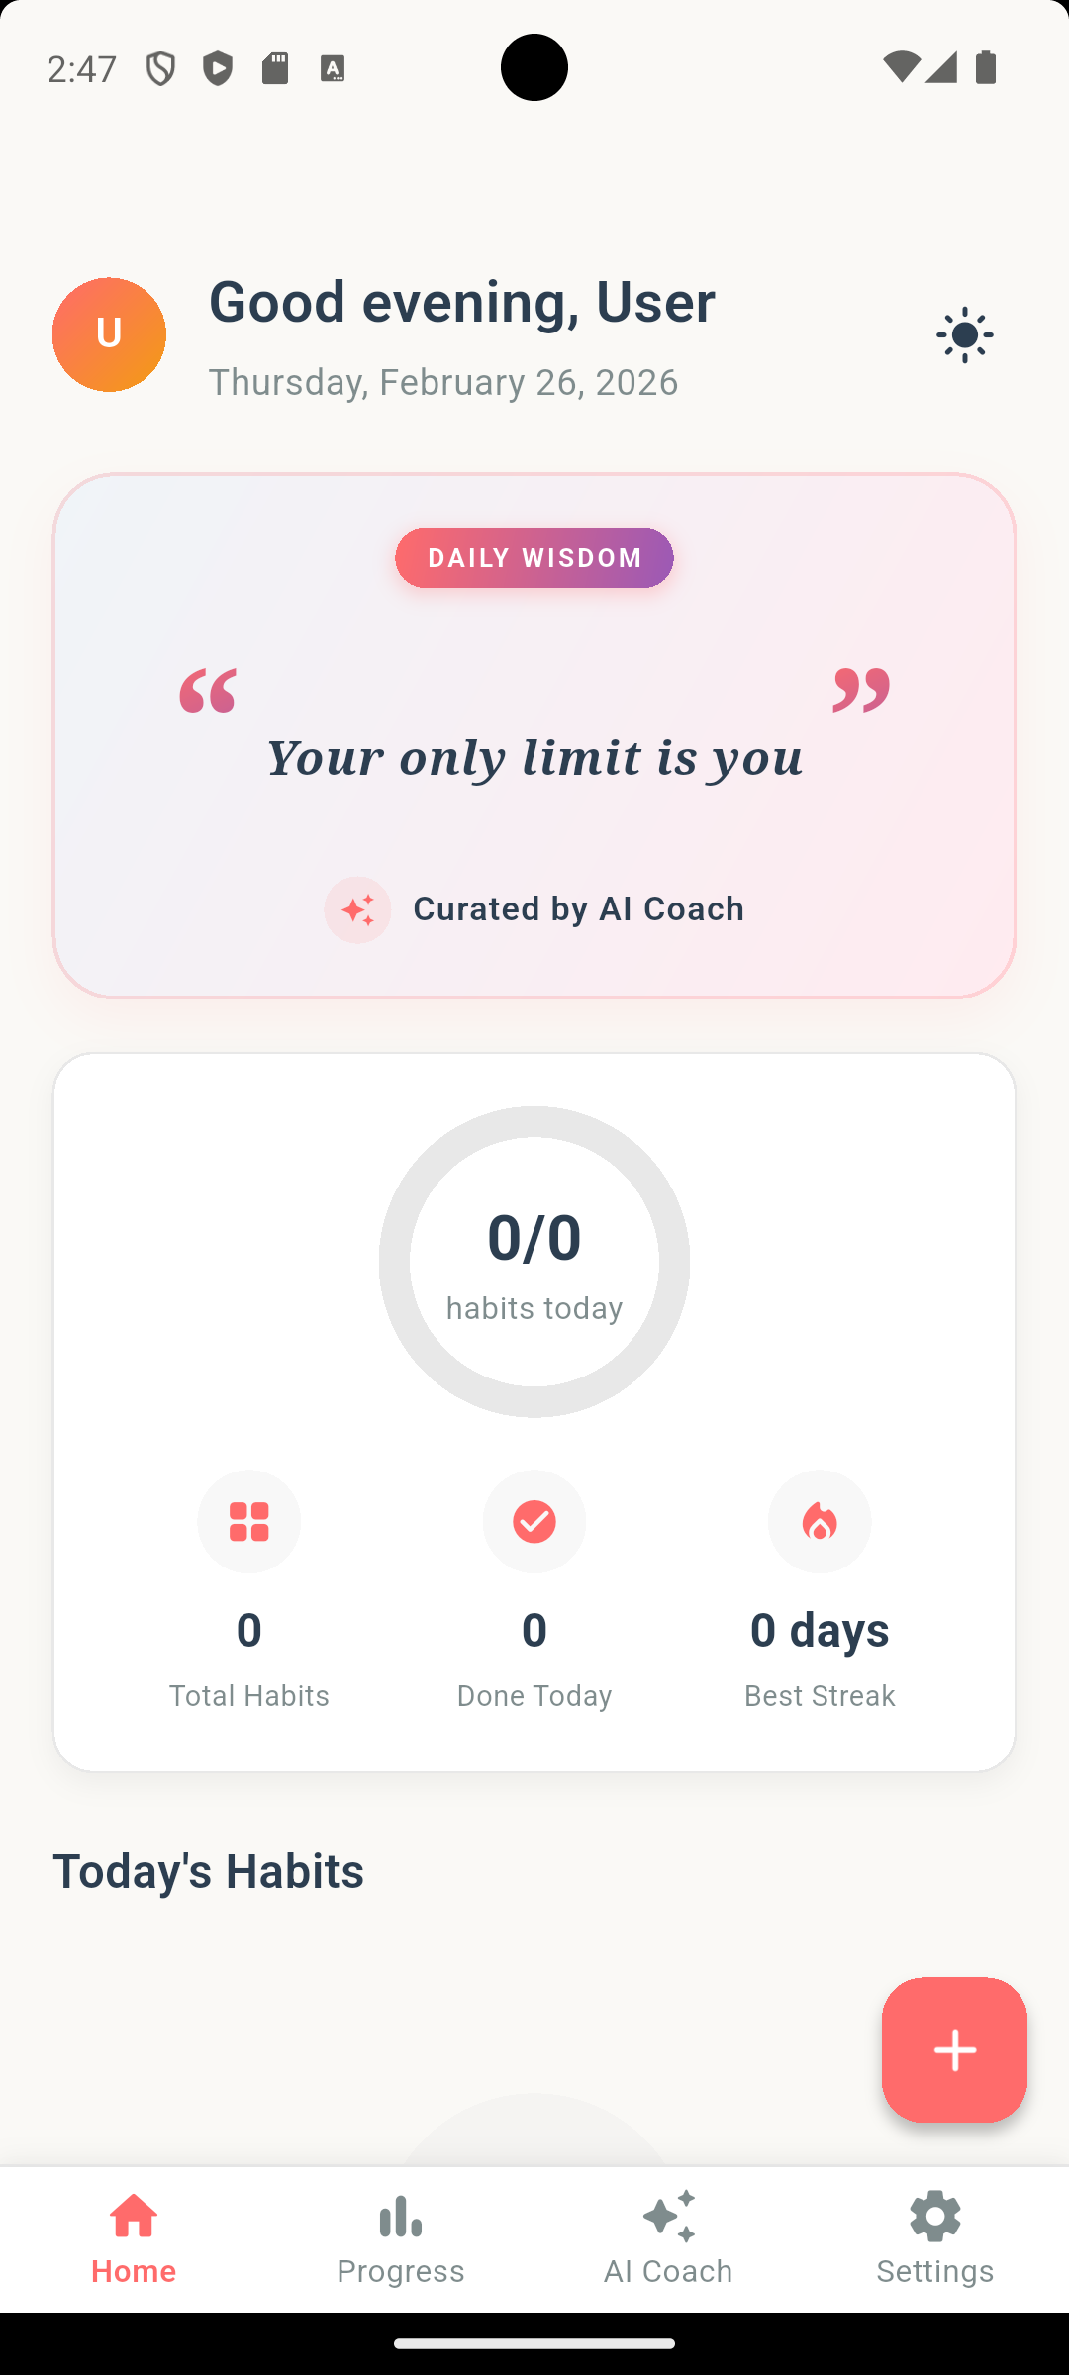
Home Screen — Full view

Home Header
At the top of the screen, you will see a personalised greeting based on the time of day (e.g., "Good Morning, John"). This uses your first name from your profile.

Motivational Quote Card
Below the header is a Daily Wisdom card that displays a rotating motivational quote to keep you inspired. A new quote appears each day.

Summary Stats Card
The Summary Stats Card shows at-a-glance metrics for your habit performance:
Stat | Description
Completion Rate | Percentage of habits completed today
Current Streak | Your longest active daily streak
Total Habits | Number of active habits you are tracking
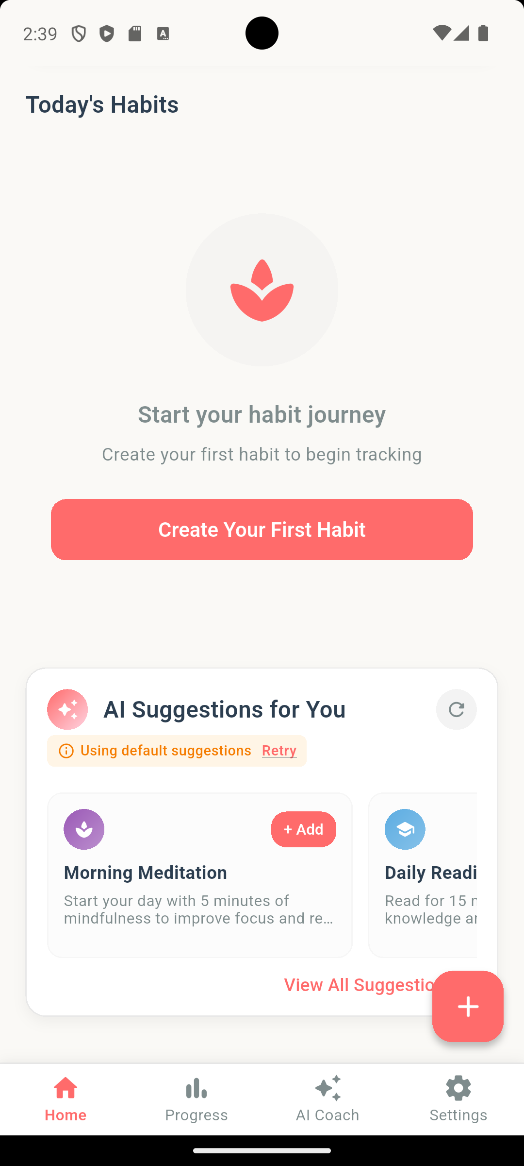
Home Screen — Habit List with completed and pending habits

Today's Habits List
The core of the Home screen is your habit list, showing all habits scheduled for today. Each habit card displays:
- Habit name and category (colour-coded)
- Current streak count
- A checkbox to mark the habit as complete or incomplete

Completing a Habit
- Tap the checkbox or the habit card to toggle completion.
- The card will update visually to reflect the completed state.
- Your streak counter will increment automatically.

Uncompleting a Habit
- Tap the checkbox again on a completed habit.
- The completion will be undone for today.

AI Suggestion Card
At the bottom of the Home screen, an AI Suggestion Card may appear with a personalised habit recommendation. This card shows:
- A suggested habit title and description
- The category and estimated time commitment
- An "Add Habit" button to create the suggested habit with one tap

Creating a New Habit (FAB)
On the Home tab, a floating action button (+) appears in the bottom-right corner. Tap it to navigate to the Habit Creation Screen.

5. Creating & Managing Habits

Creating a New Habit
Tap the + button on the Home screen to open the Habit Creation screen.
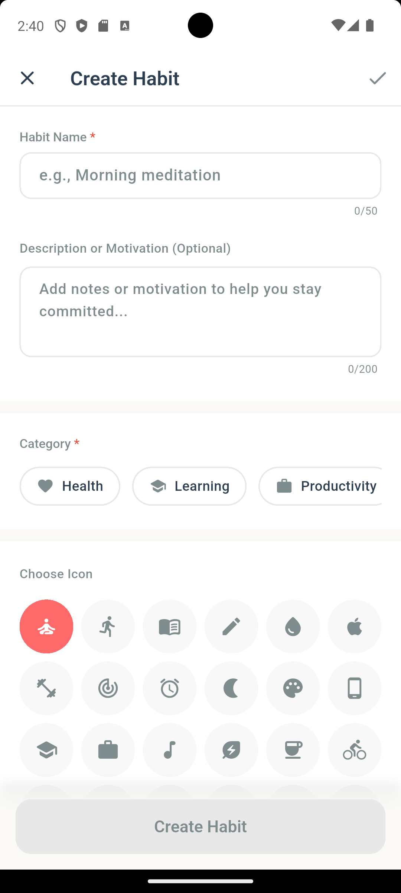
Habit Creation Screen — Empty form

Step 1: Habit Name
- Enter a descriptive name for your habit (maximum 50 characters).
- A character counter appears as you approach the limit.

Step 2: Description (Optional)
- Add an optional description to provide context for your habit.

Step 3: Category Selection
Choose one of the five categories:
Category | Icon | Example Habits
Health | Heart | Drink water, Take vitamins
Fitness | Dumbbell | Exercise, Go for a run
Learning | Graduation cap | Read a book, Study
Mindfulness | Lotus | Meditate, Journal
Productivity | Briefcase | Plan the day, Deep work
Each category has its own colour theme applied throughout the app.

Step 4: Icon Selection
- Choose an icon to visually represent your habit.
- The available icons are contextual to the selected category.

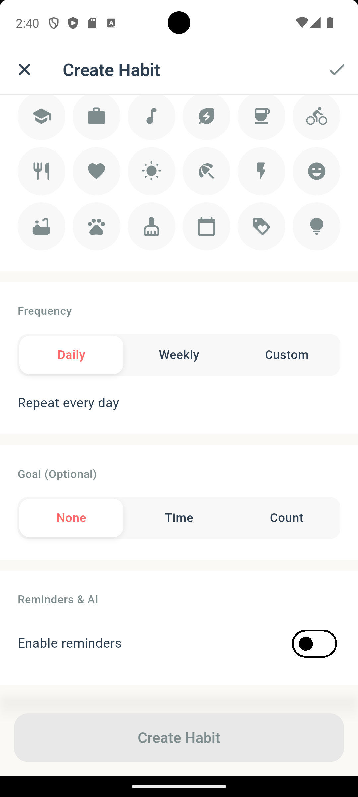
Habit Creation Screen — Frequency selection

Step 5: Frequency
Select how often you want to perform the habit:
Frequency | Description
Daily | Every day
Weekly | Select specific days of the week (Mon, Tue, etc.)
Custom | Every X days / weeks / months

Step 6: Goal Setting (Optional)
Set a measurable target:
Goal Type | Example
None | No specific target — simply complete or skip
Time-based | e.g., 30 minutes of reading
Count-based | e.g., 8 glasses of water
- Enter the goal value and unit (minutes, hours, times, pages, etc.).

Step 7: Reminders (Optional)
- Toggle reminders on.
- Set the reminder time using the time picker.
- Choose a notification style:
- Standard — A simple reminder notification
- Motivational — An AI-generated motivational message
- Silent — Badge only, no sound

Step 8: Save
Tap the Save button (or "Create Habit") to add the habit to your daily tracking.

Creating a Habit from an AI Suggestion
- Navigate to the AI Coach > Suggestions tab or find a suggestion on the Home screen.
- Tap the "Add Habit" button on any suggestion card.
- The Habit Creation screen opens pre-filled with the AI's recommended name, category, frequency, goal, and reminder time.
- Review and adjust any fields as needed.
- Tap Save to add the habit.

Editing an Existing Habit
- Navigate to a habit's Detail Screen (tap on a habit from the Home list).
- Tap the Edit icon (pencil) in the app bar.
- The Habit Creation screen opens in edit mode with all fields pre-filled.
- Make your changes and tap Save.

Deleting a Habit
- Navigate to the habit's Detail Screen.
- Tap the Delete icon (trash) in the app bar.
- Confirm the deletion in the dialog that appears.
- The habit and all associated data will be permanently removed.

6. Progress & Analytics
The Progress tab is your analytics dashboard, providing a comprehensive view of your overall habit performance.
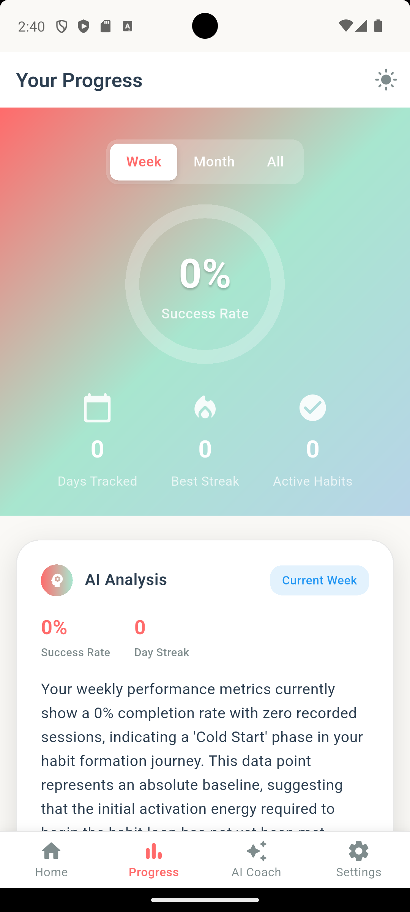
Progress Screen — Full view

AI Weekly Summary
At the top of the Progress screen, the AI Weekly Summary card provides:
- Week range (e.g., "Feb 17 – Feb 23")
- Completion rate for the period
- Current streak across all habits
- Top performing category
- AI-generated insight summarising your week
- Highlights — Key achievements and patterns
- Encouragement — A personalised motivational message
- Next Steps — Prioritised action items with timeframes
If the summary is outdated (older than 24 hours), a banner appears prompting you to refresh.

Category Breakdown
A pie/donut chart visualises how your habits are distributed across categories (Health, Fitness, Learning, Mindfulness, Productivity). Each category shows the number of habits and its percentage share.

Weekly Heatmap
A 7-day heatmap displays daily completion rates for the current week. Each day shows:
- The date number
- A colour intensity reflecting the completion rate (darker = higher)
- A completed/total count (e.g., "5/7")

Trend Charts
Interactive line charts show your completion rate trends. Toggle between:
View | Period
Week | Current week (Mon–Sun)
Month | Current month
All Time | Full history since first habit

Best & Worst Performing Habits
Two ranked lists show:
- Best Performing — Habits with the highest completion rates
- Worst Performing — Habits that need the most attention
Each entry displays the habit name, category, success rate, and completion count.

Achievement Gallery
A gallery of badges and milestones you've earned. Achievements are organised into categories:
Category | Examples
Streak | "3-Day Streak", "7-Day Streak", "30-Day Streak"
Completion | "First Completion", "100 Completions"
AI | "Used AI Coach", "Applied AI Suggestion"
Category | "Balanced Tracker" (habits across all categories)
Consistency | "Never Missed a Week", "Perfect Month"
Special | Unique milestones and challenges
Each achievement shows:
- Badge icon and name
- Description of how to earn it
- Progress bar (for locked achievements)
- Unlock date (for earned achievements)
- Tips for working towards the achievement

Quick Actions
At the bottom of the Progress screen, quick action buttons are available:
- Export — Export your habit data (navigates to export options)
- Share — Share your progress summary

7. AI Coach
The AI Coach tab provides personalised, AI-powered guidance to help you build better habits. It features a gradient hero section with the title "Your AI Coach" and the subtitle "Personalized insights to help you succeed."

Tab Navigation
The AI Coach has four tabs, selectable via a pill-style tab bar:
Tab | Icon | Description
Suggestions | Lightbulb | AI-generated personalised habit recommendations
Insights | Chart | Weekly AI analysis with patterns and action steps
Scores | Speedometer | AI-powered scoring and performance evaluation
Actions | Checklist | Actionable items for habit improvement

Usage Limits
A usage indicator icon appears next to the tab bar. Tap it to view your current AI usage:
- Free-tier users have limited AI requests per period.
- The indicator turns yellow/warning when usage limits are reached.
- Pro/Mastery tier users have unlimited AI access.

Suggestions Tab
The Suggestions tab shows AI-generated habit recommendations tailored to your existing habits, categories, completion rate, and streak data.
Each suggestion card includes:
Field | Description
Title | The recommended habit name
Description | What the habit involves
Why This Helps | AI explanation of the expected benefit
Category | Which category the habit falls under
Estimated Impact | High, Medium, or Low (colour-coded)
Estimated Minutes | Daily time commitment
Frequency | Daily or weekly (with specific days)
Goal | Suggested goal type and target
Add Habit button | One-tap to create the habit (pre-filled form)

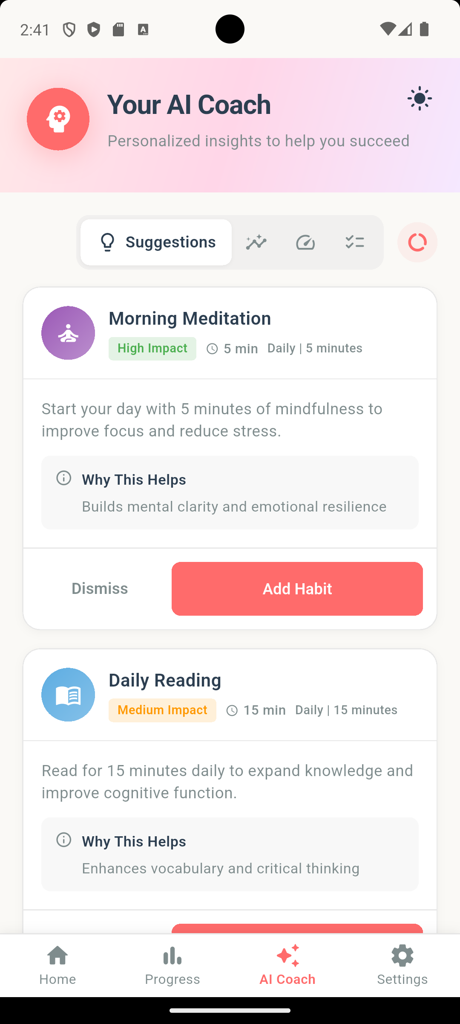
AI Coach — Suggestions tab with suggestion cards

Insights Tab
The Insights tab provides a weekly AI analysis of your habit performance. It includes:
- Weekly Summary — Completion rate, streak, and top category
- AI-Generated Insight — A narrative analysis of your week
- Highlights — Bullet-point achievements and notable patterns
- Encouragement — A personalised motivational message
- Discovered Patterns — Behavioural patterns the AI has identified:
- Time Patterns — "You complete habits better in the morning"
- Day Patterns — "You're most consistent on weekdays"
- Habit Sequences — "Meditation helps you complete other habits"
- Trigger Patterns — "You complete habits after breakfast"
- Next Steps — Prioritised actions with timeframes (Today, This Week)
Each pattern shows a confidence score (High, Medium, Low).
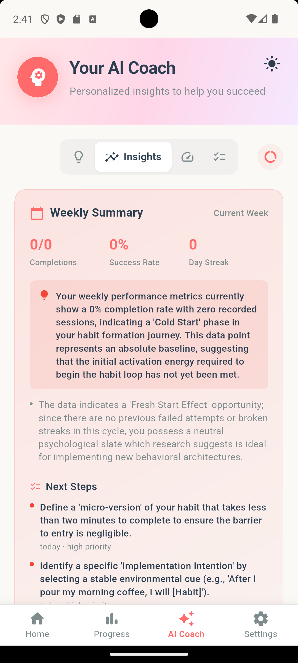
AI Coach — Insights tab with patterns

Scores Tab
The Scores tab provides AI-powered scoring of your habit performance, evaluating consistency, effort, and progress across dimensions.
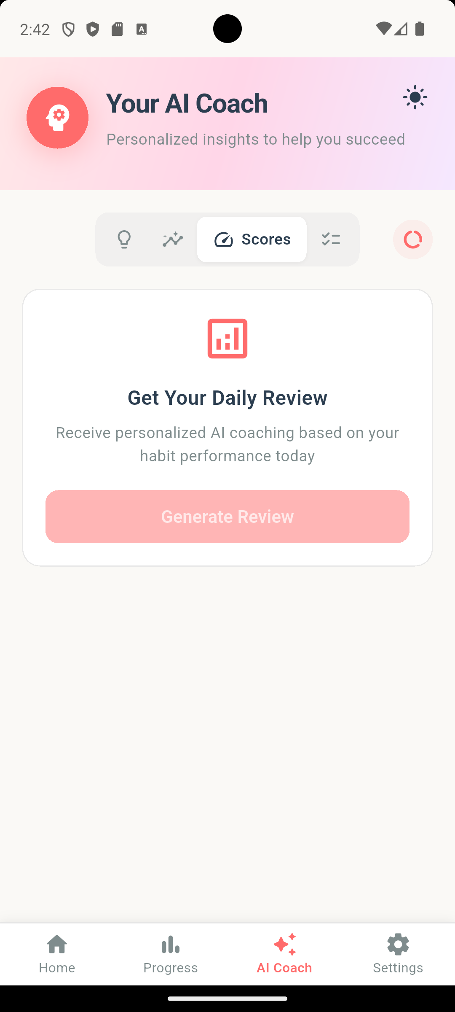
AI Coach — Scores tab

Actions Tab
The Actions tab shows personalised, actionable items generated by the AI to help you improve. Each action item includes:
Field | Description
Title | What to do
Description | Detailed explanation
Type | Today, This Week, or Challenge
Priority | High (red), Medium (orange), or Low (blue)
Related Habit | Which habit the action is linked to (if any)
Metric | How to measure success
Checkbox | Mark the action as completed
Actions are sorted by priority and can be completed by tapping the checkbox.
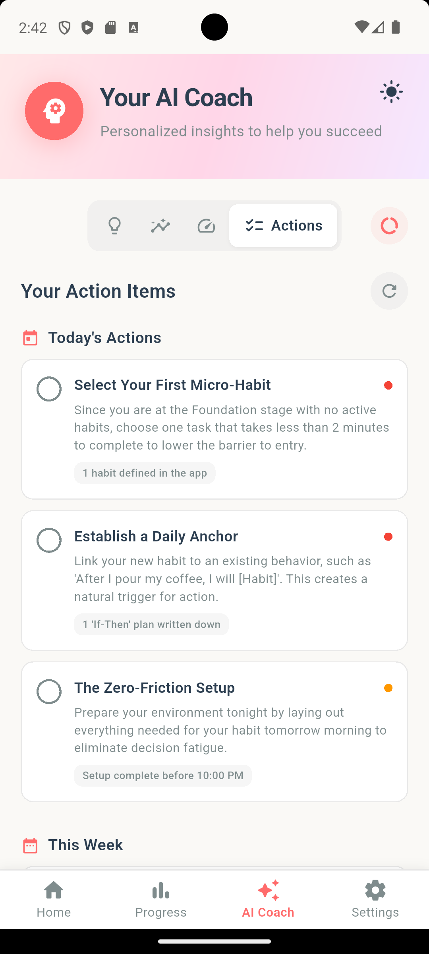
AI Coach — Actions tab with action items

Refreshing AI Content
- Tap the refresh button in the tab navigation area to regenerate AI content for the active tab.
- A cooldown period applies between refreshes. If you attempt to refresh during cooldown, a tooltip shows the remaining wait time.
- Content is automatically loaded when you first visit a tab.

Tips (within AI Coach)
Throughout the AI Coach interface, AI Tips are organised by category and provide habit-building guidance:
Tip Category | Focus
Getting Started | Basics for new habit builders
Staying Consistent | Maintaining streaks and routines
Overcoming Challenges | Dealing with setbacks and obstacles
Advanced Strategies | Optimisation for experienced users
Mindset & Motivation | Psychological strategies for success
Each tip includes:
- Title and content
- Key Points — Bullet-point takeaways
- Actionable Step — A specific thing you can do right now

8. Settings
The Settings tab provides comprehensive configuration options. It opens with a floating app bar and scrollable content.
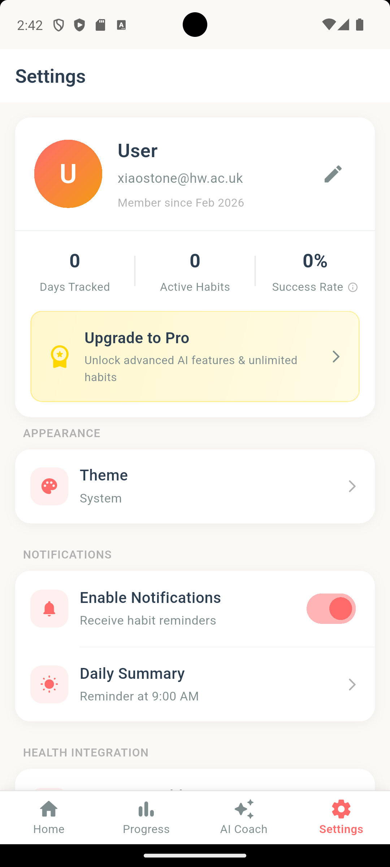
Settings Screen — Full view

Profile Section
At the top of Settings, your profile card displays:
- Avatar — Shows your initials or profile image (gradient circle)
- Full Name — Your display name
- Email — Your account email
- Member Since — Date you joined
- Stats Row — Days Tracked | Active Habits | Success Rate (last 7 days)
- Upgrade to Pro banner (if not subscribed)

Editing Your Profile
- Tap the edit icon (pencil) on the profile card.
- A modal opens where you can update:
- First Name
- Last Name
- Avatar URL (profile image link)
- Tap Save to apply changes.
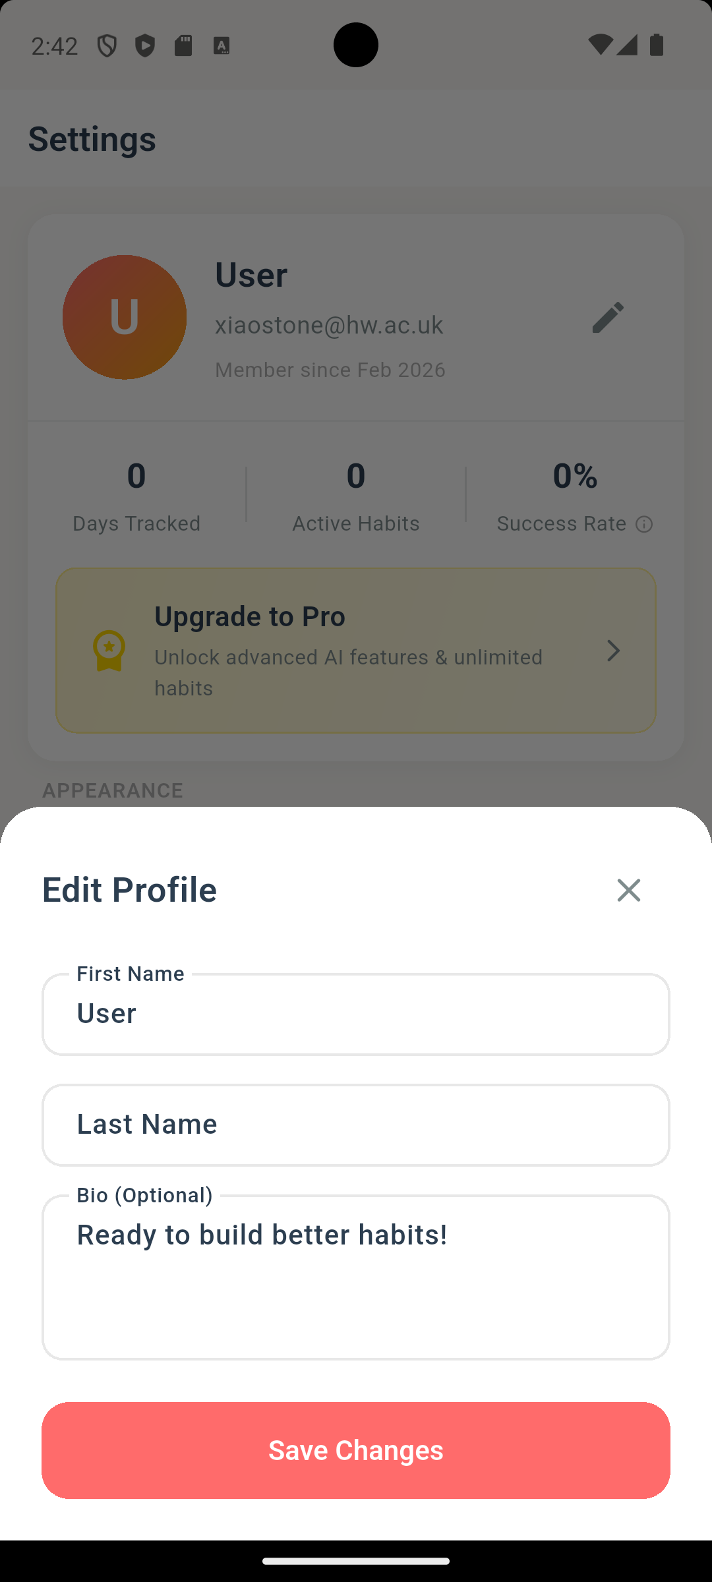
Settings — Profile edit modal

Appearance
Setting | Options
Theme | Light, Dark, System Default
- Tap Theme to open the theme selector.
- Choose your preferred theme.
- The app will update immediately.
Tip: You can also toggle between light and dark mode using the sun/moon icon on the AI Coach screen.

Notifications
Setting | Description
Enable Notifications | Master toggle for all habit reminders
Daily Summary | Set the time for your daily summary notification

Configuring Notifications
- Toggle "Enable Notifications" on.
- Grant notification permissions when prompted by the system.
- Tap "Daily Summary" to choose the time for your daily summary reminder.
- Choose a time using the time picker.
- A confirmation snackbar will appear (e.g., "Daily summary set for 9:00 AM").

Health Integration
Available on iOS and Android only.
Connect Aura to your device's health platform to enhance AI insights with physical activity data.
Platform | Health Source
iOS | Apple Health
Android | Google Health Connect

Connecting Health Data
- Toggle "Connect Health Data" on.
- Review the data access prompt (Steps, Sleep, Activity, Heart Rate).
- Tap "Connect" to grant permissions.
- Once connected, a "Health Correlations" option appears showing:
- 7-Day Summary — Average steps and sleep hours
- Key Findings — AI-discovered correlations between health metrics and habit completion
- Recommendations — Action plans based on health-habit patterns

Account
Setting | Description
Subscription | View or manage your Pro subscription
AI Usage | View current AI request usage and limits
Export Data | Download your habit data
Sign Out | Sign out of your account
Delete Account | Permanently delete your account and all data

Exporting Data
- Tap "Export Data".
- Choose the export format:
- CSV — Spreadsheet-compatible format
- JSON — Machine-readable format
- The file will be saved to your device's Downloads folder (Android) or Documents folder (iOS).
- A share dialog opens allowing you to send the file via email, messaging, or cloud storage.

Signing Out
- Tap "Sign Out".
- Confirm in the dialog that appears.
- You will be returned to the Login screen.

Deleting Your Account
- Tap "Delete Account" (shown in red).
- Read the warning about permanent data loss.
- Confirm the deletion.
- Your account and all associated data will be permanently removed.
Warning: Account deletion is irreversible. All habits, history, achievements, and AI data will be permanently erased.

Help & Support
Option | Description
FAQ | Common questions and answers
Tutorials | Step-by-step guides for app features
Contact Support | Reach the support team
Report Bug | Submit a bug report
Request Feature | Suggest new features
AI Transparency | Learn how AI works in Aura
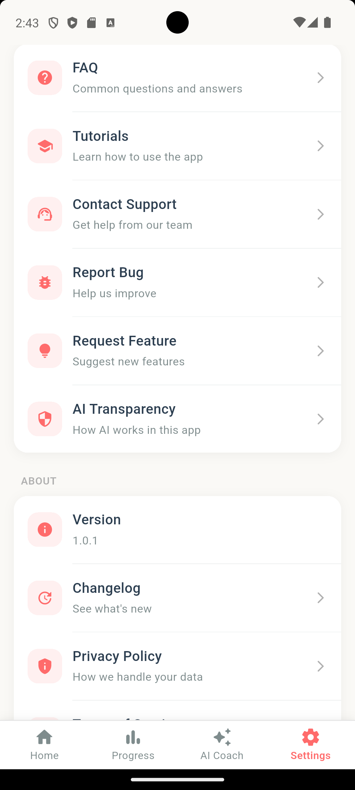
Settings — Help & Support section

About
Option | Description
Version | Current app version (e.g., 1.0.1)
Changelog | View release notes and what's new
Privacy Policy | How your data is handled
Terms of Service | User agreement
Open Source Licenses | Third-party software credits
Rate App | Leave a review on the app store
Credits | Made by Stone

9. Troubleshooting & FAQ

Login Issues
Q: I forgot my password. How do I reset it?
A: On the Sign In screen, enter your email and tap "Forgot Password?". A reset link will be sent to your email.
Q: Google Sign-In is not working.
A: Ensure your Google Play Services are up to date (Android). If the issue persists, try signing in with email and password instead.
Q: Apple Sign-In is not showing.
A: Apple Sign-In is only available on iOS devices. On Android, use email/password or Google Sign-In.
Q: I get an error when signing up.
A: Ensure your email is valid and your password is at least 6 characters. If the email is already registered, try signing in instead.

Notification Issues
Q: I'm not receiving habit reminders.
A: Check the following:
- Notifications are enabled in Settings > Notifications.
- The app has notification permissions in your device's system settings.
- Battery optimisation is not blocking background notifications (Android).
- Do Not Disturb mode is not active on your device.
Q: How do I change my daily summary time?
A: Go to Settings > Notifications > Daily Summary and select a new time.

AI Coach Issues
Q: The AI Coach is not loading content.
A: This can happen if:
- You have no habits created yet — the AI needs habit data to generate recommendations.
- You've reached the free-tier AI usage limit — wait for the cooldown period.
- Your internet connection is unstable — the AI coach requires an active connection.
Q: Why are AI suggestions not personalised?
A: The AI requires at least a few days of habit tracking data to generate personalised content. Keep tracking consistently and the suggestions will improve.
Q: My AI weekly summary says "outdated".
A: Tap the refresh/regenerate button to generate a fresh weekly summary based on your latest data.

Data & Syncing
Q: Will my data sync across devices?
A: Yes. Aura uses cloud storage (Firebase) to sync your data. Sign in with the same account on any device to access your habits.
Q: How do I export my data?
A: Go to Settings > Account > Export Data and choose CSV or JSON format.

Health Integration
Q: Health Connect is not installed (Android).
A: Tap the "Install" button in the prompt to download Health Connect from the Google Play Store.
Q: I connected health data but see "Not enough data yet."
A: Health correlations require at least 7 days of combined health and habit data.

General
Q: How do I delete a habit?
A: Open the habit's Detail Screen (tap on it from the Home list), then tap the delete icon in the app bar.
Q: Can I undo a completed habit?
A: Yes. Tap the checkbox again on any completed habit to undo the completion for today.
Q: How do I contact support?
A: Go to Settings > Help & Support > Contact Support to reach the team.
Q: How do I report a bug?
A: Go to Settings > Help & Support > Report Bug and provide a description of the issue.

