HTML/CSS course

Assignment 2

We create a recipe page.

File name: favorite_food.html

Soup

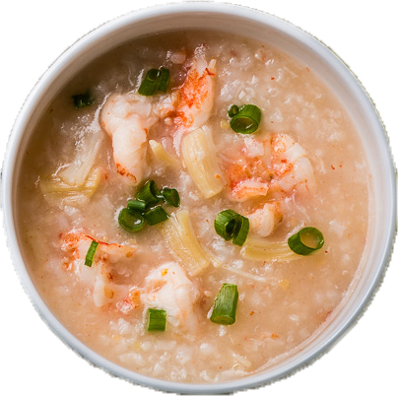

Recipe by: [your name]

A **seafood congee** is the rice soup consisting of shrimp, rice, green onion and salt. It is unbelievably delicious and easy to cook.

Ingredients:

* Rice
* Shrimp
* Green onion
* Salt

Directions:

1. Cook a regular rice soup
2. When the rice soup is cooked, add shrimp to the soup
3. Cook the soup until the shrimp is cooked
4. Add proper amount of salt
5. Add green onion, stir a few times
6. The delicious seafood congee is ready to serve