Some Hotel_Room objects have random descriptions

Ability to send texts

Description if hotel room “My x (e.g. pink shirt) is lying on the bed”

Make sure dropping an object leaves it in the right place, Kaitlyn or Britney (OnPhone)

Touch, feel, kiss, lick suck – If I know about fluffy, Not the time for that, else, do some

List the non-clothing objects Britney’s carrying

Clothing that has worn not listed in inventory

15:54 > britney, drop blue
Britney has better things to do. - need to figure out where to move object

Britney go when undressed, make sure it doesn't stop me leaving

An extra space:
16:04 > x mobile
It's a picture of Britney in a yellow t-shirt and yoga pants.

16:05 > swipe right

Oops!
16:06 > exit
I open the door and exit the room.I'm still holding the phone, it's one of those ones with a cord.

16:07 > hang up
"Bye, Igor.

Extra space (britney initial just returning a newline?)
16:07 > l

Hotel Room
According to the floor plan on the back of the door, I'm in room 203.

You can also see your yellow t-shirt here.

Extra space:
16:08 > e

Elevator
I'm are in the hotel's main elevator, which seems to be on the second floor.

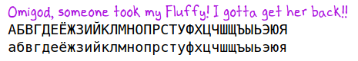

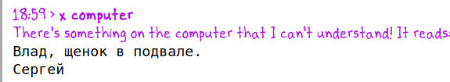

The elevator is ready.

Undress (both)
Selfie verb
Britney, photograph me
Photograph us

Reply to come here in britney's voice
17:22 > call britney
Hey Kaitlyn, what's up?

17:22 > britney, come here
I asked Britney to come meet me here, then hung up.

In hotel room, you hear a knock on the door, you open it, she walks in
Just then, Britney arrived.
17:24 >

