3D Dress Simulator Project

# Section I. Reason

Customer

1. Improve customer Online shopping experience.
   1. They can try the clothes online.
   2. Reduce the time on fitting room. They can pre-order the clothes online and pick up in store and try it in store.
   3. Increase the number of choices.
   4. try the combination of clothes/ Jewelry/Jeans …
   5. able to see the looking in different scenario

On the company side

1. It is a good promotion.
   1. They can highlight the on sale and best sell clothes.
   2. Can work with different companies ( high end)
2. Reduce the chances of return
3. Better management inventory.
   1. They can deliver the needed clothes to the store. Well distribute the clothes to fulfil the demand.
   2. Company can analyze the need of market.
4. Jewelry company can prevent stolen.
5. Can custom the clothes (high end) (overwighted)
6. Dress recommendation system (basic on historical, and famous model/Star) ( good promotion)

# Section II. Potential Sellers

1. Web Shipping vender: Amazon
2. Physical vender: Macy ….
3. Clothes company: prada ….
4. Handbag company: Coach ….
5. Diamond/Jewelry: Buccella ….

# Section III. Brainstorm

System

* Platform
  + PC application?
    - Language: Python?
  + Web?
    - Language: Python? JavaScript?
    - Web platform: Django? Apache?
  + Phone? Andriod?
    - Language: Java?
* Feature
  + Main
    - How to setup the environment?
      * Which library used?
        + Handle the requirement of speed and model’s clarity (like real)
    - Photo to 3D model
      * Algorithm
        + Complexity
        + Accuracy
      * Scale Standard
      * Detail of the 3D model
        + Skins detail? ( No need)
        + Face detail? (Priority)
        + Body Shape? (Priority)

Can it be simplify?

* + - * Photo format
        + Size
        + How many ( ideal: at least 4 : 0,90,180,360 degree)
        + Clarity
        + Source?

Photo?

Camera?

Any?

* + - * Interface to main system
    - Dressing Simulation
      * Clothes
        + Parameter

Dimension

Elastic coefficient

opacity

* + - * + Model import from common 3D software

Easiness for company to generate their model

Interface between the mode

Standard requirement

Pixel

Format

Scale

…….

Level of reality of the clothes

* + - * Dressing
  + Sub
    - Scene
    - Pos
    - Light
    - Make up
    - Environment
      * Wind
* Requirement
  + System for generation user
    - Android: Low end CUP + GPU
    - Web : Server side computation, Low-Middle end CPU + Low end GPU
    - PC : Low-End CPU
  + Time
    - Instant / low latency
    - Good algorithm to reduce time
  + Package/Model size
    - Andriod
      * 4G
      * 5G : neglectable
    - Web/PC
      * Less concern

# Section VI. Demo Requirement

The demo demonstrates the key features of the programs.

1. Environment Setting
   1. Scale
   2. Dimension
   3. Rotation function
   4. Zoom in and out function
   5. Server/Website setting
      1. Python server: Flask ( it is a small scale fast development framework for **small** project)
      2. SQL
2. Photo to 3D model convertor
   1. Input information
      1. 4 photos from each side ( front, back, left and right)
      2. Face photo
      3. Provide the height
      4. Scale of the model
      5. (optional parameter) width, CUP size
   2. Input requirement
      1. Photo should be in RAW/JPG format
3. Import clothes model
   1. Input information
      1. A 3d model from CAD software
      2. Model should indicate the scale
      3. Dimension
      4. Elasticity parameter
      5. Opacity
      6. Size (X, M, L, XL)
   2. Input information
      1. The python software should meet the standard requirement of the CAD file (temporary goal). Final goal: meet the standard of industry software
4. Dynamic dressing simulation
   1. Basic simulation
      1. Show the fitness of the clothes
      2. Could apply to all clothes and human models (even overfit)

# Section V. Demo Architecture

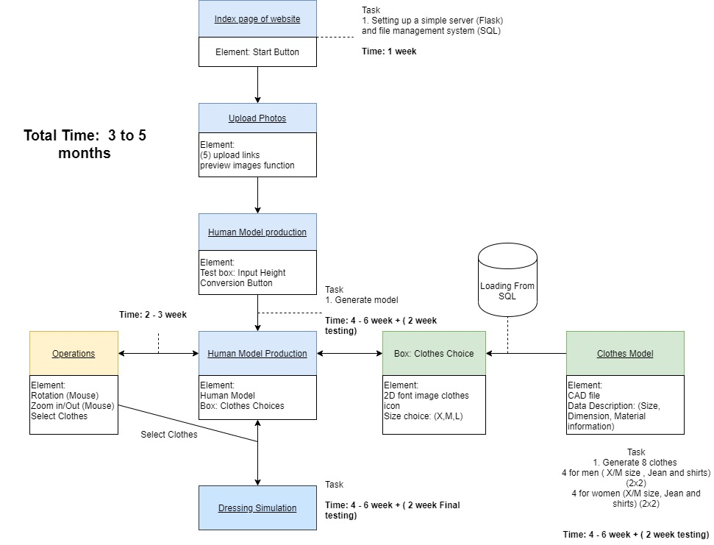

# Section V. Timeline

|  |  |  |  |  |  |  |  |
| --- | --- | --- | --- | --- | --- | --- | --- |
|  | Reseach and Setup | Coding |  |  |  |  | Review |
| Fenil | Find the standard of Clothe Model  and interface between Model and Python | Build 8 Clothes Model | | | Add to SQL and Test | Dress Dynamic Simulation | Final Testing, Fix bug  and Reduce Computation |
| Lam | Find proper library for 3D simulation  and set up server | Build human Shape | hand and leg adjument | Face adjument | Test |
|  | ~ 1 week | ~2 week | ~ 1 week | ~ 1 week | ~2 week | ~ 4 week | ~ 2 week |
| Date: 6/13 | Goal : 6/20 | Goal:7/4 | Goal:7/11 | Goal: 7/18 | Goal:8/1 | Goal: 8/29 | Goal: 9/12 |
|  |  |  |  |  |  |  |  |
|  |  | Human sketch, Human body Female body shape Homo sapiens Woman ... | | Human Anatomy - Man 3D model | CGTrader |  |  |  |
|  |  |  |  |  |
|  |  |  |  |  |
|  |  |  |  |  |
|  |  |  |  |  |
|  |  |  |  |  |
|  |  |  |  |  |
|  |  |  |  |  |
|  |  |  |  |  |  |  |  |

# Section VI. Advanced Features

* + 1. Scenario
       1. Wedding
       2. Night Club
       3. Branch
    2. Motion
       1. Dressing
       2. Running
       3. Walking
       4. Stage Walk
    3. Pose
    4. Environment Dynamic
       1. Windy
    5. Image Effect
       1. Light
       2. Shadow
       3. Mixup
    6. Image Output
    7. Dress Recommendation system