样例 1 — scene03_marker_normal
项目 |  |  | 内容
Video ID |  |  | scene03_marker_normal
Source |  |  | Cosmos
Task |  |  | ____________________
Duration / FPS / Frames |  |  | 10.06 s / 16 FPS / 161 frames
Evaluation Object |  |  | marker
Video Path |  |  | outputs/cosmos_predict2_roboengine3x2/videos/scene03_marker_normal.mp4
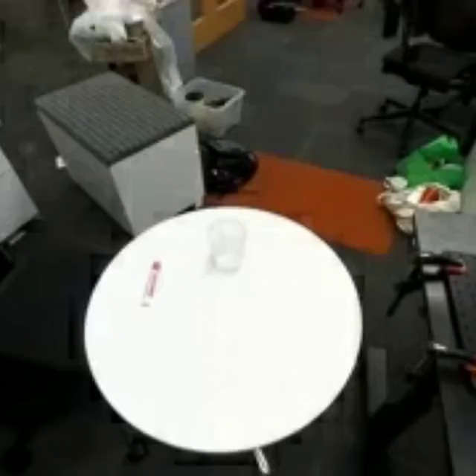 | 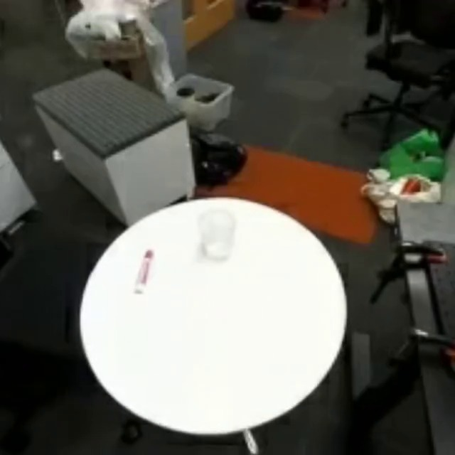 | 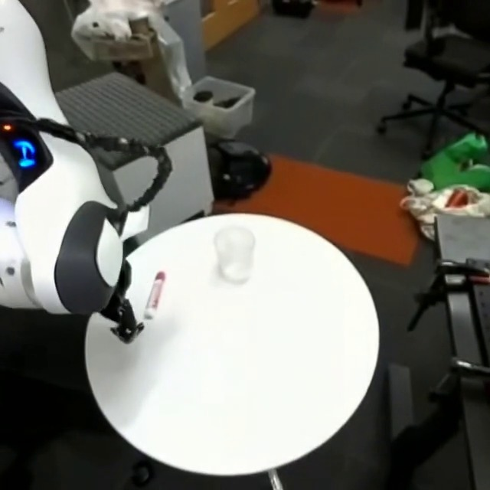 |  | 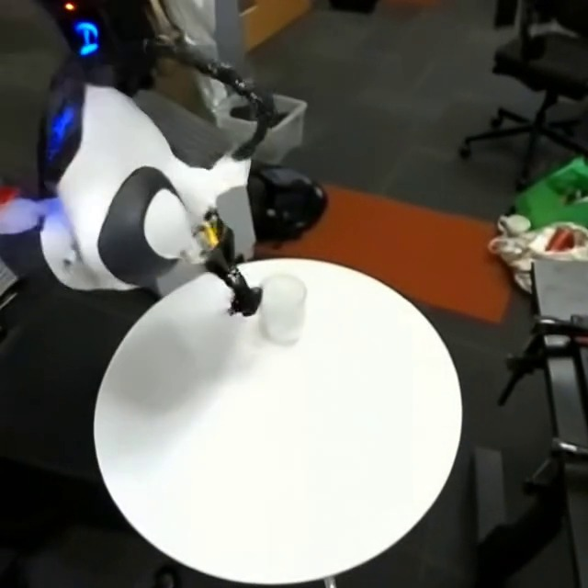 | 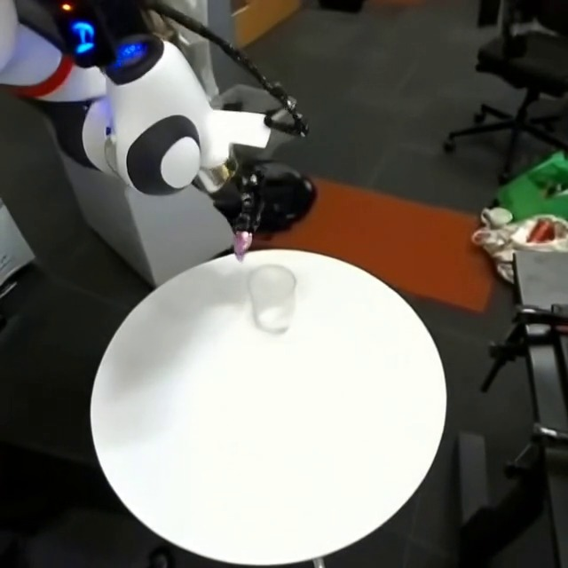 | 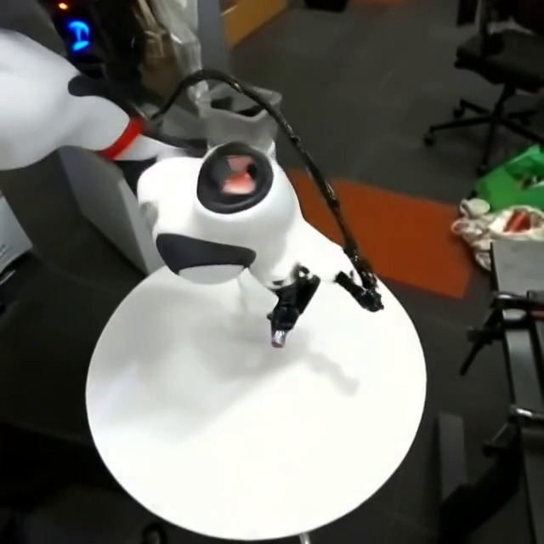
Frame 000 | 0.00 s | Frame 001 | 0.06 s | Frame 035 | 2.19 s |  | Frame 080 | 5.00 s | Frame 125 | 7.81 s | Frame 160 | 10.00 s
Evaluation Object 确认： □ TARGET_CORRECT □ TARGET_WRONG □ TARGET_UNCERTAIN 人工确认的 Evaluation Object：____________________
视频状态： □ NORMAL □ ABNORMAL □ UNCERTAIN 异常类型： □ ABNORMAL_DISAPPEARANCE □ UNREASONABLE_REAPPEARANCE □ IDENTITY_CHANGED □ ABNORMAL_DEFORMATION
□ MOTION_JUMP □ MOTION_FREEZE □ MOTION_DISCONTINUITY □ OTHER: __________
Object Existence
评价目标物体是否持续、合理存在；合理遮挡不等于异常消失。
Point | Time / s | Frame | Score [0–1] | 状态 / 原因
Start
Peak
Recovery
Control
Shape Normality
只评价目标物体自身几何形状；正常旋转、透视和遮挡不算异常形变。
Point | Time / s | Frame | Score [0–1] | 状态 / 原因
Start | 2.2 |  | 0.3
Peak | 4 |  | 0.1 | 目标物体形状畸变，变成原来面积一半
Recovery
Control
Motion Smoothness
评价运动是否连续、合理；正常抓取加减速、旋转和轻微接触抖动不算异常。
Point | Time / s | Frame | Score [0–1] | 状态 / 原因
Start
Peak
Recovery
Control
Score：1.0 正常 | 0.8 轻微异常 | 0.5 明显异常 | 0.2 严重异常 | 0.0 完全失效
异常过程简述： ____________________________________________________________ 人工审核： □ ACCEPT □ REVIEW_AGAIN Evidence 是否存在明显错误： □ NO □ YES
例：NORMAL_OCCLUSION / ABNORMAL_DISAPPEARANCE / DEFORMATION / MOTION_JUMP / RECOVERED Existing V2 curves: Reference Only（非人工 GT）
样例 2 — scene01_duck_deformation
项目 |  |  | 内容
Video ID |  |  | scene01_duck_deformation
Source |  |  | Cosmos
Task |  |  | ____________________
Duration / FPS / Frames |  |  | 10.06 s / 16 FPS / 161 frames
Evaluation Object |  |  | orange rubber duck
Video Path |  |  | outputs/cosmos_predict2_roboengine3x2/videos/scene01_duck_deformation.mp4
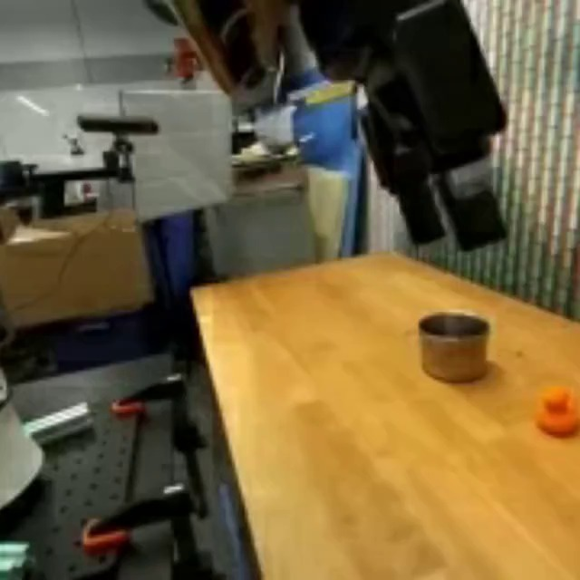 | 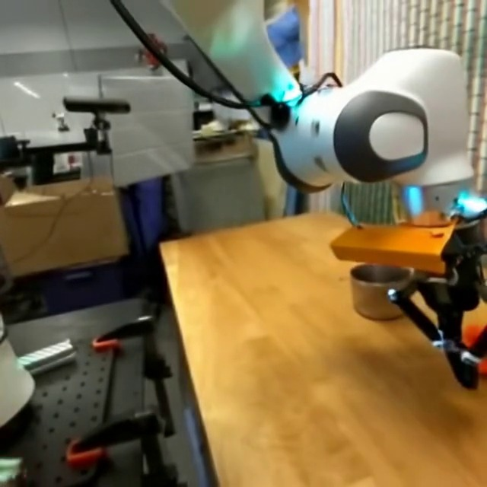 | 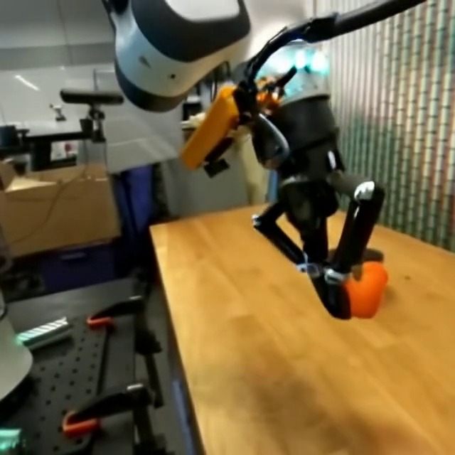 |  | 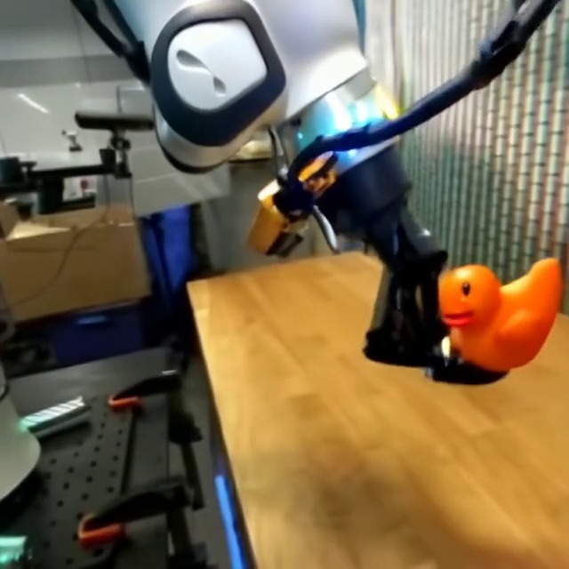 | 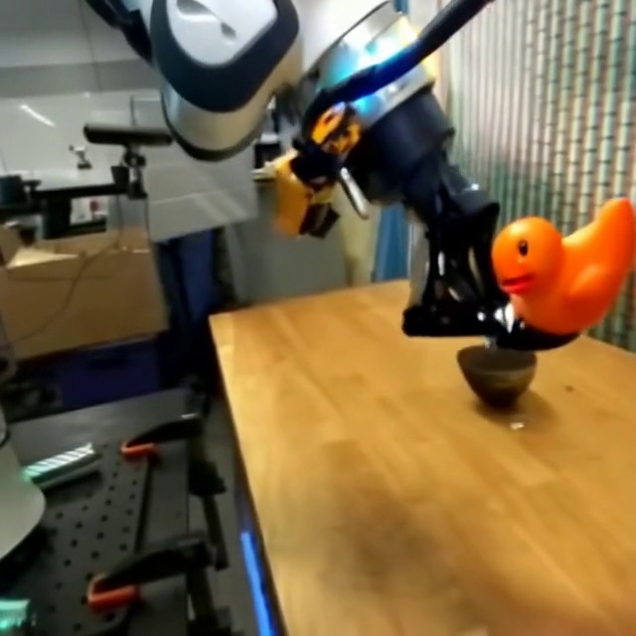 | 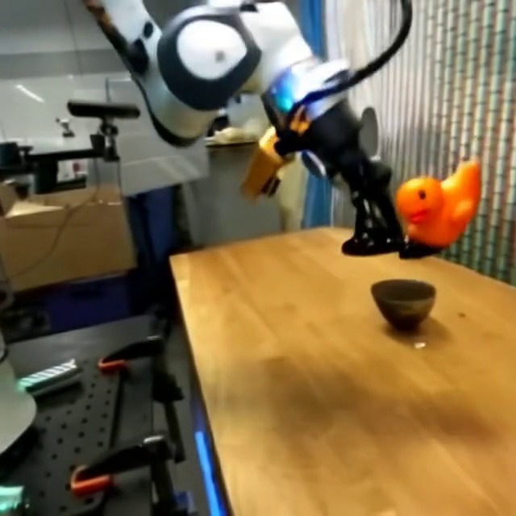
Frame 000 | 0.00 s | Frame 035 | 2.19 s | Frame 080 | 5.00 s |  | Frame 125 | 7.81 s | Frame 143 | 8.94 s | Frame 160 | 10.00 s
Evaluation Object 确认： □ TARGET_CORRECT □ TARGET_WRONG □ TARGET_UNCERTAIN 人工确认的 Evaluation Object：____________________
视频状态： □ NORMAL □ ABNORMAL □ UNCERTAIN 异常类型： □ ABNORMAL_DISAPPEARANCE □ UNREASONABLE_REAPPEARANCE □ IDENTITY_CHANGED □ ABNORMAL_DEFORMATION
□ MOTION_JUMP □ MOTION_FREEZE □ MOTION_DISCONTINUITY □ OTHER: __________
Object Existence
评价目标物体是否持续、合理存在；合理遮挡不等于异常消失。
Point | Time / s | Frame | Score [0–1] | 状态 / 原因
Start
Peak
Recovery
Control
Shape Normality
只评价目标物体自身几何形状；正常旋转、透视和遮挡不算异常形变。
Point | Time / s | Frame | Score [0–1] | 状态 / 原因
Start
Peak
Recovery
Control
Motion Smoothness
评价运动是否连续、合理；正常抓取加减速、旋转和轻微接触抖动不算异常。
Point | Time / s | Frame | Score [0–1] | 状态 / 原因
Start
Peak
Recovery
Control
Score：1.0 正常 | 0.8 轻微异常 | 0.5 明显异常 | 0.2 严重异常 | 0.0 完全失效
异常过程简述： ____________________________________________________________ 人工审核： □ ACCEPT □ REVIEW_AGAIN Evidence 是否存在明显错误： □ NO □ YES
例：NORMAL_OCCLUSION / ABNORMAL_DISAPPEARANCE / DEFORMATION / MOTION_JUMP / RECOVERED Existing V2 curves: Reference Only（非人工 GT）

