**Survivable Social Network on a Chip Team S-16 A2**

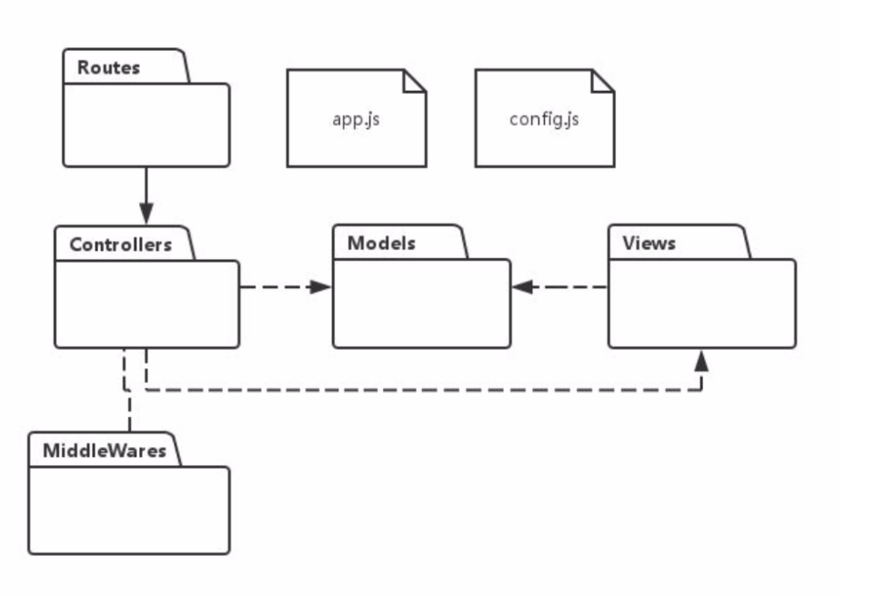

A social network that easily can be setup in a local area to allow for people to talk to each other without larger internet access

**Hardware**: Beaglebone Black with wireless dongle and portable rechargeable battery. Clinet connection devices

**Software**: The main server is written in NodeJS with a sqlite database. The front end uses a combination of framework7. The communication between the backend frontend is implemented with http restful get/put requests and the socketIO framework.

**Software Abstraction:**  To simplify the system a model view controller abstraction is used. Each functional page has its own controller on both the front and back end. The functional pages are:  
 *Login* handles new user creation and returning user login

* *Search* handles the look up of information that is on the system such as past posts or user active users
* *Test* handles load testing and performance monitoring of the system
* *Public Message* handles user send public messages to everyone
* *Private Message* Handles users send a private message to a specific user
* *Announcement* handles sending announcements that immediately show up on all users screens
* *Map* Handles uses viewing and recording position information
* *History* Handles the user history and history viewing
* *Profile* Handles the users profile and profile viewing

The SNOC is designed to be very responsive and handle a moderate scale, however it has not been designed to support a massive user base. This allows for us to optimize performance for a smaller number of people so direct socket connections are used for server client message passing of dynamic data such as new message.

**Architectural Decisions with Rationale**

* Server-side JS (node.js) for low footprint and reasonable performance (event-based, non-blocking asynchronous I/O, easily configurable pipe-pipe-and-filter for processing incoming requests via middleware)
* Lightweight MVC on the server side via the express framework
* RESTful API for core functionality to reduce coupling between UI and back-end
* Event-based fast dynamic updates via web-sockets
* The CRUD operations on DB are done in an OO way through a ORM library.
* Single Page Application: most requests are sent through Ajax. Update the content on screen without reloading the whole page.
* MVVM pattern on the front end side. Angular.js supports two way data binding

**Design Decisions with Rationale**

* ORM(Proxy): Design and implement the models in an OO way and map models to db tables
* Use Adapter design pattern to substitute a test database
* The Singleton design pattern is used for DB connections and for logger functionality