

***Clear Reflection***

|  |  |
| --- | --- |
| **STUDENTS** | * Hassan Sheraz(1654088) * Ahmed Raza (1654016) * Khair-Un-Nisa (1655026) |
| **FACULTY** | Miss Kinza |
| **BATCH** | Cf-2504-E |
| **SEMESTER** | 2rd Semester |

**Index**

**Introduction** 3

**Objectives of Projects** 5

**Problem Statement** 6

**Home Page** 7

**Our Services Page** 9

**Our Agents Page** 11

**Contact Us Page** 12

# **Introduction**

Mailix Company: Delivering Excellence in Logistics and Transportation

In today’s fast-paced world, businesses that provide multifaceted services have gained an upper hand, not only for their convenience but also for the seamless experience they offer. One such innovative company in this space is XYZ Logistics, a trailblazer that has been reimagining the logistics and delivery industry. With a mission to simplify people's lives through efficient and reliable services, XYZ Logistics provides an array of offerings, from postal services and courier parcels to full-fledged home shifting solutions. This diversity enables the company to cater to a broad range of customer needs, setting it apart from competitors that specialize in a single service.

XYZ Logistics began as a small postal service provider, helping individuals and businesses send letters and small packages. Recognizing the changing needs of its clientele and the growing demand for diverse services, the company gradually expanded its operations to include courier parcels, making it easier and faster for customers to send packages both domestically and internationally. Their courier service covers a wide network, offering a secure, speedy, and economical way for people to send items across various distances. This expansion allowed XYZ Logistics to cater not only to private individuals but also to businesses, including e-commerce platforms that require fast, reliable shipping to meet customer expectations.

While the postal and courier services contributed to the company’s growth and reputation, XYZ Logistics soon identified an additional gap in the market: a need for professional, trustworthy home-shifting solutions. Moving houses can be a daunting experience, with a myriad of logistical challenges to consider, from packing and transporting belongings to ensuring everything arrives safely at the new location. Leveraging their experience in transportation and logistics, XYZ Logistics launched a comprehensive home-shifting service designed to alleviate the stress of moving. This service provides end-to-end support, including professional packing, safe and secure transportation, and careful unpacking at the destination. XYZ Logistics equips its team with specialized training to handle fragile items, furniture, and other household goods, ensuring they are well-prepared for every type of move, whether across town or to a new city.

An essential aspect of XYZ Logistics’ success is its commitment to customer satisfaction. In a market where customers value reliability and timeliness, the company has established a strong reputation through consistent performance and attention to detail. For instance, their tracking system allows customers to monitor the status of their packages and shipments in real-time, adding a layer of transparency and security that clients appreciate. This tracking capability extends across all services, from simple letter postings to complex, multi-truck moves, offering peace of mind to customers regardless of the service they choose.

Moreover, XYZ Logistics continually invests in technology to streamline its operations and enhance customer experiences. For their courier services, the company has introduced an automated logistics system that optimizes delivery routes, which not only reduces delivery times but also minimizes fuel consumption and carbon emissions. For home-shifting services, they have developed a digital inventory system that helps clients keep track of their belongings, reducing the chances of misplaced or lost items. Additionally, XYZ Logistics offers a convenient online platform where customers can book services, manage payments, and request support, making it easy to navigate all services under one roof.

XYZ Logistics also places a strong emphasis on sustainability, reflecting its commitment to environmental responsibility. The company has implemented various eco-friendly initiatives, such as using biodegradable packaging materials and reducing paper usage by encouraging digital receipts. For transportation, they prioritize using fuel-efficient vehicles and, where possible, electric options to reduce their carbon footprint. These efforts have not only helped XYZ Logistics build a positive brand image but have also resonated with environmentally conscious customers who are increasingly seeking out businesses that share their values.

XYZ Logistics has built a successful and multifaceted business model by catering to the evolving needs of modern customers. By offering services that range from postal delivery and courier parcels to full-scale home-shifting solutions, they provide convenience, reliability, and value under a single brand. The company's dedication to innovation, customer satisfaction, and sustainability has established it as a trusted partner in logistics, setting a high standard for others in the industry. This combination of services not only enhances XYZ Logistics' reach across various market segments but also ensures that clients have a go-to solution for their diverse logistical needs, making everyday challenges just a little bit easier to navigate.

# **Objectives of Projects**

An essential feature of this logistics management system is its advanced search functionality, designed to enhance accessibility and efficiency in retrieving records. This feature enables both staff and customers to quickly and easily access detailed information about any delivery, providing comprehensive insight into the logistics process. For a logistics company like XYZ Logistics, where numerous parcels and home-shifting requests are processed daily, the ability to search and retrieve data instantly is critical to ensuring smooth operations and high levels of customer satisfaction.

With the advanced search option, users can filter records based on various criteria, such as delivery date, service type (e.g., express, standard), customer name, recipient contact details, package weight, and destination. This specificity in search allows logistics managers to locate information swiftly, without having to manually sift through extensive records, saving time and reducing the potential for human error. For instance, if a customer needs to track the status of a specific delivery, the support team can simply enter the relevant details, such as the tracking number or the recipient’s name, to retrieve the information immediately.

Moreover, the advanced search tool is integral to prioritizing tasks based on service requirements. When dispatching parcels, the search functionality can help identify high-priority deliveries (like express shipments), ensuring these are processed and dispatched first. This prioritization supports timely delivery commitments and helps maintain trust with customers who rely on XYZ Logistics for prompt service.

In addition to facilitating immediate data retrieval, this feature contributes to better decision-making and analytics. By making data readily accessible, the system enables the logistics team to analyze trends, assess performance, and make informed adjustments to improve services.

Ultimately, the advanced search capability transforms the database into an actionable resource, streamlining operations, improving service responsiveness, and supporting XYZ Logistics' commitment to reliability and customer satisfaction.

# **Problem Statement**

Mailix Courier faces a pressing challenge in streamlining its last-mile delivery operations to meet the escalating demands of a rapidly growing customer base. The existing delivery framework encounters inefficiencies leading to delayed deliveries and occasional package mishandling. Additionally, maintaining optimal environmental sustainability practices poses a complex challenge, requiring innovative solutions to reduce the company's carbon footprint. The current tracking system needs enhancement to provide real-time, accurate information to clients, enhancing transparency and customer trust. Balancing the need for speed and reliability while aligning with eco-friendly practices remains a formidable obstacle. Mailix Courier recognizes these challenges as impediments to its goal of delivering unparalleled logistics services. Addressing these issues head-on is crucial for sustaining and advancing Mailix Courier's position as a leading force in the competitive courier industry.

Requirement Specification:

The Web site is to be created based on the following requirements.

The home page must describe the keywords or highlight the calligraphy designs with all navigation links defined.

* The site should provide the brief information about calligraphy as from where it originated etc.
* There should be a well-designed menu with necessary sub menu options.
* There should be various categories (forms and styles) like easy for kids, complex for elders and so on
* There should also be categories of designs as Arabic, Indic, Greek etc(more categories can be added)
* Proper description of the letters and fonts must be added in the website.
* Contact us page: contact us details with location should be displayed using GeoLocation API (eg. GoogleMaps).
* About Us
* Feedback form
* Gallery section should be added.
* Color combination must be uniform throughout the project.
* Navigation must be smooth.

# **Home Page**



**About Us Page**

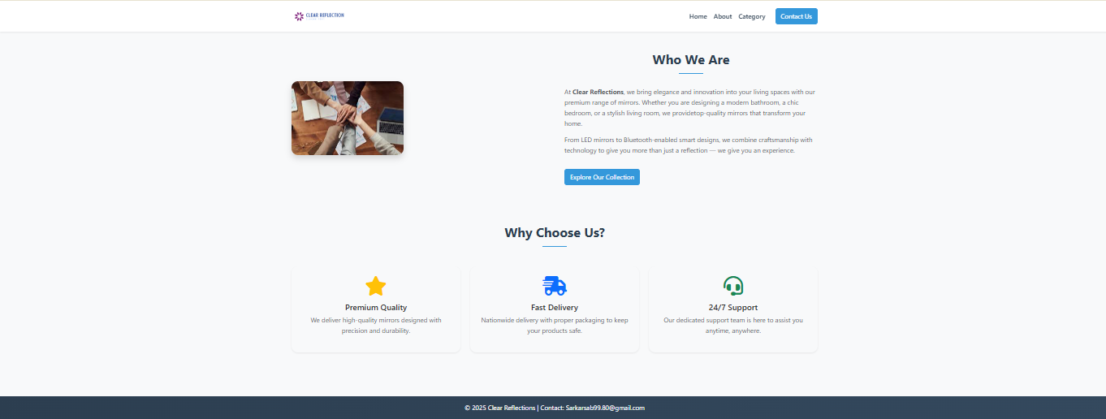

# **Our Categories Page**

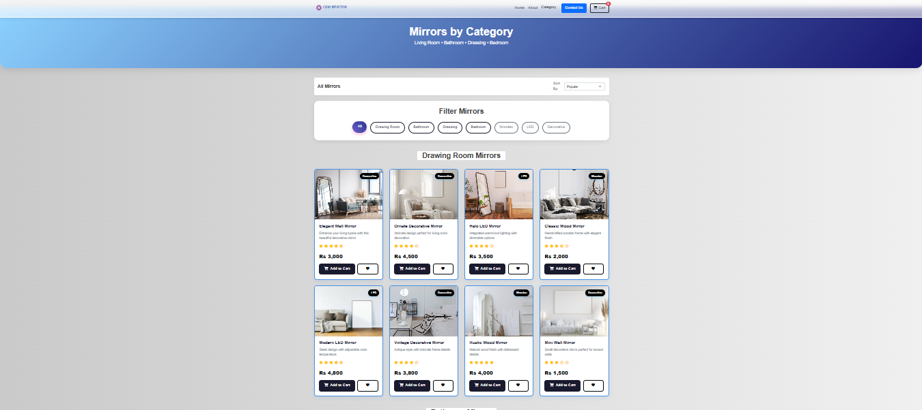

# **Our Admin Panel**

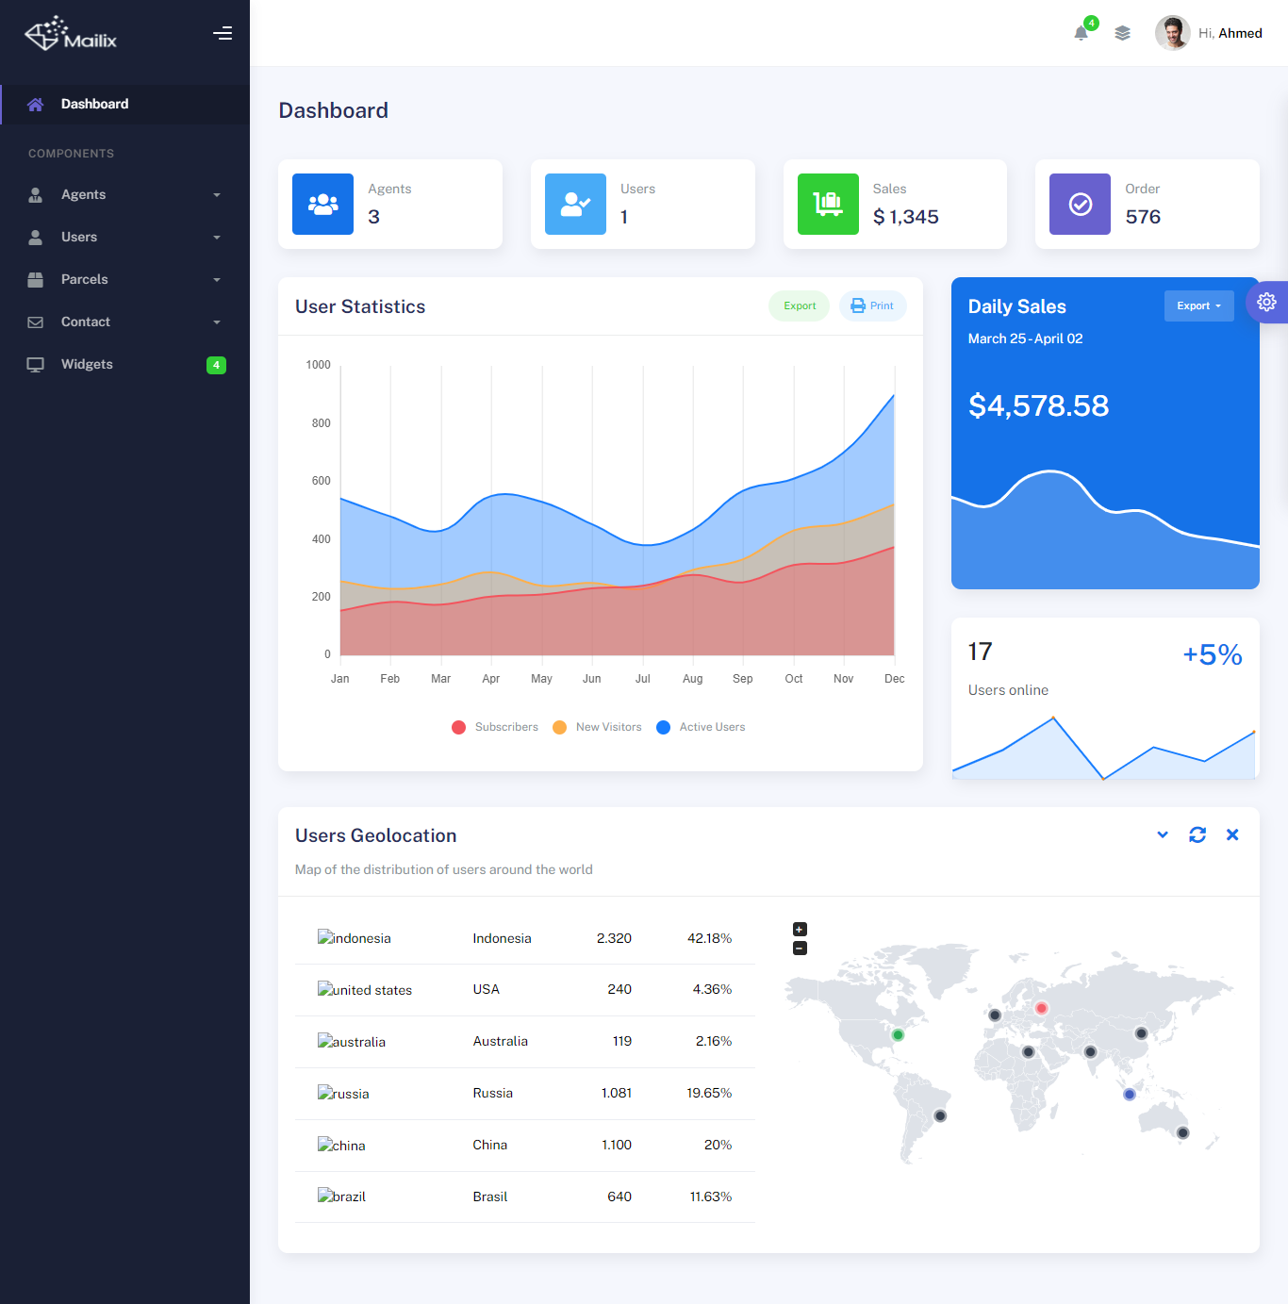

# **Contact Us Page**

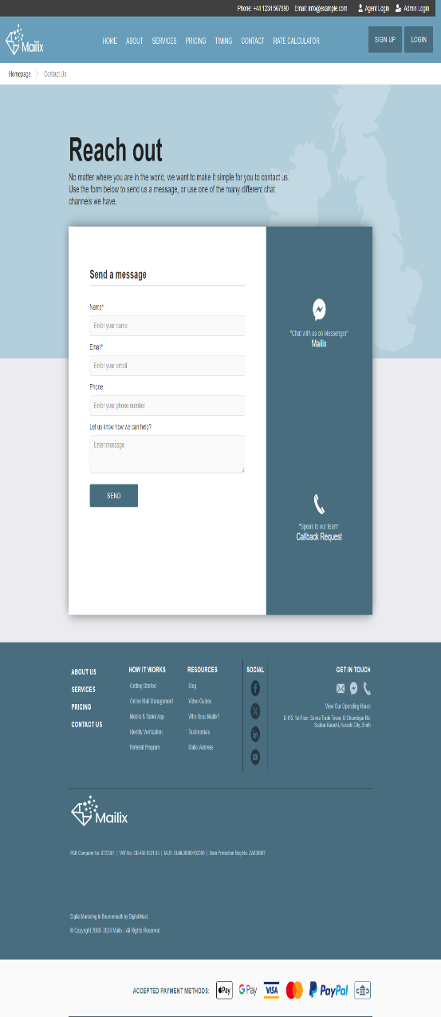

**Site Map**

Mailix

Feedbacks

Company Overview

Fast Services

Reasons To Choose Us

Contact Us

About

Home

Categories

­­

­­

Provide Solutions

Bathroom mirrors

Thank You.