**Universal Task Documentation**

Universal Automation Center support for UiPath

UAC-UiPath (RPA) Integration

Associated Activities:

Date: 22 Dec 2019

Author: Ravi Kumar Murugesan

Revision: 01

CONFIDENTIALITY INFORMATION

Distribution list: Stonebranch Customer

|  |  |  |  |
| --- | --- | --- | --- |
| **Version** | **Date** | **Author** | **Changes** |
| 0.1 | 02-Aug-2020 | Ravi Kumar M | Draft |
| 0.2 | 04-Aug-2020 | Ravi Kumar M | Update Overall view |

**Abstract:**

This Universal Tasks is to schedule, trigger & Monitor the UiPath (RPA) Process Name from the Universal controller.

Contents

1 Disclaimer 3

2 Scope 3

3 Managing UiPath RPA task in Universal controller 3

3.1 UiPath Components 3

3.2 Implementation Details 4

4 Installation 4

4.1 Software Requirements for Linux Agent 4

4.2 Installation Steps 5

5 Universal Task Configuration 6

6 Universal Tasks for RPA-UiPath 6

6.1 Trigger UiPath Process 6

7 Document References 7

# Disclaimer

No support and no warranty are provided by Stonebranch GmbH for this document and the related Universal Task. The use of this document and the related Universal Task is on your own risk.

Before using this task in a production system, please perform extensive testing.

Stonebranch GmbH assumes no liability for damage caused by the performance of the Universal Tasks

# Scope

This document provides details on how to install and use the Universal Tasks for UiPath (RPA) Integration. If more Task will be created in the future this document will be updated accordingly.

High-Level View of the Universal Task:

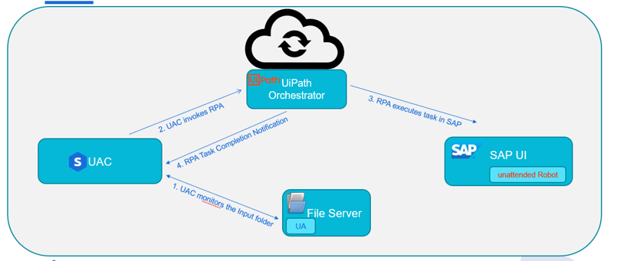

# Managing UiPath RPA task in Universal controller

## UiPath Components

There are 3 components involved in this integration and their details are as follows.

* **Universal controller:** 
  + Universal task - RPA-UiPath is created in the universal controller and its integrated with UiPath Orchestrator through the REST-API’s
  + Through this Universal task the universal controller can perform the below operations with respect to UiPath RPA
    - start an UiPath RPA task
    - Monitor an UiPath RPA Task
    - Maintain dependency between the RPA Task.
* **UiPath Orchestrator:**
* This is the component where UiPath manages or Orchestrates the robot from a centralized place.
* Orchestrator provides RestAPI’s where this can be used by 3rd party systems securely through Oauth2.0 authentication mechanism
* Here in this case the universal task in the universal controller communicates with UiPath Orchestrator for trigger and monitoring of any RPA related Task.
* Also, the necessary credentials that the robot must use for applications can be placed in orchestrator encrypted.
* **UiPath Robots:**
  + The UiPath Robots are the ones that executes the RPA task in machine where it is installed.
  + As soon as there was a request from universal controller to UiPath Orchestrator for starting RPA task, Orchestrator assign the RPA task to the robot and the robot will execute the task in a specified machine and report back the status of RPA task to the Orchestrator.

Universal controller fetches the RPA task status by polling the UiPath Orchestrator in regular intervals.

## Implementation Details

Details about the universal tasks for UiPath as below:

* Universal task uses requests module in python
* Accepts input parameters like UiPath Process Name, UiPath service Instance, UiPath Account Name, UiPath Orchestrator URL & Oauth2.0 access token is consumed by the universal task from Global Variable : Uipath_access_token
  + Oauth2.0 access token is generated using a webservice task that runs every 24 hours.
  + Refer : <https://docs.uipath.com/orchestrator/reference/authenticating> for access token generation
* Universal controller hosted environment should be able to post the message to UiPath Orchestrator machine .
* The Universal Task supports both Universal Agent for Linux/Unix and Windows.

# Installation

## Software Requirements for Linux Agent

**Universal Task name:**  RPA-UiPATH

Requirements:

* Python 3.6
* For Python the following modules are required:
  + *sys, for system-specific parameters and functions*
  + *requests, to interact with a UiPath Orchestrator via Api calls*

***Note: Please check requests python library is available already, if not then it needs to be added via python installer***

* *pip install requests*
* Universal Controller V6.4.7.0 or higher
* Universal Agent V6.5.0.0 or higher installed on a Linux/Windows Server

## Installation Steps

The following describes the installation steps:

1. **Check the current Python Version**

*python -V (Note: Capital “V”)*

If your Version is Python 3.6 or later all is fine. If a no python or a lower Version has been installed upgrade your python Version or install the Universal Agent with the Python binding option (--python yes). This option will install python 3.6. along with your universal agent.

e.g.

sudo sh ./unvinst --network_provider oms --oms_servers 7878@xxx.xxx.xx.xx --oms_port 7878 --oms_autostart no --ac_netname OPSAUTOCONF --opscli yes --python yes

1. **Add the required python modules**

In a command shell run as sudo or root:

* For Python the following modules are required:
* *pip install requests*

*or in case of universal Agent with python binding:*

*/opt/universal/python3.6/bin/python3 -m pip install requests*

Only run these if not available already:

* *pip install sys*

Note:

It is assumed that the modules logging, sys, datetime, os are already available. If not install them via pip. Only the module *requests* are not part of your installation.

1. **Import RPA-UiPATH Universal Task including the Universal Template to your Controller**

Go to “All Tasks” and load via the Import functionality the Universal Tasks configuration into the Controller.

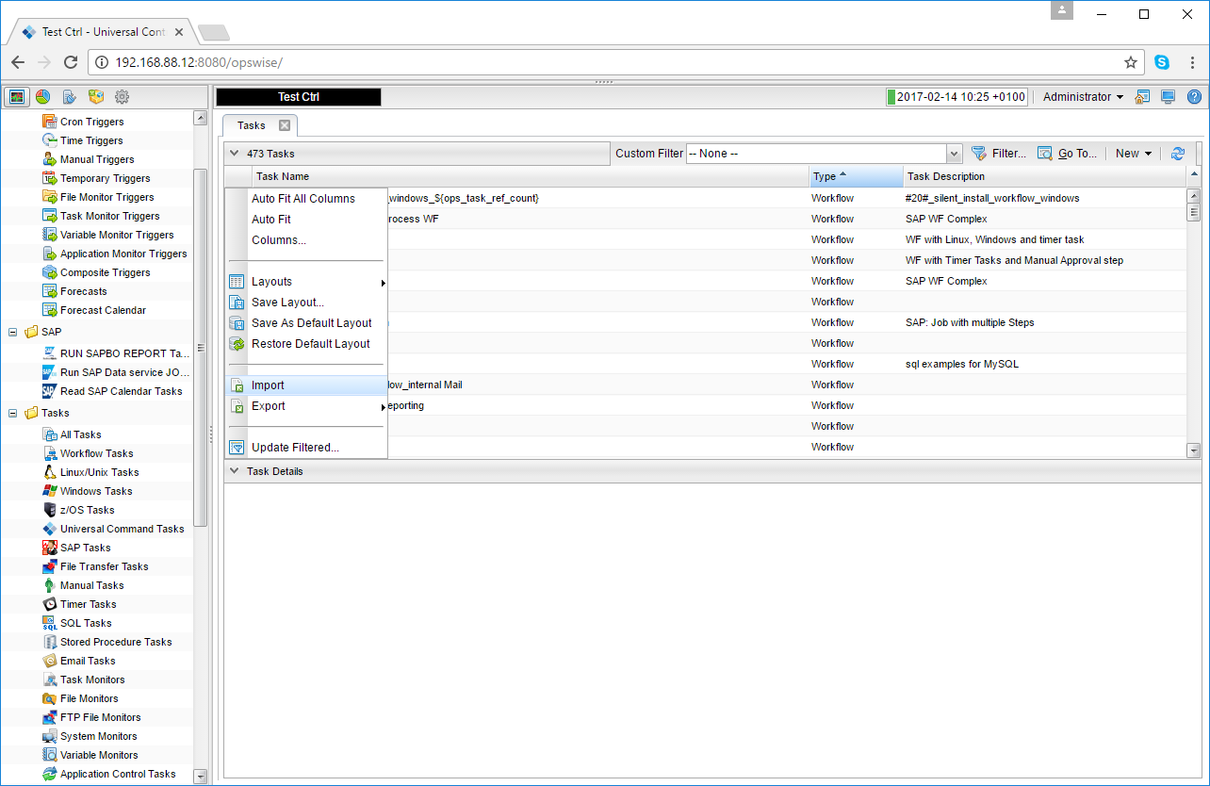 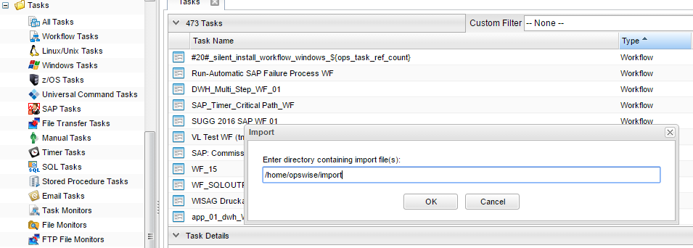

# Universal Task Configuration

1. **RPA-UiPath Universal Task(sample): Triggering an UiPath Process from Universal controller**

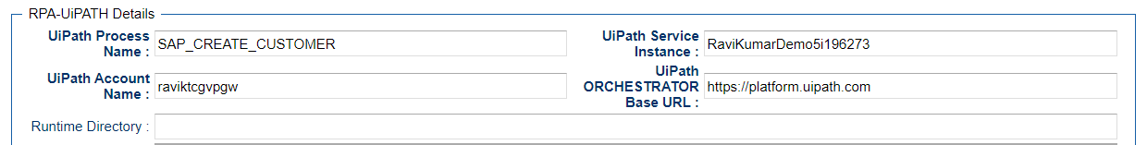

# Universal Tasks for RPA-UiPath

The following contents describes the UiPath integration through the universal task.

| UT Name | Description |
| --- | --- |
| RPA-UiPath | Schedule, Trigger & Monitor UiPath RPA Process |

## Trigger UiPath Process

Triggering an UiPath process from universal controller based on the below input parameters

**Field Description:**

|  |  |
| --- | --- |
| Field | Description |
| Agent | The Agent that runs the Python script assigned to the Universal Task |
| UiPath Process Name | Actual RPA workflow name that needs to be triggered by UiPath Bot |
| UiPath service Instance | Service instance name can retrieve using the Api get :  [https://platform.uipath.com/cloudrpa/api/account/[account_logical_name]/](https://platform.uipath.com/cloudrpa/api/account/%5baccount_logical_name%5d/)  getAllServiceInstances |
| UiPath Orchestrator URL | URL for the UiPath Orchestrator where its installed. Normally the cloud orchestrator/Community URL is https://platform.uipath.com |
| UiPath Account Name | This is the UiPath Orchestrator Tenant Name https://platform.uipath.com/cloudrpa/api/getAccountsForUser |

Note: Access token is generate using the webservice task as below

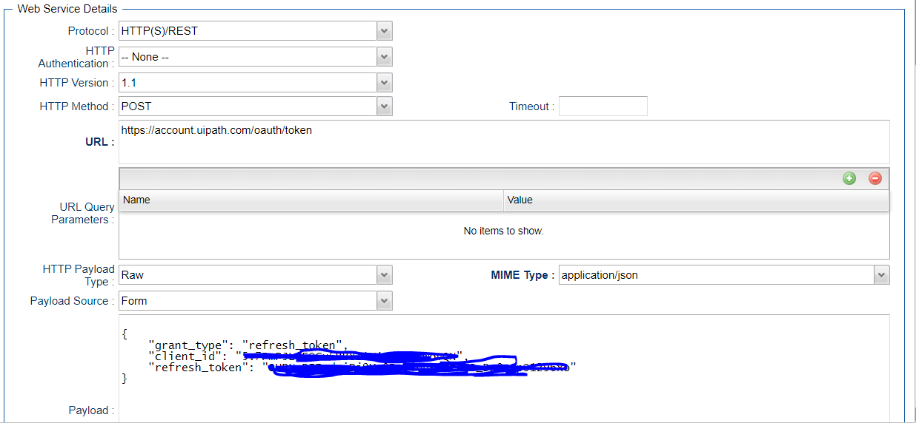

Generated Access token can be stored in a global variable by using the UAC function for the above webservices task in actions🡺set Variable

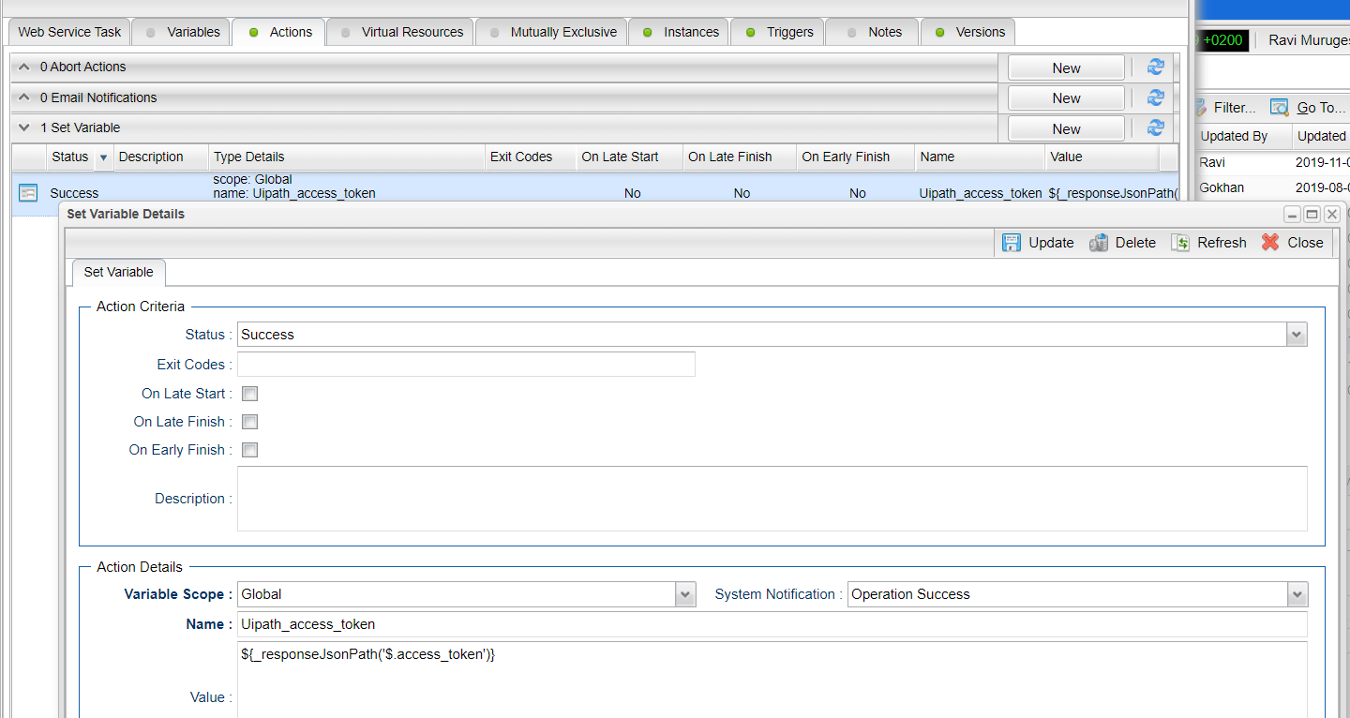

# Document References

This document references the following documents:

|  |  |
| --- | --- |
| Ref# | Description |
| 1. UiPath | <https://docs.uipath.com/orchestrator/reference/about-odata-and-references> |
| 1. requests | <https://pypi.org/project/requests/#description> |
| 1. Universal controller API | <https://docs.stonebranch.com/confluence/display/UC67/RESTful+Web+Services+API> |