DETERMINING THE EFFICACY OF DISSOLVED PHOSPHORUS TESTING IN THE CASE OF RIVERWATCH OF ADDISON COUNTY, VERMONT
Castin Stone
Department of Geology, Middlebury College, Middlebury, Vermont 05753, USA
Submitted in partial fulfillment of the requirements for the degree of:
Bachelor of Arts Department of Geology Middlebury College Middlebury, VT
May 2022

Abstract
Water quality monitoring is an essential component of watershed health. In order to monitor effectively, organizations such as River Watch of Addison County, Vermont, are constantly adapting best practices for which variables to monitor and when. One variable, dissolved phosphorus, is potentially redundant in light of total phosphorus measurements. This thesis aims to answer three questions:
Is dissolved phosphorus testing necessary for understanding watershed health?
Does dissolved phosphorus reveal any information that total phosphorus does not?
Can dissolved phosphorus be predicted?
By utilizing the programming language R, this thesis provides answers for all three questions, leading to an ultimate recommendation to River Watch that they can discontinue dissolved phosphorus testing in good conscience. This paper proposes a linear model to predict dissolved phosphorus, as well as recommendations for future work.

Acknowledgements

I would like to thank professors Will Amidon and Pete Ryan for their excellent advisement,
professor Alex Lyford for his help in understanding R,
the members of stack exchange,
Angelina Savchuk for the python code used to create multiple catchments at once,
Wang and Liu’s watershed tools developed for QGIS,
Carleton University’s open source watershed generation tutorial for QGIS,
And my friends and family for supporting me as I worked on this paper and the rest on my senior year, I could not have completed either this paper or my college career without you. Thank you.

Table of Contents
ABSTRACT................................................................................................................................................. 2
ACKNOWLEDGEMENTS ....................................................................................................................... 3 INTRODUCTION....................................................................................................................................... 6
BACKGROUND....................................................................................................................................... 11
METHODS ............................................................................................................................................... 18
DATASET.................................................................................................................................................. 18
GIS ANALYSIS ........................................................................................................................................ 22
why GIS?….............................................................................................................................22
versions used......................................................................................................................... 23
workflow................................................................................................................................ 24
removed stations.................................................................................................................... 27
R ANALYSIS ............................................................................................................................................ 29
packages used.......................................................................................................................... 29
percent DP................................................................................................................................ 29
TP DP slope analysis................................................................................................................. 29
upstream analysis....................................................................................................................... 31
linear regression model creation guidelines.............................................................................. 32
PCA........................................................................................................................................... 34
K means..................................................................................................................................... 34
RESULTS ................................................................................................................................................. 37
TP DP slope analysis............................................................................................................... 37
upstream analysis..................................................................................................................... 37
linear regression model results................................................................................................ 38
PCA........................................................................................................................................ 45
K means.................................................................................................................................. 50
DISCUSSION ........................................................................................................................................... 59
CONCLUSION ......................................................................................................................................... 64 REFERENCES.......................................................................................................................................... 65 APPENDIX A: SQL CODE .................................................................................................................... 69
APPENDIX B: R CODE .......................................................................................................................... 74
APPENDIX C: PY GIS CODE ............................................................................................................... 92

Introduction

Reigning in water pollution is a top priority for the state of Vermont. Initiatives are passed, permits are issued, and educational materials are distributed to ensure clean and clear water bodies for the sake of safety, the economy, and local pride¹. Effective and consistent monitoring is the only way to ensure compliance to and effectiveness of water quality initiatives. Choosing where, when, and which variables to monitor is a constant balancing act undertaken by monitoring organizations. For Addison County’s River Watch (ACRW), these variables include total and dissolved phosphorus, total nitrogen, total suspended solids, turbidity, and E. coli². One variable, dissolved phosphorus, is potentially redundant, as phosphorus can be measured using other methods. This paper acts as the first long term study of dissolved phosphorus using ACRW’s extensive dataset, answering three questions; what does dissolved phosphorus reveal about Addison County’s watersheds? Can dissolved phosphorus be predicted using other water quality variables? And is dissolved phosphorus testing necessary to protect ecological and public health?

Phosphorus is a plant nutrient found in molecules ranging from ATP to DNA³ ⁴; absolutely necessary for life, but in conjunction with natural systems it can encourage the harmful phenomenon known as eutrophication⁵. Eutrophication occurs when excessive amount of plant nutrients, usually phosphorus or nitrogen as they typically limit plant growth, allow rapid unimpeded growth of algae. Algae respond first to an influx of nutrients as they are the fastest growers in the ecosystem. Typically harmless, algae then create massive blooms on the surface⁶, blocking out light and the exchange of oxygen. Non-algae aquatic plants are smothered by the lack of sunlight and oxygen. Without these plants introducing dissolved oxygen into the system, these bloom-covered areas become what's known as a dead zone. Like a fire eating up all the oxygen in a room the decomposing matter uses up all available oxygen in the water, making it impossible for organisms like fish and other aquatic species to survive⁷.

In addition to ecological harms, algal blooms pose a significant threat to human health. Some forms of algae produce deadly neurotoxins, the ingestion of which can lead to serious illness, death, and may contribute to conditions such as ALS⁸ ⁹. In 2020 105 cyanobacteria (blue-green algae) blooms were reported in Lake Champlain⁹, which triggered beach closures on 23 days during the summer season¹⁰. As of 2019, 145,000 people, about 20% of the basin’s population, rely on the lake for potable water¹. Any contamination of this crucial water supply represents a significant public health risk.

The governments of the Lake Champlain basin recognize the threat of eutrophication and phosphorus pollution to their valuable aquatic systems¹¹. Beyond economic importance and safety concerns, keeping waterways clean is a point of local pride central to Champlain basin identity¹². The EPA, Canada, and the states of New York and Vermont work together to limit phosphorus pollution to the lake¹¹.
One type of collaboration, known as total maximum daily load (TMDL), consists of plans to monitor, implement, and enforce water quality standards for one municipality or watershed¹³. TMDLs set an achievable limit to the amount of pollutant allowed into an aquatic system. TMDLs range in size from a single creek to an entire lake basin, and multiple TMDLs are in place at any given time. For example, Otter Creek has 22 TMDLs for various sections as small as one mile of stream and as large as the town of Ferrisburgh¹⁴. Plans prescribed by a TMDL may include monitoring, permitting, and changes in engineering requirements for new construction. Engineering interventions along Vermont roads, such as proper dirt and gravel road maintenance, drainage ditches, and rock filled ditches, can slow down a torrent of storm water¹⁵. Slowing stormwater allows sediment, a large source of phosphorus in surface waters, to enter a watershed, to settle out of runoff before entering aquatic systems. Redirecting runoff from impervious surfaces, such as asphalt, onto surfaces such as forest and swampland allows phosphorus to be processed and retained by multiple environments as opposed to a single highly contaminated stream¹⁶.

A national pollutant discharge elimination system, or NPDES permit, is another way of enforcing clean water standards. States are authorized to give out permits which specify the amount of pollutant acceptably discharged from a point source¹⁷. Point sources, like construction sites and wastewater plants, must apply for these permits, and are required to test their wastewater regularly. Non-point sources, such as impervious surfaces, are covered and regulated through the federal Clean Water Act¹⁸. The largest source of phosphorus into Lake Champlain is the agricultural sector, followed by stream channel erosion, developed lands, and forests¹². Municipalities must seek out MS4 permits regulating the flow of urban runoff¹⁹. Permit holders are generally required to monitor pollution outflow from their sites, adhere to a pollutant management plan, and report their adherence back to the state regularly. Those who would seek out a permit include construction sites manufacturing sites and large areas of impervious surfaces municipalities and agricultural areas¹⁷. In the event of a disaster, FEMA funding goes towards projects goes towards rebuilding in accordance with updated standards. The town and state government share the cost of road grants.

Not only do proper pollution reduction strategies successfully limit pollution related damages, they are also often less expensive to maintain compared to practices not based around sustainability¹⁵. Effective monitoring identifies problems before they become major financial burdens, further saving costs. Integrating local stakeholders, such as businesses residents and municipalities, into decision making processes fosters a sense of communal responsibility and connection to the land, encouraging more participation, voluntary compliance, and pollution reduction measures above and beyond state requirements²⁰.

All programs to address aquatic pollution rely on frequent and accurate testing of water quality variables, without which the efficacy of such programs would be impossible to determine²¹. Water quality testing operations at a large scale are undertaken by state or federal agencies such as the US Geological Survey¹², however on a smaller scale water quality monitoring is undertaken by nonprofit volunteer organizations. Riverwatch of Addison County is one such organization. Their work is the culmination of a decades long pursuit of citizen science with volunteers collecting monthly samples among 99 locations for over 20 years². As is the case for any volunteer organization, resources, whether in the form of money from government grants or volunteer hours, are limited. The question always remains as to what the are most effective, most informative, and least labor and money intensive data collection methods available. Measuring a variable twice, as is done by measuring both total and dissolved phosphorus, is a significant and poorly understood cost. Until now, Riverwatch has had no long-term studies on its extensive data set to suggest whether dissolved phosphorus monitoring is necessary.

Background

Phosphorus is referred to as a limiting nutrient, one that is so essential for plant growth and so relatively rare in the environment that growth is often halted by an insufficient supply⁴. Unlike nitrogen, another commonly limiting nutrient, the only natural input of phosphorus into the ecosystem is rock weathering¹⁶. Because rock weathering is so slow, only a small amount of natural phosphorus enters the ecosystem annually. In anthropogenic systems, humans synthesize plant fertilizer, nutrient supplements for livestock, and other phosphorus containing compounds that enter the ecosystem at a rate much higher than previous natural influxes²². The same properties that make phosphorus so valuable for humans to produce, that it is essential and limiting for plant growth, makes excess amounts of phosphorus destabilizing for aquatic ecosystems. An influx of nutrients advantages smaller and faster growing organisms, such as algae, as opposed to larger and more stable aquatic plants⁵.

Phosphorus and nitrogen pollution often cause similar results; however, the two elements behave very differently in aquatic systems. While nitrogen, in most cases, occurs as a soluble ion like nitrate, phosphorus can take many forms in addition to a soluble ion, which makes phosphorus pollution harder to understand²³. A phosphate ion, (PO₄⁻), can become strongly attached to the surface of soil particles. The negatively charged phosphate ion is attracted to the surface of positively charged clay particles in a process called adsorption. Clay particles with sorbed phosphate can exist as particles suspended in the water column, or as sediment deposited on the riverbed. Alternatively, negatively charged phosphate can become attached to positively charged metal cations in a process called complexing. Soluble phosphorus can be integrated into organic phosphorus in the form of organisms, which can eventually be decomposed back into other forms of phosphorus. As a highly soluble ion, phosphate is almost never precipitated out of the water as a salt. This can result in high concentrations of phosphate in comparison to other, less soluble, ions.
Phosphorus distributed over land is washed by storm events into rivers and streams, which then carry the phosphorus into more stagnant waters where algal blooms can occur⁵. Total phosphorus is a measure of the entire phosphorus load contained in a sample, including settled particulates²⁴. Dissolved phosphorus measures only one molecule: dissolved phosphate ions. Depending on the environment phosphorus can change form rapidly. The condition of the water carrying phosphorus, whether turbid or clear, oxidizing or reducing, biodiverse or not, influence the forms of phosphorus passed down to the following aquatic systems²³ ²⁵. A concept called uptake length is used to describe the distance a phosphate ion travels while completing one half cycle from dissolved to particulate or organic form. The other half of the cycle from particulate or organic form back to a dissolved ion is called turnover time²³. The shorter the uptake length and turnover time, the faster a stream system is cycling through phosphorus. Short uptake lengths are indicative of lower order streams, streams which are closer to their source. Uptake lengths in first order streams can be less than 100 meters, indicating a cycling time of hours or minutes.
The past and present conditions of the watershed affect the forms phosphorus will take¹⁶. For example, the fraction of phosphorus in organic structures increases and decreases as the seasons change, a reduction in metal cations reduces the fraction of complexed phosphorus, and phosphorus bound to clay particles can settle to the bottom only to be resuspended and released later, a phenomenon known as legacy phosphorus²². Legacy phosphorus creates a serious issue for watershed improvement, as concentrations of phosphorus may remain high as deposited sediments leach phosphorus back into the water, despite measures taken to reduce the anthropogenic input of phosphorus. Phosphorus sorption and release changes the amount of bioavailable phosphorus in the water, as phosphorus attached to clay particles will not be absorbed by plants. Organic debris in bed sediments, on riverbanks, and suspended in the water column can also decay, increasing the amount of bioavailable phosphorus. On the other hand, plant growth and animal consumption will reduce the amount of bioavailable phosphorus as the resource is depleted. Figure 1 shows the possible changes in state a phosphorus ion can go through. The different forms of phosphorus present can also indicate the source of nutrient pollution²². Phosphorus composition is often the only indicator of its source, as all points in a watershed drain to one outlet²³.

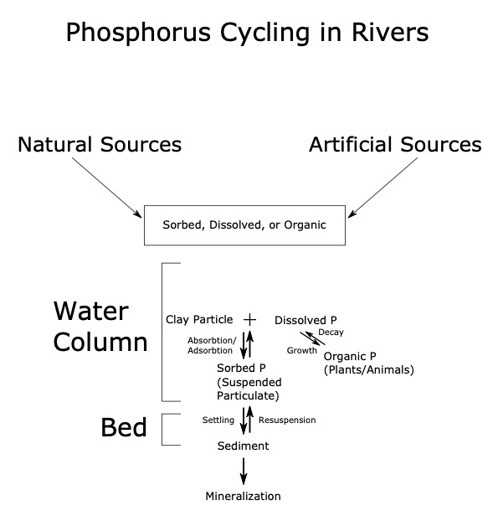
Figure 1: Transformations phosphorus may undergo in streams.

Different sources of phosphorus pollution have unique temporal and typological patterns²⁶. One common distinction between sources of phosphorus pollution is continuous versus episodic discharge. Continuous discharge is a steady stream of phosphorus pollution into a system, while episodic discharge is dependent on human or weather events²³. An example of a continuous source is wastewater discharge from a sewage treatment plant, while an episodic source may be a large rainfall event washing away phosphorus from a recently fertilized field. Rainfall dependency is another key indicator of a pollutant source. Runoff, a key source of phosphorus pollution into rivers and streams, is completely rain- (or snow) -fall dependent and can carry pollutants from an entire basin into a single stream. Differences in the concentration of phosphorus can also help identify the source²³, with wastewater and farmyards contributing more concentrated pollution, while surface runoff from roads, fields, and urban areas tends to be more diffuse.
The point in time that phosphorus appears in a watershed can determine the type of pollutant source; whether episodic or continuous, rain independent or rain dependent. For example, diurnal patterns show up in continuous wastewater discharge as demand increases during waking hours, high phosphorus levels during winter months can indicate an agrarian source, as fully wetted fields release their accumulated phosphorus, and episodic flows are strongly controlled by storm events; rainfall flushing out or overflowing caches of P that build up over time²³. Systems such as farmyards, city roads, and pasture are examples of episodic, rain dependent phosphorus sources. Continuous flows, like sewage leaks, are independent of rainfall.
There are a few possibilities when a large spike in phosphorus is detected. The source can only be within the catchment above the initial spike in phosphorus, however groundwater flow may also feed a river system. Groundwater and surface flow are affected by similar factors, like topology and geology, but can differ substantially²⁵.
Addison County River Watch is a volunteer nonprofit organization that has been continuously measuring water quality since 1992²¹. River Watch tests for pH, water temperature, nitrate, total suspended solids, total phosphorus, dissolved phosphorus, turbidity, alkalinity, and e. coli bacteria. Any of these could be diagnostic of pollutant sources and dangers to public health, and together they can describe the health of a river system. Volunteers have collected the data from 99 locations across Addison County from minor tributaries like Mud Creek to large rivers like Otter Creek. Samples from many sites are collected on a monthly basis. Some sites are measured less frequently. Sites involved in monthly data collections are measured all on the same day. Not every sample is measured using all available tests, creating some gaps.

The major rivers / watersheds are Otter Creek, Lewis Creek, Middlebury River, New Haven River, and the Lemon Fair River. Middlebury, New Haven, and Lewis have the steepest gradient and are all dominated by forest cover (>60%). Lemon Fair and Otter Creek are plurality agrarian (>45%), with high proportions of wetlands (>7%).

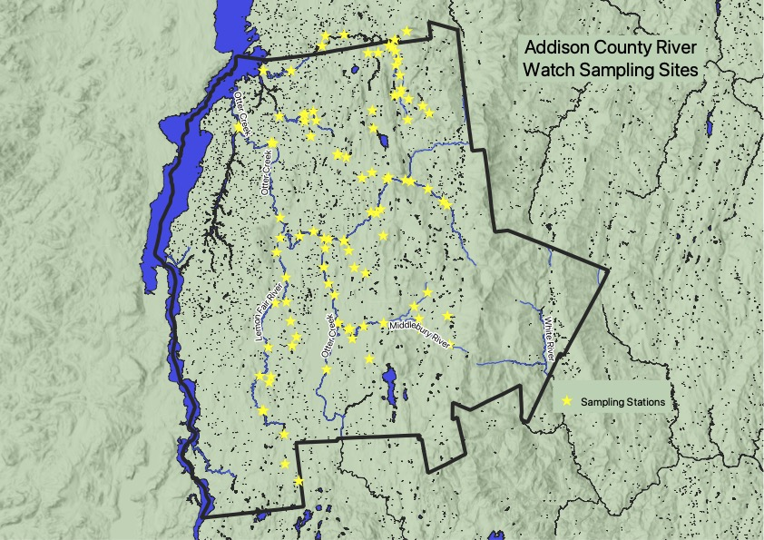

Figure 2: site map of ACRW sampling stations across Addison County.

Methods

River Watch data set

The dataset collected by ACRW and used in this paper spans from 1997 to 2021, with no data collected in 2020 due to disruptions related to the COVID-19 pandemic. In total 4513 samples and 12 variables were measured across 99 sites (Figure 2). The variables measured have changed over time, for example dissolved phosphorus testing was introduced in 2008 and continues to 2019. Since this thesis analyzes dissolved phosphorus, only observations with a dissolved phosphorus measurement were used. This narrows the range of dates from 1997-2021 to 2008-2019. Across this 11-year period a variety of environmental factors influenced the data, from hurricanes to winter storms. This data is assumed to be representative of the three watersheds in Addison County, with outlets on Otter Creek, Little Otter Creek, and Lewis Creek terminating in Lake Champlain.

Some terms will recur in this section on a regular basis. An observation, or the shorthand for observations, obs, is a single row in an R dataframe. This row is a collection of metrics yielded from one water sample (Figure 3). An attribute is a column in an R dataframe, representing all the values of, for example, total phosphorus (TP). An attribute of an observation is a single number, representing the value of the attribute for the given observation. If an attribute of an observation is blank, the value is NA. A catchment is the area that drains to a single point on a stream. Each station has its own unique catchment. Watershed is a more general term referring to the total area draining to either a single outlet or a single body of water, such as Lake Champlain. Total phosphorus is abbreviated as TP, dissolved phosphorus is abbreviated as DP, total suspended solids is abbreviated as TSS, total nitrogen is abbreviated as TN, and turbidity is abbreviated as Turb..

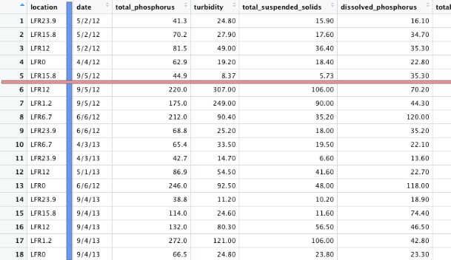
Figure 3: example of an R data frame. The red line represents an observation, or obs. In this data set the obs are the metrics associated with a single sample. The blue line represents an attribute, in this case the date the sample was taken. The date attribute for the highlighted sample is 9/5/12, or the date on which the sample 5 was collected.

The data were isolated to instances where dissolved phosphorus were tested. Data availability varies widely between the years of data collection. Five variables: total phosphorus (TP), dissolved phosphorus (DP), total nitrogen (TN), turbidity (Turb.), and total suspended solids (TSS), were chosen as they appeared the most consistently. Examples of excluded variables include E.Coli., chlorides, and nitrate concentrations.

Not every site was tested for dissolved phosphorus every month. If the sample was not tested for dissolved phosphorus, it was removed from analysis. In this reduced dataset, some stations have no recorded values for a certain variable, for example, station LCR14.3 has no recorded measurements for total suspended solids.

To counter the very rich but sporadic nature of the data the R package MICE, which stands for multivariate imputation by chained equations, was used to impute values. Most R processes reject entire observations based on a single blank variable, severely limiting analysis. Imputation is the process by which an algorithm inserts data in a dataframe where it did not exist before. This process uses surrounding data to guess at a likely value for the missing attribute²⁷. The method of imputation used for this paper is predictive mean matching. PMM compares observations with missing values to observations without missing values and imputes a value from a set of predictions that are the most similar²⁸. A score for each of the stations; how many values were imputed by the MICE algorithm, and therefore how reliable the analysis is for that station, is in figure 4. More imputed values represent less concrete information. Under ideal conditions, imputation would not be necessary, however real-world data collection is never ideal. Due to changes in what tests River Watch performed, which stations were sampled, and how many variables were tested for each sample at different points in time, performing an analysis on only the given data would yield less significant results. The MICE imputation filled in 124 instances of TN, 66 instances of Turb., and 233 instances of TSS. 423 variables were imputed in total, or 10.9% of the dataset. This imputation allowed analysis to be performed on 775 observations as opposed to 417.

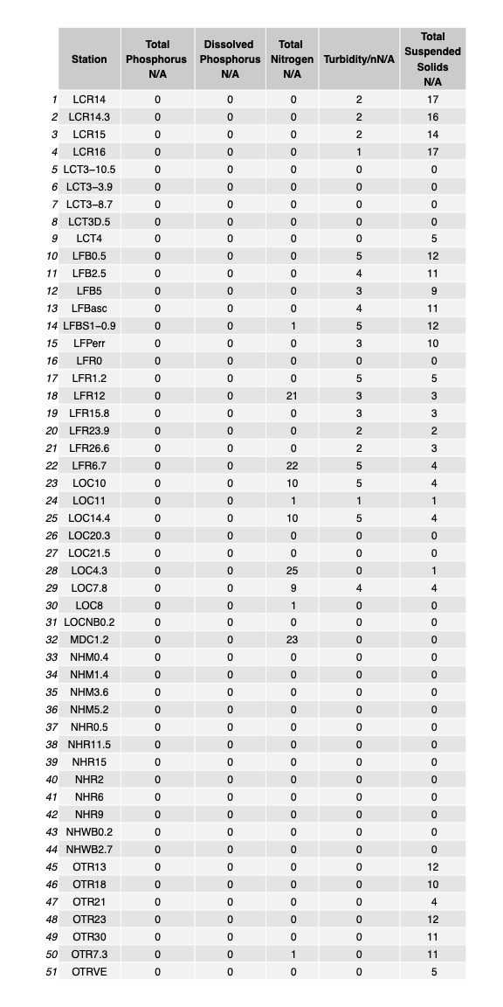
Figure 4: breakdown of NA values by station by variable.

GIS analysis

Why GIS?

Phosphorus pollution may be influenced heavily by the catchment in which it originates, as different land uses provide different types of phosphorus sources, distance from the head of the stream determines how much land the water has already passed through, and catchment area determines how much land drains to a stream. To extract watershed characteristics, first unique catchment areas were created for each point representing a station. The unique catchment area represents the land that drains into the stream up to the station, but not stations upstream (Figure 5).

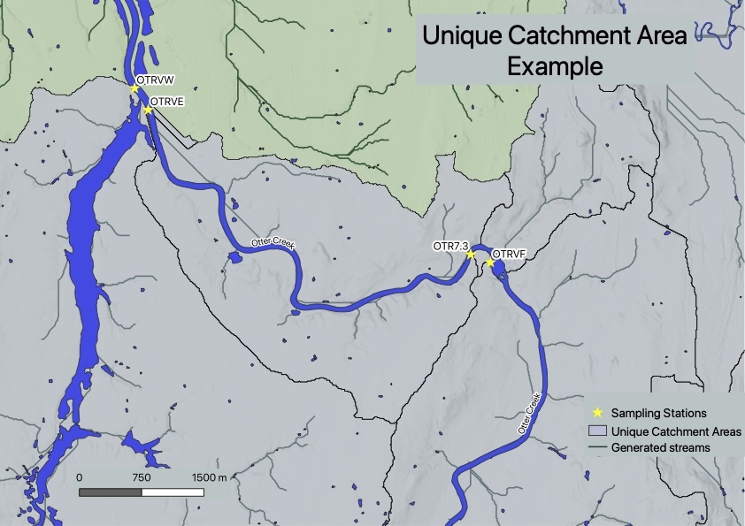

Figure 5: Unique catchment areas for stations OTRW, OTRVE, OTR7.3, and OTRVF. If a pollutant source appeared in the unique catchment of OTR7.3, its impacts would be measured in samples from stations OTR7.3, OTRVE, and OTRVW, but not OTRVF, as OTRVF is upstream of the pollutant source. The rivers in this figure flow from the bottom of the image (south), to the top (north), toward Lake Champlain.

Versions used

All GIS work was performed on QGIS version 3.10.9-A Coruña. Plugins used include QuickOSM version ﻿1.14.2, Processing version ﻿2.12.99, Clipper version 1.2, SAGA version 2.3.2, and GDAL version 2.4.1.

Workflow

To start my GIS analysis I downloaded a statewide Digital Elevation Model, or DEM, of the state of Vermont from the US Geologic Survey²⁹. The DEM was then clipped by a polygon representing the boundary of Addison County with a 5 kilometer buffer surrounding the boundary. A 5 kilometer buffer was chosen as hydrologic activity does not follow municipal boundaries, and the buffer would be large enough to capture potential stream activity affecting the watershed polygons created later in the process. the clipped DEM was then modified with the fill and sinks tool developed by Wang and Lieu, which fills local depressions in the DEM. This step is required because the streams generated later are linear; the model cannot account for water filling a depression, as the pooling water cannot be represented as a line. Therefore, when the generating stream encounters a rise in elevation, the stream is interpreted as terminating (Figure 6). This is an issue for local depressions, as streams would terminate in every closed depression encountered, which does not occur in reality.

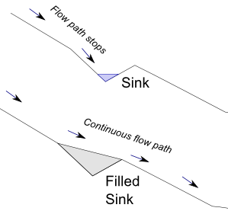
Figure 6:³⁰ illustration of fill sinks functionality by Carleton University Open Source GIS Tutorials user Omargaweesh.

The Strahler order tool was then used to extrapolate likely streams from the filled DEM. The point layer of station locations was then snapped, with a tolerance of 10 meters, to streams with a Strahler order above six. This was done so that small deviations of generated streams from actual streams would not impede analysis. Streams of order six or higher represented significant and permanent streams, and lined up most closely with mapped streams. The filled DEM was used in combination with the snapped station points to generate the upslope area, or catchment area, draining to each station. The Python code used to generate 99 upslope areas with one command was written by Angelina Savchuk and obtained through the website stack exchange³¹. The py GIS script is attached in Appendix C. The result of this code created multiple overlapping polygons in one multi-polygon layer. To extract the unique catchment areas, two steps were used. The first step was to identify the most upstream stations, and clip other polygons in the layer using the clippy plug in. The second step was to use the Polygon self intersection tool, which isolated the remainder of the unique catchment areas. After running the fix geometries tool on the new multi polygon intersects layer, the stations were joined 1 to 1 with the snapped stations point layer using the intersects predicate to attach identifying station names with their unique catchment areas. The stream order was also joined through this method.
In order to determine average land use statistics for each catchment area, the 30 meter resolution national data set National Land Cover Dataset 2019³² was selected for ease of processing, as the higher resolution (0.5 m) statewide land use raster³³ proved too computationally expensive. The national land use data set was clipped using the Addison County boundary with 5 kilometer buffer. The clipped land use raster and the unique catchments layer were then processed by the zonal histogram tool and the field calculator using the following procedure: layers 21, 22, 23, and 24, representing four different intensities of urban development, were combined into the field percent urban. The land use layers 41,42, 43, 90, and 95, representing different types of forests and wetlands, were combined into the field percent natural. Land use layers 81 and 82, representing agricultural fields and pastures, were combined into the field percent agricultural. These fields were multiplied by pixel area (900 m²), divided by the area of each unique catchment area, and multiplied by 100 to derive the percentages of land use for each unique catchment area. All calculations were done to three decimal places.

The average elevation of each station’s catchment was calculated using the unfilled DEM and the unique catchment areas. This process was accomplished using zonal statistics tool to three decimal places. Stream order was incorporated into the dataset using two joins, one with the stations snapped to the six order streams or higher, and a layer consisting only of the sixth order streams or higher, and then with the snapped stations and their corresponding unique catchment areas.

Removed stations

Stations OTR 30, OTR 26, OTR 25, and Mir 0, we removed from analysis due to a DEM fill error (Figure 7). The stream corresponding to the stations, Otter Creek, did not have a comparable generated counterpart. The stations were more than 10m but as far as 400 meters away from the closest generated channel. Catchments for these stations deviated from reality to such an extent that metrics derived from these catchments were unusable. Due to the error originating with the DEM fill, fixing the errors would require a new DEM or more advanced tools. Streams generated over the faulty fill did not align with existing streams, so the stations and their catchment areas were removed from analysis.

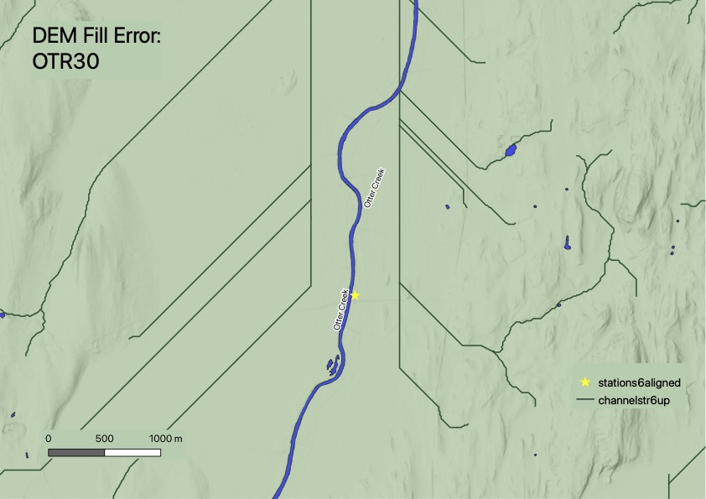

Figure 7: DEM fill error. Here station OTR30 is shown alongside actual and generated stream channels. The fill sinks tool erroneously filled a very large depression, creating straight channels not matching the existing stream. Station OTR30 is over 400 meters away from the nearest generated channel.

R analysis

Packages used

The R packages used in this analysis are as follows: readr version 2.0.2, dplyr version 1.0.7, lubridate version 1.8.0, tidyverse version 1.3.1, ggplot2 version 3.3.5, readxl version 1.3.1, cluster version 2.1.2, ggrepel version 0.9.1, grid version 4.1.1, gridExra version 2.3, gtable version 0.3.0, plotly version 4.10.0, ggfortify version 0.4.14, mice version 3.14.0, and factoextra version 1.0.7.

Percent DP

Percent DP represents the percentage of TP that DP takes up. This number should always be between 0% and 100%, as TP is composed of dissolved and other forms of phosphorus.

TP DP slope analysis

To test the assumption that dissolved and total phosphorus always trend in the same direction over time when isolated for seasonality i.e., DP never increases while TP decreases and vice versa, the trends were isolated using the following procedure. The stations were subset by month to isolate seasonal impacts on TP and DP trends. These subsets were plotted by year with DP or TP along the Y axis and year along the X axis (Figures 8 and 9). The directionality of the slope was determined, with negative one representing a negative slope, positive one representing a positive slope. The slopes were simplified to 1 or -1 to investigate only the direction, and not the magnitude, of change in DP or TP over time. Subtracting the TP slope direction from the DP slope direction would yield either 2, -2, or 0. 2 represents a trend where TP increased (slope of >0), but DP decreased (slope of <0). -2 represents a trend where TP decreased (slope of <0), but DP increased (slope of >0). 0 represents a trend where TP and DP are either both increasing or both decreasing.

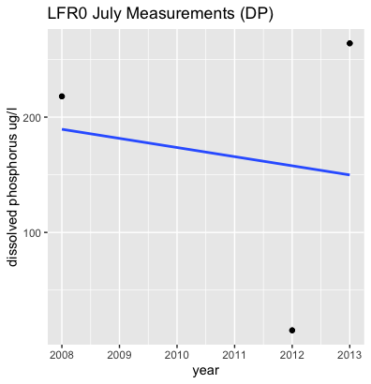
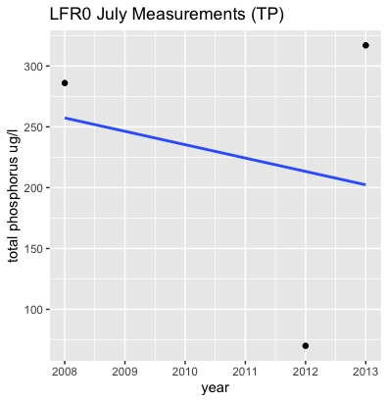

Figures 8 and 9: TP and DP July measurements for station LFR0 with trendline In this case both TP and DP are decreasing over time, in the TP DP trend analysis this would result in values of -1 for the station LFR0 in July. Note that only a handful of stations are tested per month, leading to large gaps when stations were not tested.

Upstream analysis

In order to analyze how DP concentrations change over the course of a stream, each station was assigned a variable based on the stream's eventual output location and the position relative to other stations in the stream. For example, station OTRVW is the last station before Otter Creek terminates in Lake Champlain, and therefore is position 1 in the stream. Both variables were recorded by hand. To determine stream position both the generated stream channels and the actual stream channels were taken into account (Figure 10).

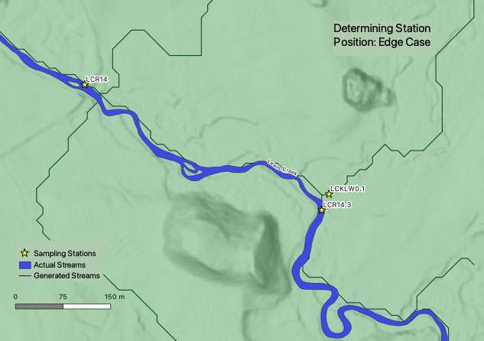

Figure 10: Differences in actual and generated stream channels. Sites LCR14.3, LCKLW0.1, and LCR14 are pictured along with the actual and generated channels. The number of stations upstream of each station changes in this instance if assigned based on the actual or generated channel. In this case generated channels were used, as the generated stream channel showed detail (input streams) that the actual did not.

Linear regression model creation guidelines

A linear regression model is a form of predictive model that assumes that the predicted variable has a linear relationship to predictive variables. A linear model produces an equation that approximates a variable based on a linear equation. The linear regression function in R also indicates the significance of predictive variables to the predicted variable. One aspect of linear regression that must be taken into consideration is that redundant variables, i.e., variables that share predictive power, are shown in results as insignificant. To counter this, multiple linear regression analyses were performed, each using a different set of variables. In the following models, DP is assessed for its potential to be predicted using other water quality and watershed metrics.

Different configurations of variables were used to determine which had the most predictive value. The first linear regression analysis performed on all 15 water quality and watershed variables (TP, DP, TN, TSS, Turb., month, day, year, percent urban land, percent natural land, percent agricultural land, stream order, average elevation, and position in stream), another was performed without percent land cover of natural and urban categories, and a final linear regression performed without average elevation, stream order, and catchment area.

The linear regression model was tested for accuracy using a subset of 20% of observations randomly selected from the original data set which were removed prior to the creation of the model. This allowed for the model to be validated on an independent dataset, resulting in a fuller picture of potential accuracy. Only instances with all variables measured can be tested for accuracy. This issue could be circumvented by imputing the missing values in the test set, however since this is a test of accuracy, introducing imputed values would not give a full picture of how well the model works. The statistic used to assess accuracy is means squared, i.e., the mean of the squared residuals. This value measures the mean distance between the actual and predicted values to the power of 2. Out of 155 observations originally isolated from the complete data set, 80 were tested for accuracy.

PCA

To supplement the k means analysis of water quality variables, a principal component analysis (PCA), from the stats package, was performed on all quantitative variables (excluding percent DP, as that measure is derived from two existing measurements, DP and TP). These variables are: TP, Turb., TSS, DP, TN, month, day, year, %urban, %natural, %agricultural, average elevation, stream order, and stream position. The PCA, or principal component analysis, is able to return principal components, or axes composed of the original variables, that represent the most variation in the data set.

K means

A K means analysis assigns clusters based on observations’ proximity to each other within a n-dimensional space. The axes of this space are composed of each variable fed into the K means analysis. K means cluster assignment is an iterative process that minimizes the distance between the center point of a cluster and each observation in that cluster. The number of clusters can be selected arbitrarily. One method of determining the ideal number of clusters is called an elbow plot (figure 11). An elbow plot graphs the sum of the total distance between points within the cluster and the center of the cluster, and the number of cluster. The “elbow” of the plot occurs at the point of diminishing returns, i.e. the minimum number of clusters that minimize the distance between observations and the center of the cluster. A minimum number of clusters is desired, as the distance between observations in a cluster and the cluster center will continue to reduce until each observation has its own cluster.

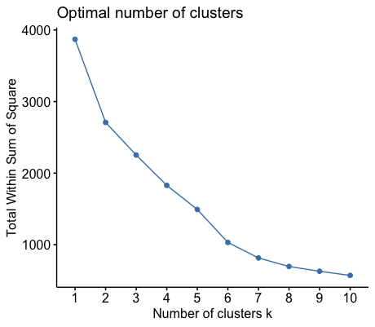
Figure 11: an elbow plot for all observations. The “elbow”, or point of diminishing returns, occurs at six clusters, so six clusters were chosen for k means clustering.

K means analysis can only take into account quantitative variables, meaning that the stations themselves and the eventual outlet of the stream could not be taken into account. In addition, K means analysis will only assign a cluster to observations with all variables present, similar to the linear regression analysis. Similar to the linear regression analysis, imputation can be used to utilize more of the data.

Three K means analysis were performed. One analysis took into account every observation, a second analysis took into account the station averages, and a third took into account monthly station averages. Only one imputation was performed on the data; the same imputed data set from the linear regression analysis was summarized into station averages and monthly station averages. This hopefully increases the accuracy of the imputation prediction, and minimizes variation between the K means and linear regression analysis. Even with imputation, some stations had no recorded measurements of a variable. This issue was exacerbated with monthly station averages, as many observations had to be dropped. Of 99 stations, 51 station averages and 284 station monthly averages could be assigned a cluster.

Results

TP DP slope analysis

Out of 130 combinations of month and station where enough data were available to determine trend, none showed DP moving counter to the trend of TP. This indicates that when isolated for seasonality, DP and TP trend in the same direction.

Upstream analysis

DP generally increased as streams moved toward their respective outlets. This is in line with expectations as streams generally start in forested higher elevation areas and move through areas with more agricultural and urban activity as they proceed to their outlet. One important caveat to keep in mind is that stations are grouped by outlet only; adjacent points in figure 12 do not necessarily correlate to stations on the same stream, as many stream systems drain to one outlet.

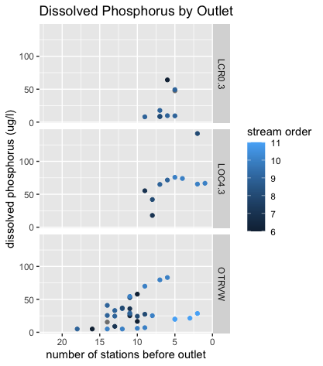
Figure 12: Station DP averages plotted by proximity to outlet. Note that adjacent points may not be hydrologically adjacent, as many stream systems drain to one outlet, and that the x axis is reversed to show stations at the head of their streams on the left, with progression to the outlet from left to right.

Linear regression analysis

Of the 15 variables input into the linear model, TP, TSS, and Turb. were the most significant (see figure 14). Checking the next most significant variables, percent agricultural land and stream order, indicated that stream position decreased in significance when potentially redundant variables were removed (stream order and average elevation removed) and percent agricultural land increased in significance (percent natural and urban removed).
Figures 15, 16, and 17 show the results of the linear models, and Figure 13 shows an example of how to interpret the results.
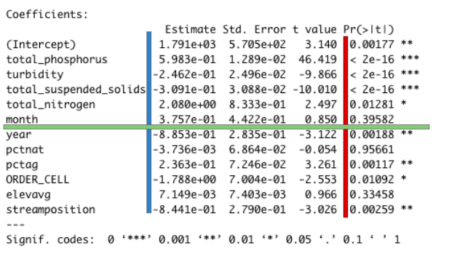
Figure 13: an example of a linear model. Two columns are particularly important when interpreting the results of a linear model. The estimate column, highlighted by the blue bar, represents the coefficient that would be attached to the corresponding variable if put into an equation in the format y = estimate*x + intercept. The Pr(>|t|) column, highlighted by the red bar, represents the significance of the variable in the linear model, or, the chance that the correlation between the predictor variable and the predicted variable happened by chance. Lower Pr(>|t|) values indicate higher significance. The month variable, highlighted by the green bar, has a coefficient of 3.757x10^-1 and a Pr(>|t|) value of 0.39582, or not very significant.

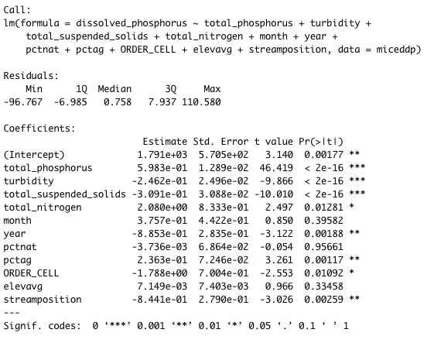
Figure 14: results of the linear model for every quantitative variable.

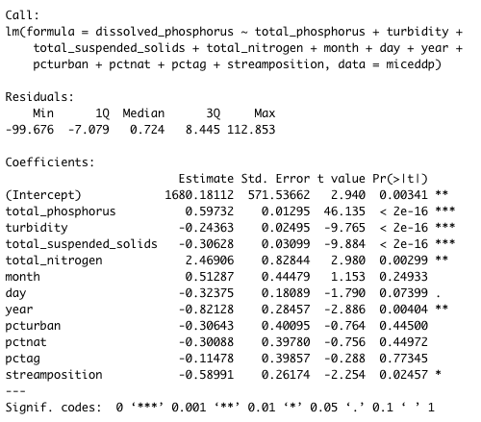
Figure 15: results of the linear model for every variable excluding average elevation and stream order
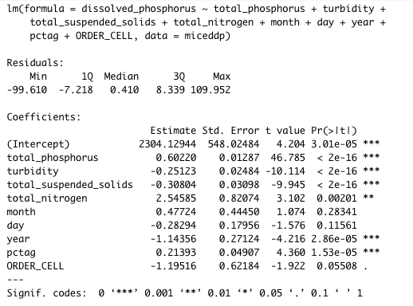
Figure 16: results of the linear model for every variable except for percent natural and percent urban land cover.

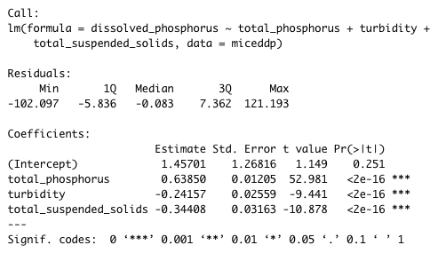
Figure 17: the results of the final linear model recommended for DP prediction.

Two models were tested for accuracy, one in which TP, TSS, and Turb. were used as predictors and one which added year and percent agricultural land as predictors. Dropping year and percent agricultural land improved the accuracy of the model by 38.96 points in means squared testing (182.61 points of means squared residuals vs 221.57), so the final model included only TP, Turb., and TSS as predictive variables. Figures 18 and 19 show visual representations of error for both models tested.

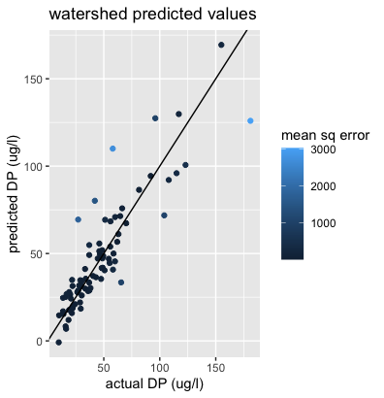
Figure 18: actual vs predicted values of dissolved phosphorus using model consisting of TP, TSS, Turb., percent agricultural land, and year. The 1:1 line represents 100% accuracy.

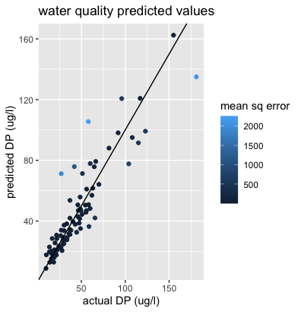
Figure 19: actual vs predicted values of dissolved phosphorus using model consisting of TP, TSS, and Turb..

The equation for predicting DP based on TP, Turb., and TSS is as follows:
DP = 0.638*TP + -0.242*Turb. + -0.344*TSS + 1.457
Where DP is positively correlated with TP and negatively correlated with both Turb. and TSS.

PCA

Three PCAs were completed, one for every observation with DP, one for station averages, and one for station averages by month. Each PCA is colored by eventual outlet location. In figure 20, the PCA for every observation with DP, the two principal components are comprised of the variables shown in figure 20, quantifying 23 and 15 percent of the variation in the data set respectively.
In figures 21 and 22, the PCA for station averages, the two principal components are comprised of the variables shown in figure 23, quantifying 36 and 15 percent of the variation in the data set respectively.
In figure 24, the PCA for station averages by month, the two principal components are comprised of the variables shown in figure 25, quantifying 25 and 15 percent of the variation in the data set respectively.
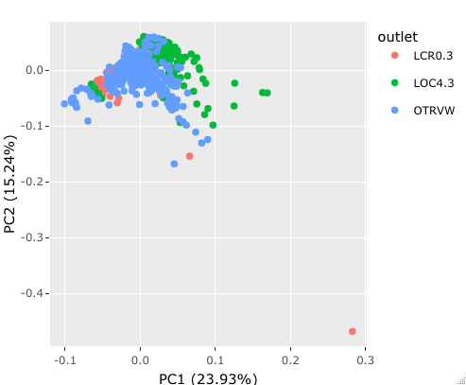

Figure 19: PCA of all samples with DP values.

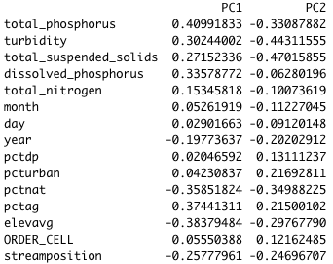
Figure 20: the contents of the first two principal components of PCA of all obs.
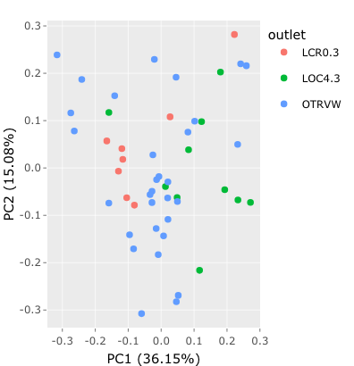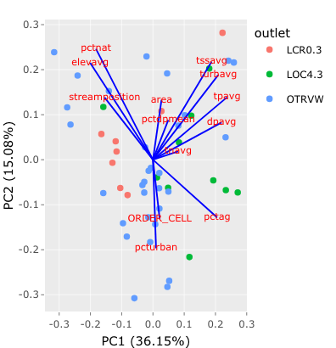

Figures 21 and 22: PCA of station averages colored by outlet. The blue lines in Figure 22 represent the axes of individual variables in the PCA space.

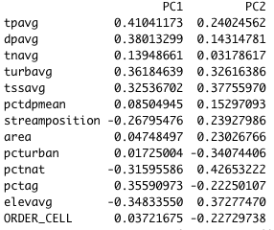
Figure 23: the contents of the first two principal components of PCA of station averages.

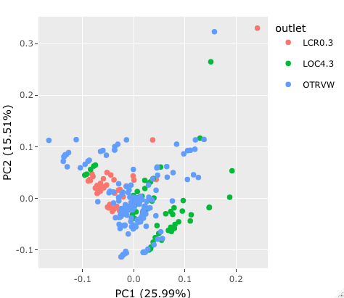

Figure 24: PCA of station averages by month. The blue lines in Figure 25 represent the axes of individual variables in the PCA space.

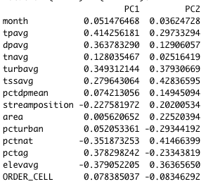

Figure 25: the contents of the first two principal components of PCA of monthly station averages.

K means

Three sets of K means clustering analyses were performed, one for every observation with DP, one for station averages, and one for station averages by month. K means clustering for individual observations is shown in figures 26, 27, and 28. In these figures trends for clusters 1 (high in DP and TP, low in TSS, and Turb.), 5 (low in DP, high in TP, TSS, and Turb.), and 6 (low in DP, TP, TSS, and Turb.) are clear. This indicates that 6 is likely a cluster of relatively pristine waters, possibly close to their source, 1 is likely an intermediate cluster with clear waters but high in phosphorus, and 5 is likely a cluster of high phosphorus waters but low dissolved phosphorus due to the introduction of sediment forcing DP to sorb onto clay particles.

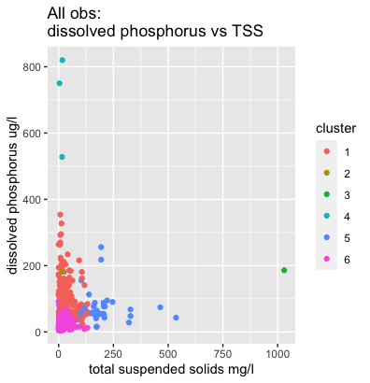
Figure 26: kmeans clusters of all observations plotted by DP and TSS.

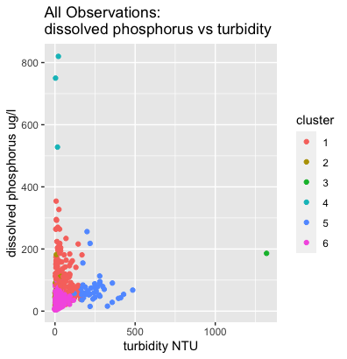
Figure 27: kmeans clusters of all observations by Turb. and DP.

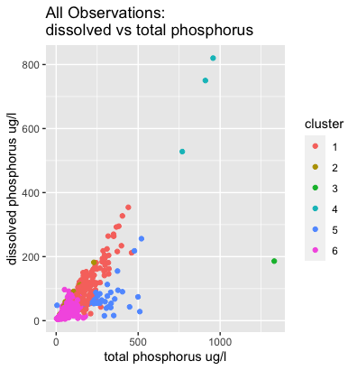
Figure 28: kmeans clusters of all observations plotted by TP and DP

K means clustering for station averages is shown in Figures 29, 30, 31, and 32. In these figures trends for 3 (medium to low for TP, DP, and Turb., low in TSS, and relatively high in percent agricultural land), 4 (high in TP and DP, medium in TSS and Turb., and relatively high in percent agricultural land), and 5 (low in TP, DP, TSS, and Turb, and low in percent agricultural land) are clear. This indicates that cluster 5 represents a series of stations with averages similar to cluster 6 of all observations, that the waters in these stations are relatively clean and clear, possibly due to being at the top of their respective stream systems. Cluster 4 represents stations heavily influenced by agricultural runoff, with lots of sediment and phosphorus contamination. Cluster 3 represents stations with high proportions of agricultural land, but very low in sediment load and phosphorus contamination. Stations in cluster 3 represent major successes to look to. A list of stations and their clusters is found in Figure 33.
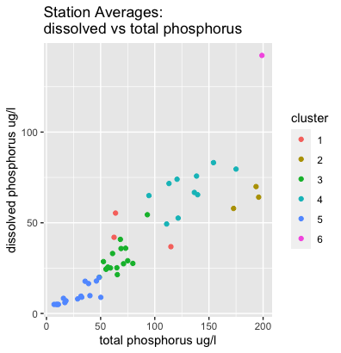
Figure 29: kmeans clusters of station averages by TP and DP

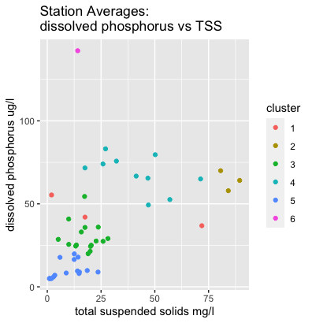
Figure 30: kmeans clusters of station averages by TSS and DP

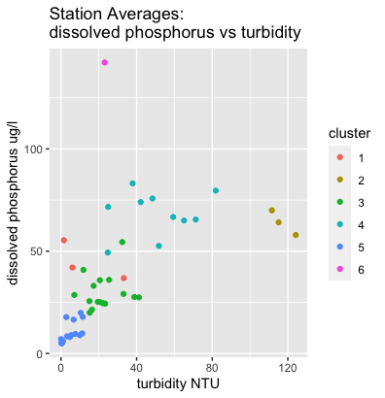

Figure 31: kmeans clusters of station averages plotted by Turb and DP

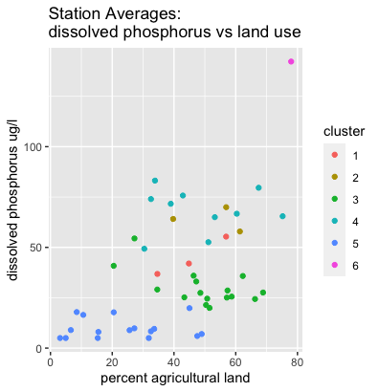
Figure 32: kmeans clusters of station averages plotted by percent agricultural land and DP

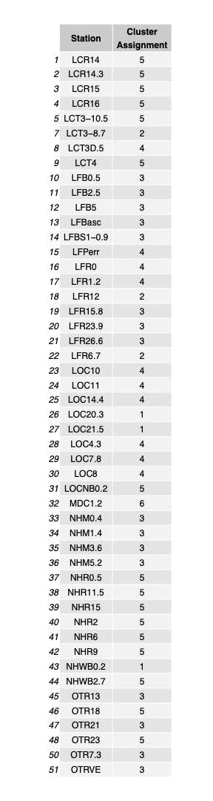
Figure 33: stations and their corresponding cluster assignments.

Discussion

Dissolved phosphorus may be negatively correlated with TSS and turbidity due to the abundance of clay particles associated with high values of TSS and Turb. High volumes of clay particles may encourage sorbtion of dissolved phosphorus, changing it from affecting the measurement of DP to the measurement of TP. Dissolved phosphorus being highly correlated with total phosphorus makes sense, as DP is a fraction of TP, and according to the trend analysis, TP and DP trend in the same direction over time. The relative insignificance of total nitrogen was surprising, as both represent limiting nutrients, i.e. one nutrient of the two is expected to be low; both being low represents a system that is nearly perfectly utilizing all nutrients, and both being high represents a system with a third limiting nutrient. This may be due to the predicted variable being dissolved, and not total, phosphorus. More studies looking into the relationship between different forms of nitrogen and phosphorus are warranted.
Another surprise is the lack of significance attributed to the month the sample was collected, as DP is highly seasonal. This may be because month is a categorical, not continuous, variable, and month 1 is chosen, in nature’s eyes, arbitrarily. The linear model may not have been able to compensate for these issues and thus reported month as an insignificant variable. Alternatively, the month may not be important for DP prediction, but the season is. Quantifying seasons runs into the same issues outlined for months, so while further study may be illuminating it might not be applicable to a linear model.

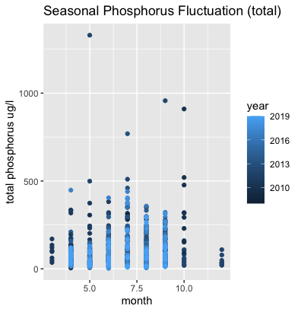
Figure 34: total phosphorus concentrations by month. TP is less influenced by seasonality than DP (see next figure). However, TP peaks around July and subsides to a low around December / January, just like DP.
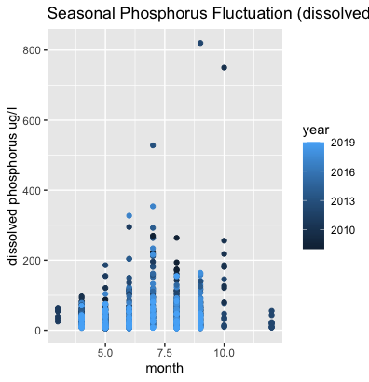
Figure 35: dissolved phosphorus concentrations by month. DP is highly seasonal, peaking in July and subsiding to a low around December / January.

One issue with the concept of unique catchment area is with the irregularity of sampling. If a station is not sampled from, the change in water quality metrics could be due to the catchment of the station sampled from, or the station(s) upstream that were not sampled from. Ideally, each variation of site sampling for each month would have individually computed catchments, guaranteeing that each observation has the correct catchment characteristics. This approach is too computationally expensive for the scope of this thesis. This issue makes it extremely difficult to pinpoint sources of pollution; monthly sampling over the course of several years, as pinpointing pollutant sources requires constant monitoring, would be required, with samples taken at each station each month, or a subset of stations that are always sampled from. Another issue with unique catchment areas is that the characteristics of the unique catchment area are applied to all obs of a station. This is only a problem if the catchment areas calculated are not accurate. Due to DEM fill error, the inability for generated streams to compensate for engineered interventions (any interventions would not be visible based on elevation alone), and the divergence of generated from actual streams, the accuracy of the unique catchment areas generated for this thesis is highly questionable. This is one possible explanation for why watershed metrics derived from these catchments were not significant in the linear regression models. Alternatively, it is possible that watershed metrics are unimportant to dissolved phosphorus specifically, as it may be more responsive to conditions in stream (such as sediment load) than conditions overland.

The computational expense, i.e., computing stets of catchments for each unique combination of stations sampled from in a single month, is why the upstream analysis uses the averages of every station, not the observations themselves. With a complete dataset (values for every station every month, with all water quality variables measured) another type of analysis, known as “fingerprinting” would be available. Fingerprinting compares the water quality variables over time, either monthly, yearly, or seasonally, and pinpoints what month, year, or season a pollutant source is introduced into a particular catchment. This analysis could pinpoint the time and location (within a particular station’s catchment) a pollutant source was introduced. Another application of fingerprinting involves testing for different types of phosphorus. By tracking the changes in DP and TP, the type of pollutant source may be hinted at. Another method of determining pollutant type involves determining how the water quality variables change over time. Whether a site experiences seasonal, daily, yearly or no fluctuations can hint at the source of pollution.

Fingerprinting is the ideal result of DP testing, and it is prohibitively expensive. Testing enough to run a fingerprinting analysis for all of ACRW’s 99 stations would incur much higher costs without any guarantee of usable results. As such fingerprinting is a targeted approach to mystery pollutants and is not a feasible tool for assessing overall watershed health. Without fingerprinting, the usefulness of DP testing is limited. As a fraction of TP, DP follows the same seasonal trends with little variation. DP more strongly adheres to seasonal trends (Figures 34 and 35). This seasonality is in line with expectations, as a pollutant high in DP, agricultural runoff, reaches peak output during the summer months. This reveals a quality of the Addison County watershed that is already known: that agriculture plays a significant role in phosphorus pollution and Addison County land cover has significant agriculture.

Comparing seasonal slopes of total and dissolved phosphorus runs into a key issue: not many data points exist for each station each month. In figures 8 and 9, used as an example of the slope comparison, only three observations exist for the month of July at station LFR0. In total, 482 station and month combinations have insufficient data for slope comparison. As is almost always the case, DP is a fraction of TP, so the trends matching up is not surprising. What is surprising are a few observations with higher dissolved than total phosphorus. This should not happen and is likely a result of error in testing or typos either in the original dataset or introduced in the process of converting excel formatted data into R.

Conclusion

Dissolved phosphorus testing, while an excellent tool in the scope of understanding pollutant sources and types, is not an efficient use of resources for Addison County River Watch as the amount of testing required to complete fingerprint analyses is much higher than their current testing frequency. Assuming a $30 charge for each test,³⁴ ACRW spent $23,250 on 775 dissolved phosphorus tests in the 12 year period between 2008 and 2019, giving potential savings of around $2,000 per year without dissolved phosphorus testing.
Measurements of dissolved phosphorus can be approximated using the linear model outlined in this paper. As an equation, that model is:
DP = 0.638*TP + -0.242*Turb. + -0.344*TSS + 1.457
Which gives approximated dissolved phosphorus concentration in ug/l.

References
1. Harmful Algal Bloom Action Plan Lake Champlain. 145.
2. ACRWC. Lewis Creek Association https://www.lewiscreek.org/acrwc.
3. 5.6 Phosphorus | Monitoring & Assessment | US EPA. https://archive.epa.gov/water/archive/web/html/vms56.html.
4. Phosphorus Basics | Integrated Crop Management. https://crops.extension.iastate.edu/encyclopedia/phosphorus-basics.
5. Eutrophication: Causes, Consequences, and Controls in Aquatic Ecosystems | Learn Science at Scitable. https://www.nature.com/scitable/knowledge/library/eutrophication-causes-consequences-and-controls-in-aquatic-102364466/.
6. US EPA, O. The Effects: Dead Zones and Harmful Algal Blooms. https://www.epa.gov/nutrientpollution/effects-dead-zones-and-harmful-algal-blooms (2013).
7. Trzaskos, P. S. & Malchoff, M. Lake Champlain Fisheries Habitat. 56.
8. Living near waterbodies as a proxy of cyanobacteria exposure and risk of amyotrophic lateral sclerosis: a population based case-control study - ScienceDirect. https://www.sciencedirect.com/science/article/pii/S0013935120304230?casa_token=5BE3pKrT3QAAAAAA:B5pIDPTEA2ACB6wecOh9LbgNn1MYm_F4DjBuEjFOA29F3Thznw_WWt3uXXEun6-tSmGxcMwtLQ.
9. Cyanobacteria (Blue-Green Algae) Tracker. Vermont Department of Health https://www.healthvermont.gov/tracking/cyanobacteria-tracker (2016).
10. Water Quality Archives. Burlington Parks, Recreation & Waterfront https://enjoyburlington.com/water-quality-archives/.
11. Galvez, R. & Levine, S. CANADA-USA AGREEMENT ON EUTROPHICATION CONTROL AND PROTECTION OF LAKE CHAMPLAIN. (2003).
12. US EPA, O. Lake Champlain Phosphorus TMDL: A Commitment to Clean Water. https://www.epa.gov/tmdl/lake-champlain-phosphorus-tmdl-commitment-clean-water (2015).
13. TMDL Information | Department of Environmental Conservation. https://dec.vermont.gov/watershed/map/tmdl.
14. Basin 3 - Otter Creek, Little Otter Creek, and Lewis Creek Basin Planning | Department of Environmental Conservation. https://dec.vermont.gov/water-investment/watershed-planning/tactical-basin-planning/basin3.
15. Ryan, J., Bird, E. & Dimitruk, C. From Bennington to Burlington: Bringing Vermont’s Municipal Roads to a Common Standard for Water Quality. 35.
16. Mainstone, C. P. & Parr, W. Phosphorus in rivers — ecology and management. Sci. Total Environ. 282–283, 25–47 (2002).
17. US EPA, O. NPDES Permit Basics. https://www.epa.gov/npdes/npdes-permit-basics (2015).
18. VERMONT LAKE CHAMPLAIN PHOSPHORUS TMDL PHASE 1 IMPLEMENTATION PLAN. (2016).
19. Municipal Separate Storm Sewer System (MS4) General Permit | Department of Environmental Conservation. https://dec.vermont.gov/watershed/stormwater/permit-information-applications-fees/ms4-permit.
20. Addison County Community Trust. What We Do. Addison Trust https://www.addisontrust.org/what-we-do.html (2022).
21. Addison County River Watch Collaborative – Addison County Regional Planning Commission | Vermont. https://acrpc.org/regional-programs/natural-resources/acrwc/.
22. Records, R. M., Wohl, E. & Arabi, M. Phosphorus in the river corridor. Earth-Sci. Rev. 158, 65–88 (2016).
23. Withers, P. & Jarvie, H. Delivery and Cycling of Phosphorus in Rivers: A Review. Sci. Total Environ. 400, 379–95 (2008).
24. BASIN: General Information on Phosphorus. http://bcn.boulder.co.us/basin/data/NEW/info/TP.html.
25. Lannergård, E. E. et al. New Insights Into Legacy Phosphorus From Fractionation of Streambed Sediment. J. Geophys. Res. Biogeosciences 125, e2020JG005763 (2020).
26. The assessment and prediction of temporal variations in surface water quality—a case study | SpringerLink. https://link.springer.com/article/10.1007/s10661-018-6814-0.
27. Buuren, S. van et al. mice: Multivariate Imputation by Chained Equations. (2021).
28. Imputation by Predictive Mean Matching: Promise & Peril. Statistical Horizons https://statisticalhorizons.com/predictive-mean-matching/ (2015).
29. VT USGS NED DEM (10 meter) - statewide. https://geodata.vermont.gov/documents/3caf2e5280fe489bb62c3bc5234c4e3e/explore.
30. File:Image072.png - CUOSGwiki. https://dges.carleton.ca/CUOSGwiki/index.php/File:Image072.png.
31. Savchuk, A. Answer to ‘Qgis SAGA Upslope Area for several points automation’. Geographic Information Systems Stack Exchange https://gis.stackexchange.com/a/348816 (2020).
32. Dewitz, J. National Land Cover Database (NLCD) 2019 Products. (2021) doi:10.5066/P9KZCM54.
33. LandLandcov_BaseLC2016. https://maps.vcgi.vermont.gov/gisdata/metadata/LandLandcov_BaseLC2016.htm.
34. Current Prices. https://anlab.ucdavis.edu/Prices.

Appendix A: SQL code

/*

1st step being sort out combined tables into one root table, and then join with the others

let's keep track:

1997-2017: qc_id, projectid, locationid, locationname, larosasiteid, visitdate, starttime, activitycategory, symbol, result, remarkcode, characteristicid, characteristicname, unitcode, rid

--want to:
-merge with 2021 data
-done with copy/paste in xlsx files

2018: Sample Number, Order, Location, Date, QA, E. Coli. (mpn/100ml),,Total Nitrogen (mg/L),, Total Phosphorus (ug/L),, Dissolved Phosphorus (ug/L),, Total Suspended Solids (mg/L),, Turbidity (NTU),,, Mean TP for LF,, Geomean of Ecoli all,,, TP - DP, DP %, mnBF_Turb

--want to:
-merge with 2019 data
-done with copy/paste in xlsx files

2019: Sample Number, Location, Date, QA, Final E. Coli.(mpn/100ml), TN (mg-N/l), TP(ug P/L), TDP (ug P/L), TSS (mg/L), Turbidity (NTU)

--want to:
-merge with 2019 data
-done with copy/paste in xlsx files

2021: Lab Project ID, Sample Type, Lab Sample ID, Parent Sample, Client Sample ID, Collected On, Year, Month, Day, Collected By, Analyte, Method, Result, UOM, Rem, Min, Max, Analyzed On, Analyzed By, Reporting Limit, Code, Size, Type, FIPS, Comments

--want to:
-merge with 1997-2017 dataset
-done with copy/paste in xlsx files*/

/* Actions taken on 1992-2017+2021 combined table:

--want to:
-extract observationns by 'characteristicid'
-join extracted tables into new table
-discard E. coli observations

--deleted suffix (ex. 523105-R-LCC0.3 to LCC0.3) inlocationid on all 2021 obervations, moved corrected locationid to larosasiteid where larosasiteid = NULL

IMPORT AS: slimtable*/

SELECT DISTINCT characteristicid
FROM slimtable;

/*characteristicid
NOx Nitrate
Total Nitrogen
Ecoli
TNOX Total Nitrate/Nitrite Nitrogen (mg/l)
RegAlk Alkalinity
TN Total Nitrogen (mg/l)
TurbNTU Turbidity
TSS Total Suspended Solids (mg/l)
Total Phosphorus
Chloride
DP Dissolved Phosphorus (ug/l)
TP

Pairs:
-TN / Total Nitrogen
-TP / Total Phosphorus

unpaired:
-Chloride
-TurbNTU
-DP
-NOx
-TNOX
-RegAlk
-TSS

taking:
-TN/Total Nitrogen
-TP/Total Phosphorus
-DP
-TSS
-TurbNTU
*/

SELECT *
FROM slimtable
WHERE characteristicid = 'TN'
OR
characteristicid = 'Total Nitrogen';

/*1419 rows*/

SELECT larosasiteid AS location, visitdate AS date, result AS total_nitrogen, characteristicid, unitcode AS unit
FROM slimtable
WHERE characteristicid = 'TN'
OR
characteristicid = 'Total Nitrogen';

/*1419 rows*/

CREATE TABLE total_nitrogenisolated AS
SELECT larosasiteid AS location, visitdate AS date, result AS total_nitrogen, characteristicid, unitcode AS unit
FROM slimtable
WHERE characteristicid = 'TN'
OR
characteristicid = 'Total Nitrogen';

/*export tables in csv*/

SELECT larosasiteid AS location, visitdate AS date, result AS total_phosphorus, characteristicid, unitcode AS unit
FROM slimtable
WHERE characteristicid = 'TP'
OR
characteristicid = 'Total Phosphorus';

/*4155 rows*/

CREATE TABLE total_phosphorusisolated AS
SELECT larosasiteid AS location, visitdate AS date, result AS total_phosphorus, characteristicid, unitcode AS unit
FROM slimtable
WHERE characteristicid = 'TP'
OR
characteristicid = 'Total Phosphorus';

/*export table as csv*/

SELECT larosasiteid AS location, visitdate AS date, result AS dissolved_phosphorus, characteristicid, unitcode AS unit
FROM slimtable
WHERE characteristicid = 'DP';

/*700 rows*/

CREATE TABLE dissolved_phosphorusisolated AS
SELECT larosasiteid AS location, visitdate AS date, result AS dissolved_phosphorus, characteristicid, unitcode AS unit
FROM slimtable
WHERE characteristicid = 'DP';

/*export table as csv*/

SELECT larosasiteid AS location, visitdate AS date, result AS total_suspended_solids, characteristicid, unitcode AS unit
FROM slimtable
WHERE characteristicid = 'TSS';

/*690 rows*/

CREATE TABLE total_suspended_solidsisolated AS
SELECT larosasiteid AS location, visitdate AS date, result AS total_suspended_solids, characteristicid, unitcode AS unit
FROM slimtable
WHERE characteristicid = 'TSS';

/*export as csv*/

SELECT larosasiteid AS location, visitdate AS date, result AS turbidity, characteristicid, unitcode AS unit
FROM slimtable
WHERE characteristicid = 'TurbNTU';

/*1708 rows*/

CREATE TABLE turbidityisolated AS
SELECT larosasiteid AS location, visitdate AS date, result AS turbidity, characteristicid, unitcode AS unit
FROM slimtable
WHERE characteristicid = 'TurbNTU';

/*export as csv*/

CREATE TABlE expandedslimtable AS
SELECT *
FROM total_phosphorusisolated;

/*picking the longest table to join everything to..... and hoping it just works*/

CREATE TABLE expandedslimtablea AS
SELECT expandedslimtable.*, turbidityisolated.turbidity
FROM expandedslimtable FULL OUTER JOIN turbidityisolated
ON expandedslimtable.location = turbidityisolated.location AND expandedslimtable.date = turbidityisolated.date;

CREATE TABLE expandedslimtableb AS
SELECT expandedslimtablea.*, total_suspended_solidsisolated.total_suspended_solids
FROM expandedslimtablea FULL OUTER JOIN total_suspended_solidsisolated
ON expandedslimtablea.location = total_suspended_solidsisolated.location AND expandedslimtablea.date = total_suspended_solidsisolated.date;

CREATE TABLE expandedslimtablec AS
SELECT expandedslimtableb.*, dissolved_phosphorusisolated.dissolved_phosphorus
FROM expandedslimtableb FULL OUTER JOIN dissolved_phosphorusisolated
ON expandedslimtableb.location = dissolved_phosphorusisolated.location AND expandedslimtableb.date = dissolved_phosphorusisolated.date;

CREATE TABLE expandedslimtablefinal AS
SELECT expandedslimtablec.*, total_nitrogenisolated.total_nitrogen
FROM expandedslimtablec FULL OUTER JOIN total_nitrogenisolated
ON expandedslimtablec.location = total_nitrogenisolated.location AND expandedslimtablec.date = total_nitrogenisolated.date;

/*export as csv, 5248 rows*/

SELECT *
FROM expandedslimtablefinal
WHERE location = 'NULL';

/*0 rows, meaning that no data got left behind in other tables*/

SELECT DISTINCT "visitdate", "locationid"
FROM slimtable

/*4381 rows, meaning we may have picked up some data*/

/*did pick up some data, 2016 and 2017 have some duplicate instances (ex. multiple readings of TP, etc.) which caused there to be up to 32 instances of unique sets of variables with the same date and location marker. This occured in 25 instances. Removed later in R analysis.*/

/*next step is to join the 2018-2019 data with the expandedslimtablefinal data, probably will just use xlsx copy*/
Appendix B: R code

```{r packages step 1, include=FALSE}
#load in required libraries
library(readr)
library(dplyr)
library(lubridate)
library(tidyverse)
library(ggplot2)
library(readxl)
library(cluster)
library(ggrepel)
library(gridExtra)
library(grid)
library(gtable)
library(plotly)
library(ggfortify)

#mice and factoextra require an additional step
```

```{r packages step 2, include=FALSE, cache = TRUE}
#complete load in of mice and factoextra
library(mice)
library(factoextra)

```

```{r load data}
#load in cleaned up csv
#arranged all data in observation: characteristic format
compiledRWdataset <- read_csv("compiledRWdataset.csv")

qgisstats <- read_csv("catchmentsfulldata.csv")

siteposition <- read_csv("siteposition.csv")

```
```{r create dponlyset}
#remove all obs without dp measurement
dponlyset <- subset(compiledRWdataset, dissolved_phosphorus>0)

head(dponlyset)

summary(dponlyset)

```

```{r dataset exploration}

#Investigation of compiledRWdataset and dponlyset to find any string values (ex. <5) that need to be replaced
#examining datasets (run each command in the shell to see individual stats)

unique <- unique(compiledRWdataset[c("location", "date")])
#4130 obs, 4130 unique combinations of station and date
unique <- unique(dponlyset[c("location", "date")])
#903 obs, 903 unique combinations of station and date
unique <- unique(compiledRWdataset["dissolved_phosphorus"])
#no strings
unique <- unique(compiledRWdataset["total_phosphorus"])
#strings = "< 5""<5""<0.5"
unique <- unique(compiledRWdataset["total_nitrogen"])
#strings = "<0.1""<0.10"
unique <- unique(compiledRWdataset["total_suspended_solids"])
#no strings
unique <- unique(compiledRWdataset["turbidity"])
#no strings
unique <- unique(compiledRWdataset["location"])
#Would need to fix "LFR0.5 (is this supposed to be LFB0.5)", "LFR 15.8 Discharge pipe", and many stations like "OTR7.3 BLK","OTR7.3 DUP","OTR7.3 BLK","OTR7.3 DUP" if this set were to be used in analysis
unique <- unique(dponlyset["location"])
#many stations need fixing; "LFR0.5 (is this supposed to be LFB0.5)" needs to be manually changed to "LFB0.5", others need to be split after a space ex."LFR23.9 Lab filtered"

timeandplace <- c("location","date")
#grouping by date and location to search for duplicate entries
unique <- dponlyset %>%
group_by(across(all_of(timeandplace))) %>%
summarize(count = n_distinct(dissolved_phosphorus,total_nitrogen,total_phosphorus,turbidity,total_suspended_solids))
#45 duplicated instances of a specific time and location, from 2 to 32 instances of duplication.
#Data problem: each duplicated instance is unique from the other, unable to determine which is the "correct" instance
#2016-2017 were the culprits, with some instances of multiple recordings for the same variable on the same date. However, not all of the dates with duplicate instances have that issue.

```

```{r replacing string values}
#replacing string values with equivalent numbers (half of cut off)

dponlyset['total_phosphorus'][dponlyset['total_phosphorus'] == '< 5' | dponlyset['total_phosphorus'] == '<5'] <- '2.5'
dponlyset['total_phosphorus'][dponlyset['total_phosphorus'] == '<0.5'] <- '0.25'
dponlyset['total_nitrogen'][dponlyset['total_nitrogen'] == '<0.1' | dponlyset['total_nitrogen'] == '<0.10'] <- '0.5'

#fixing error
dponlyset['location'][dponlyset['location'] == 'LFR0.5 (is this supposed to be LFB0.5)'] <- 'LFB0.5'
#cutting off location strings from and including the first space, this concatenates strings from ex. "LFR23.9 Lab filtered" to "LFR23.9"
dponlyset$location <- sub(" .+", "", dponlyset$location)

#checking unique to see if replacement worked
unique <- unique(dponlyset["total_phosphorus"])
unique <- unique(dponlyset["total_nitrogen"])
#no more string entries; replacement worked
unique <- unique(dponlyset["location"])
#no more erroneous station names, 56 unique stations in total

dponlyset <- transform(dponlyset, total_phosphorus = as.numeric(total_phosphorus),
total_nitrogen = as.numeric(total_nitrogen))

#changing total_phosphorus and total_nitrogen into numeric

summary(dponlyset)

```

```{r creating day month and year and dp% collumns}

dponlyset = dponlyset %>%
mutate(datefix = strptime(dponlyset$date, format = "%m/%d/%y")) %>%
mutate_at(vars(datefix), funs(month, day, year))
#"date" from char to r readable format, then to three separate columns

#percent dissolved phosphorus, the fraction of TP that DP takes up
dponlyset = dponlyset %>%
mutate(pctdp = (dissolved_phosphorus/total_phosphorus)*100)
#ranges from 4.558% to 960%, with 162 entries above 100%
#%DP should never be above 100%, as TP should be DP plus the particulate phosphorus...

head(dponlyset)
summary(dponlyset)
```

```{r removing duplicate instances}

dponlyset$timeandplace <- paste(dponlyset$location, dponlyset$datefix, sep="_")

timeandplace = c("location","datefix")
#creating duplicate count to prepare for a join
duplicatecount <- dponlyset %>%
group_by(across(all_of(timeandplace))) %>%
summarize(count = n_distinct(dissolved_phosphorus,total_nitrogen,total_phosphorus,turbidity,total_suspended_solids))
#same code as unique earlier, counts the number of unique instances of a date and location (should only be one each, duplicates need to be removed)
duplicatecount$timeandplace <- paste(duplicatecount$location, duplicatecount$datefix, sep="_")
duplicatecount <- subset(duplicatecount,select=c(count,timeandplace))

#joining dponlyset with duplicate count
dponlyset <- left_join(dponlyset, duplicatecount, by = "timeandplace",)
#removing duplicate instances
dponlyset <- dponlyset[dponlyset$count == 1, ]
#dropping count collumn
drop <- c("count")
dponlyset = dponlyset[,!(names(dponlyset) %in% drop)]

#can re run unique code to check
#unique <- dponlyset %>%
# group_by(across(all_of(timeandplace))) %>%
# summarize(count = n_distinct(dissolved_phosphorus,total_nitrogen,total_phosphorus,turbidity,total_suspended_solids))

#814 obs remaining in dponlyset

```

```{r join with QGIS and siteposition data}

#joining the prepped data with additional data gathered by QGIS

#standardizing station names with dponlyset standard
qgisstats$LaRosaSi_1 <- sub(" .+", "", qgisstats$LaRosaSi_1)
siteposition$LaRosaSiteID <- sub(" .+", "", siteposition$LaRosaSiteID)

#station typos:
#"LFR4" is not a valid station name, LCT4 is, and LFR3.7 is, "LFR4" obs must be removed since actual station is indeterminable

#"LCT3-3.9" is a valid station name, but not collected in qgisstats
#"LCKLW0.1" is a valid station name, "LCHLW1.0" is not, "LCKLW0.1" is not included in qgisstats

#removing a station typo and another station not found in QGIS data
dponlyset <- dponlyset[!(dponlyset$location=="LCHLW1.0"),]
dponlyset <- dponlyset[!(dponlyset$location=="LCKLW0.1"),]
dponlyset <- dponlyset[!(dponlyset$location=="LCHLW0.1"),]
dponlyset <- dponlyset[!(dponlyset$location=="LFR4"),]

#join QGIS and siteposition data with dponlyset
dponlyset <- dponlyset %>%
left_join(qgisstats, by = c("location" = "LaRosaSi_1"))
dponlyset <- dponlyset %>%
left_join(siteposition, by = c("location" = "LaRosaSiteID"))

```

```{r removing 20% of points for test set}
#creates a set of 20% of randomly selected obs from dponlyset that will be an accuracy test for linear models created later
#set seed so that the randomly selected obs are the same obs each time the code is run
set.seed(2484)
dptestset <- dponlyset[sample(nrow(dponlyset), (nrow(dponlyset))*0.2), ]

#setting up a check that the entries were removed
total = nrow(dponlyset)

#remove entries from dponlyset that match entries in dptestset
dp80set <- anti_join(dponlyset, dptestset, by="timeandplace")

```

```{r}
#mice imputation prep

#changing location from char to factor (location factor turned out to be unwielldy to use)
miceprep <- dp80set %>%
mutate(location = as.factor(location))
miceprepkmeans <- dponlyset
#removing date and datefix
miceprep <- subset(miceprep, select = -c(datefix,date))
miceprepkmeans <- subset(miceprepkmeans, select = -c(datefix,date))

head(miceprep)

```

```{r mice imputation}
#preforming the mice imputation
#"area" (col. 12) for some reason throws an error, not sure why
imputeddponly <- mice(miceprep %>%
filter(location != "LFR4") %>%
select(1:11,13:19), m = 5, method = 'pmm', seed = 500)

summary(imputeddponly)
head(imputeddponly)

miceddp <- complete(imputeddponly, 2)

imputeddponlykmeans <- mice(miceprepkmeans %>%
filter(location != "LFR4") %>%
select(1:11,13:19), m = 5, method = 'pmm', seed = 500)

micedkmeans <- complete(imputeddponlykmeans, 2)

```

```{r}
#lm for miceddp

dpsinglemodel <- lm(dissolved_phosphorus ~ total_phosphorus + turbidity + total_suspended_solids + total_nitrogen + month + year + pctnat + pctag + ORDER_CELL + elevavg + streamposition, data = miceddp)

summary(dpsinglemodel)

```

```{r different configuration of lm: test for redundant variables 1}
#different configuration of lm: test for redundant variables 1

#removing avg elevation and stream order (ORDERCELL) to test stream position for sig.
dpordermodel <- lm(dissolved_phosphorus ~ total_phosphorus + turbidity + total_suspended_solids + total_nitrogen + month + day + year + pcturban + pctnat + pctag + streamposition, data = miceddp)

summary(dpordermodel)
#streamposition decreases in significance
```

```{r different configuration of lm: test for redundant variables 2}
#different configuration of lm: test for redundant variables 2

#removing pct urban and pct nat to test pct ag for significance
dpagmodel <- lm(dissolved_phosphorus ~ total_phosphorus + turbidity + total_suspended_solids + total_nitrogen + month + day + year + pctag + ORDER_CELL, data = miceddp)

summary(dpagmodel)
#pct ag jumps up in significance to 1.53e-05 from 0.00117
```

```{r}

#create a pooled model, step one build the model with a multiple linear regression

dpmodelimputed <- lm(dissolved_phosphorus ~ total_phosphorus + turbidity + total_suspended_solids + total_nitrogen + year + pctag, data = miceddp)

dpmodelimputedwqonly <- lm(dissolved_phosphorus ~ total_phosphorus + turbidity + total_suspended_solids, data = miceddp)
summary(dpmodelimputedwqonly)

```

```{r testing accuracy of model using dptestset}

#predicting DP for usable obs in dptestset
dptestset <- na.omit(dptestset)
dptestset$pred <-predict(dpmodelimputed, dptestset)
dptestset$predwq <-predict(dpmodelimputedwqonly, dptestset)

#finding mean squared error of predictions
dptestset$error <- (dptestset$dissolved_phosphorus - dptestset$pred)^2
dptestset$errorwq <- (dptestset$dissolved_phosphorus - dptestset$predwq)^2
print(mean(dptestset$error))
print(mean(dptestset$errorwq))

p <- dptestset %>%
ggplot(aes(x = dissolved_phosphorus, y = pred)) +
geom_point(aes(color = error))
p + labs(x = "actual DP (ug/l)", y = "predicted DP (ug/l)", title = "watershed predicted values", color = "mean sq error") + geom_abline(slope=1)

p <- dptestset %>%
ggplot(aes(x = dissolved_phosphorus, y = predwq)) +
geom_point(aes(color = errorwq))
p + labs(x = "actual DP (ug/l)", y = "predicted DP (ug/l)", title = "water quality predicted values", color = "mean sq error") + geom_abline(slope=1)

```

```{r grouping by station}
#grouping by station
stationavg <- dponlyset %>% group_by(location) %>%
summarise(tpavg = mean(total_phosphorus),
dpavg = mean(dissolved_phosphorus),
tnavg = mean(total_nitrogen),
turbavg = mean(turbidity),
tssavg = mean(total_suspended_solids),
pctdpmean = mean(pctdp))
#72 stations carried over

#re-joining site stats
stationavg <- stationavg %>%
left_join(siteposition, by = c("location" = "LaRosaSiteID"))
stationavg <- stationavg %>%
left_join(qgisstats, by = c("location" = "LaRosaSi_1"))

#grouping by location and month, so monthly average for each station (hopefully)
monthandplace <- c("location", "month")

stationmonthlyavg <- dponlyset %>% group_by(across(all_of(monthandplace))) %>%
summarise(tpavg = mean(total_phosphorus),
dpavg = mean(dissolved_phosphorus),
tnavg = mean(total_nitrogen),
turbavg = mean(turbidity),
tssavg = mean(total_suspended_solids),
pctdpmean = mean(pctdp))

#rejoining site stats
stationmonthlyavg <- stationmonthlyavg %>%
left_join(siteposition, by = c("location" = "LaRosaSiteID"))
stationmonthlyavg <- stationmonthlyavg %>%
left_join(qgisstats, by = c("location" = "LaRosaSi_1"))

##grouping with imputed dataset

#grouping by station
micedstationavg <- micedkmeans %>% group_by(location) %>%
summarise(tpavg = mean(total_phosphorus),
dpavg = mean(dissolved_phosphorus),
tnavg = mean(total_nitrogen),
turbavg = mean(turbidity),
tssavg = mean(total_suspended_solids),
pctdpmean = mean(pctdp))
#72 stations carried over

#re-joining site stats
micedstationavg <- micedstationavg %>%
left_join(siteposition, by = c("location" = "LaRosaSiteID"))
micedstationavg <- micedstationavg %>%
left_join(qgisstats, by = c("location" = "LaRosaSi_1"))

#grouping by location and month, so monthly average for each station (hopefully)
monthandplace <- c("location", "month")

micedstationmonthlyavg <- micedkmeans %>% group_by(across(all_of(monthandplace))) %>%
summarise(tpavg = mean(total_phosphorus),
dpavg = mean(dissolved_phosphorus),
tnavg = mean(total_nitrogen),
turbavg = mean(turbidity),
tssavg = mean(total_suspended_solids),
pctdpmean = mean(pctdp))

#rejoining site stats
micedstationmonthlyavg <- micedstationmonthlyavg %>%
left_join(siteposition, by = c("location" = "LaRosaSiteID"))
micedstationmonthlyavg <- micedstationmonthlyavg %>%
left_join(qgisstats, by = c("location" = "LaRosaSi_1"))

```

```{r count of NAs per station}

stationsummary <- dponlyset %>%
group_by(location) %>%
summarise(TPna = sum(is.na(total_phosphorus)),
DPna = sum(is.na(dissolved_phosphorus)),
TNna = sum(is.na(total_nitrogen)),
Turbna = sum(is.na(turbidity)),
TSSna = sum(is.na(total_suspended_solids)))

monthandplace <- c("location", "month")

stationmonthlysummary <-dponlyset %>%
group_by(across(all_of(monthandplace))) %>%
summarise(TPna = sum(is.na(total_phosphorus)),
DPna = sum(is.na(dissolved_phosphorus)),
TNna = sum(is.na(total_nitrogen)),
Turbna = sum(is.na(turbidity)),
TSSna = sum(is.na(total_suspended_solids)))

#create a table of station NA values

pdf(file = "stationNA.pdf", height = 16, width = 8)
grid.newpage()
colnames(stationsummary) <- c("Station", "Total\nPhosphorus \nN/A", "Dissolved \nPhosphorus\nN/A", "Total \nNitrogen\nN/A", "Turbidity/nN/A", "Total\nSuspended\nSolids\nN/A")
grid.table(stationsummary)
dev.off()

#create a table of station cluster values

stationclusters <- select(micedstationavg,1,16)
view(stationclusters)

pdf(file = "stationclusters.pdf", height = 15, width = 4)
grid.newpage()
colnames(stationclusters) <- c("Station", "Cluster\nAssignment")
grid.table(stationclusters)
dev.off()

summary(stationmonthlysummary)

```

```{r kmeans prep}

#hi um, do I want to do the kmeans analysis on the imputed set? hello????? Q for Lyford (to find this block later)

#k-means prep
#setting up kmeans so that there are five numeric columns of water quality variables
k_means <- micedkmeans
k_means <- k_means[c(2:6)]
k_means <- na.omit(k_means)

k_means[] <- as.numeric(unlist(k_means))
k_means <- scale(k_means)
head(k_means)

#kmeans prep for station clusters
k_meansstation <- micedstationavg
k_meansstation <- k_meansstation[c(2:6)]
k_meansstation <- na.omit(k_meansstation)

k_meansstation <- scale(k_meansstation)
#this works, but they no longer have an ID tag, df is still in the same order
head(k_meansstation)

#kmeans prep for monthly avg per stations
k_meansmonthly <- micedstationmonthlyavg
k_meansmonthly <- k_meansmonthly[c(3:7)]
k_meansmonthly <- na.omit(k_meansmonthly)

k_meansmonthly <- scale(k_meansmonthly)
#this works, but they no longer have an ID tag, df is still in the same order
head(k_meansmonthly)

```

```{r optimal clusters analysis}
#finding the optimal number of clusters for dponly kmeans

fviz_nbclust(k_means, kmeans, method = "wss")
#finding the "elbow" at 6

#finding the optimal number of clusters for station kmeans

fviz_nbclust(k_meansstation, kmeans, method = "wss")
#finding the "elbow" at 6

#finding the optimal number of clusters for monthly avg kmeans

fviz_nbclust(k_meansmonthly, kmeans, method = "wss")
#finding the "elbow" at 6

```

```{r kmeans analysis, include=FALSE}
#k-means analysis for complete dataset
km <- kmeans(k_means, centers = 6, nstart = 25)
km

#kmeans analysis for stations
km2 <- kmeans(k_meansstation, centers = 6, nstart = 25)
km2

#kmeans analysis for monthly averages
km3 <- kmeans(k_meansmonthly, centers = 6, nstart = 25)
km3

#change matricies to df and add cluster assignment as variable "cluster"
k_means <- data.frame(k_means) %>%
mutate(cluster = km$cluster %>% as.vector())
k_meansstation <- data.frame(k_meansstation) %>%
mutate(cluster = km2$cluster %>% as.vector())
k_meansmonthly <- data.frame(k_meansmonthly) %>%
mutate(cluster = km3$cluster %>% as.vector())

```

```{r rejoining clusters to main dataset}

micedkmeans <- cbind(micedkmeans, cluster = k_means$cluster)
micedstationavg <- cbind(micedstationavg, cluster = k_meansstation$cluster)
micedstationmonthlyavg <- cbind(micedstationmonthlyavg, cluster = k_meansmonthly$cluster)

```

```{r}
#visualizing results using principle componnent analysis

#removing na values from miceddp
micedkmeans <- na.omit(micedkmeans)
#pca for imputed dponlyset
dponlyset.pca <- prcomp(micedkmeans[,c(-1,-11,-17,-19)], center = TRUE,scale. = TRUE)
print(dponlyset.pca)

p <- autoplot(dponlyset.pca, data = micedkmeans, colour = 'outlet')

ggplotly(p)

#removing na values from micedstationavg
micedstationavg <- na.omit(micedstationavg)
#pca for imputed station averages
stationavg.pca <- prcomp(micedstationavg[,c(-1,-8,-16)], center = TRUE,scale. = TRUE)
print(stationavg.pca)

p <- autoplot(stationavg.pca, data = micedstationavg, colour = 'outlet',
loadings = TRUE, loadings.colour = 'blue',
loadings.label = TRUE, loadings.label.size = 3)

ggplotly(p)

#removing na values from micedmonthlystationavg
micedstationmonthlyavg <- na.omit(micedstationmonthlyavg)
#pca for imputed monthly station averages
stationmonthlyavg.pca <- prcomp(micedstationmonthlyavg[,c(-1,-9,-17)], center = TRUE,scale. = TRUE)
print(stationmonthlyavg.pca)

p <- autoplot(stationmonthlyavg.pca, data = micedstationmonthlyavg, colour = 'outlet',
loadings = TRUE, loadings.colour = 'blue',
loadings.label = TRUE, loadings.label.size = 3)

ggplotly(p)

```

```{r plots for dponlyset}

p <- dponlyset %>%
ggplot(aes(x = month, y = dissolved_phosphorus)) +
geom_point(aes(color = year))
p + labs(y="dissolved phosphorus ug/l", title = "Seasonal Phosphorus Fluctuation (dissolved)") + theme(plot.title = element_text(size=12)) + scale_x_continuous(breaks=c(1,3,5,7,9,11))+ scale_y_continuous(expand = c(0, 0))

p <- dponlyset %>%
ggplot(aes(x = month, y = total_phosphorus)) +
geom_point(aes(color = year))
p + labs(y="total phosphorus ug/l", title = "Seasonal Phosphorus Fluctuation (total)")

unique %>%
ggplot(aes(x = tpavg, y = pctdpmean)) +
geom_point(aes(color = `km2$cluster`))

unique <- dponlyset[dponlyset$location == "LFR0", ]
unique <- unique[unique$month == "7", ]
p <- unique %>%
ggplot(aes(x = year, y = dissolved_phosphorus)) +
geom_point()
p + labs(y = "dissolved phosphorus ug/l", title = "LFR0 July Measurements (DP)") + geom_point() +
geom_smooth(method=lm, se=FALSE)
p <- unique %>%
ggplot(aes(x = year, y = total_phosphorus)) +
geom_point()
p + labs(y = "total phosphorus ug/l", title = "LFR0 July Measurements (TP)") + geom_point() +
geom_smooth(method=lm, se=FALSE)

```

```{r kmeans plots}
#change cluster from numeric to factor, as clusters are not related to one another numerically
micedkmeans <- micedkmeans %>%
mutate(cluster = factor(cluster))
micedstationavg <- micedstationavg %>%
mutate(cluster = factor(cluster))
micedstationmonthlyavg <- micedstationmonthlyavg %>%
mutate(cluster = factor(cluster))

#yearly station averages, tp vs dp, turb vs dp, and tss vs dp
p <- micedstationavg %>%
ggplot(aes(x = tpavg, y = dpavg)) +
geom_point(aes(color = as.factor(cluster))) #+
# geom_label_repel(aes(label = location))
p + labs(x = "total phosphorus ug/l", y = "dissolved phosphorus ug/l", title ="Station Averages:
dissolved vs total phosphorus", color = "cluster")

p <- micedstationavg %>%
ggplot(aes(x = turbavg, y = dpavg)) +
geom_point(aes(color = as.factor(cluster)))
p + labs(x = "turbidity NTU", y = "dissolved phosphorus ug/l", title ="Station Averages:
dissolved phosphorus vs turbidity", color = "cluster")

p <- micedstationavg %>%
ggplot(aes(x = tssavg, y = dpavg)) +
geom_point(aes(color = as.factor(cluster)))
p + labs(x = "total suspended solids mg/l", y = "dissolved phosphorus ug/l", title ="Station Averages:
dissolved phosphorus vs TSS", color = "cluster")

p <- micedstationavg %>%
ggplot(aes(x = pctag, y = dpavg)) +
geom_point(aes(color = as.factor(cluster)))
p + labs(x = "percent agricultural land", y = "dissolved phosphorus ug/l", title ="Station Averages:
dissolved phosphorus vs land use", color = "cluster")

#complete dataset, tp vs dp, turb vs dp, and tss vs dp
p <- micedkmeans %>%
ggplot(aes(x = total_phosphorus, y = dissolved_phosphorus)) +
geom_point(aes(color = as.factor(cluster))) #+
# geom_label_repel(aes(label = location))
p + labs(x = "total phosphorus ug/l", y = "dissolved phosphorus ug/l", title ="All Observations:
dissolved vs total phosphorus", color = "cluster")

p <- micedkmeans %>%
ggplot(aes(x = turbidity, y = dissolved_phosphorus)) +
geom_point(aes(color = as.factor(cluster)))
p + labs(x = "turbidity NTU", y = "dissolved phosphorus ug/l", title ="All Observations:
dissolved phosphorus vs turbidity", color = "cluster")

p <- micedkmeans %>%
ggplot(aes(x = total_suspended_solids, y = dissolved_phosphorus)) +
geom_point(aes(color = as.factor(cluster)))
p + labs(x = "total suspended solids mg/l", y = "dissolved phosphorus ug/l", title ="All obs:
dissolved phosphorus vs TSS", color = "cluster")

```

```{r TP DP directional analysis}

#plot (DP/TP) by year, subset by month,

#OPTIONAL: load all plots subset by month and stations(50x12 plots)

# dponlyset %>%
# sample_n(1000, replace=TRUE) %>%
# ggplot() +
# geom_point(aes(x = year, y = dissolved_phosphorus)) +
# geom_smooth(aes(x = year, y = dissolved_phosphorus), method = dpsinglemodel) +
# facet_grid(month ~ location)

#ok that worked just fine however: the interface isn't made to look at like 50x12 plots at once
```

```{r collecting monthly trends per station}

#return a matrix of slopes for each station each month

#cleaning up, remove all rows w N/A entries
dponlycomplete <- na.omit(dponlyset)

#vector of variables to subset by
subset_by <- c("month", "location")

#return a df of slopes (and r^ values) for each station each month

dprslope <- dponlycomplete %>%
group_by(across(all_of(subset_by))) %>%
summarize(slope = lm(year~dissolved_phosphorus)$coefficients[2],
r2 = summary(lm(year~dissolved_phosphorus))$r.sq)

tprslope <- dponlycomplete %>%
group_by(across(all_of(subset_by))) %>%
summarize(slope = lm(year~total_phosphorus)$coefficients[2],
r2 = summary(lm(year~total_phosphorus))$r.sq)

```

```{r isolating trend}

#change slope values to [1, 0 , -1] using replace()

dpslopedirection <- replace(dprslope$slope, dprslope$slope<0,-1)
dpslopedirection <- replace(slopedirection, slopedirection>0,1)

tpslopedirection <- replace(tprslope$slope, tprslope$slope<0,-1)
tpslopedirection <- replace(slopedirection, slopedirection>0,1)

#subtract TPs - DPs
comparedslopes <- tpslopedirection - dpslopedirection

summary(comparedslopes)

#all 0, so tp and dp always move in the same direction

```

```{r upstream analysis}
#plotting

t <- stationavg %>%
ggplot(aes(x = streamposition, y = dpavg)) +
geom_point(aes(color = ORDER_CELL)) +
xlim(22, 1) +
theme(aspect.ratio = 1)

t + facet_wrap(vars(outlet)) + labs(title = "average DP by station", x = "number of stations before outlet", y = "dissolved phosphorus (ug/l)", color = "stream order")

t <- stationavg %>%
ggplot(aes(x = streamposition, y = pctdpmean)) +
geom_point(aes(color = ORDER_CELL)) +
xlim(22, 1) +
theme(aspect.ratio = 1)

t + facet_wrap(vars(outlet)) + labs(title = "average DP by station (% of TP)", x = "number of stations before outlet", y = "dissolved phosphorus (ug/l)", color = "stream order")

t <- stationavg %>%
ggplot(aes(x = streamposition, y = dpavg)) +
geom_point(aes(color = ORDER_CELL)) +
xlim(22, 1)

t + facet_grid(rows = vars(outlet)) + labs(title = "Dissolved Phosphorus by Outlet", x = "number of stations before outlet", y = "dissolved phosphorus (ug/l)", color = "stream order")

#ggplot(mpg, aes(cty, hwy)) + geom_point()

# dponlyset %>%
# sample_n(1000, replace=TRUE) %>%
# ggplot() +
# geom_point(aes(x = year, y = dissolved_phosphorus)) +
# geom_smooth(aes(x = year, y = dissolved_phosphorus), method = dpsinglemodel) +
# facet_grid(month ~ location)

```
APPENDIX C: PYGIS CODE

import processing
import os # This is is needed in the pyqgis console also
from qgis.core import (QgsVectorLayer)
#provide path to outflow points where x, y are stored in fields named 'x', 'y' (or rename geom.asPoint() to match your coordinates fields)
path_outflow_points = '/Users/edithstone/Desktop/Thesis/GIS processing/DEM/stations6aligned.shp'

#provide path to filled and clipped DEM
path_DEM = #insert your path here

#provide path where to store temporary outputs from processing algorythims
path_to_temp_output1 = '/Users/edithstone/Desktop/Thesis/GIS processing/DEM/upslope_raster{}.sdat'
path_to_temp_output2 = '/Users/edithstone/Desktop/Thesis/GIS processing/DEM/polygonize{}.shp'
path_to_temp_output3 = '/Users/edithstone/Desktop/Thesis/GIS processing/DEM/extract{}.shp'

#provide path to final output
path_final = '/Users/edithstone/Desktop/Thesis/GIS processing/DEM/merged_outflow.shp'

#adds outflow point vector file to processing
outflow_points = QgsVectorLayer(path_outflow_points, "Outflow points layer", "ogr")

#creates an empty list to which extracted polygons will be appended and then this list will be used for merging all the polygons
output_3_list=[]

#iterates over all points in the outflow file. i is going to serve as polygone identifier
for i,f in enumerate(outflow_points.getFeatures()):

#specifies geometry
geom = f.geometry()

#creates a raster file with upslope area
output_1 = processing.run("saga:upslopearea", {'TARGET_PT_X': geom.asPoint().xcoord(), 'TARGET_PT_Y': geom.asPoint().ycoord(), 'ELEVATION': path_DEM, 'METHOD': 0, 'AREA': path_to_temp_output1.format(str(i))})

#converts raster to polygon
output_2 = processing.run("gdal:polygonize", {'INPUT': output_1['AREA'], 'BAND': '1', 'OUTPUT': path_to_temp_output2.format(str(i))})

#extracts only polygons with value 100
output_3 = processing.run("qgis:extractbyattribute", {'INPUT': output_2['OUTPUT'], 'FIELD': 'DN', 'OPERATOR': '0', 'VALUE': '100', 'OUTPUT': path_to_temp_output3.format(str(i))})

#adds a file name to the list that will be used for merging
output_3_list.append(output_3['OUTPUT'])

#merges all extracted polygons into one shapefile
output_4 = processing.runAndLoadResults('qgis:mergevectorlayers', {'LAYERS' : output_3_list, 'OUTPUT': path_final})

