ГОСУДАРСТВЕННОЕ ОБРАЗОВАТЕЛЬНОЕ УЧРЕЖДЕНИЕ ВЫСШЕГО ПРОФЕССИОНАЛЬНОГО ОБРАЗОВАНИЯ

«ДОНЕЦКИЙ НАЦИОНАЛЬНЫЙ ТЕХНИЧЕСКИЙ УНИВЕРСИТЕТ»

Кафедра ПИ им. Фельдмана

Факультет ИСП

Отчет по лабораторной работе №2

Тема: «Работа с ветками»

Курс: «Профессиональная практика программной инженерии»

Выполнил:

ст. гр. ПИ-18а

Дробоцкий В.А.

Проверили:

Филипишин Д. А.

Донецк – 2022

Модуль моделей ORM — ветка db_models

Результат вывода git log --pretty='format:%h %ad | %s%d [%an]' —graph

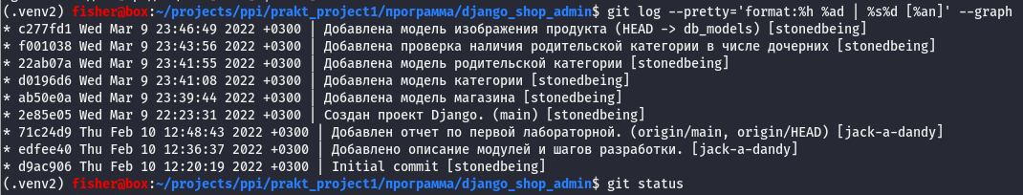

Модуль администратора магазинов — shop_admin

Результат вывода git log --pretty='format:%h %ad | %s%d [%an]' —graph

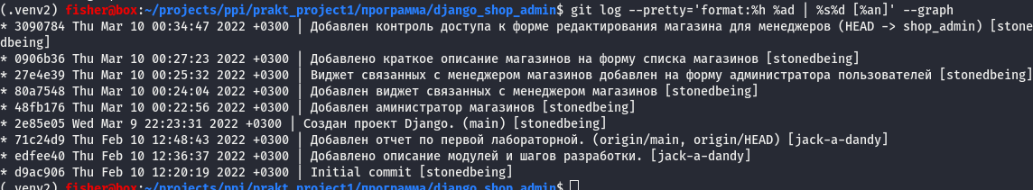

Модуль администратора категорий — category_admin

Результат вывода git log --pretty='format:%h %ad | %s%d [%an]' —graph

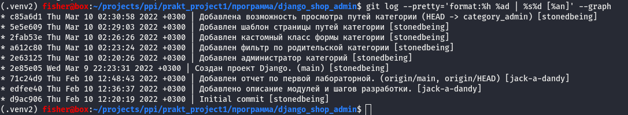

Модуль администратора продуктов — product_admin

Результат вывода git log --pretty='format:%h %ad | %s%d [%an]' —graph

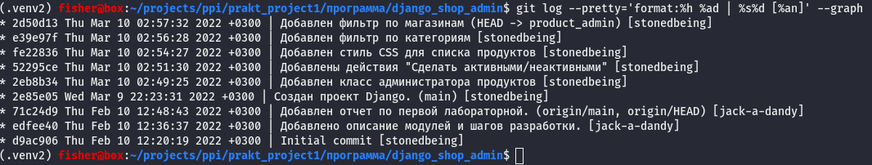

Модуль контроля доступа — access_control

Результат вывода git log --pretty='format:%h %ad | %s%d [%an]' —graph

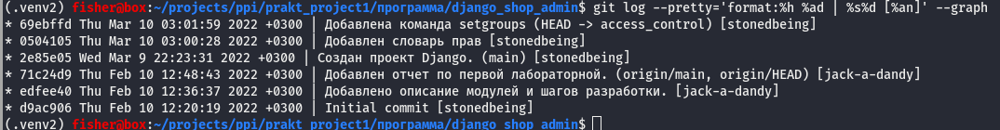

Ветки были слиты в порядке создания.

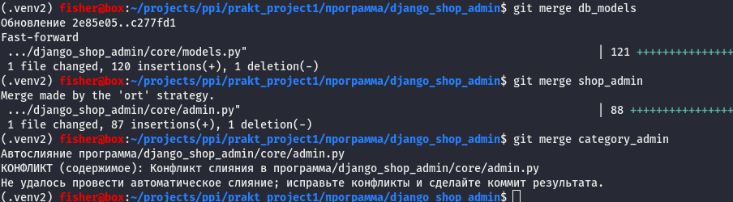

При слиянии ветки category_admin получили конфликт в файле admin.py.

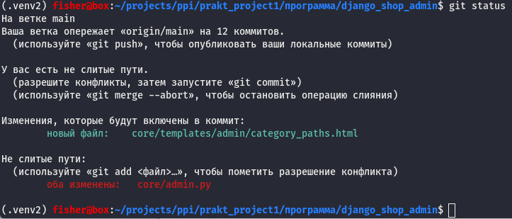

Конфликт в добавленных новых классах.

=======

class ParentCategoryFilter(admin.SimpleListFilter):

title = 'Род. категория'

parameter_name = 'parents__id'

def lookups(self, request, model_admin):

objs = Category.objects.filter(from_category__isnull=False).only('title').distinct().order_by('title')

return [(o.pk, o.title) for o in objs]

def queryset(self, request, queryset):

value = self.value()

if value is not None:

return queryset.filter(parents__id=self.value())

return queryset

class CategoryAdminForm(forms.ModelForm):

parents = forms.ModelMultipleChoiceField(label='Родительские категории',

queryset = Category.objects.only('title').order_by('title'),

required=False,

widget=FilteredSelectMultiple(

verbose_name='Родительские категории',

is_stacked=False

))

children = forms.ModelMultipleChoiceField(label='Дочерние категории',

queryset=Category.objects.only('title').order_by('title'),

required=False,

widget=FilteredSelectMultipleWithReadonlyMode(

verbose_name='Дочерние категории',

is_stacked=False

)

)

class Meta:

model = Category

fields = '__all__'

def __init__(self, *args, **kwargs):

super(CategoryAdminForm, self).__init__(*args, **kwargs)

instance = kwargs.get("instance")

if instance and instance.pk:

self.fields['parents'].queryset=Category.objects.filter(

~(Q(pk=instance.pk)|Q(pk__in=instance.category_set.values('id')))

).only('title').order_by('title')

self.fields['parents'].initial=instance.parents.all()

self.fields['children'].queryset=Category.objects.filter(

~(Q(pk=instance.pk)|Q(pk__in=instance.parents.values('id')))

).only('title').order_by('title')

self.fields['children'].initial=instance.category_set.all()

self.fields['children'].widget.attrs['readonly']=True

def save(self, commit=True):

category = super(CategoryAdminForm, self).save(commit=False)

if commit:

error=1

try:

with transaction.atomic():

category.save()

data = self.cleaned_data['parents']

if self.fields['parents'].has_changed(self.fields['parents'].initial, data):

category.parents.set(data)

error=2

data = self.cleaned_data['children']

if self.fields['children'].has_changed(self.fields['children'].initial, data):

category.category_set.set(data)

except forms.ValidationError as e:

self.add_error('parents' if error==1 else 'children', e)

except Exception as e:

self.add_error(None, e)

return category

@admin.register(Category)

class CategoryAdmin(admin.ModelAdmin)

list_display = ('title','id', 'description', 'category_actions')

search_fields = ('products__id', 'title')

list_filter = (ParentCategoryFilter,)

ordering = ('title',)

readonly_fields = ('id',)

form = CategoryAdminForm

def get_fields(self, request, obj=None):

return ('id', 'title', 'description', 'parents', 'children')

def get_urls(self):

urls = super().get_urls()

custom_urls = [

path(

'<int:category_id>/paths/',

self.admin_site.admin_view(self.process_paths),

name='category-paths',

),

]

return custom_urls + urls

def category_actions(self, obj):

return format_html(

'<a class="button" href="{}">Показать пути</a>',

reverse('admin:category-paths', args=[obj.pk])

)

category_actions.short_description = 'Действия'

category_actions.allow_tags = True

def process_paths(self, request, category_id, *args, **kwargs):

obj = self.get_object(request, category_id)

context = self.admin_site.each_context(request)

context['opts'] = self.model._meta

paths = list(obj.get_all_paths())

context['paths'] = paths

context['title'] = f'Пути к категории {obj.title} ({len(paths)})'

return TemplateResponse(

request,

'admin/category_paths.html',

context,

)

>>>>>>> category_admin

Просто улаляем разделители конфликта в файле для его разрешения.

Затем получили новый конфликт при слиянии с product_admin

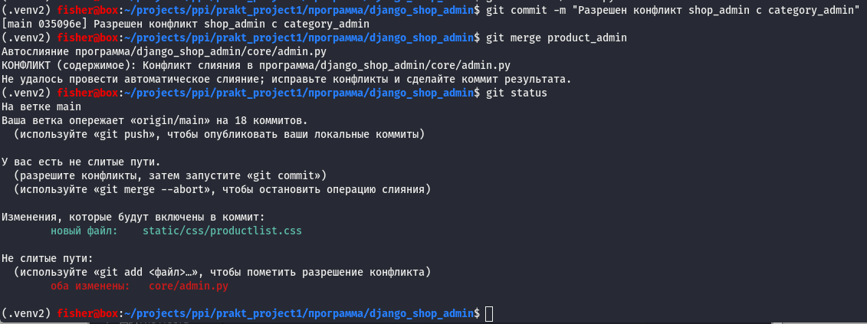

=======

class ShopFilter(admin.SimpleListFilter):

title = 'Магазин'

parameter_name = 'shop__id'

def lookups(self, request, model_admin):

objs = Shop.objects if request.user.is_superuser else request.user.managed_shops

objs = objs.filter(products__isnull=False).only('title').distinct().order_by('title')

>>>>>>> product_admin

return [(o.pk, o.title) for o in objs]

def queryset(self, request, queryset):

value = self.value()

if value is not None:

<<<<<<< HEAD

return queryset.filter(parents__id=self.value())

return queryset

class CategoryAdminForm(forms.ModelForm):

parents = forms.ModelMultipleChoiceField(label='Родительские категории',

queryset = Category.objects.only('title').order_by('title'),

required=False,

widget=FilteredSelectMultiple(

verbose_name='Родительские категории',

is_stacked=False

))

children = forms.ModelMultipleChoiceField(label='Дочерние категории',

queryset=Category.objects.only('title').order_by('title'),

required=False,

widget=FilteredSelectMultipleWithReadonlyMode(

verbose_name='Дочерние категории',

is_stacked=False

)

)

class Meta:

model = Category

fields = '__all__'

def __init__(self, *args, **kwargs):

super(CategoryAdminForm, self).__init__(*args, **kwargs)

instance = kwargs.get("instance")

if instance and instance.pk:

self.fields['parents'].queryset=Category.objects.filter(

~(Q(pk=instance.pk)|Q(pk__in=instance.category_set.values('id')))

).only('title').order_by('title')

self.fields['parents'].initial=instance.parents.all()

self.fields['children'].queryset=Category.objects.filter(

~(Q(pk=instance.pk)|Q(pk__in=instance.parents.values('id')))

).only('title').order_by('title')

self.fields['children'].initial=instance.category_set.all()

self.fields['children'].widget.attrs['readonly']=True

def save(self, commit=True):

category = super(CategoryAdminForm, self).save(commit=False)

if commit:

error=1

try:

with transaction.atomic():

category.save()

data = self.cleaned_data['parents']

if self.fields['parents'].has_changed(self.fields['parents'].initial, data):

category.parents.set(data)

error=2

data = self.cleaned_data['children']

if self.fields['children'].has_changed(self.fields['children'].initial, data):

category.category_set.set(data)

except forms.ValidationError as e:

self.add_error('parents' if error==1 else 'children', e)

except Exception as e:

self.add_error(None, e)

return category

@admin.register(Category)

class CategoryAdmin(admin.ModelAdmin)

list_display = ('title','id', 'description', 'category_actions')

search_fields = ('products__id', 'title')

list_filter = (ParentCategoryFilter,)

ordering = ('title',)

readonly_fields = ('id',)

form = CategoryAdminForm

def get_fields(self, request, obj=None):

return ('id', 'title', 'description', 'parents', 'children')

def get_urls(self):

urls = super().get_urls()

custom_urls = [

path(

'<int:category_id>/paths/',

self.admin_site.admin_view(self.process_paths),

name='category-paths',

),

]

return custom_urls + urls

def category_actions(self, obj):

return format_html(

'<a class="button" href="{}">Показать пути</a>',

reverse('admin:category-paths', args=[obj.pk])

)

category_actions.short_description = 'Действия'

category_actions.allow_tags = True

def process_paths(self, request, category_id, *args, **kwargs):

obj = self.get_object(request, category_id)

context = self.admin_site.each_context(request)

context['opts'] = self.model._meta

paths = list(obj.get_all_paths())

context['paths'] = paths

context['title'] = f'Пути к категории {obj.title} ({len(paths)})'

return TemplateResponse(

request,

'admin/category_paths.html',

context,

)

=======

return queryset.filter(shop__id=self.value())

return queryset

class CategoryFilter(admin.SimpleListFilter):

title = 'Категория'

parameter_name = 'categories__id'

def lookups(self, request, model_admin):

filters = {'products__isnull': False}

if not request.user.is_superuser:

filters['products__shop__id__in']=request.user.managed_shops.values_list('id', flat=True)

objs = Category.objects.filter(**filters).only('title').distinct().order_by('title')

return [(o.pk, o.title) for o in objs]

def queryset(self, request, queryset):

value = self.value()

if value is not None:

return queryset.filter(categories__id=self.value())

return queryset

@admin.register(Product)

class ProductAdmin(NumericFilterModelAdmin):

list_display = ('title','main_image', 'id', 'amount', 'price', 'active', 'shop_id')

fieldsets = ((None, {'fields':('id', 'shop', 'title', 'description', 'active', 'amount', 'price')}),

('КАТЕГОРИИ', {'fields': ('categories',), 'classes': ('collapse',)}),

('ОСНОВНОЕ ФОТО', {'fields': ('main_image',)}),

)

search_fields = ('id', 'title')

list_filter = ('active',CategoryFilter,ShopFilter)

readonly_fields = ('id',)

filter_horizontal = ('categories',)

actions = ('make_active', 'make_inactive')

list_per_page = 50

class Media:

css = {'all': ('css/productlist.css',)}

def main_image(self, instance):

url = instance.images.only('image').first()

if url:

return format_html("<img src='{}{}' width=100 height=100 style='object-fit:contain' />",

settings.MEDIA_URL, url.image)

else:

return format_html("<img alt='—' />")

main_image.short_description = 'Фото'

def formfield_for_manytomany(self, db_field, request, **kwargs):

if db_field.name == "categories":

kwargs["queryset"] = Category.objects.only('title').order_by('title')

return super().formfield_for_manytomany(db_field, request, **kwargs)

def formfield_for_foreignkey(self, db_field, request, **kwargs):

if db_field.name == 'shop':

qs = None

if not request.user.is_superuser:

qs = request.user.managed_shops

else:

qs = Shop.objects

kwargs['queryset']=qs.only('title').order_by('title')

return super().formfield_for_foreignkey(db_field, request, **kwargs)

def get_queryset(self, request):

qs = super().get_queryset(request)

if request.user.is_superuser:

return qs

else:

return qs.filter(shop__id__in=request.user.managed_shops.values_list('id', flat=True))

@admin.action(description='Сделать активными')

def make_active(self, request, queryset):

queryset.update(active=True)

@admin.action(description='Сделать неактивными')

def make_inactive(self, request, queryset):

queryset.update(active=False)

>>>>>>> product_admin

Тут ситуация немного запутанная из-за идентичных кусочков кода в разных классах. Для решения конфликта нужно переместатить часть кода, а так же скопировать и вставить другую часть.

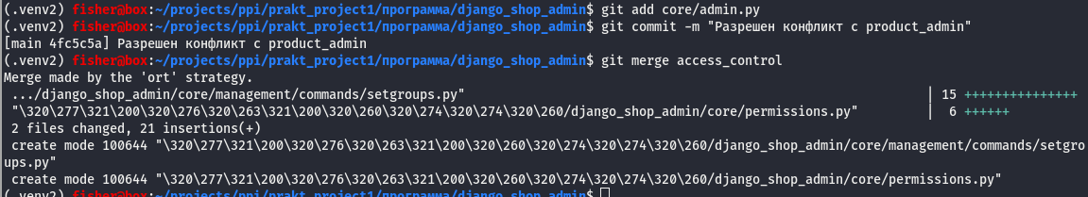

Результат

