**How to Test**

# Testing Authorization Server for Access Token (Postman)

1. Setup Authorization in Postman

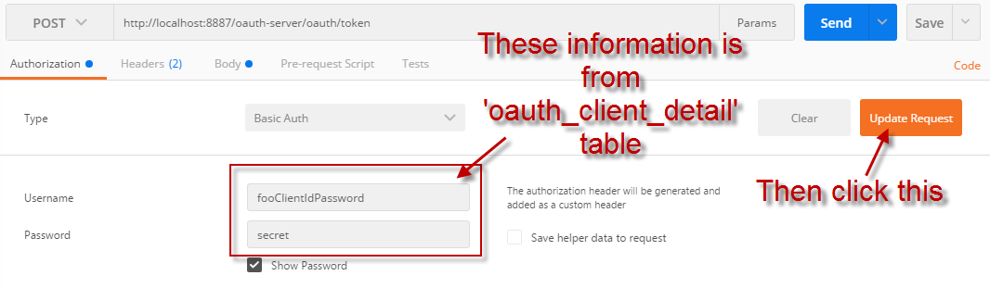

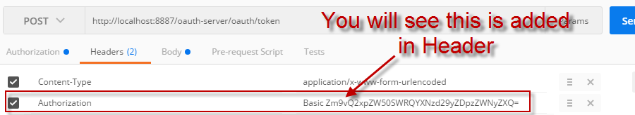

1. Add credentials in Body

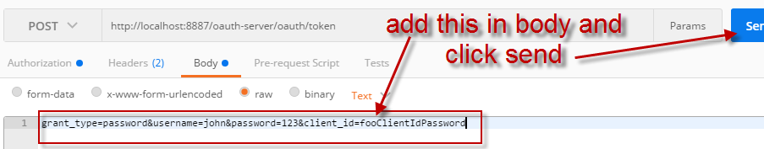

Or

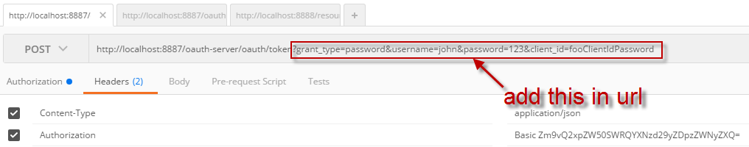

1. You will get access token:

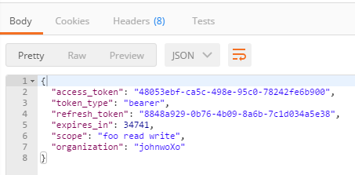

# Testing Authorization Server by Refresh Token (Postman)

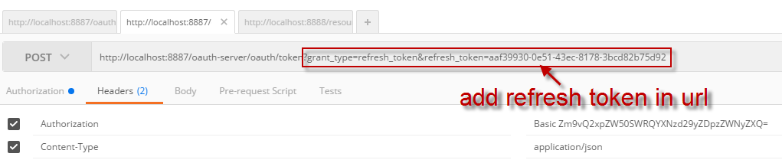

You will get new access_token with new expires_in time:

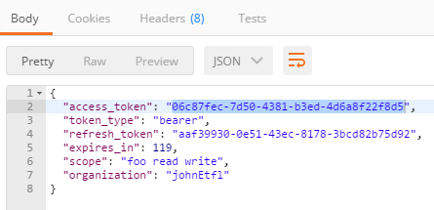

# Testing Resource Server by Access Token (Postman)

