**Questions For Investigation**

As a general note, be sure to keep a record of any resources that you use or refer to in the creation of your project. You will need to report your sources as part of the project submission.

1. What is our independent variable? What is our dependent variable?

The independent variable is the words condition when participant takes the test. The dependent variable is the time it takes participant to name the ink colors.

2. What is an appropriate set of hypotheses for this task? What kind of statistical test do you expect to perform? Justify your choices.

In this task, we are trying to study if the incongruent condition could increase the time to name the ink colors or not, thus the following set of hypotheses can be used for this task:

The null hypothesis: the incongruent words condition has no effect on the population time it takes to name the ink colors. H0: µincongruent = µ congruent or H0: µDifference = 0

The alternative hypothesis: the incongruent words condition will increase the population time it takes to name the ink colors H1: µincongruent > µ congruent or H1: µDifference > 0

The t-test will be used because the sample size is very small n=24 and we do not know the population parameters. Because we care about that the incongruent condition will increase the time to name the color, we are only considering the tail on the right, that is the one-tailed t-test in the positive direction. Because the same participants take the test twice under two conditions, the paired/dependent samples t-test should be used.

3. Report some descriptive statistics regarding this dataset. Include at least one measure of central tendency and at least one measure of variability.

|  |  |  |  |
| --- | --- | --- | --- |
|  | Congruent | Incongruent | Difference |
| Mean Time (s) | 14.051 | 22.016 | 7.965 |
| Median Time (s) | 14.357 | 21.018 | 7.667 |
| Standard Deviation | 3.559 | 4.797 | 4.865 |

4. Provide one or two visualizations that show the distribution of the sample data. Write one or two sentences noting what you observe about the plot or plots.

Most time under congruent words condition are between 8s and 20s while most time under congruent words are between 16s and 28s.

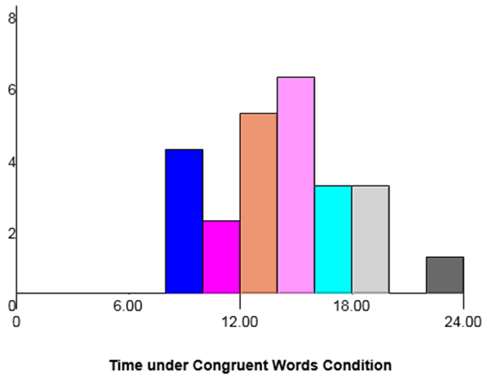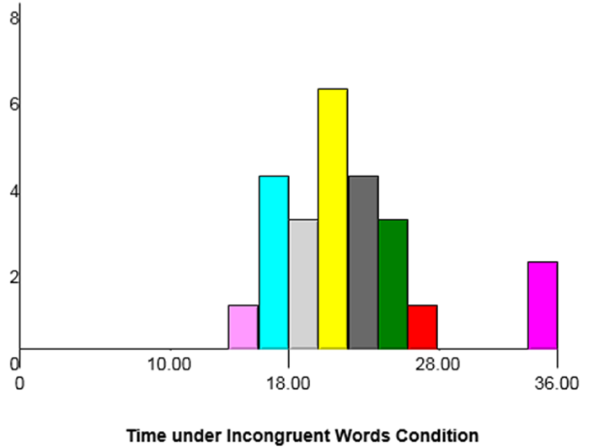

5. Now, perform the statistical test and report your results. What is your confidence level and your critical statistic value? Do you reject the null hypothesis or fail to reject it? Come to a conclusion in terms of the experiment task. Did the results match up with your expectations?

H0 : µD = 0

HA : µD > 0

n = 24

df = 23

t-critical value if α=.05 is 1.714

The mean of the difference is 7.965

The standard deviation of the difference (SD) is 4.87

The standard error of the mean is 0.99

The t-statistic is 8.02

Based on the t-statistic and t-critical value, the results are statistically significant, and we will reject the null because p<0.05

Cohen’s d = 1.64

The 95% confidence interval for the mean difference CI: (5.91, 10.02)

The results did match up with my expectations.

6. Optional: What do you think is responsible for the effects observed? Can you think of an alternative or similar task that would result in a similar effect? Some research about the problem will be helpful for thinking about these two questions!

According to <https://en.wikipedia.org/wiki/Stroop_effect>, there are several theories can be used to explain the observed stroop effect. For example, the “Processing speed” theory suggests “there is a lag in the brain’s ability to recognize the color of the word since the brain reads words faster than it recognizes colors.”

Here is a similar task:

In the congruent words condition, the words being displayed are shape words whose names match the shapes in which they are printed, for example: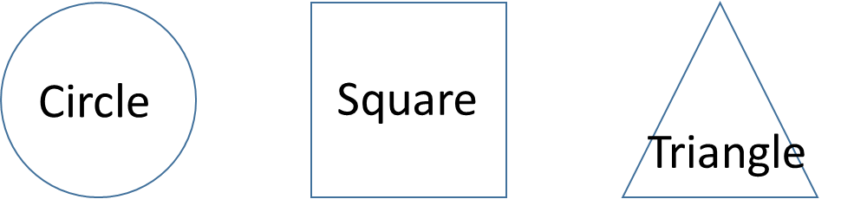

In the incongruent words condition, the words being displayed are shape words whose names do not match the shapes in which they are printed, for example: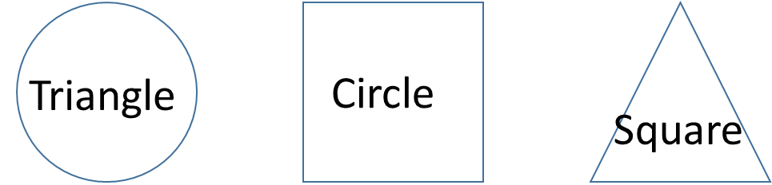

Similarly, in each case, we measure the time it takes to name the shape in equally-sized lists. Each participant will go through and record a time from each condition.