1. Turnaround Times
   1. (8ms + 10ms + 10ms)/3 = 9.33ms
   2. (8ms + 6ms + 11)/3 = 8.33ms
2. To make the computer feel responsive to the user. Any small delay would result in a noticeable freeze.
3. Gantt Charts
   1.  Turnaround time: (8ms + 11ms + 13ms + 14ms + 20ms)/5 = 13.2ms Wait time: (0ms + 8ms + 11ms + 13ms + 14ms)/5 = 9.2ms
   2.  Turnaround time: (20ms + 6ms + 3ms + 1ms + 12ms)/5 = 8.4ms Wait time: (12ms + 3ms + 1ms + 0ms + 6ms)/5 = 4.4ms
   3.  Turnaround time: (19ms + 3ms + 5ms + 20ms + 11ms)/5 = 11.6ms Wait time: (11ms + 0ms + 3ms + 19ms + 5ms)/5 = 7.6ms
   4. 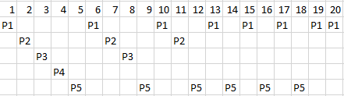 Turnaround time: (20ms + 11ms + 8ms + 4ms + 18ms)/5 = 12.2ms Wait time: (12ms + 8ms + 6ms + 3ms + 12ms)/5 = 8.2ms
   5. SJF has the shortest average wait time for this set of processes.
4. 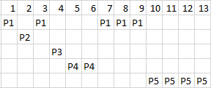 Turnaround time: (9ms + 1ms + 1ms + 3ms + 7ms)/5 = 4.2ms Wait time: (4ms + 0ms + 0ms + 1ms + 3ms)/5 = 1.6ms
5. Priority time can result in starvation if a low priority process never gets to run because there are always higher priority processes.
6. RR
   1. The process with 2 pointers would run twice as many times.
   2. An advantage is that more pointers could be added to give certain processes priority, allowing them more time to run. A disadvantage is that there would still be lost time in the overhead to check the ready queue and run the same process that was already running.
   3. I would just have priority attached to each process in the ready queue that would dynamically change the quantum.