***Lost or can't find your ticket? Instantly have it re-sent to your Rogers wireless phone for FREE: text REPEAT to 4849.***

**SMS (text message):   
Contains a 13 digit code that can be manually entered by our scanning staff at the event.**

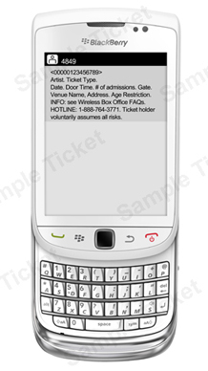

**Either message can be used as your ticket.**

**MMS (picture message):   
Contains both a 13-digit code and a 2D bar code that can be scanned by our staff at the event.**

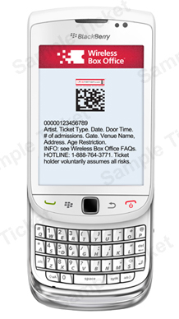

* **Red Hot Chili Peppers - Saturday, November 24, 2012**
* 4 Tickets - Reserved Seating - PL1 - Floor - Section G Row 10 Seats 1-4$286.00
* Total:$286.00
  + **Order #:0130291345295**
* **Grand Total:$286.00**

**Service charge savings by using the Wireless Box Office:$57.60**