# *“Chicken Micken”* Game Project

## Team Dee Dee members

|  |  |
| --- | --- |
| Георги Ивалинов Георгиев | GeorgiGeorgiev |
| Здравко Петров | Z_Petrov |
| Анна Николова Стоянова | naturalna |

## Project purpose

In this project we develop a side scrolling 2D shooter game called “Chicken Micken”. The player can move freely around the screen, in order to avoid attacks of the enemies represented by Flying Chickens. The Player can also shoot at the chickens with hatchets, and win points for each kill that “The Exterminator” made. The game offers 6 challenging levels, also Main Menu and Game Over Screen.

## Class Diagram

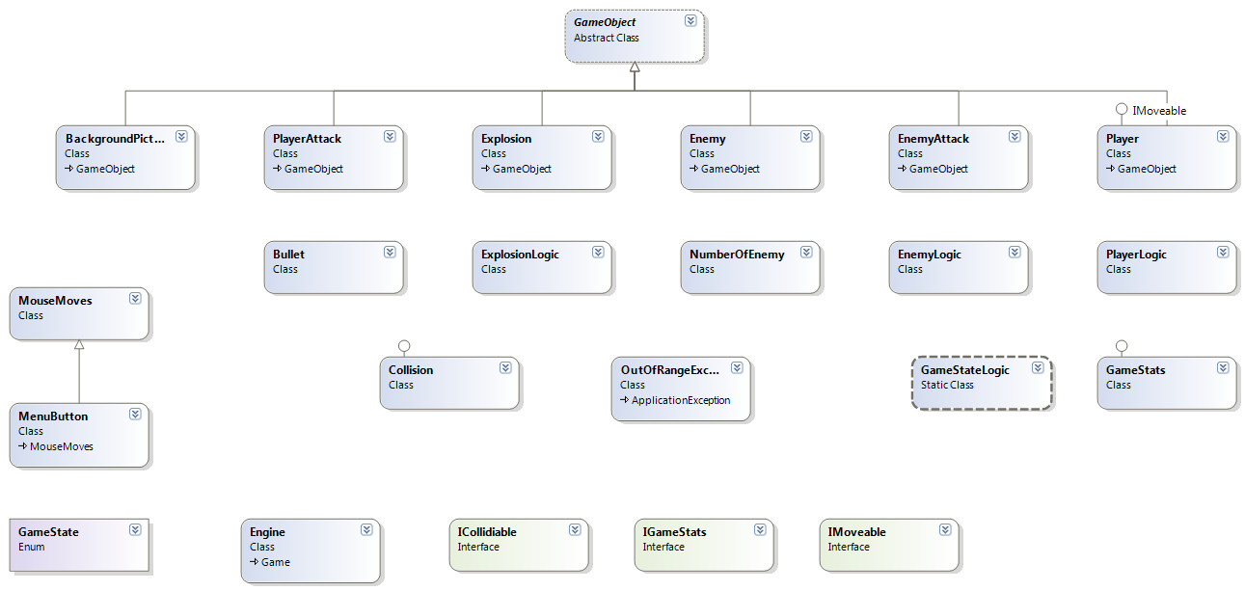

## Class explanation

**1. Abstract Class**

**GameObject** -This is the abstract GameObject class of the game which is used to initialize new object with different texture, form, drawable and update method.

**2.Classes**

**BackgroundPicture** –This class main target is to draw the background of the Play Field.

**Bullet –** Main target of the class is to initialize EnemyAttack

**Collision** – The class Collision checks if the Player hit an enemy, Player attack hit Enemy, Enemy attack hit Player

**Enemy** – This class initializes each Enemy

**EnemyAttack** - This class target is to define the Enemy Logic for Attack.Drawing and updating it.

**EnemyLogic** – The class target is to generate the enemy Logic – moving and shooting.

**Engine** - Creating new instance of the objects that we use in the game. Updating the instances. Drawing on the screen.

**Explosion** - Main target of the class is to initialize the “Deaths”, “Explosions” with a fading effect.

**ExplosionLogic** – Target of the class is to Draw the initialized the Created explosions on the screen.

**GameStats** - In this class is implemented the methods of the IGameStats.

**MenuButton** - This class target is to define the buttons of the menu and draw them on the screen.

**MouseMoves** - This is the MouseMoves class in witch we create a hover efect of the mouse and create the main logic when the left button is pressed

**NumberOfEnemy** – Generate Number, interval and position of the Chickens

**Player** – Initializing the Player Object a.k.a. “The Exterminator” with texture, form, lives, speed.

**PlayerAttack** - This class target is to initialize the player attacks and make them spin

**PlayerLogic** - This class target is to define the Main Player Logic - Adding, Updating and Drawing shots

**3.Enumeration**

**GameState -**This is an enumeration for the game states

**4.Interfaces**

**ICollidiable** – This interface implements the all collisions

**IMoveable** - This interface implements the Restriction of movement in the bounds of the Playing window

**IGameStats** - Interface where we initialize the Drawing Methods on the screen

**5.Exceptions**

**OutOfRangeException** – implement exception if the player scoresor lives are negative

## URL of TFS repository

<http://deedee.codeplex.com/SourceControl/list/changesets>