1.0. Team member information:

Students’ IDs | Students’ Full Names | Contribution level
U2411008 | Marjona Alisherova | Equally contributed
U2411034 | Ayjan Niyazova | Equally contributed
U2411024 | Maxmudjonova Dildora | Equally contributed
U2411055 | Niyazbek Turdibaev | Equally contributed

2.0. Instructions:

2.1 File Naming and Submission
(1) Save your document as: GroupNumber_MMProject (ex. Group1_MMProject).
(2) Your submission must be in Microsoft Word format. No other file types will be accepted.
(3) You should start writing your report after the Rubric Section, without deleting any part of the following instructions.

2.2 Academic Integrity and Plagiarism:
All work must be original. Any copied or plagiarized content will be subject to investigation as per the academic regulations of Inha University in Tashkent (IUT) and reviewed by the Committee for Award and Penalty.

Plagiarism Definition:
- Copying any text directly from external sources is considered plagiarism.
- Any information taken from other sources must be properly paraphrased and referenced.
- Avoid paraphrasing entire texts; you may only use selected parts of the text appropriately.
- All data, including numbers, statistics, and factual information, must be properly cited.

2.3 Referencing:
Students are required to use a recognized referencing style (ex. APA, Harvard, or MLA) consistently throughout all submitted work. All written assignments must include proper in-text citations and a corresponding reference list. Accurate acknowledgment of all sources is essential to uphold academic honesty and integrity. Failure to do so may result in penalties for plagiarism.

2.4 Formatting:
(1) Follow clear and logical structuring of answers as indicated by the questions/following guidelines provided below.
(2) Formatting requirements: Times New Roman, 12, double-spaced.

3.0. Task Instructions:

3.1 Company Options (choose ONE)
1. Baby Island (B2C): Baby Island is a premium wellness and early development center in Tashkent that specializes in hydrotherapy, baby massage and sensory learning programs for infants aged 0–3. Its goal is to increase awareness and bookings for its hydromassage service, positioning it as both a health and bonding experience for parents and their babies. The company aims to attract new parents, strengthen brand trust and improve customer retention through personalized communication and safety-focused messaging.
Objective: Achieve 100 paid hydromassage session bookings from parents with children aged 0–3 in Tashkent within three months, through a targeted Instagram and Telegram marketing campaign focused on baby wellness and safety.
2. C-Space (B2B): C-Space is a coworking and business hub in Tashkent offering flexible office solutions for startups, freelancers and small teams. Its goal is to expand its client base among small and growing businesses by highlighting productivity benefits, networking opportunities and modern workspace features. The company seeks to develop a targeted marketing approach emphasizing community, affordability, and convenience for entrepreneurs.
Objective: Sign 15 new monthly coworking contracts with small business teams (3–10 employees) within four months, using any relevant channel.
3. Safia (B2C): Safia is a well-known Uzbek food brand offering dairy products, snacks, and healthy beverages. At Inha University in Tashkent, Safia recently introduced a “Grab-and-Go” line designed for busy students and staff seeking quick, nutritious options between classes. The goal is to increase product awareness and sales on campus through innovative promotions, packaging and partnerships that appeal to young, health-conscious consumers.
Objective: Sell 500 units of Safia Grab-and-Go snacks at Inha University each month during the semester.

4. Samad’s Coffee Station (B2C): Samad’s Coffee Station is a small coffee business located inside Inha University in Tashkent. It offers freshly brewed coffee, tea, and light snacks for students and staff seeking affordable, high-quality drinks between classes. Recently, competition has increased with the arrival of a mobile coffee truck and Safia’s new “Grab-and-Go” snack line. To stay competitive, Samad’s Coffee Station launched a Telegram ordering bot, allowing customers to pre-order drinks and pick them up quickly without waiting in line.
Objective: Achieve 500 pre-ordered coffee transactions through the Telegram bot per month during the semester, by promoting convenience, speed, and personalized loyalty offers for students and staff.

3.2 What you must deliver (two files+presentation):
- Report (max 12 pages – excluding the Appendix page, approx. 3,000 words): professional marketing plan with evidence.
- Appendix Folder: survey instrument, raw data (CSV/Excel), cleaned dataset, charts/ tables, interview notes (if any).
- Presentation: 10-15 minutes + 10 minutes for Q&A. Week 15 Saturday and maybe Sunday.

3.3 Step-by-Step Tasks (and what to submit)

Phase 1 – Market Research
Step 1. Market Overview (Secondary Research)
Find out what’s happening in the market.
- Look up key facts: who the customers are, who the competitors are, and what current trends exist.
- Write a short 5Cs summary (Company, Customers, Competitors, Collaborators, Context).
- Use real sources (websites, news, reports) and mention them.
- Write 1–2 pages only.
- This helps you understand the background before making any marketing decisions.

Step 2. Customer Research (Primary Research)
Collect information from real people.
- For Baby Island or Safia (B2C): Survey at least 60 consumers and do 3–5 short interviews.
- For C-Space (B2B): Survey 20 business owners or managers, or interview 8–10 people (small business owners) if needed. Evidence of conducted interviews should be submitted (photos, business visits, business names).
- Mention how you will reach people (Telegram, LinkedIn, friends, etc.).
- Create your questionnaire (Google Form or Word) and share a few screenshots of results.
- Ask simple questions about awareness, preferences, price and habits.

Step 3. Results and Insights
Look at your data and explain what it means.
- Show 2–3 charts or tables (like gender, age or preferences).
- Write 3–5 key findings, for example: “Most parents choose Baby Island because of hygiene and safety.”
- Keep it short, about 2–3 pages.
- Focus on what you learned, not only what you asked.

Phase 2 – Marketing Strategy
Step 4. Segmentation–Targeting–Positioning (STP)
Decide who your main customers are and how you’ll attract them.
- Divide your audience into groups (for example, young parents, students, freelancers).
- Choose one main target.
- Write a Positioning Statement:
For [target group], [brand] is the [category] that offers [main benefit].
- Create one short persona (typical customer profile). Be specific - choose one clear type of customer.
- Write 1-2 pages.

Step 5. SMART Goals
Set clear goals for your marketing plan connected to the main objective described in the case.
- Example: if you main objective is“Get 100 new bookings in 3 months”, then your SMART goals should break this big goal into smaller, trackable marketing actions:
  - Reach 10,000 parents in Tashkent through Instagram and Telegram ads and organic posts within 3 months.
  - Generate 150 trial session bookings from new customers, converting at least 100 into paid sessions.
  - Collect feedback from at least 80 parents after their first visit, aiming for an average satisfaction rating of 4.5/5 or higher.
- Write 3–5 SMART goals (specific, measurable, realistic, time-based).
- Write 1 page.
- Each goal should be easy to measure.

Step 6. Marketing Mix (4Ps / 7Ps)
Plan your main actions:
- Product/Service: What exactly are you offering?
- Price: What is the price and why?
- Place: Where will people find or use it?
- Promotion: How will you tell people about it (ads, events, social media)?
- If it’s a service (like Baby Island or C-Space), preferably make 7Ps.
- Write 2–3 pages maximum.
- Each action should connect to your goals.

Phase 3 – Implementation
Step 7. Budget and Timeline
Show your plan in numbers and time.
- Make a small budget table (cost of ads, events, materials, etc.).
- Add a timeline table (what will happen each week or month).
- 1–2 pages total.
- Use simple estimates - this is a learning project, not a real business plan.

Step 8. KPIs (How You’ll Measure Success)
Choose 4–5 key numbers to check if your plan works.
Examples:
- Number of new customers
- Instagram reach or followers
- Sales or bookings
- Customer satisfaction
- Make a simple table with KPI name, how to measure it and how often.
- Only include what really matters.

Step 9. Executive Summary
Write this part at the end.
- 200–300 words only.
- Summarize your idea: the company, main goal, target audience, key findings, and expected results.
- Place this on the first page of your report.
- Imagine you are presenting your idea to the company’s manager - make it short and clear.

Rubric: Total 54 points (including individual part of the presentation). 40% of your course grade. Any AI or plagiarized part will be deducted up to 50%. For severe cases, your response for that specific part will be nullified.

Section & Criteria Description | 0 (Incomplete) | 1 (Satisfactory) | 2 (Good) | 3 (Excellent)
1. Market Overview – Summarize company, market trends, and competitors using the 5Cs framework (Company, Customers, Competitors, Collaborators, Context) with real sources. | Missing or irrelevant; no sources used. | Basic overview with minimal facts or sources. | Clear 5Cs summary with relevant sources. | Excellent and data-driven overview with strong understanding of the market context.
 | 0 (Incomplete) | 1 (Satisfactory) | 2 (Good) | 3 (Excellent)
2. Customer Research – Conduct and present survey/interviews (B2C ≥ 60 responses; B2B ≥ 20 or 8–10 interviews) with real evidence (screenshots, links). | No data collected or unreliable sample. | Some data but weak design or presentation. | Sufficient data with clear visuals and short analysis. | Strong and reliable data collection with proof and insightful summary.
 | 0 (Incomplete) | 2 (Satisfactory) | 4 (Good) | 6 (Excellent)
3. Results & Insights – Analyze data, show charts and summarize 3–5 key findings linking to marketing decisions. | No results or analysis. | Basic findings, weak interpretation. | 3–4 clear findings supported by charts. | Strong, actionable insights clearly connected to the marketing goal.
 | 0 (Incomplete) | 2 (Satisfactory) | 4 (Good) | 6 (Excellent)
4. STP (Segmentation–Targeting–Positioning) – Identify customer segments, choose main target, create persona and write positioning statement. | Missing or illogical segments. | Basic segmentation, unclear target. | Clear segments and target with basic positioning. | Excellent, data-based segmentation and positioning with well-defined persona.
 | 0 (Incomplete) | 1 (Satisfactory) | 2 (Good) | 3 (Excellent)
5. SMART Goals – List 3–5 specific, measurable marketing goals linked to the main objective. | No goals or too vague. | Some goals but not measurable or time-bound. | 3–4 clear and reasonable SMART goals. | 4–5 precise SMART goals aligned with objectives and KPIs.
 | 0 (Incomplete) | 2 (Satisfactory) | 4 (Good) | 6 (Excellent)
6. Marketing Mix (4Ps / 7Ps) – Propose product, price, place and promotion strategy (or 7Ps for services) linked to research findings. | Missing or unrealistic. | Some Ps covered but limited detail. | All Ps explained with logic and clarity. | Creative and coherent 4Ps/7Ps plan supported by data and SMART goals.
 | 0 (Incomplete) | 1 (Satisfactory) | 2 (Good) | 3 (Excellent)
7. Budget & Timeline – Provide simple cost and time plan showing how and when the campaign will be implemented. | Missing or unrealistic. | Rough or unclear plan. | Logical and organized budget and timeline. | Clear, practical, and professional budget and schedule.
 | 0 (Incomplete) | 1 (Satisfactory) | 2 (Good) | 3 (Excellent)
8. KPIs (Measurement & Control) – List 4–5 key performance indicators to measure campaign success. | Missing or irrelevant KPIs. | Few KPIs not linked to goals. | 3–4 relevant KPIs with basic measures. | 4–6 strong, measurable KPIs directly tied to SMART goals.
 | 0 (Incomplete) | 1 (Satisfactory) | 2 (Good) | 3 (Excellent)
9. Executive Summary – Write a 200–300-word summary covering the company, goal, target, key insights and expected impact. | Missing or unclear. | Basic summary, lacking focus. | Clear and complete summary. | Excellent, concise, and professional summary with clear impact.
 | 0 (Incomplete) | 1 (Satisfactory) | 2 (Good) | 3 (Excellent)
10. Organization & Referencing – Formatting, clarity and citation of sources (APA / Harvard / MLA). | Disorganized and no references. | Some structure, limited references. | Well-structured, some references used. | Professional layout with consistent referencing style and clarity.
Presentation Deck | 0 (Incomplete) | 2 (Satisfactory) | 4 (Good) | 6 (Excellent)
11. Content & Understanding (individual evaluation) – Demonstrates understanding of marketing concepts, research findings, and the proposed strategy. | Unclear, inaccurate, or incomplete content. | Covers main ideas but lacks depth or connection to data. | Clear and relevant content supported by research. | Deep understanding, excellent connection between insights and strategy.
Student IDs:
1.
2.
3.
4.
5.
6.
7.
8.
 | 0 (Incomplete) | 2 (Satisfactory) | 4 (Good) | 6 (Excellent)
12. Delivery & Communication (individual evaluation) – Confidence, clarity of speech, engagement, and time management. | Unclear, rushed, or read directly from slides. | Understandable but lacks confidence or consistency. | Clear, confident, good pace and tone. | Professional, engaging, natural delivery with excellent time control.
Student IDs:
1.
2.
3.
4.
5.
6.
7.
8.
 | 0 (Incomplete) | 1 (Satisfactory) | 2 (Good) | 3 (Excellent)
13. Visuals & Organization – Slide clarity, logical flow, and visual support for key points. | Disorganized or hard to read slides. | Some structure but visuals weak or cluttered. | Clear and structured slides with relevant visuals. | Highly professional, visually appealing, and logically sequenced slides.

Marketing Plan for Samad’s Coffee Station
for Marketing Management Team Project
Marjona Alisherova U2411008
Ayjan Niyazova U2411034
Maxmudjonova Dildora U2411024
Niyazbek Turdibaev U2411055

Executive Summary
This marketing plan focuses on Samad Coffee Station. The core objective is to achieve 500 orders per month through the Telegram ordering bot. Currently, this number is around 200 orders per month. To understand why it’s so low and how to achieve the goal, we conducted an online survey and deep interviews with students and the owner himself. 99 students participated in the survey, which revealed that 2 out of 3 students suffer from crowds during breaks, and almost half of the students feel that prices are high on campus. Additionally, it shows that 60% were unaware of the bot. The proposed solution is to raise bot awareness which, will eventually solve the problem of overcrowding. To achieve that Samad needs to place posters and stickers with QR promoting the bot in spots regularly pass through, as a result targeting the big convenience seeker group, that can tolerate a slight price difference.
Market Overview
Company
Samad’s Coffee Station is a campus-based shop opened on 1st November, 2022, at Inha University in Tashkent. Its key strength is that Samad has over six years of barista experience, previously working in Moscow, making him professional. Next is high quality product. And most important is really good customer service. It includes not only making orders fast without mistakes, also the personal interactions such as remembering customers’ names and their order preferences, holding conversations like friends and joking all these give customers a special experience that allows Samad reengage his customers. Recently, even though Samad has increased coffee prices, no drops in customers were recorded. It tells about the high loyalty of his consumers. Before moving to Inha University, he made sure that the student population will satisfy his business growth.
Despite these strong sides of Samad's Coffee Station, his Telegram pre-ordering bot is not being developed, which causes complaints among students. Also, Station has minimal marketing and promotion comparing to its rivals such as Safia or Fretta. Samad tells himself that he is unwilling to expand his business and prefers someone else to do this job instead. For positive outcomes, he is ready to generously reward this person.
Customers
The main customers of Samad's Coffee Station are IUT students but also administrative staff and IUT guests make small part of its consumers. The most popular drinks are cappuccino and lemon tea. As Samad claims himself, his regular customers choose him over and over again because they simply value him. He thought that his sales would drop when he increased prices but it did not happen. The Shop's owner Samad analyzes his customers' behavior and is able to provide them with personalized service such as remembering small details about preferred ingredients. Also, he has promotion named "every sixth cup for free". To monitor this, he uses last 4 digits of customers' personal phone numbers. To exceed need expectations, he gives small cookies with coffee. These efforts really motivate people to undoubtedly choose Samad's products.
Competitors
At Inha University we have two more options not including Samad's Coffee and they are Safia and Fretta. Samad says that he does not consider any of them as his competitors. Maybe Safia wins in terms of lemon tea and baked goods but regarding coffee quality Samad is a priority choice. However, when Fretta opened on the campus, Samad's sales dropped in 52% in the first two weeks that caused a big concern.
Collaborators
Samad closely collaborates with IUT community and also his Telegram pre-ordering bot was developed by IUT students who voluntarily decided to support his business. Also, moving from his previous coffee station called "Shift 3" to Inha was IUT student's suggestion. Potential IUT student representative tried to help him open a new location in other University but because of rector there, it did not happen. Samad himself tried Pharmaceutical University, however, due to inconsistent demand there, he gave up on this idea. Regarding ingredients for drinks, he relies on local suppliers and buys in bulk at the Sampi wholesale store for almost 5 years.
Context
Students' preferences on drinks change because of increasing competition and other options provided. Samad notices that each year the number of purchased coffee decreases and it shows potential threat for future growth. To stay solvent, Telegram pre-ordering bot was launched in the middle of September. Currently bot takes 50 orders per week. This shows adaptation to broader digitalization trends and opportunities to improve convenience and reduce waiting times in long queues. Seasonality also impacts demand because during winter season it is divided to peak hours such as 9-10AM and 12-13PM but during warmer period there is more consistent demand because of iced drinks options such as mojito and iced tea. Students' contribution ensures customer flow but also attracts new competing businesses to Inha University.
Customer Research
Data was gathered through a survey among the students of INHA using Google Forms. Through this, we realize the extent of the potential of Samad's Coffee Shop's pre-ordering Telegram bot. The link was shared in Telegram groups for students, which helped us understand the audience of customers.
A total of an opinion poll took 99 students and staff. They told us about the bugs in the bot, frequently ordered drinks and how satisfied with the service, and also shared ideas on how to improve service performance. The poll structure is meticulously crafted so that we can get a better set of data. The questions consisted of a single choice of answer, open-ended questions and also an evaluation scale. Our survey identified different groups of people, from everyday to casual shoppers. The survey gave us the opportunity to collect information about the reasons for the use of the bot, service satisfaction, expected problems, the most frequent time of purchase and the waiting time of the order.
Based on the survey, we can understand the needs of the customer, which will eventually give us the opportunity to form a marketing strategy for better development of the Telegram bot.
Result and Insights
By analyzing the responses to the interview and online survey, important aspects such as students' viewing and their perception of coffee consumption in the Samad’s shop were identified. This information gave a clear idea of the often encountered problems that have already become schematic and also the discovery of further opportunities for coffee and stimulation of demand in telegrams bot. Based on the results we analyzed, important conclusions were drawn.
One of the most important findings is the high concentration of buyers in the morning hours, which makes the service overloaded. According to the survey, 75% of students buy coffee from 8:00 to 12:00, and there are busier hours in the period from 10:00 to 12:00, this statistic was reported by the owner Samad. Also, 66% of customers named the main problem in increased demand for coffee during breaks , but at the same time students reported that they are waiting for order about 3-5 minutes. 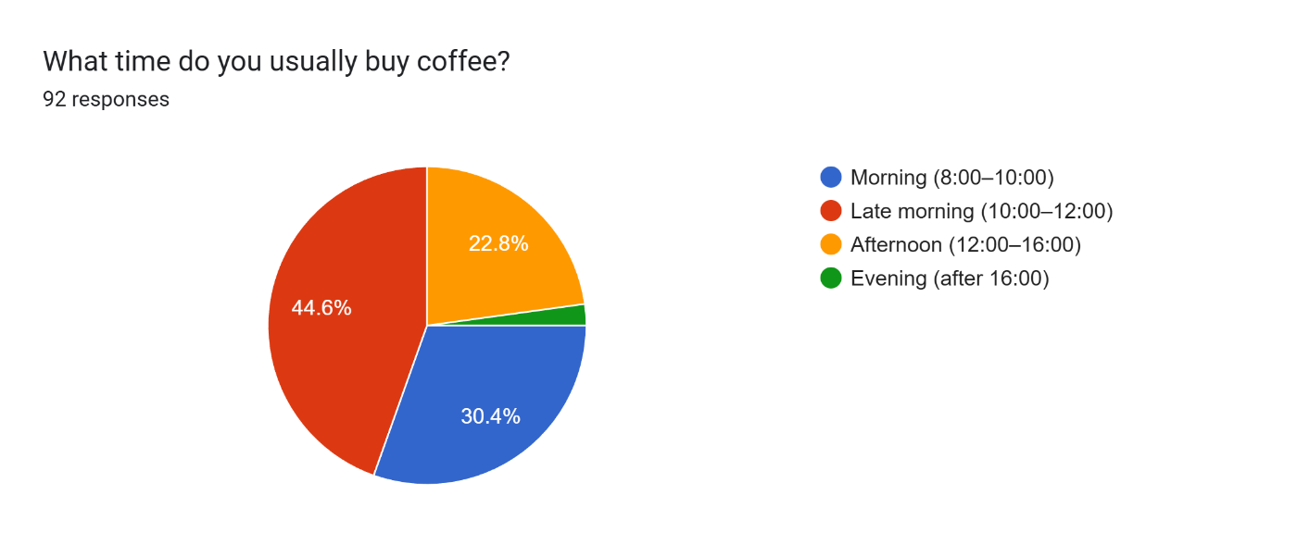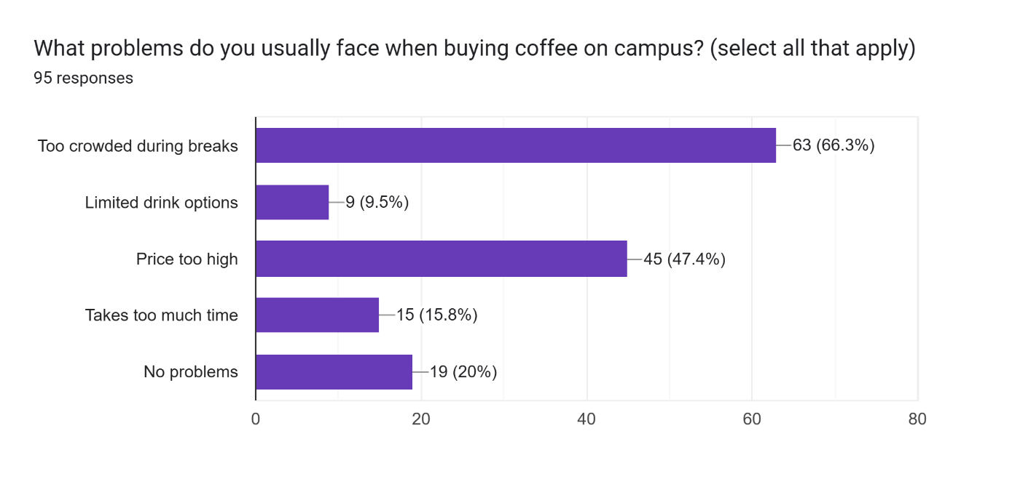
The second important finding is that there is a lack of awareness and an extremely low level of understanding of how a bot works to place orders in Telegram. Contrary to expectations, only 40.4% of students have heard about the bot, while 59.6% do not know of its existence. Moreover, of those who know, only about 10% have ever used it. The most common reasons for not using a bot were: ignorance of its existence, ignorance of how it works, and preference for personal order. At the same time, most students stated that they would have used the bot if it had clearly saved them time or brought a small reward. This suggests that the bot has untapped potential, but its current visibility and communication is insufficient. Awareness raising is thus one of the most important opportunities for this project.
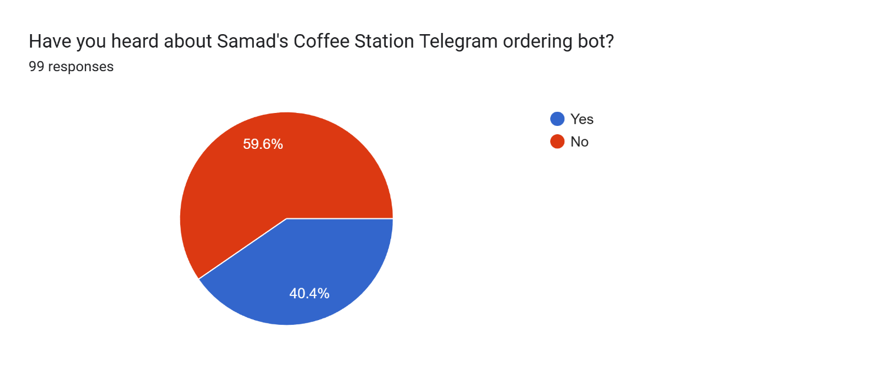
The third finding shows a generally positive perception of Samad’s Coffee Station but if we take into account the price sensitivity and adding more drink options, it raises some questions. In a survey Samad’s Station was the most preferred drink supplier on campus and was chosen by 50.5% of respondents. It is more than Safia, Fretta or Azbi. Customer satisfaction was also high and the average rating was 4.15 out of 5. However, almost half of the students, precisely 47%, found the prices too high and suggested in the comments to reduce the price or add more snacks and drinks to the menu. This says that while students value Samad’s service and mostly prefer his coffee comparing to other shops, they also pay attention to affordability and diversity. Therefore, improving service through faster service, small promotions or the addition of small snacks can be more effective than changing the main product itself.
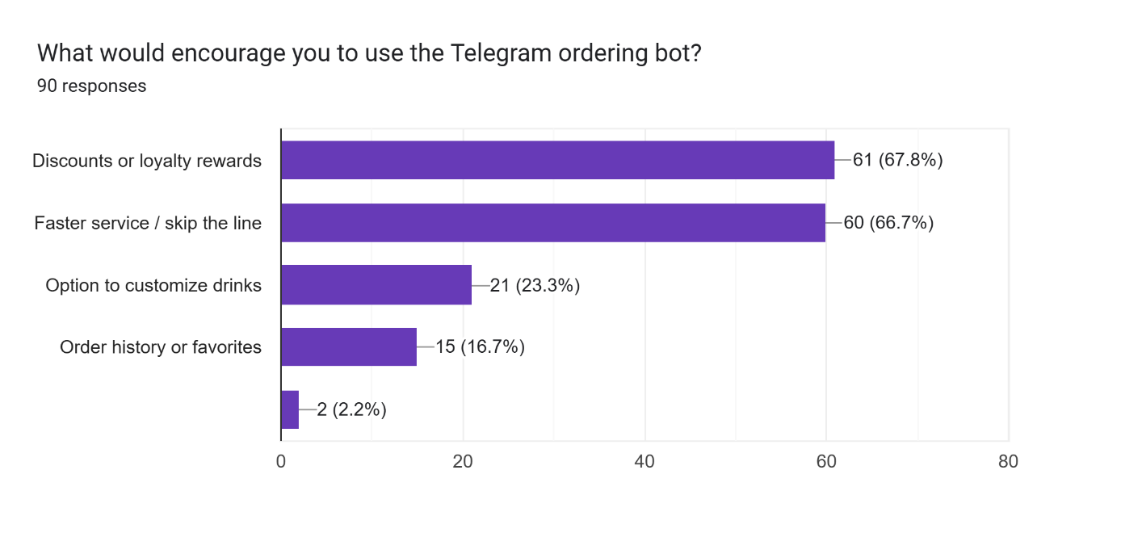

Segmentation–Targeting–Positioning
Segmentation
Demographic segmentation:
There are 2 groups. IUT students aged between 17 and 23 of both genders. They make the majority of customers and spend almost whole day at the university.
University staff aged from approximately 25 to 60. They make low-volume segment. Less frequent consumers.
Geographic Segmentation:
Since, Samad’s Coffee Station is located only at INHA University, most of its customers currently lives in Tashkent. For that reason geographic segmentation is irrelevant in our
Behavioral segmentation:
A) Consumers that usually buy coffees in the mornings and during lunch breaks. They choose this time to perk up with caffeine.
B) Students of UK program after 3pm and finish lectures at 7pm. That's why they purchase drinks at a late hour.
C) Bot users group that place order in advance to not being late
Psychographic segmentation: There are 3 groups:
- Convenience seekers (66%). Students that don’t want to wait in lines.
- Price sensitive (44,5%). They feel that all options on campus are overpriced.
- Variety seekers (9,5%). They are love to see more options in product line.
Targeting
Despite the fact that all segments are fairly important for Samad's Coffee Station, the target audience is convenience seekers. This group makes the largest part of daily demand with 75% of all purchases between 8AM and 12PM. Moreover, they stay loyal even after price increases. And most importantly, this group plays crucial role for achieving 500 pre-orders through Telegram bot per month because they can skip long queues and quickly get their drinks.
Positioning
For students at INHA University Samad's Coffee Shop is the specialty coffee brand that offers high-quality handcrafted drinks, fast service and a personalized experience. By enhancing speed, convenience (especially fix bugs that occur in Telegram pre-ordering bot) and personal connection, Samad can outperform other competitive businesses on campus.
Customer Persona
From the observations that we did, the customer persona is a female student at the age of 18. Why female and 18-years old? Even though, both genders are Samad's consumers still the number of female ones predominates. Most freshman students tend to be at the age of 18. This female student is coffee addicted and drinking one, helps her stay focused and energized during the whole day. Also, she is a frequent customer during morning times. She does not want to stand in long queues therefore, makes orders through Telegram bot. She stays tuned with promotions, discounts and news regarding Coffee Shop and strongly participates in Samad's raffles. She may visit Safia or Fretta for bakery but always returns to Samad's drinks for its taste, speed and convenience.
SMART Goals
First goal - to make more students know about Telegram bot. Currently, the percentage of the students who are familiar with it is 40,4 which makes it clear that the majority don’t even know its existence. That is why it is important to inform them about it first. To make it happen, firstly posters with QR codes and stickers near elevators will be placed, and posts on the IUT telegram channels and social media will be posted once every two weeks by doing this we want to increase awareness of the bot up to 75% in a month.
Second goal - students should not only know about the bot but also start to use it. Although the bot has been working for several months, currently only about 50 orders are made through it per week. We want to raise the number of orders to 125 per week within 2 months. This also will solve the problem with waiting in the queue during peak hours because part of customer switch to online. To achieve this, small actions will be introduced for bot users, creating simple and clear instructions and adding a separate shelf for quick order pickup. This will make the process more convenient and clear.
Third goal - enhancement of overall customer satisfaction. Currently the average score is 4,15 out of 5. We want to increase it to 4,35 in two months. This can be done due to a more clear and understandable process, faster service, a small expansion of the assortment and improving bot by fixing existing bugs while implementing new features such as notification system and keeping up with “every sixth coffee for free”. This will not only improve the work of Samad’s Coffee station but will also strengthen the positive attitude of students to the brand.
All these goals create a clear and practical plan. They help transform research results into specific actions that can be completed in the short term. These actions take into account students’ needs/wishes and support the further development of Samad’s Coffee Station.
Marketing Mix
Based on the results of our research, the marketing business of Samad’s Coffee Station has been redesigned in a way that directly tackles its key issues, identified during our survey – especially congestion during peak hours, limited awareness of the Telegram bot and the need for faster and more convenient service. 4Ps platform guarantees that improvements will be implemented not only to communication but also to the service process, product offering and physical environment.
Product
Samad offer variety of coffee options as well as tea and a little bit of snacks. From our interview we find out that most popular products are cappuccino and lemon tea. Since consumers’ satisfaction with the beverages themselves is already high, cardinal changes in the assortment are not needed. Instead, the company needs minor expansion in the product line, such as light snacks like cookies, sugar-free options and seasonal drinks. However, owner shared that he doesn’t want to sell products like sodas, water and energetics because you can find them in every shop. These additions meet students’ demands for diversity, while keeping Samad Station as coffee shop, that emphasis on the quality of the coffee as the main product.
Price
The prices in Samad’s Coffee Station are relatively a bit higher than its competitors. Difference is 3000-5000 sums which can be explained by better ingredients. This price sensitivity also reflects on survey results, almost more than half of students feel that prices are high. However, a complete price reduction is neither sustainable nor necessary. Instead, the plan is to consider short-term, low-cost incentives, specially directed towards wider adoption of the Telegram bot. Small advantages such as minor discounts for orders with the help of the bot or special offers like “every sixth drink for free” make a bot position a more attractive option, without reducing the overall perception of the brand’s value.
Place
Samad’s Coffee Station operates only in INHA University in the center of first floor in A building. There are two ways to place order: first in person and second is related to our objective ordering online through bot. Convenience is central to the positioning strategy that’s why it is important to enhance physical distribution of the service. Adding special shelves for placing orders using a bot allows students to quickly receive orders placed without having to stay in a queue. This shift defines the order processing procedure on the campus in a new way and directly influences the problem of the morning overload. Besides, strategically placed QR codes inside campus elevators simplify access to the bot and make it more intuitive.
Promotion
The strategy of promotion is focused on visibility and interaction. Since there was a lack of information, there were difficulties in using bots. Promotional materials must appear where students communicate most often. This includes posters in both buildings and QR code stickers in elevator cabins. An idea that Samad supported as particularly effective. Moreover, merchandized stickers will be given as gift for top 5 users of the bot every week.

Budget:
Items | Description/Purpose | Estimated cost
Bot improvements | Fix bugs and launch new features | ≈300 000 sums
Stand + large poster to it | Put next to the station | ≈200 000-430 000 sums
Posters (A3 format) with QR (3) | Put one in wall next to the station, one at the entrance | ≈3*5 000=15 000 sums
Elevator QR stickers (6) | Put in elevator. | ≈6*10 000=60 000 sums
Bot pickup shelf | Small shelf where the ready order stored. | ≈300 000 sums
Merchindized stickers (100) | Sticker gifts for bot active user. | ≈300 000 sums
Total: |  | ≈1 000 000-1 205 000 sums
Timeline:
Weeks | Tasks
Week 1 | Ask IUT administration for permission to place elevator stickers; Contact with a developer for bot improvements.
Week 2 | Design all promotional materials (posters, elevator stickers and merchandised stickers); Design and make special bot pick up shelf.
Week 3 | Place all promos and shelf; Relaunch bot with new features; Promote ordering bot through student groups & Telegram channels.
Week 4 | Introduce additional snacks.
Week 5-Week 8 | Measure all KPIs weekly.

KPIs
KPI | Linked SMART Goal | Baseline | Target | Measurement Method | Frequency
Bot Awarness Rate | 1st Goal | 40% | 75% in month | QR scan tracking | once in two week
Weekly bot orders | 2nd Goal | 50 orders per week | 125 order per week in 2 months | Bot analytics | weekly
Daily sales volume | 2nd Goal | n/a | +15-20% increase in 2 months | Sales report | monthly
Customer satisfaction score | 3rd Goal | 4.15/5 | 4.35+ in 2 month | Survey | monthly

Appendix:
Price for bot improvement was discussed with an ex front-end developer.
Price for stands: https://uzum.uz/product/1686591?utm_source=sharing&utm_medium=product_page_android&utm_campaign=native
https://artvision.uz/product/x-stend/
Folder with all research data:
https://drive.google.com/drive/folders/1z3fB0EuHKBPAXiWZAwNJT8_hvjSFFDLS?usp=sharing
Survey Results: https://drive.google.com/file/d/1pu7QO6d4dzigwzxvckjVlKG1D4ZjVwYH/view?usp=sharing
Interviews with students: https://drive.google.com/drive/folders/1v4zO5A6GnjdpWbBdYOeX7D6fYiRQbpeN?usp=sharing
Interview with owner:
https://drive.google.com/drive/folders/1d3TH5b_JrmuGV54GpluL_hV2f0d86_KB?usp=sharing

