By Naveen , BCA 1st sem

Question.1 - To accept student details and display them .

Answer.1 – Program :

/* Here is a program to accept student details and display them

</> Naveen

Date: 19 oct 2021

*/

#include<stdio.h>

#include<conio.h>

void main()

{

//Header

printf("\n\t Program to accept student details from user");

printf("\n\t****************** **********************");

// Decalring variable

char FNAME[20], SNAME[20], FFNAME[20], FSNAME[20];

long long CNUM,FCNUM;

//Taking input from user

printf("\n\t Enter Student Name : ");

scanf("%s %s",&FNAME,&SNAME);

printf("\n\t Enter Student Contact Number :");

scanf("%lld",&CNUM);

printf("\n\t Enter student Father name :");

scanf("%s %s",FFNAME,FSNAME);

printf("\n\t Enter Father contact number :");

scanf("%lld",&FCNUM);

printf(“\n\tRepresenting the output : \n\n”);

printf("\n\t Student name is %s %s \n",FNAME,SNAME );

printf("\n\t Student Contact Number is %lld \n",CNUM);

printf("\n\t Father name is %s %s \n",FFNAME,FSNAME);

printf("\n\t Father contact number is %lld \n",FCNUM);

}

OUTPUT :

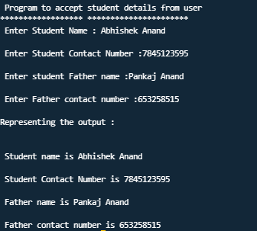

Question 2.- To find simple interest

Answer 2.- Program :

/* Here is a program to find simple interest

</> Naveen

Date: 19 oct 2021 */

#include<stdio.h>

#include<conio.h>

//Defining values

#define INTEREST 0.1

int main()

{

//Header

printf("\n\t Program to calculate simple interest");

printf("\n\t *************************************\n\n");

//Declaring Variables

int p_amount,year;

float SI;

//Prompt user to take input

printf("\n\t Annual rate of interest per annum is %8.2f",INTEREST);

printf("\n\t Enter Principal Amount :");

scanf("%d",&p_amount);

printf("\n\t Year for simple interest you want to calculate :");

scanf("%d",&year);

//Simple interest formula

SI=p_amount*INTEREST*year;

//output

printf("\n\t Simple interest for %d year is %8.2f",year,SI);

}

OUTPUT :

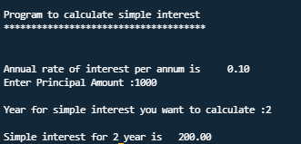

Question.3 – To find sum of two numbers.

Answers.3 – Program :

/* Here is a program to add two numbers

</> Naveen

Date: 19 oct 2021 */

#include<stdio.h>

#include<conio.h>

int main()

{

//header

printf("\n\t Program to add numbers ➕");

printf("\n\t ******************************");

//declaring variable

int num1,num2,sum;

//prompt user to give input

printf("\n\tEnter First Number :");

scanf("%d",&num1);

printf("\n\tEnter Second Number :");

scanf("%d",&num2);

//Calculations

sum=num1+num2;

//Printing output

printf("\n\tSum of %d and %d = %d",num1,num2,sum);

}

OUTPUT :

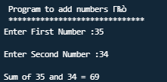

Question 4 -To find product of three numbers.

Answer 4- Program :

/* Here is a program to find product of three numbers

</> Naveen

Date: 19 oct 2021 */

#include<stdio.h>

#include<conio.h>

int main()

{

//Header

printf("\n\tHere is program to find product of three numbers ✖");

printf("\n\t********************* ***************************");

//Declaring variable

int num1,num2,num3,product;

//Prompt the user to give input

printf("\n\t Enter 1st number :");

scanf("%d",&num1);

printf("\n\t Enter 2nd number :");

scanf("%d",&num2);

printf("\n\t Enter 3rd number :");

scanf("%d",&num3);

//Calculations

product=num1*num2*num3;

//Giving output

printf("\n\tProduct of %d,%d,%d is %d",num1,num2,num3,product);

}

OUTPUT :

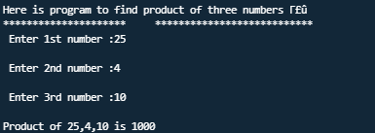

Question 5- To find average of marks scored in 5 subjects

Answers5 – Program :

/* Here is a program to find average of marks scored in 5 subjects

</> Naveen

Date: 19 oct 2021 */

#include<stdio.h>

#include<conio.h>

int main()

{

//Header

printf("\n\t Program to Find Average Of Marks Scored in 5 Subjects");

printf("\n\t ****************** ****************************************");

//Declaring variable

float s1,s2,s3,s4,s5,sum,avg;

//Prompt user for input

printf("\n\t Marks scored in 1st Subject :");

scanf("%f",&s1);

printf("\n\t Marks scored in 2nd Subject :");

scanf("%f",&s2);

printf("\n\t Marks scored in 3rd Subject :");

scanf("%f",&s3);

printf("\n\t Marks scored in 4th Subject :");

scanf("%f",&s4);

printf("\n\t Marks scored in 5th Subject :");

scanf("%f",&s5);

//Calculation Average

sum=s1+s2+s3+s4+s5;

avg=sum/5;

//Printing output

printf("\n\t Average of %8.2f,%8.2f,%8.2f,%8.2f,%8.2f = %8.2f",s1,s2,s3,s4,s5,avg);

}

OUTPUT :

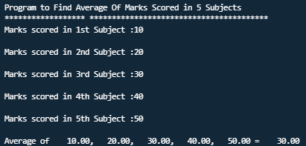

Question6- To find the total purchase made on 4 different items purchased

Answer6- Program:

/* Here is a program to find the total purchase made on 4 different items purchased

</> Naveen

Date : 21 oct 2021

*/

#include<stdio.h>

#include<conio.h>

int main()

{

printf("\n\tHere is program to find the total purchase made on four different items purchased.");

printf("\n\t*******************************************************************************");

int i1,i2,i3,i4,sum;

printf("\n\t Price of 1st item :");

scanf("%d",&i1);

printf("\n\t Price of 2nd item :");

scanf("%d",&i2);

printf("\n\t Price of 3rd item :");

scanf("%d",&i3);

printf("\n\t Price of 4th item :");

scanf("%d",&i4);

sum=i1+i2+i3+i4;

printf("\n\tYour total purchase is : %d",sum);

}

OUTPUT :

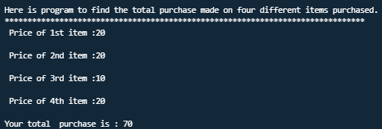

Question7 – To find square of a number

Answer7- Program:

/* Here is program to find square of a number

</> Naveen

Date : 21oct2021

*/

#include<stdio.h>

#include<conio.h>

void main()

{

printf("\n\t This is a program to find square of a number");

printf("\n\t *******************************************");

long long num, sq;

printf("\n\t Input the number you want to find square of :");

scanf("%lld",&num);

sq=num*num;

printf("\n\t Square of %lld is %lld ",num,sq);

}

OUTPUT:

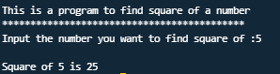

Question8- To find cube of a number

Answer8- Program :

/* Here is program to find square of a number

</> Naveen

Date : 21oct2021

*/

#include<stdio.h>

#include<conio.h>

void main()

{

printf("\n\t This is a program to find cube of a number");

printf("\n\t *******************************************");

long long num, cb;

printf("\n\t Input the number you want to find cube of :");

scanf("%lld",&num);

cb=num*num*num;

printf("\n\t Cube of %lld is %lld ",num,cb);

}

OUTPUT :

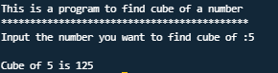

Question9 – To find square root of a number

Answer9- Program :

/* Here is a program to find a square root of given number

</> Naveen

Date : 22 oct 2021

*/

#include<stdio.h>

#include<conio.h>

#include<math.h>

int main()

{

int num,sqart;

printf("\n\tThis is a program to find square root of a given number");

printf("\n\t *****************************************************");

printf("\n\t Enter the number : ");

scanf("%d",&num);

sqart=sqrt(num);

printf("\n\t Square root of %d is %d",num,sqart);

}

OUTPUT :

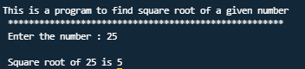

Question10 – To find Area of circle

Answer10 – Program :

/* Here is a program to find the Area of circle

</> Naveen

Date 22oct 2021

*/

#include<stdio.h>

#include<conio.h>

#define PI 3.14

int main()

{

float rad,area;

printf("\n\t This program is to find the area of circle");

printf("\n\t *****************************************");

printf("\n\n\n\t Enter the radius of circle :");

scanf("%f",&rad);

area=PI*rad*rad;

printf("\n\t Here value of PI is %8.2f",PI);

printf("\n\n\t Area of circle having radius %8.2f is %8.2f",rad,area);

}

OUTPUT :

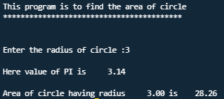

Question11 – To find perimeter of a rectangle

Answer11 – Program :

/* Here is a proram to find perimeter of rectangle

</> Naveen

Date : 22oct2021

*/

#include<stdio.h>

#include<conio.h>

int main()

{

int ln,br,permtr;

printf("\n\n\tThis program is to find perimeter of rectangle ");

printf("\n\n\t***********************************************");

printf("\n\t Enter length of rectangle : ");

scanf("%d",&ln);

printf("\n\t Enter breadth of rectangle : ");

scanf("%d",&br);

permtr=2*(ln+br);

printf("\n\tPerimeter of rectangle of given length %d and breadth %d is %d",ln,br,permtr);

}

OUTPUT :

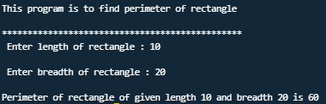

THANK YOU SO MUCH 😊