Web tool for Apache, MySQL, and PHP
The Web App Tool was created for the purpose of having ALL the main webserver commands used when trouble shooting web issues in one place. When you start the app, the following info gets display on the output window:
- Checks Apache config syntax.
- Apache version
- OpenSSL version
- Apache Service status
- PHP version
- MySQL version
- MySQL status
The main app has the following commands/options:
- Re-Start http (Apache)
- Stop http (Apache)
- Start http (Apache)
- Open httpd conf file
- Open Vhost file
- Re-Start MySQL
- Stop MySQL
- Start MySQL
- Open PHP ini file
- Allows to re-displayed apps information int the output window.
Screen shot of the output window and the main app:
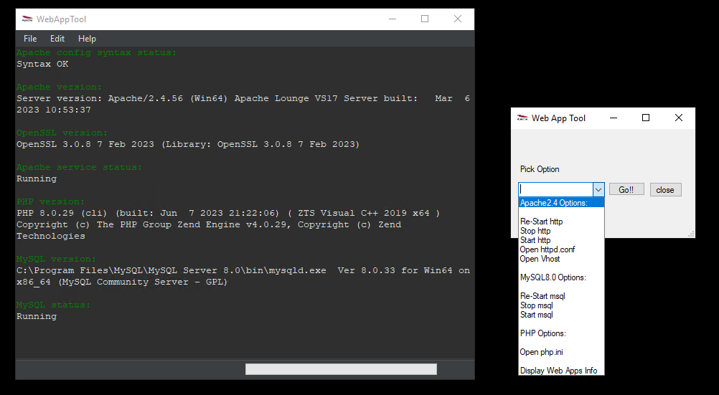
A config file is provided so users can easily run the app. As we know web admins like to install these apps in a nonstandard drive/path.

