# NG-FORM LIBRARY

NG-FORM LIBRARYis a library for adding forms in our project.

**How to use it?**

1. Create a New folder in your Angular project and name it as **projects**.
2. Add the **library folder (E.g.: ng-form-library**folder**)** inside the projects folder.
3. Add the following code in your **angular.json** file inside the projects alongside of your application.

"ng-form-library": {

      "root": "projects/ng-form-library",

      "sourceRoot": "projects/ng-form-library/src",

      "projectType": "library",

      "prefix": "ng",

      "architect": {

        "build": {

          "builder": "@angular-devkit/build-ng-packagr:build",

          "options": {

            "tsConfig": "projects/ng-form-library/tsconfig.lib.json",

            "project": "projects/ng-form-library/ng-package.json"

          }

        },

        "test": {

          "builder": "@angular-devkit/build-angular:karma",

          "options": {

            "main": "projects/ng-form-library/src/test.ts",

            "tsConfig": "projects/ng-form-library/tsconfig.spec.json",

            "karmaConfig": "projects/ng-form-library/karma.conf.js"

          }

        },

        "lint": {

          "builder": "@angular-devkit/build-angular:tslint",

          "options": {

            "tsConfig": [

              "projects/ng-form-library/tsconfig.lib.json",

              "projects/ng-form-library/tsconfig.spec.json"

            ],

            "exclude": [

              "**/node_modules/**"

            ]

          }

        }

      }

    }

1. Import the Library Module in the **Module** file.

import { NgFormLibraryModule } from 'projects/ng-form-library/src/lib/ng-form-library.module';

Also addNgFormLibraryModuleto the imports array in the same file.

1. Add the following in the **tsconfig.json** file.

"resolveJsonModule": true,

"esModuleInterop": true

This allows us the json files import in the ts.

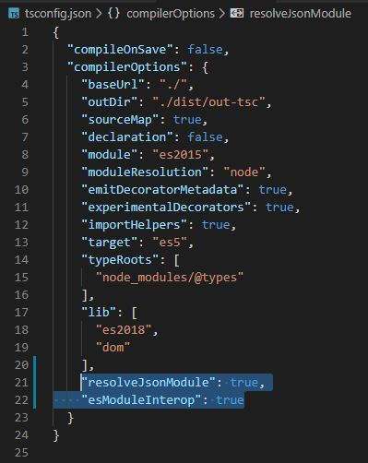

1. Install bootstrap, jquery and flatpicker.

npm install - - save bootstrap

npm install - - save jquery

npm install - - save flatpickr angularx-flatpickr

1. Add the following in your project array in the **angular.json** file.

* In **styles** Array,

"./node_modules/bootstrap/dist/css/bootstrap.min.css",

"./node_modules/flatpickr/dist/flatpickr.css"

* In **scripts** Array,

"./node_modules/jquery/dist/jquery.min.js",

"./node_modules/bootstrap/dist/js/bootstrap.min.js"

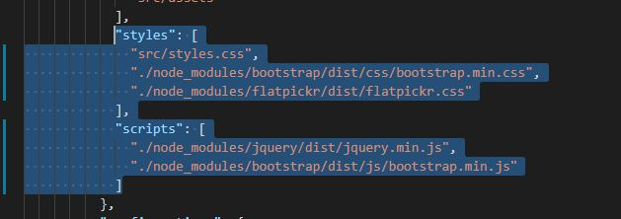

1. Go to the component where you want to add the form.

In html file:

Add the below code

<ng-form-generator [config]="config" (getFormData)="fetchFormData($event)"></ng-form-generator>

Here,

**config**is a model that contains the following fields.

* formName

It is the type of form that you want to use.

* Fieldstoexclude

**fieldstoexclude** is the array of fields that you want to exclude from a particular form(you have to add the label Name of the fields to exclude).

* Country

**country** is needed to populate the State field in the form. So if the value of country is India then all the States in India will be populated in the Select box in the State field.

In TS File:

You have to include the imports and declare the variables that is needed to be passed to the child component.

Add the below code in the ts file:

//import the model from the library

import { configModel } from 'projects/trailib/src/public-api';

import { FormGroup } from '@angular/forms';

//variable declaration

config:configModel;

//passing values

this.config = {

"formName":"RegisterIndia",

"fieldsToExclude":["Username"],

"country":"Australia"

}

//Sample Function to get Form Value

fetchFormData(formValues: FormGroup) {

//The FormValues can be accessed by formValues.value

}

Here,

* Config

It is the variable that passes the values in the configModel to the child Component. It contains the values for the formName, fieldstoexclude and country. The values of the fields in the model can be viewed by hovering over the variable.

* fetchFormData(formValues : FormGroup)

This function captures the form that is passed from the child component.

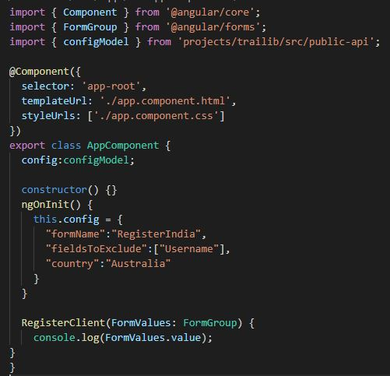

In the Library:

forms.json is the file that contains the json object of the Forms. So if there is anything to be changed (like adding or removing validation changing label name etc.) we can do it in this file. (**Folder**: ng-form-library)

**References:**

1. <https://indepth.dev/creating-a-library-in-angular-6-using-angular-cli-and-ng-packagr/>
2. <https://juristr.com/blog/2017/10/demystify-dynamic-angular-forms/>
3. <https://www.positronx.io/angular-checkbox-tutorial/>
4. <https://www.typescriptlang.org/docs/handbook/enums.html>
5. <https://devhints.io/jsdoc>