· npm init: This command initializes a new Node.js project and creates a package.json file in your project directory. The package.json file is a metadata file that holds information about your project, such as the project name, version, dependencies, scripts, and more.

· -y **or** --yes: This flag automatically accepts all the default values that npm init would normally prompt you to provide. For example, instead of asking you for the project name, version, description, entry point, etc., it uses the defaults (e.g., "name": "project-name", "version": "1.0.0", "main": "index.js", etc.).

· 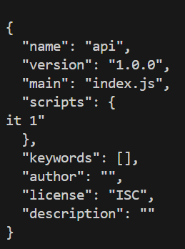

· npm install express

· create index.js

· npm init: This command initializes a new Node.js project and creates a package.json file in your project directory. The package.json file is a metadata file that holds information about your project, such as the project name, version, dependencies, scripts, and more.

· npm init: This command initializes a new Node.js project and creates a package.json file in your project directory. The package.json file is a metadata file that holds information about your project, such as the project name, version, dependencies, scripts, and more.