Christopher Storey

CMSC 636, Fall 2016

Homework #1

**Assignment 1: Visualization Construction**

**Tool Overview**

***Data-Driven Documents (D3)***: D3 is a comprehensive Javascript library that extension is designed for manipulating documents. In particular the Document Object Model or DOM is the underlying technology for HTML, SVG, CSS and other modern internet standards. This package takes these standards and makes it much easier to manipulate and construct robust web applications within a browser window.

DS3 is widely known for its success and impact as a widely adopted open source project. The number and types of visualizations that can be created using DS3 is virtually limitless. Since the entire JavaScript object model can be leveraged, DS3 programs allow tremendous creativity and flexibility during the design process. In my opinion, the following are DS3’s major strengths:

* Fast
* Supports large datasets
* Flexible
* Widely adopted
* Extensible
* Can support either Object oriented or Functional Programing paradigms
* Standards-based
* Free/open sourced

On the other hand, DS3’s comprehensive nature comes with a learning curve. Likewise, debugging large/complex programs can be difficult.

***Tableau Public***: Tableau is a commercial application that positions itself to provide easy to use visualization capabilities that where beyond the reach of most business customers just a few years ago. The package’s treatment of design principles guides the practitioner to create visualizations that eliminate many of the pitfalls encountered with other packages. Out of the box, there is database connector support for over 13 different data sources, ranging from desktop databases and flat files to large scale Hadoop implementations running on cloud infrastructure. Tableau can even handle joins of data from these disparate sources, providing even more flexibility. In my opinion, the following are Tableau’s major strengths:

* Provides an API to enable integration of Tableau’s engine into software development efforts
* Flexible
* Polished and robust
* Scalable

**Four Visualizations**

Visualizations 1 and 2 were not produced due to a bug in my DS3 code. Although it compiled, I could not produce images prior to the assignment deadline. The first of these images was supposed to take the dataset and produce a Line and Bar Chart to show trending and to allow comparisons of data fields with differing scales. The second diagram was supposed to be a 3D Scatter Diagram using Force nodes that would visualize data using a collection of DS3’s built-in design options – line thickness, opacity, and node scaling capabilities.

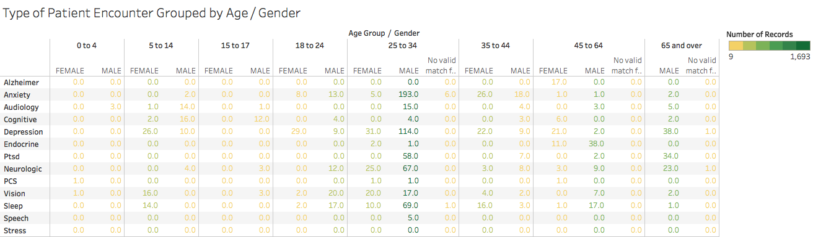

Caption: This Tableau Chart was designed to consistently highlight the most heavily serviced TBI illnesses by age and gender. Data selection includes: Alzheimer, Anxiety, Audiology, Cognitive, Depression, Endocrine, Ptsd, Neurologic, PCS, Vision, Sleep, Speech and Stress broken down by Age Group and Gender. Color shows sum of Number of Records. Details are shown for Alzheimer, Anxiety, Audiology, Cognitive, Depression, Endocrine, Ptsd, Neurologic, PCS, Vision, Sleep, Speech and Stress. The depiction of age information for both genders side by side allows for easy comparison. Furthermore, the use of color gradients to highlight the number of patient encounters aids the decision maker by pulling the eye towards important distinctions between data elements.

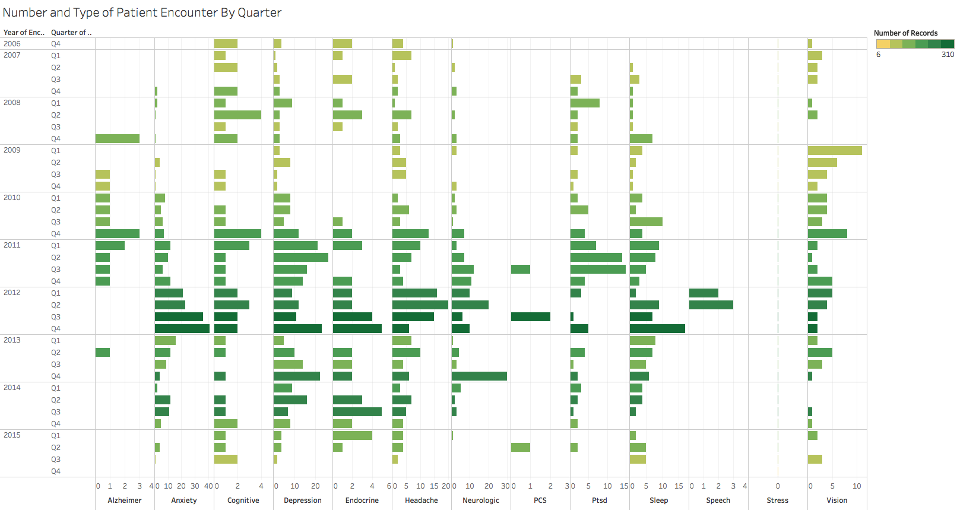

Caption: This Tableau Chart was designed to quickly highlight staff utilization based upon the number of patient encounters of each type over time. Data selection includes: Sum of Alzheimer, sum of Anxiety, sum of Cognitive, sum of Depression, sum of Endocrine, sum of Headache, sum of Neurologic, sum of PCS, sum of Ptsd, sum of Sleep, sum of Speech, sum of Stress and sum of Vision for each Encounter date Quarter broken down by Encounter date Year. Color shows sum of Number of Records. The depiction of relative patient utilization across illness categories makes it easy for decision makers to pinpoint seasonality trends, as well as areas where funding or staffing decisions could be made. Color graduation from yellow to green further highlights density of encounters in the most utilized categories of TBI illnesses.