**Design Patterns**

Authenticator and role based access design patterns are implemented.

**Memory Management**

Deletion of objects created with ‘new’.

Main.cpp line 30-50  
Resource.cpp line 49-50  
Subject.cpp line 26

**String Security**

String library is preferred to char array. All strings are initialized.

**Integer Overflow Check**

pressureSensor.cpp line 25-30 integer overflow check.

**Input Validation**

Invalid input can not crash the program.

Resouce.cpp line 29-36  
Subject.cpp line 55-67  
AuthenticationInfo.cpp line 48-62, 74-88

**File Input / Output Security**

‘Ifstream’ and ‘ofstream’ are used intead of ‘fopenf’ and ‘fscanf’.

**Zero Compiler Warning**

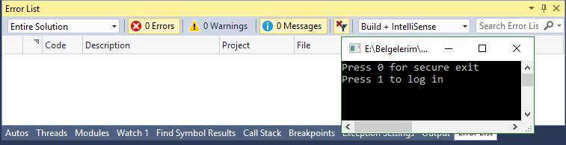

**Compiler Options**

