Welcome to the readme file for the library database program, developed by Andrew Fagrey and Benjamin Kaiser.

Instructions to opperate the database:

1). Open the link given to the database (either will work)

<http://dev.mcs.sdsmt.edu/~7168318>

<http://dev.mcs.sdsmt.edu/~7285523>

2). Use the database (which should look like something below):

**Library Database Main Window Screen**

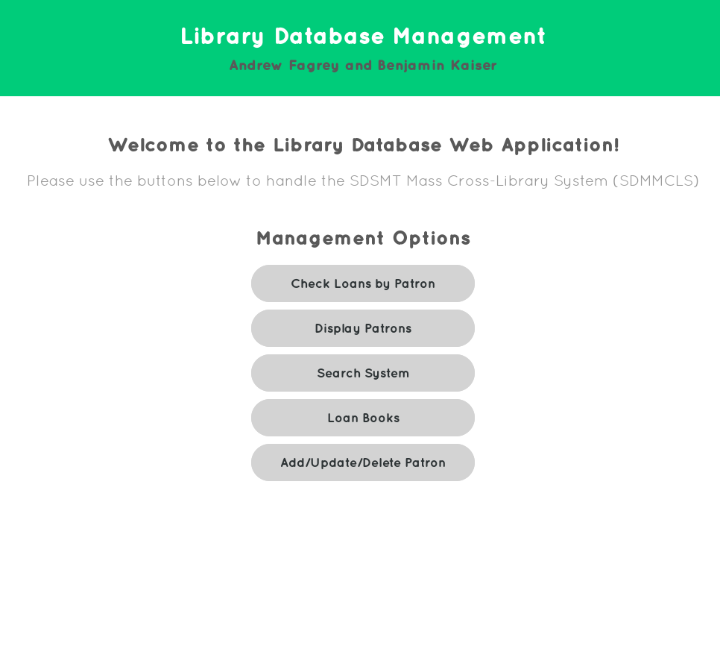

**Display Patrons**

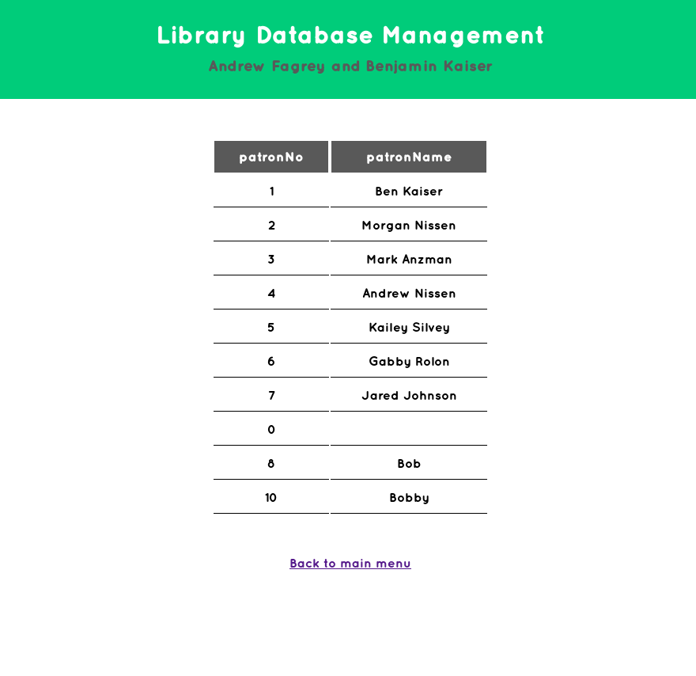

**Search System main screen**

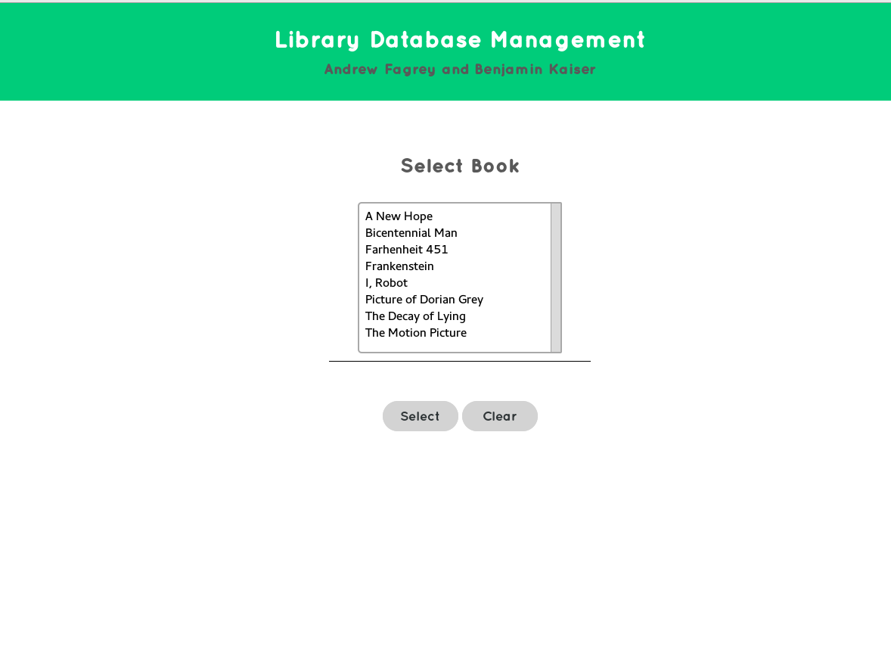

**Search – sub menu**

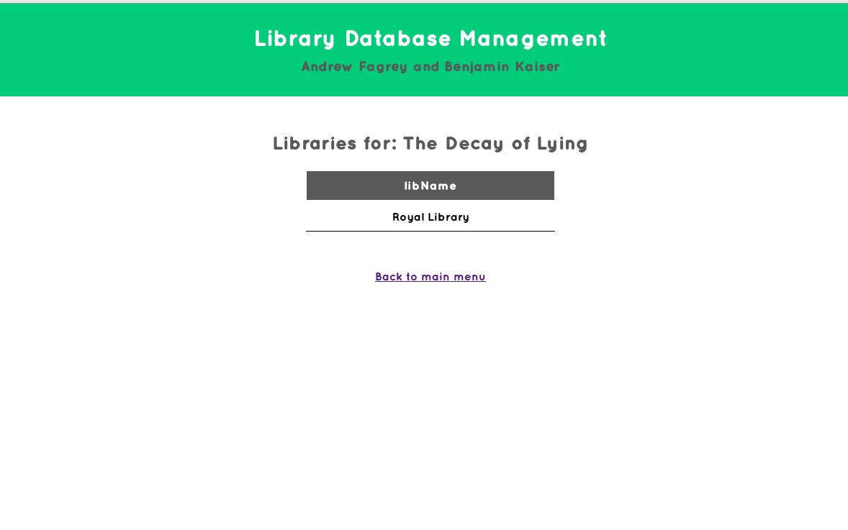

**Loan books – select a patron**

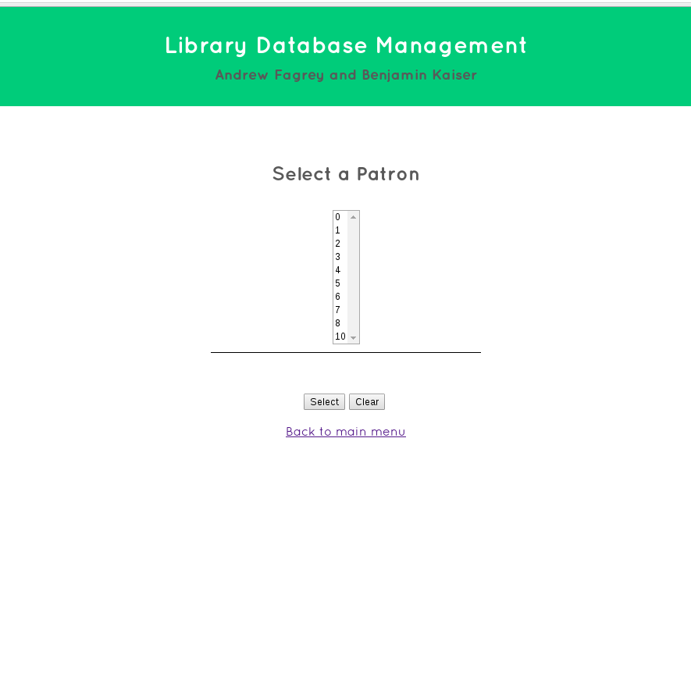

**Loan books – select a book**

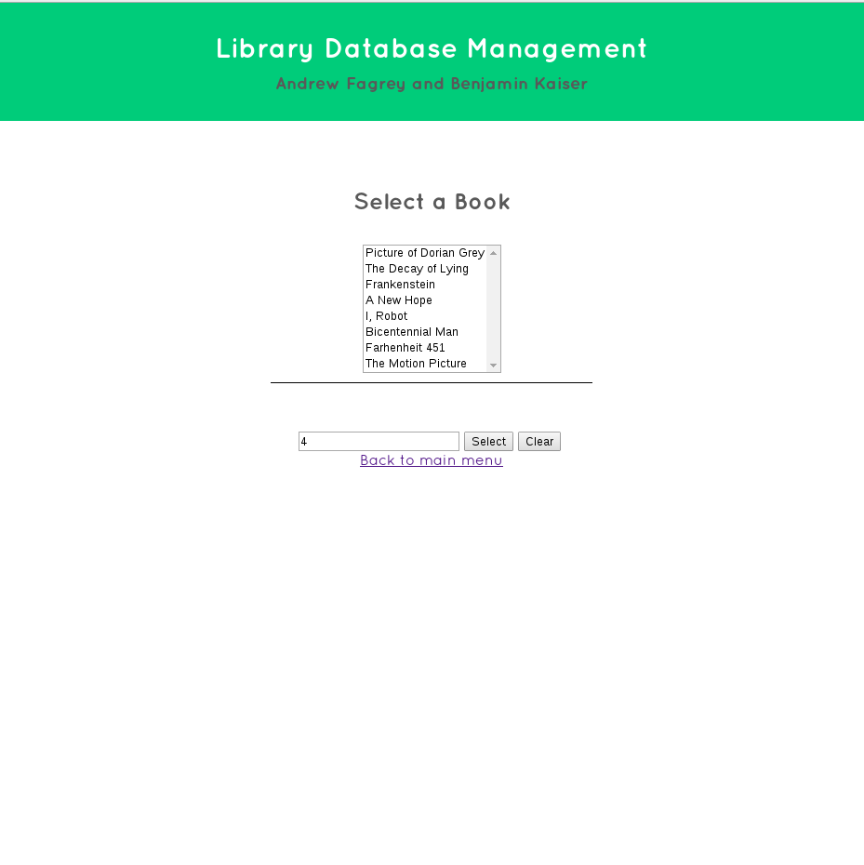

**Add / Update**

