Unreal Engine Games:

# Smite

Hi-Rez Studios; MOBA; UE3

Smite uses a fairly generic over-shoulder camera angle to display the player character and actions, it also has a fairly in-depth physics system. Thus using Unreal Engine 3 to start is a reasonable decision by the developers of the game. The game is multi-platform thus creating the game engine from scratch there would be more pain than it is worth, thus using a genericised game engine like Unreal helps massively for multi-platform builds.

# Injustice: Gods among Us

Nether Realm Studios; Fighting; UE3

Nether Realm Studios uses the Unreal engine to quickly drop characters in and start animating them so that they can quickly iterate and improve Unreal Engine’s systems to optimise of the fighting game genre. Injustice has a 60fps framerate that was easily accessed using the engines properties.

# Bioshock

2K Studios; First Person Shooter; UE2

The Original unreal engine was made for the Unreal series of games. This series of games are first person shooters, thus 2K’s decision to base their first person shooter on the Unreal Engine was a good one that enables them to quickly get to coding the unique parts of their game.

Unreal Blueprints:

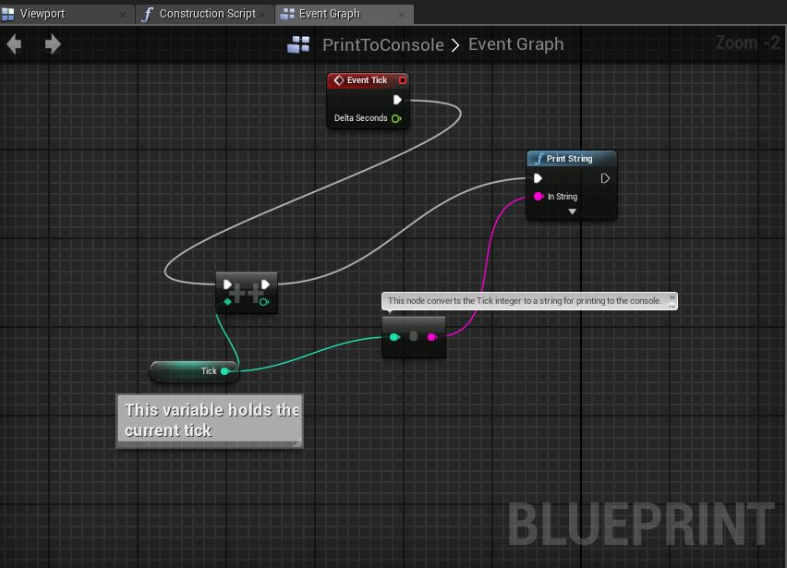

This screenshot shows the blueprint system in Unreal Engine 4. It shows two types of comments used within the editor, as well as a simple tick counting method which outputs to the console.

Credit Task: Comparison between UE4 and Unity.

|  |  |  |
| --- | --- | --- |
|  | Unreal Engine 4 | Unity |
| Programing Language | C++ | C# or Javascript |
| Visual Scripting | Blueprints | N/A |
| Basic 3D modelling | In engine modelling using basic shapes + Easy importing | Easy importing for 3D models, no basic shapes |
| Assets store | Well defined | Larger in scope, mostly free. |
| Profiler | All versions | Only UnityPro |
| Graphical Engine | Complex Particle Simulations and Dynamic Lighting | Basic lighting inbuilt, Dynamic lighting can be found on the asset store. Particle interactions are simple, but there are more complex interactions in the asset store for sale. |
| Pricing | Free but takes 5% of sales | Free version and Pro Version.  No royalties; Pro version costs US$75/month |
| Physics System | Detailed collision system | Detailed Collision system, inbuilt mathematics (Quaternions) |
| Mascot | None | Image result for unity chanUnity-Chan |

Reference: <http://blog.digitaltutors.com/unreal-engine-4-vs-unity-game-engine-best/>

Comparing when to use Unreal Engine 4 to Unity, your choice boils down to what you expect to be doing with the engine, and how experienced you are in OO programing. Both engines lend themselves to 3D games over 2D and to First and Third Person perspectives when creating games. Both Engines have detailed and significant collision and physic systems; However Unity supports quaternions simpler in the base engine. In terms of other features, Unity has less features built into the base engine but has a larger asset store with many assets and functionalities free for purchase from this store. Unity is in a simpler language for moderately experienced programmers to use; however most simple functionality that is hard to create using C++ is easily accessible using the blueprint visual scripting system. Which engine the programmer uses comes down entirely to preference, both are generic systems that can implement good functionality for any basic genre of game.