|  |  |  |  |  |  |  |  |  |  |  |  |
| --- | --- | --- | --- | --- | --- | --- | --- | --- | --- | --- | --- |
| Hotspot Mobiles, TC/4/192/1,Old No.SP-1/726,  Karyavattom, Trivandrum, Kerala  695581  **Phone : 9562440770, 9633661169**  **Email :** [**hotspotmobiles000@gmail.com**](mailto:hotspotmobiles000@gmail.com) | | | | |  | | INVOICE- INV-001 | | | | |
|  | | | | |  | | | |  | | |
| INVOICE COMPOSITION SCHEME(B2C ) | | | | | | | | | | | |
| Invoice No : | | INV-001 | | | | | | |  | | |
| Date : | | 2024-08-04 | | | | | | |  | | |
| Invoice To : | | | | | Mob : | 1234567890 | | | | | |
| John Doe | | | | | Email : | johndoe@example.com | | | | | |
| NY | | | | | State : | California | | Code : | | CA123 | |
|  | | | | | | | | | | | |
| SL NO | Item Name | | GST% | HSN No | | Qty | Rate | | | | Amount |
| 1 | Item 1 | | 18% | HSN001 | | 10 | 100 | | | | 1000 |
| 2 | Item 2 | | 18% | HSN002 | | 5 | 200 | | | | 1000 |
|  |  | |  |  | |  |  | | | |  |

## Other Charges:

**Net** **Amount** **:** **2,033.05**

Amount in Words : Rs. Two Thousand Three Hundred Ninety-Nine And Zero Paise Only

All the Particulars shown in this invoice are true and correct

# Thanks Visit Again - HOTSPOT MOBILES

**CGST** **:**

**SGST** **:**

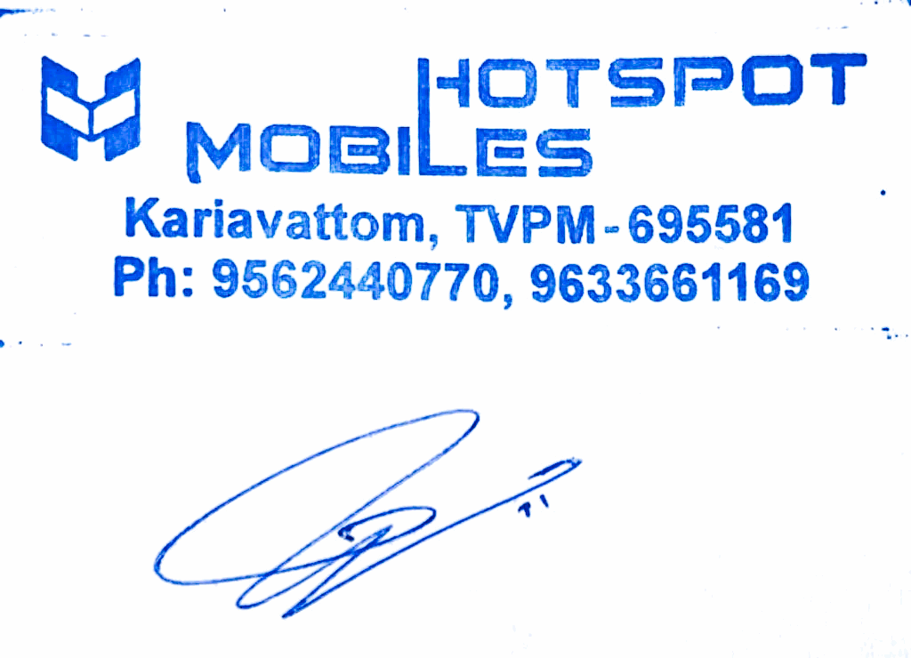**Total** **Amount** **:** **Other** **Charges** **:** **RoundOff** **:**

182.98

182.98

**2,399.00**

0.00

0.00

**Page** **1** **of** **1**